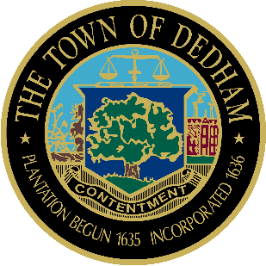 | TOWN OF DEDHAM  MEETING  NOTICE | POSTED:  TOWN CLERK

POSTED IN ACCORDANCE WITH THE PROVISIONS OF M.G.L. CHAPTER 30A SECTION 20 AS AMENDED.
Board or Committee: | Conservation Commission
Location: | Lower Conference Room, Dedham Town Hall
Day, Date, Time: | Thursday November 15, 2018, 7:00 PM
Submitted By: | Renee Johnson
Date: | November 13, 2018

AGENDA:

- 7:00 PM -Applications To Be Continued to November 6, 2018
  - 235 & 243 Bussey Street, ANJOM, LLC, Applicant – Scott Henderson, Henderson Consulting Services, Rep – Demolition of five existing structures on-site and construction of a new mixed use building (MSMP 2017-23).
  - 339 Washington Street, Garnett Realty Trust, Applicant – Sue Harrington, GCG Engineering, Rep. Major Stormwater Permit Application for the redevelopment (mixed use addition) of a commercial building (MSMP 2015-25).
  - 270 & 290 Bussey Street, Delapa Plaza East, Inc, App – Jim Devellis, DeVellis Zrein, Inc – Rep. –Commercial/residential redevelopment of an existing commercial building in Buffer Zone to Bordering Vegetated Wetlands, Bank, and Land Under Water; and Riverfront Area (DEP File # 141-0535, MSMP 2018-07).

- Applications Opened Previously (to be heard this evening):
  - 7:00 PM – 456 Providence Highway & 62 Eastern Avenue, RK Associates, Inc., App - Forrest Lindwall, Mistry Associates, Rep. –Demolition of a 2-story commercial building and construction of a 1,800 sf 1-story retail building (DEP File #141-TBD, MSMP 2018-19).
2.2 7:10 PM - 218 High Street, Map 111, Lot 3, Antonio Ferrara, Applicant – Byron Holmes, Holmes Engineering, Representative: Major Stormwater Management Permit for the construction of a new two family dwelling (MSMP #2018-22).
  - 7:10 PM - 218 High Street, Map 111, Lot 67, Antonio Ferrara, Applicant – Byron Holmes, Holmes Engineering, Representative: Major Stormwater Management Permit for the construction of a new single family dwelling (MSMP 2018-23).

- New Applications:
  - 7:20 PM – 14 Glancy Lane, Visual Property and Investments, LLC, App. – Jack Tabares, Farland Corp., Rep. – Demolition of an existing single family dwelling and replacement with new single family dwelling (MSMP 2018-29).

Informal Discussion- (The following items may be discussed at any point during the meeting)
Old/New Business - This item is included to acknowledge that there may be matters not reasonably anticipated by the Chair that could be raised during the Public Comment period by other members of the Committee, by staff or others
- Draft Stormwater Management Regulations
- Agents Report
- Meeting Minutes – 11/1/18

