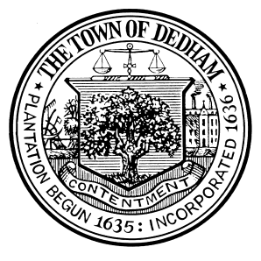 | TOWN OF DEDHAM  MEETING  NOTICE | POSTED:  TOWN CLERK

POSTED IN ACCORDANCE WITH THE PROVISIONS OF M.G.L. CHAPTER 30A SECTION 20 AS AMENDED.

Board or Committee: | Dedham Human Rights Commission
Location: | Dedham Middle School Library
Day, Date, Time: | November 14, 2018 6:00 PM
Submitted By: | Margaret Adams, Clerk for Dedham Human Rights Commission
Date: | November 7, 2018

AGENDA

Public Input

Approval of Meeting Minutes

Discussion of person to be Guest Speaker on MLK Day

Discussion on Logo Design Advertisement and Engagement of Middle and High School

MLK Day Flyer preparation

Donations for MLK Day

School Music programs for MLK Day

Discussion on Webpage Planning

Discussion of National Violence and Impact on Local Communities

Discussion of Possible HRC Community Resource Guide

Old/New Business*

*This item is included to acknowledge that there may be matters not reasonably anticipated by the Chair that could be raised during the Public Comment period by other members of the Committee, by staff or others.

