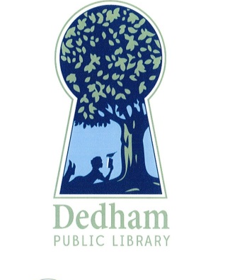
Bonnie Roalsen, Director Margaret Connolly, Chair
Dedham Public Library Sarah Santos, Vice Chair
43 Church Street Tracy Driscoll
Dedham, MA 02026 Mary Ann Sliwa
781.751.9281 Monika Wilkinson

DPL Trustees Meeting Minutes
october 23, 2018, Endicott library, 6:30 pm
Meeting Called By | Board of Library Trustees, Dedham
Type of Meeting | Working Meeting
Chairman | Margaret Connolly
Secretary | Mary Ann Sliwa
Attendees | Margaret Connolly, Tracy Driscoll, Sarah Santos, Mary Ann Sliwa, and Monika Wilkinson
PUBLIC ATTENDEES | None

Call to Order:

The meeting was called to order at 6:32 pm by Chair, Ms. Connolly. All were present.

Working Meeting to Discuss Board of Library Trustee Self-Assessment:

Consideration was taken of each item on the self-assessment tool used by the Board of Library Trustees, Waltham Public Library, which was based on six reputable sources.

An item by item review occurred. It was decided that this would be a yearly process.

Questions about the philosophy and budget decisions regarding the Dedham Public Library were raised.

Working on guidelines for reporting library business and working with groups was mentioned. The web site and the public dissemination of Board of Library Trustees meeting minutes were discussed.

Ms. Connolly made a motion to adjourn the meeting and go into Executive Session at 8:13 pm. Ms. Wilkinson seconded. A roll call vote to go into Executive Session at 8:13 pm occurred with the following votes: Ms. Santos-aye; Ms. Driscoll-aye; Ms. Sliwa-aye; Ms. Wilkinson-aye; Ms. Connolly-aye.

Respectfully submitted,

Mary Ann Sliwa

