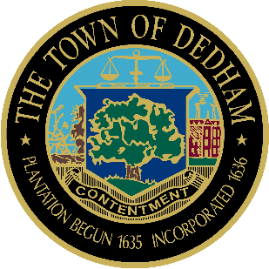 | TOWN OF DEDHAM  MEETING  NOTICE | POSTED:  TOWN CLERK

POSTED IN ACCORDANCE WITH THE PROVISIONS OF M.G.L. CHAPTER 30A SECTION 20 AS AMENDED.
Board or Committee: | Conservation Commission
Location: | Lower Conference Room, Dedham Town Hall
Day, Date, Time: | Thursday January 3, 2019, 7:00 PM
Submitted By: | Renee Johnson
Date: | December 28, 2018

AGENDA:

- 7:00 PM -Applications To Be Continued to January 17, 2019
  - 339 Washington Street, Garnett Realty Trust, Applicant – Sue Harrington, GCG Engineering, Rep. Major Stormwater Permit Application for the redevelopment (mixed use addition) of a commercial building (MSMP 2015-25).
  - 235 & 243 Bussey Street, ANJOM, LLC, Applicant – Scott Henderson, Henderson Consulting Services, Rep - Demolition of five existing structures on-site and construction of a new mixed use building (MSMP 2017-23).

- Applications Opened Previously (to be heard this evening):
2.1 7:05 PM - 270 & 290 Bussey Street, Delapa Plaza East, Inc., App – Jim Devellis, DeVellis Zrein, Inc – Rep. –Commercial/residential redevelopment of an existing commercial building in Buffer Zone to Bordering Vegetated Wetlands, Bank, and Land Under Water; and Riverfront Area (DEP File # 141-0535, MSMP 2018-07).
2.2 7:15 PM – 124 Quabish Road, Route 1 Management Land Trust, LLC as Trustee of 200 Commercial Circle Realty Trust, Applicant – Curtis Young, Wetlands Preservation, Inc., Representative – Construction of a wetland replication area in Bordering Vegetated Wetlands (DEP File #141-0545).
2.3 7:25 PM - 10 Campus Drive, Noble & Greenough School, Applicant – Paul Avery, Oak Consulting Group, Representative – 1,960 sf addition to Lawrence Auditorium (MSMP 2018-31).

- New Applications:
  - 7:35 PM – 122-124 Milton Street, Matt Jassett, Applicant – Paul Lindholm, Representative – New two family residence in Riverfront Area (DEP File # 141-TBD, MSMP 2018-33).
  - 7:40 PM – 219 Lowder Street, Collis, LLC, Gregory Carlevale, Applicant – Scott Henderson Representative. – Seven unit Planned Residential Development (MSMP 2018-34).

Informal Discussion- (The following items may be discussed at any point during the meeting)
Old/New Business - This item is included to acknowledge that there may be matters not reasonably anticipated by the Chair that could be raised during the Public Comment period by other members of the Committee, by staff or others
- Request for COCs
  - 500 High Street (Gonazalez Field ) – Robert Stanley Applicant (DEP File #141-0515, MSMP 2017-02)
- Agents Report
- Meeting Minutes – 12/6/18; 12/20/18

