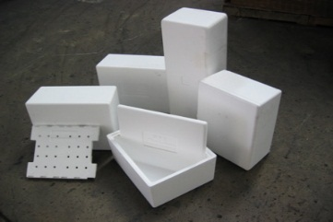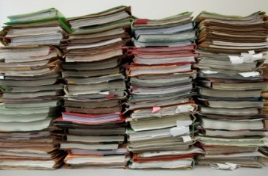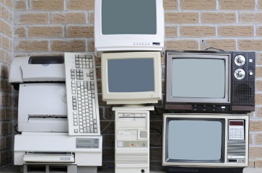



**Saturday, May 18, 2019**

**8:00am – 12:00pm**

**Location**:

**Dedham Middle School Side Parking Lot**

**70 Whiting Avenue**

**Dedham, Mass.**

**For more information contact**:

Virginia LeClair, Environmental Dept.

781-751-9210 or vleclair@dedham-ma.gov

**Textiles**

Any condition clothes, linens, stuffed animals, shoes, accessories. **Must be bagged.**

**Paper Shredding**

Secure shredding done off-site

**Scrap Metal**

**White Styrofoam**

Polystyrene cups,

grocery meat trays, takeout food packaging, rigid

foam. **No peanuts.**

**RECYCLING EVENT**

Town of Dedham

**Electronics**

Fundraiser for Neponset Valley Rotary Club – see costs to right.

For a complete list of items accepted visit www.dedham-ma.gov or “Green Dedham” on Facebook

**Bikes Not Bombs**

We want your old bikes! $10 suggested donation defrays the cost of shipping oversees. Tax deductible receipt provided with each donation. Accepted – all types and sizes of bikes, tools, parts, accessories (helmets bags, lights, pumps, locks), cycling clothing. No rusted bikes, scooters please.

**Mercury**

**Drop-off at**

**Transfer**

**Station,**

**All**

**Saturdays**

**9-12**

**Electronics Recycling Prices**

CRT TV’s & Flat Screens

13” or less $20.00

14” – 20” $30.00

21” & greater $40.00

Console, Projection TV’s $60.00

Printers $10.00

Desktop Copiers $15.00

VCR / DVD / CD / TiVo and

Stereo Equipment $5.00

PC / CPU $20.00

Laptops $15.00

UPS Battery Back-ups $10.00

**Mercury**

CFL’s, U- shaped lamps, switches, thermometers, thermostats, button-cell batteries, 2’ & 4’ straight/round bulbs