A Meeting of the Board of Selectmen was held on Thursday March 14, 2019, 6:30pm, in the Lower Conference Room, Town Hall, 26 Bryant Street, Dedham, Massachusetts

Present were:
James A. MacDonald – Chair
Brendan G. Keogh - Vice Chair
Dr. Dennis J. Teehan Jr.
Michael L. Butler
Dennis J. Guilfoyle

Mr. MacDonald called the Meeting to order at 6:35 pm

Pledge of Allegiance

Led by Mr. MacDonald

Official Swearing-In - Dedham Fire Department: Deputy Chief Stephen Lynch; Captain Bruce McGraw; Captain William Walsh; Captain Robert DeVincent; Captain Edward Berry; Captain Richard Staunton; Lieutenant Kevin O’Brien

Chief Spillane stated that they are here tonight to swear in and congratulate seven members of the Department as they begin their new leadership roles.

- Deputy Chief Stephen Lynch
- Captain Bruce McGraw
- Captain William Walsh
- Captain Robert DeVincent
- Captain Edward Berry
- Captain Richard Staunton
- Lieutenant Kevin O’Brien

Chief Spillane stated that these members are here tonight because they dedicated themselves to the Fire Service and to this Department as a whole. She Spillane added that they have repeatedly proven themselves on the Fire grounds. Chief Spillane continued, saying Captains will be tasked with organizing training, overseeing the Fire and health and wellness program. Chief Spillane informed all that six of the seven officers have an average of 20 years on the job.

Chief Spillane stated that being promoted will carry all the responsibilities that come with the job. Chief Spillane added that it is very important to continuously learn and to pass that knowledge on to the next generation of Firefighters.

Chief Spillane congratulated the Firefighters and their families.

Paul Munchbach swore in Lieutenant Kevin O’Brien.

Lieutenant. O’Brien was pinned by his father.

Paul Munchbach swore in the five new Captains.

Edward Berry was pinned by his wife, Tracey.

Robert DeVincent was pinned by his mother.

Richard Staunton was pinned by his wife, Lisa.

William Walsh was pinned by his father, Mark.

Bruce McGraw was pinned by his wife, Kathy.

Mr. Munchbach swore in Deputy Chief Stephen Lynch.

Stephen Lynch was pinned by his father, Tom.

Mr. Lynch thanked Chief Spillane for all the support and added that this is just a great group to work with. Mr. Lynch thanked his parents, his in-laws and his wife Leslie.

Mr. Walsh thanked Chief Spillane for the opportunity to serve the Town in this position. Mr. Walsh also thanked his wife Kelly, his children and the rest of his family for their love and support.

Mr. DeVincent thanked the Town and his family for putting up with his swings while he was studying.

Mr. McGraw stated that this is more than a job it’s a brotherhood. Mr. McGraw then thanked Chief Spillane and the Board of Selectmen for this opportunity. Mr. McGraw also thanked his family for their support and added that it is a privilege to get this opportunity.

Mr. Berry thanked Chief Spillane and the Town for this opportunity. Mr. Berry also thanked his family for their and support.

Mr. O’Brien thanked his mother and father as well as other family members and friends that supported him through this

The Board members shared some thoughts and advice with the Firefighters.

Dr. Teehan stated that this is a hard job. Dr. Teehan added that he has the utmost respect of each and every one of you in hopes your successful career and stay safe.

Mr. Keogh thanked the Firefighters and their families. Keogh informed all that his brother Steve is a Chief in the Boston Fire Department and remembered all the times he was studying hard and making his family proud.

Mr. Butler stated that this night represents another generation of terrific leaders in the Public Safety Department. Mr. Butler added that he appreciates the sacrifice that has to be made.

Mr. Guilfoyle congratulated all of the Firefighters. Mr. Guilfoyle advised the newly sworn in Firefighters to learn as much as they can from the more experienced guys in the Department and urged them to use common sense.

Mr. MacDonald stated that the emergencies and challenges that these Firefighters face on a daily basis, the average person cannot deal with but the Town asks you to deal with these to keep the residents safe. Mr. McDonald added that he would like these Firefighters to retire and enjoy their pension and their families.

Dedham Citizens Open Discussion

Amy Beckwith – 2 Wampatuck Road

Ms. Beck read a prepared statement. A number of us received letters dated 3-6-19, stating the Town’s intent to readdress, which gave us only 10 days to comply. A meeting was set up and took place this morning. Participants were many of the affected Wampatuck Road residents, officials from the Town’s GIS Management office, building Commissioner, Chief of Police and Chief of the Fire Department, assistant Town Manager. We residents believe the Town’s interpretation of the standards to be too rigid, unreasonable and an unnecessary hardship for each of us. We believe there is a rationale between the State and the Town, so the Town can arrive at an alternate decision that is satisfactory to both the Town and the Wampatuck Road residents. The residents in attendance at today’s meeting were advised that the appeal process, afforded to them by the assistant Town Manager. In addition the Assistant Town Manager agreed to suspend any decision on this matter until an appeal was filed and reviewed by the Board of Selectmen. The residents confirmed with the Assistant Town Manager that we would be filing a written appeal with the Board of Selectmen.

Jim Kaufman – 248 Highland Street. Mr. Kaufman stated that he was present in support of Jim and Amy Beckwith and the other residents on Wampatuck. Mr. Kaufman informed all that there was a house at 219 Lowder St. that the Planning Board approved for demolition and approved the building of a seven unit condo structure. Mr. Kaufman stated that one of the issues involved is the driveway will be on Wampatuck so they want the address for this new building to be Wampatuck. Mr. Kaufman added that the driveway to the house at 19 Lowder St. had previously been on Wampatuck. Mr. Kaufman stated that it’s an incredible inconvenience for all these folks to have to change their address after decades of living there. Mr. Kaufman wondered if the Board of Selectmen could help in any way.

Discussion & Vote Re: Adoption of Rules & Regulations for Holders of Alcoholic Beverage Licenses in the Town of Dedham

Mr. Butler stated that the Board had asked all Dedham liquor license holders to submit suggestions to the Board and received comments from Showcase Cinemas and Gilberts. Mr. Butler informed all that Deputy Chief Buckley, Town Counsel and he met to discuss the proposed changes. Other than Showcase and Gilbert’s, the Board received no other suggestions.

Deputy Chief Buckley stated that the Showcase Cinema had asked for clarification on rule number seven which deals with the Town following Chapter 42 of the Town’s General Bylaws which includes fingerprinting all Managers of record. Deputy Chief Buckley stated that Chief D’Entremont would like to go back and fingerprint all license holders. Deputy Chief Buckley suggested that that be done by September 2019.

Deputy Chief Buckley stated that Rule number 8 originally had 50% of the time that alcohol is served, which is not enforceable by the Dedham Police, Deputy Chief Buckley suggested that the industry standard is 40 hours a week, so they asked for that change to be made.

Deputy Chief Buckley stated that the Town currently requires that servers be trained within 90 days of hire. The original proposal was 30 days but there was discussion that that was not long enough, so we will split it down the middle and make it 45.

Deputy Chief Buckley informed all that the three year mandatory renewal of TIPS training will remain unchanged.

Mr. Guilfoyle moved to approve the changes to the rules and regulations for holders of alcoholic beverage licenses in the Town of Dedham; seconded by Mr. Butler. On the Vote: Mr. Keogh, yes, Dr. Teehan, yes, Mr. Butler, yes, Mr. Guilfoyle, yes, Mr. MacDonald, yes.

Public Hearing – Issuance/Transfer of Stock/New Stockholder for Genki Enterprises, Inc. d/b/a Genki, 202 Legacy Place

Attorney Meihuei Hu, representing Genki, was present before the Board.

Ms. Hu stated that Genki has been in Legacy Place for over six years. Ms. Hu added that today’s hearing is a petition for the restructure of the Corporation. Ms. Hu informed all that one of the shareholders, because of personal family business, had to relocate to New York. Ms. Hu stated that he offered his share, 7%, up for sale and one of the existing shareholders bought it. Therefore we are applying to the ABCC to correct the shareholder percentage interest. Ms. Hu informed the Board that other than that there are no changes.

Mr. Guilfoyle moved to close the Public Hearing; seconded by Dr. Teehan. On the Vote: Mr. Keogh, yes, Dr. Teehan, yes, Mr. Butler, yes, Mr. Guilfoyle, yes, Mr. MacDonald, yes.

Dr. Teehan moved approval of the request for the restructure of the Corporation from Genki; seconded by Mr. Keogh. On the Vote: Mr. Keogh, yes, Dr. Teehan, yes, Mr. Butler, yes, Mr. Guilfoyle, yes, Mr. MacDonald, yes.

Discussion & Vote Re: Dedham School of Music All-Town Yard Sale

Michael Emery, Board member at Dedham school of music, was present before the Board.

Mr. Emery stated that the Board should have received a letter requesting permission to place signage around Town to promote the Dedham School of Music All-Town Yard Sale.

Mr. Guilfoyle moved approval; seconded by Dr. Teehan. On the Vote: Mr. Keogh, yes, Dr. Teehan, yes, Mr. Butler, yes, Mr. Guilfoyle, yes, Mr. MacDonald, yes.

Discussion & Vote Re: Appointment of Town Manager Search Firm

Ms. Baker informed all that at the last Selectmen’s meeting the Board interviewed the following search firms:

- The Collins Institute
- Community Paradigm
- Municipal Resources, Inc.

Ms. Baker stated that these are the three applicants for consideration to assist the Town its search for a new Town Manager.

Mr. McDonald informed all that he and Mr. Butler checked some references. Each Board Member gave their choice as to which Search Firm they chose.

Mr. Keogh
Paradigm

Dr. Teehan
Paradigm

Mr. MacDonald
Paradigm

Mr. Butler
Paradigm

Mr. Guilfoyle
Paradigm

Mr. MacDonald informed all that Paradigm came with very good references and extensive experience. Mr. McDonald informed all that the Town received price proposals from each applicant and asked Ms. Baker to open the one from Paradigm.

Ms. Baker stated that Paradigm’s total fee is $11,000 1/4 of which is due at the completion of each of the four phases.

Ms. Baker informed all that she will be going in front of the Finance Committee on Tuesday evening to request a reserve fund transfer in this amount.

Discussion & Vote Re: Appointment of Town Manager Search Committee as Special Municipal Employees

Ms. Baker informed all that in her discussions with Town Counsel in preparation of the Search Committee beginning its work, she recommended that because of the structure of the Committee and in some instances, positions that those Committee Members hold, it would be appropriate for the Selectmen to vote to designate the letters of the Town Manager’s Search Committee as special municipal employees in accordance with the provisions of Massachusetts Gen. Law 268A Section 1.

Dr. Teehan moved approval with the recommendation of Town Counsel; seconded by Mr. Keogh. On the Vote: Mr. Keogh, yes, Dr. Teehan, yes, Mr. Butler, yes, Mr. Guilfoyle, yes, Mr. MacDonald, yes.

Drainlayer License Renewal

- DiMartino Construction, Inc.
44Coutu Street
Franklin, MA 02038

Mr. Guilfoyle moved approval; seconded by Mr. Butler. On the Vote: Mr. Keogh, yes, Dr. Teehan, yes, Mr. Butler, yes, Mr. Guilfoyle, yes, Mr. MacDonald, yes.

Sustainability Advisory Committee - Appointment

Ms. Baker stated that there was a posting from February 19 for two members of the Sustainability Advisory Committee and there was one applicant, Andrew Belden. Ms. Baker added that this is a three-year term set to expire in 2022. Ms. Baker informed all she will be re-posting the other position.

Mr. Guilfoyle moved approval; seconded by Mr. Butler. On the Vote: Mr. Keogh, yes, Dr. Teehan, yes, Mr. Butler, yes, Mr. Guilfoyle, yes, Mr. MacDonald, yes.

Discussion & Vote Re: Overall Financial Policy

Mr. Butler stated earlier this week the Financial Policies Committee met to review the fourth and final Financial Policy that we wanted to rewrite. Mr. Butler added that is called the overall Financial Policy. Mr. Votta continued, saying that they talked about it made a few changes which are reflected in the redline version is attached to your notes for tonight. Mr. Butler stated that if the Board does not have any questions, he asked for them to support the overall Financial Policy’s approval.

Mr. Guilfoyle moved approval; seconded by Mr. Keogh.

Mr. Butler thanked the people on the Committee as it took a lot longer than we thought it would take.

Mr. McDonald pointed out the work that Mr. Butler did as Chair of the Committee. Mr. MacDonald added that it is not easy to get everyone together.

On the Vote: Mr. Keogh, yes, Dr. Teehan, yes, Mr. Butler, yes, Mr. Guilfoyle, yes, Mr. MacDonald, yes.

Discussion & Vote w/ Finance Director Re: Special Cable Franchise Fund(s)

Dir. of Finance, Andrea Terkelsen, was present before the Board. Ms. Terkelsen stated that she has provided a memo with 2 requests related to our Franchise Cable Activities.

Ms. Terkelsen stated that the 1st item is a request ask the Board to release $125,000 from that special fund, which is part of our Franchise Capital monies to continue our efforts to improve our IT infrastructure, as it relates to and as we are playing move over to the Ames building.

Ms. Terkelsen stated that the 2nd request is to ask the Board for the approval to release $926,000 to DVAC. This amount represents the balance accumulated in the special franchise fund over the last several years. Ms. Terkelsen added that the three franchise holders provide an amount of 5%, typically on a quarterly basis. Ms. Terkelsen continued, saying that historically the Board of Selectmen and the Town has elected to keep back 1% of that franchise money and the remaining 4% is provided to DVAC, on a regular basis, to assist them with their operating expenses throughout the year.

Mr. Butler clarified that the first request is for $125,275 from Dedham’s Capital Cable Fund. The second request is to write a check for $926,006. Mr. Butler asked Ms. Terkelsen if both requests were coming out of the same fund.

Ms. Terkelsen stated that it is the same fund but they kept those two streams of money completely separate and that is reflected in the third page in the memo provided.

Ms. Baker stated that at the time that the 5% PEG Access was assessed, there were only two license holders, RCN & Comcast. Ms. Baker added that there had been a negotiation as MediaOne owed the Town over $400,000. The Selectmen then negotiated and entered into an agreement that at that time was overseeing our programming and the studio. It was agreed that the 4% would go directly to that organization and the 1% would be held back for any number of reasons.

Mr. Guilfoyle moved approval of the release of $125,275.14 to continue the efforts to improve our IT infrastructure as related to the Ames building; seconded by Mr. Butler.

Mr. Keogh informed all that since he is an employee of Verizon he will recuse himself for the next two votes.

On the Vote: Mr. Keogh, Abs., Dr. Teehan, yes, Mr. Butler, yes, Mr. Guilfoyle, yes, Mr. MacDonald, yes.

Mr. Guilfoyle moved approval of the release of $926,006.99 to DVAC; seconded by Dr. Teehan. On the Vote: Mr. Keogh, Abs., Dr. Teehan, yes, Mr. Butler, yes, Mr. Guilfoyle, yes, Mr. MacDonald, yes.

Old/New Business

Mr. Guilfoyle informed all that the great roast is tomorrow. Mr. Guilfoyle thanked Mr. Zahka and Mr. Taurasi for putting the roast together.

Mr. Guilfoyle stated that there will be a fundraiser at the American Legion, this Saturday night.

Discussion w/ Norfolk County Sheriff Jerry McDermott

Sheriff McDermott stated that he is honored to be the new Sheriff of Norfolk County. Sheriff McDermott added that he was appointed by Gov. Charlie Baker on December 22, 2018. Sheriff McDermott shared with the Board that he went to visit the jail on Christmas Eve. There were three men detoxing, which reminded him that there is a battle going on against opioids. Sheriff McDermott stated that this facility is the largest detox in the county. Sheriff McDermott informed all that 80% of the inmates at the House of corrections have a dual diagnosis, mental illness and addiction.

Sheriff McDermott informed all that he was on the Boston city Council from 2002 to 2008. Sheriff McDermott spoke about addicts self-medicating in the lies told by the big Pharma companies and how it affects every neighborhood.

Sheriff McDermott stated that he is the past Executive Director for the Habitat for Humanity, a past State Director to US Sen. Scott Brown and was recently working in the Baker - Polito Administration, running the real estate arm called DCAM (division of capital asset management and maintenance which interacted with the 14 County Sheriff’s on all of their facility needs. Sheriff McDermott informed the Board that Norfolk County is in pretty good shape, compared to the others.

Sheriff McDermott informed all that at the Dedham facility there are about 500 inmates, and we are holding 38 for the US Marshalls, two thirds of the others are pretrial and the other third are sentenced. Sheriff McDermott added that the average sentence is about three months in the longest sentence is about 24 months.

Sheriff McDermott stated that we want to make sure that when somebody leaves our care and custody, we want to know they will have a roof over their head and if they have a job. Sheriff McDermott continued, saying that they want to make sure they know where the AA and NA programs are. Sheriff McDermott stated that former Sheriff Mike Bellotti instituted a lot of great programs and we are going to enhance and continue those programs.
Sheriff McDermott informed all that he inherited a $400,000 deficit so they are trying to be prudent with their spending. Sheriff McDermott added that they want to be good neighbors to Dedham and informed all of the different programs they have to help inmates that serve their time and then are released back into the population.

Mr. MacDonald thanked Sheriff McDermott for coming in front of the Board this evening.

Dr. Teehan welcomed Sheriff McDermott to the neighborhood and stated that the Sheriff has a tough job in front of him.

Mr. Keogh stated that he was glad to see Sheriff McDermott dive right into the job day one. Mr. Keogh congratulated Sheriff McDermott on his appointment.

Mr. Butler welcomed Sheriff McDermott to Norfolk County and asked if he was visiting the other 27 Towns.

Sheriff McDermott stated that he has been doing that and will be in Wrentham the next.

Mr. Butler added that this is a very important job as you are trying to help the 500 inmates in the facility put their lives back together. Mr. Butler also thanked the Sheriff for having young men tour the prison, so they can see what’s in front of them if they continue down the path they are on.

Mr. Guilfoyle congratulated Sheriff McDermott on his appointment.

Sheriff McDermott thanked the Norfolk County Police, Fire and EMS. Sheriff McDermott added that sadly, Norfolk County hadS about 150 fatal overdoses last year. Sheriff McDermott continued, saying that if not for the first responders getting there in time and administering Narcan, the numbers would be much higher.

Mr. MacDonald stated that he thinks the way Sheriff McDermott is approaching the job along with his experience really bodes well. Mr. MacDonald wished the Sheriff and all the employees at the jail good health.

Discussion w/ Livable Dedham & Mark Fenton and Request for Alternative Transportation Work Group

Mr. MacDonald informed all that John Bethany Chairman of the Planning Loard and Jessica Porter a member of the Planning Board were present.

Diane Barry Preston - Livable Dedham, was present before the Board.

Ms. Barry Preston informed all that one of the issues that Livable Dedham is involved in improving the walk ability in the Town. Ms. Barry Preston stated that they are very fortunate to hire Mark Fenton who is a Public Health, Transportation and Planning expert. Ms. Barry Preston continued, saying that Mr. Fenton is a Professor at Tufts, an author of numerous books and the former host of PBS’s Americas Walking.

Mr. Fenton informed all that he lives in Scituate and was a member of the Planning Board, which is an elected Board. Mr. Fenton added that he does this work all over the country, primarily funded by the CDC.

Mr. Fenton shared the following Power Point presentation;

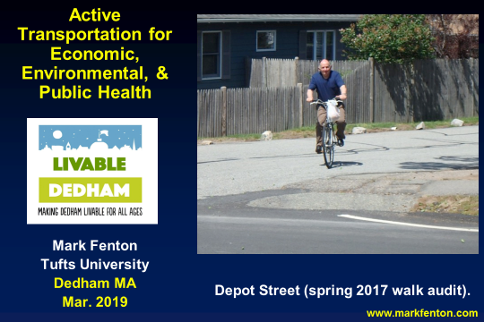

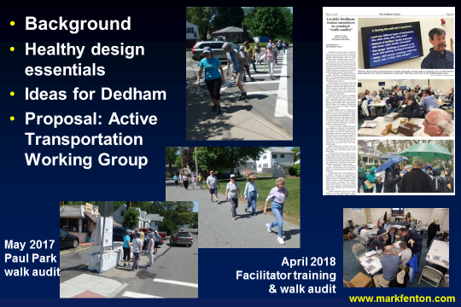







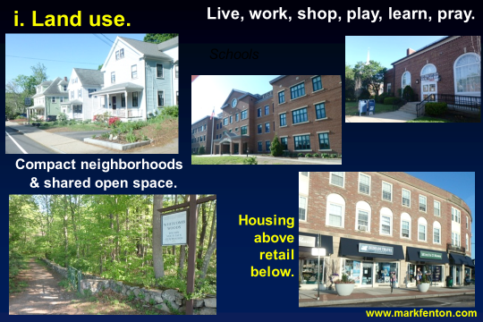

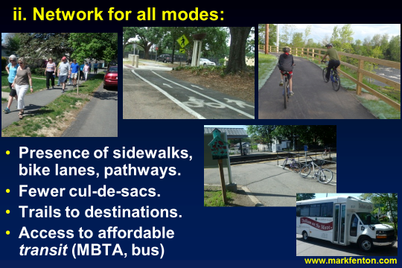



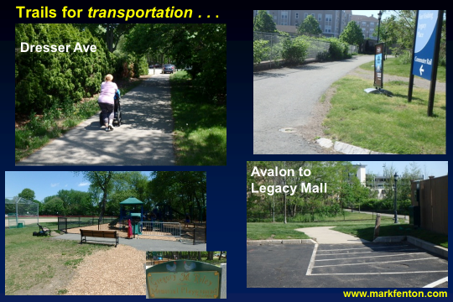

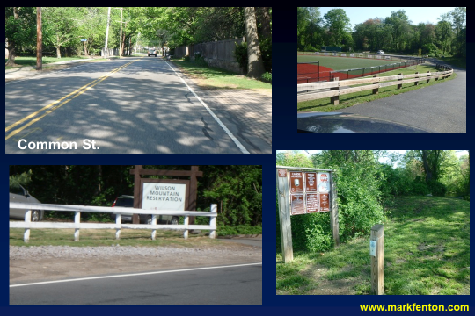



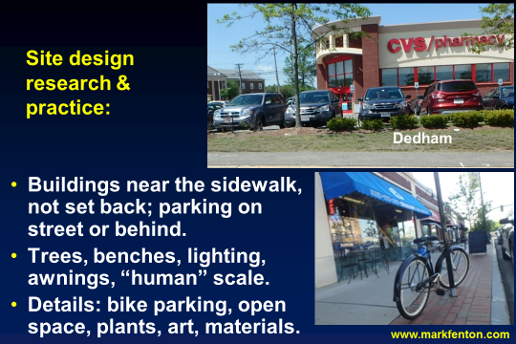



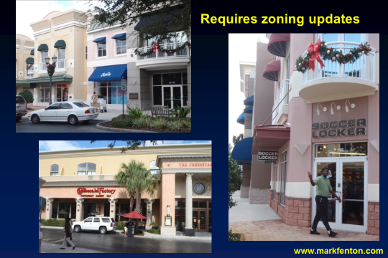







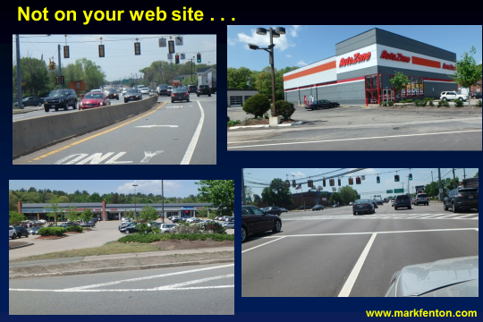

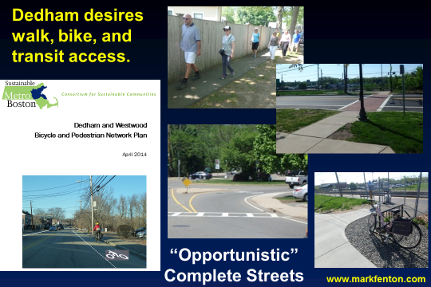

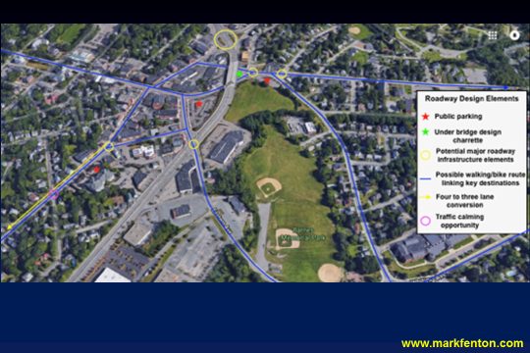

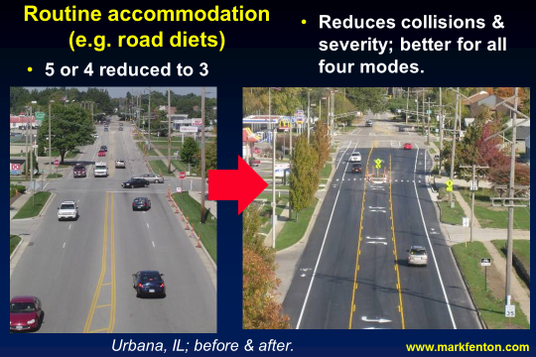







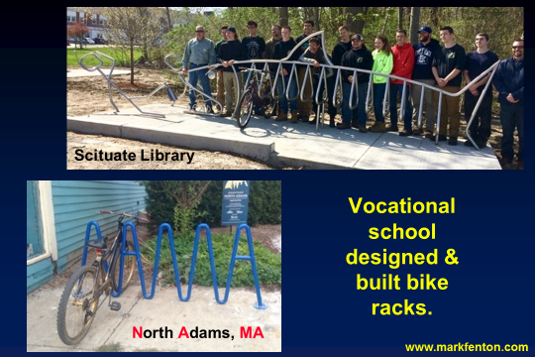

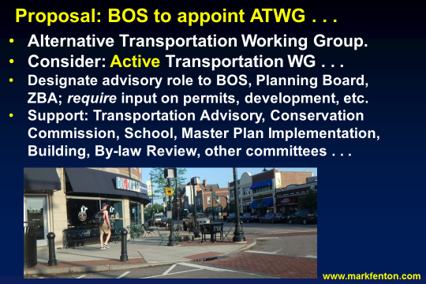



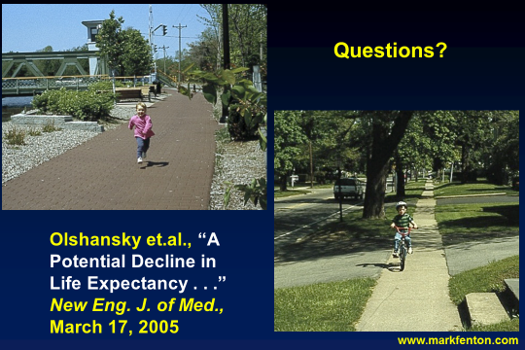

Mr. MacDonald asked Mr. Bethany, Planning Board Chair if he had anything he would like to add. Mr. Bethany stated that Jessica Porter can speak on behalf of the Planning Board.

Ms. Porter stated that they just want to make sure that there is time for questions.

Mr. MacDonald stated that looking for this Active Transportation Working Group, should be a joint effort with by the Board of Selectmen and the Planning Board.

Mr. Keogh thanked everyone involved with pushing this effort forward. Mr. Keogh added that he thinks it is extremely important to combat sedentary lifestyles that are affecting children. Mr. Keogh stated that he would like to see children outside riding bikes and playing games instead of inside playing video games.

Mr. Butler stated that the philosophy we heard tonight from Mark was present in a lot of the work that the team working on Dedham Square Design Guidelines also considered. Mr. Butler continued, saying that he is very grateful for the work that Livable Dedham is done as well as the work done by Mr. Fenton push Dedham forward to be less dependent on cars and buses and more dependent on bicycles, skate boards and walking.

Mr. Guilfoyle stated that the Planning Board has made great strides over the years to make the mixed-use buildings happen in Town. Mr. Guilfoyle pointed out that there are many positive changes going on in Dedham.

Dr. Teehan stated that everyone is in a big hurry to get where they’re going. Dr. Teehan added that people are on their cell phones while driving are especially dangerous. Dr. Teehan asked Mr. Fenton if it would be possible to take a less traveled road and make it a one way street and one half the bike path on the other.

Mr. Fenton stated that that is an entirely reasonable approach and we could mention two or three other designs that could be used in that situation.

Danielle DeLuca stated that she agrees 100% with what Mr. Fenton said in his presentation. Ms. DeLuca informed all that she’s part of the Dedham Cycle Club and they often talk about what can be done in Dedham to make it more bike-able.

Town Manager’s report

1) Lauren Bailey has accepted our offer to become Dedham’s second Human Resource Director. Her first day will be April 1. She has considerable experience in labor relations in two positions with the Commonwealth and has experience in Norwood before that.

2) Collective Bargaining negotiations are proceeding. We have agreements in principal with all groups but Dispatch and the superintendents in DPW.

3) Finance Committee meetings started with an all-day session last Saturday. The School was last night and Engineering/DPW will be next Tuesday.

4) We’ve begun a weekly Executive Meeting with the Principal of CTA, had an on-site discussion with ACMI, T2, Beacon and myself.

5) Planning Board meeting, discussion was completed on-site at the Ames building last week.

The Board was in consensus to sign a letter to the Retirement Board, as drawn up by the Town Manager.

Action by the Board

One Day Liquor Licenses

DLIT – Dedham Library Innovation Team
Fundraising Gala – Endicott Branch Library - Friday April 12, 2019, 6:30pm – 10pm

Mr. Guilfoyle moved approval; seconded by Mr. Keogh. On the Vote: Mr. Keogh, yes, Dr. Teehan, yes, Mr. Butler, yes, Mr. Guilfoyle, yes, Mr. MacDonald, yes.

Old/New Business

Mr. MacDonald informed all that next Monday, March 18 is the first meeting of the Search Committee for a Town Manager. Mr. McDonald added that March 25, 7 PM at the Endicott Estate is another Town hall to your neighborhood meeting.

Mr. Butler stated that Jason Mammone, Town Engineer, has presented to the Board a few times or the past year or two, infiltration still seems to be the single biggest cost savings opportunity Dedham has. Mr. Mammone, has a plan supported by Weston Sampson’s work and it will need a policy. Mr. Butler informed all that there will be meeting on April 1, in the middle school auditorium, at 7 PM.

Mr. MacDonald informed all that the next Board meeting will be on April 4 and will be the last meeting for Mr. Keogh, Mr. Butler and Mr. Kern.

Mr. Guilfoyle asked for a moment of silence for former Town Employee, Martin Stewart.

Mr. Guilfoyle moved to adjourn the Meeting; seconded by Dr. Teehan. On the Vote: Mr. Keogh, yes, Dr. Teehan, yes, Mr. Butler, yes, Mr. Guilfoyle, yes, Mr. MacDonald, yes.

The Meeting was adjourned at 9:25pm.

The next Meeting is scheduled for Monday April 8, 2019. This is to certify that the above is a true and accurate record of the minutes of the Selectmen’s Meeting held on March 14, 2019, which minutes were approved on July 18, 2019.

___________________________
James A. MacDonald. – Chairman

