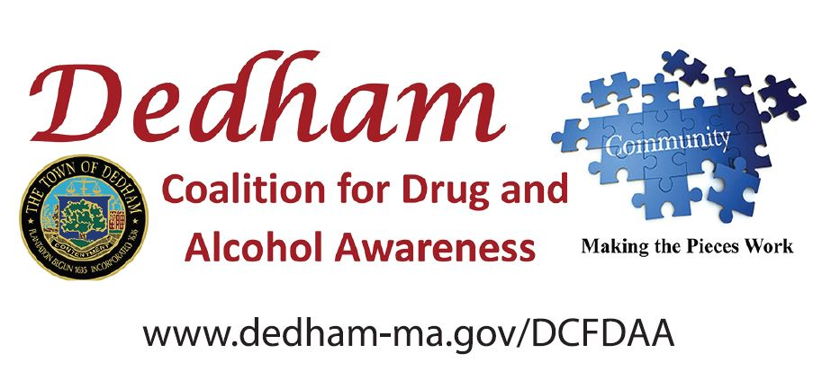

FOR IMMEDIATE RELEASE: Contact: Jessica Tracy

September 20, 2018 [jetracy@dedham-ma.gov](mailto:jetracy@dedham-ma.gov) or 781-751-9220

**White House Drug Policy Office Awards $1.25 million to the Dedham Coalition for Drug & Alcohol Awareness**

***Grants Support Administration Efforts to Emphasize Prevention Among Youth***

*$90.9 Million Awarded to Largest Ever Number of Local Coalitions, Spanning all 50 States*

**Washington, D.C.**— Marking the 20 year anniversary of the Office of National Drug Control Policy’s (ONDCP) Drug-Free Communities (DFC) Support Program grant awards, today President Trump announced $90.9 million in grants to 731 local drug prevention coalitions. This year’s group represents the largest number of single-year grantees since the program’s founding. The grants will provide local community coalitions funding to prevent youth substance use, including prescription drugs, marijuana, tobacco, and alcohol. President Trump and the ONDCP Deputy Director James W. Carroll hosted a roundtable discussion with DFC grant awardees and Youth Representatives at the White House.

 “Since our first grant awards were made in 1998, the DFC Program has continued to expand its reach in communities across the country. It is a testament to the great work DFC coalitions are doing, together with community partners that include parent groups, schools, healthcare professionals, law enforcement, businesses, and others to prevent drug use and improve the health of communities,” **said Deputy Director Carroll**. “Our local DFC coalitions are a key part of this effort because they are relentless in their work to prevent youth from initiating drug use and ultimately, saving more lives.”

**Dedham, Mass.** – A substantial grant of $1.25 million, paid over 10 years, has been awarded to The Dedham Coalition for Drug & Alcohol Awareness (DCFDAA), the town’s community coalition to prevent youth substance use.

“This funding will allow community collaboration for the reduction and prevention of youth substance use. Our goal is to provide the right tools and strategies to create a safe and drug-free place for Dedham youth,” said Jessica Tracy, Dedham Public Health Nurse and Coordinator for the DCFDAA. “Prevention is key to addressing substance misuse in our community. We know when community leaders and partners, parents and youth understand the importance of substance use prevention and begin to implement evidence based strategies, we can really start to impact the rates of alcohol and other substance use in our community.”

The Dedham Coalition for Drug & Alcohol Awareness involves and engages the local community to prevent substance use among youth. The $1.25 million grant will allow the DCFDAA to pursue its mission, *to reduce and prevent youth and adult substance use by increasing community collaboration and by utilizing evidence prevention strategies*, and includes a re-application process after the fifth year to secure the second half of funding, $625,000.

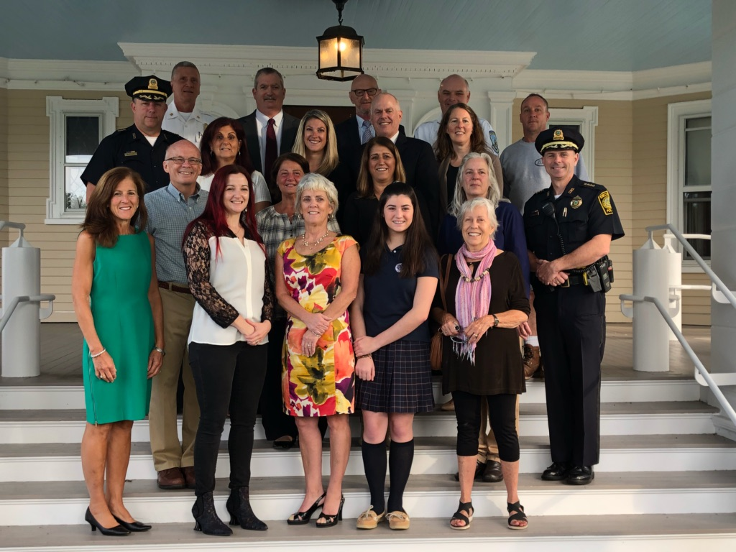***Background on the Dedham Coalition for Drug & Alcohol Awareness***

The Dedham Coalition for Drug and Alcohol Awareness (DCDAA) was formed in 2014 by the Board of Selectmen, as a direct result of the record high number of opioid related overdoses and overdose fatalities impacting Norfolk County (60 fatalities in 2013), including Dedham. The initial goal of the coalition was to provide valuable resources to those affected by substance misuse disorders and reduce overdose deaths. The communities dedication brought together founding coalition members including the Dedham Police and Fire Department, the Dedham Public Health Department, Dedham Schools, the Youth Commission, Parks & Recreation Department and parents who had lost their children due to overdose. The Dedham Board of Selectmen worked to expand the role of the Public Health nurse to a full time position (an additional 8 hours a week) in order to provide minimal coalition staff.

Sept. 20, 2018: Gathering in support of this award at Endicott Estate:

**William Spillane**, Fire Chief; **James Kern**, Town Manager; **Fredrick Newton**, President Boston Hope House; **Kevin Mont**, Director-EMS Operations & Emergency Preparedness; **Ronald Brock**, Resident; **Michael Buckley**, Dedham Deputy Chief; **Nancy Baker**, Dedham Assistant Town Manager; **Deborah Anderson**, Assistant Director Parks & Recreation, **Michael Welsh**, Superintendent Dedham Public Schools; **Monica DeWinter**, Dedham Parent; **Michael Butler**, DCFDAA Chairman, Board of Selectman; **Leanne Jasset**, Pharmacist, DCFDAA Co-Chair & Board of Health Chairman; **Gail Kelley**, RN, Director of Health Services Dedham Schools; **Christine Hamilton**, RN, Director of Risk Management Fallon Ambulance; **Michael d’Entremont**, Police Chief; **Carol Read**, Substance Abuse Prevention Collaborative-SAPC Coordinator; **Jessica Tracy**, Dedham Public Health Nurse; **Catherine Cardinale**, Dedham Health Director; **Fiona Flynn**, Dedham Youth, 9th Grade Student; **Dottie Walsh**, Dedham Cable

DCFDAA is focused on community collaboration to prevent youth substance use. Its many members include youth, parents, community leaders, business and faith-based organizations and town staff. The coalition engages multiple sectors of the community and employs a variety of environmental strategies to address local drug problems. With a public health prevention focus, the coalition works to reduce substance use in Dedham youth. More information is at www.dedham-ma.gov/DCFDAA.

The Drug-Free Communities (DFC) Support Program, created by the Drug-Free Communities Act of 1997, is the Nation’s leading effort to mobilize communities to prevent youth substance use. Directed by the White House Office of National Drug Control Policy (ONDCP), the DFC Program provides grants to community coalitions to strengthen the infrastructure among local partners to create and sustain a reduction in local youth substance use.

Prescription drug abuse prevention is one of the core measures of effectiveness for local DFC coalitions, and coalitions nationwide have led innovative opioid prevention initiatives. DFC’s 2017 National Evaluation End-of-Year Report found that at least 97% of middle school and 94% of high school youth report that they have not misused prescription drugs in the past 30-days in DFC communities.

White House Office of National Drug Control Policy | [WhiteHouse.gov/ONDCP](http://www.whitehouse.gov/ondcp) | [@ONDCP](https://twitter.com/ONDCP)

###