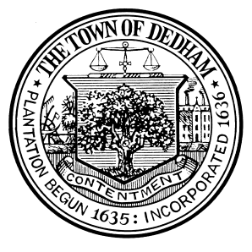 | TOWN OF DEDHAM  MEETING  NOTICE | POSTED:  TOWN CLERK

POSTED IN ACCORDANCE WITH THE PROVISIONS OF M.G.L. CHAPTER 30A SECTION 20 AS AMENDED.

Board or Committee: | Commission of Trust Funds
Location: | Dedham Town Hall, Select Board’s Chambers
Day, Date, Time: | Wednesday, May 1, 2019, 7:00pm
Submitted By: | Ron Slack
Date: | 04/23/2019

Regular Meeting
AGENDA:
7:00pm

- Re-Formation of Committee: Call to order by temporary Chair, election of new Chair, Vice Chair, and Clerk/Secretary. Selection of representative to Town Meeting.
- Public Input
- Review of Minutes from February 6, 2019
- Reminder to provide Chair, Clerk, Town Treasurer, and Town Webmaster with contact information for all commissioners
- Update on correspondence with Mr. Andrew Dervan regarding the Dervan Family Fund
- Authorization of Dervan Family Scholarship award
- Authorization of Memorial Day flowers for cemetery
- Discussion of status of scholarship reversions for failure to claim
- Updates from Chair and Clerk on Commission correspondence
- Selection of a tentative date for the next meeting, investment review meeting, traditionally held in October
- New Business*

*This item is included to acknowledge that there may be matters not reasonably anticipated by the Chair that could be raised during the Public Comment period by other members of the Committee, by staff or others.

