What Should I Do if I have a Project in Mind?
- Determine if your project will occur within a wetland resource area or buffer zone – see the graphic inside this flyer. You may need to have a wetland scientist or Conservation Commission staff member help you determine this.
- Visit the Conservation Office to review your plans and application requirements.
- Complete the required application materials.
- Attend a public hearing.
- Receive your permit before starting work

Violations
Examples of violations include the unpermitted:
- Dumping of grass, leaves, brush, or debris in a wetland or buffer zone
- Cutting of trees or shrubs within River-front Area, a wetland, or a buffer zone
- Building without a permit within Riverfront Area, a wetland, or a buffer zone

Penalties for Violating the Law
Under the Massachusetts Wetland Protection Act and the Town of Dedham Wetlands Protection Bylaw the Conservation Commission can issue Enforcement Orders requiring illegally altered land to be restored to its original condition.

Dedham Conservation Commission
26 Bryant Street
Dedham, MA 02026
Telephone: 781 751-9210
conservation@dedham-ma.gov



Town Web:

https://www.dedham-ma.gov//

DEP Website: https://malegislature.gov/Laws/GeneralLaws/PartI/TitleXIX/Chapter131/Section40

Town of Dedham Website:

https://www.dedham-ma.gov/departments/conservation/wetlands-protection

A Guide to

Wetlands Protection Laws

in Dedham

Understand your responsibilities
when managing a property!

Are you planning to:

Landscape ?

Build ?

Install a pool ?

Grade your land ?

Cut trees or shrubs ?

Before you do,

know the bottom line:
Any such activity that will alter a wetland or its buffer zone
must be permitted
by the Conservation Commission,
or fines and enforcement may occur.
Areas of Jurisdiction
Mass. Wetlands Protection Act and Regulations (310 CMR 10.00) protect:
- Wetlands (streams, ponds, rivers, swamps, etc.)
- 100-foot buffer zones
- Riverfront Area (land within 200 feet of any perennial stream)

The Dedham Conservation Commission prohibits new residential work within 30 feet (and more near steep slopes) of wetlands (streams, ponds, rivers, swamps, etc.)

Regulated Activities
Activities that will alter wetlands or buffer zones must be permitted by the Conser-vation Commission.
Regulated activities include:
- Dumping leaves, brush, grass
- Vegetation removal
- Building or construction
- Grading or excavating
- Installing a septic system
- Discharging stormwater
- Polluting wetlands or streams

For more detailed information, visit DEP’s website:
http://www.mass.gov/dep/water/resources/
wetlands.htm

Wetland Resource Areas and Buffer Zones
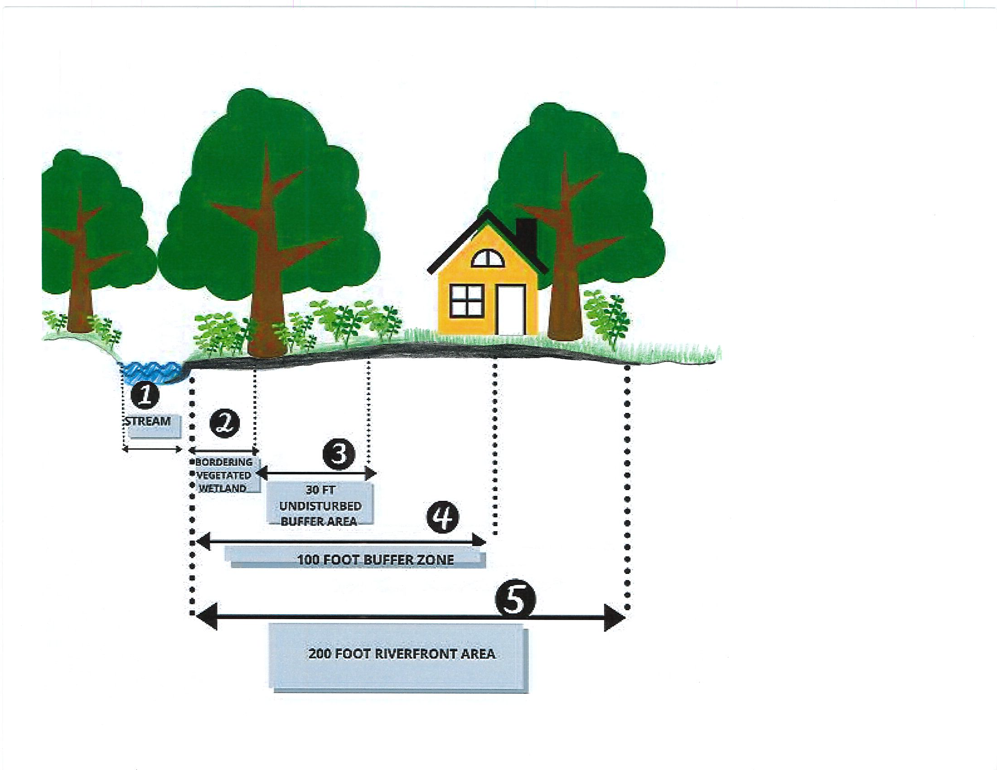

Regulated Areas and Associated Permit Requirements
- Stream: No activity is allowed without a permit and a waiver
- Bordering Vegetated Wetland (BVW): No activity is allowed without a permit and a waiver
- 30-Foot Undisturbed Buffer Area (UBA): No activity is allowed without a permit and a waiver
- 100-Foot Buffer Zone: A permit is required for most activities
- 200-Foot Riverfront Area (200’ Riverfront Area): A permit is required for many activities

