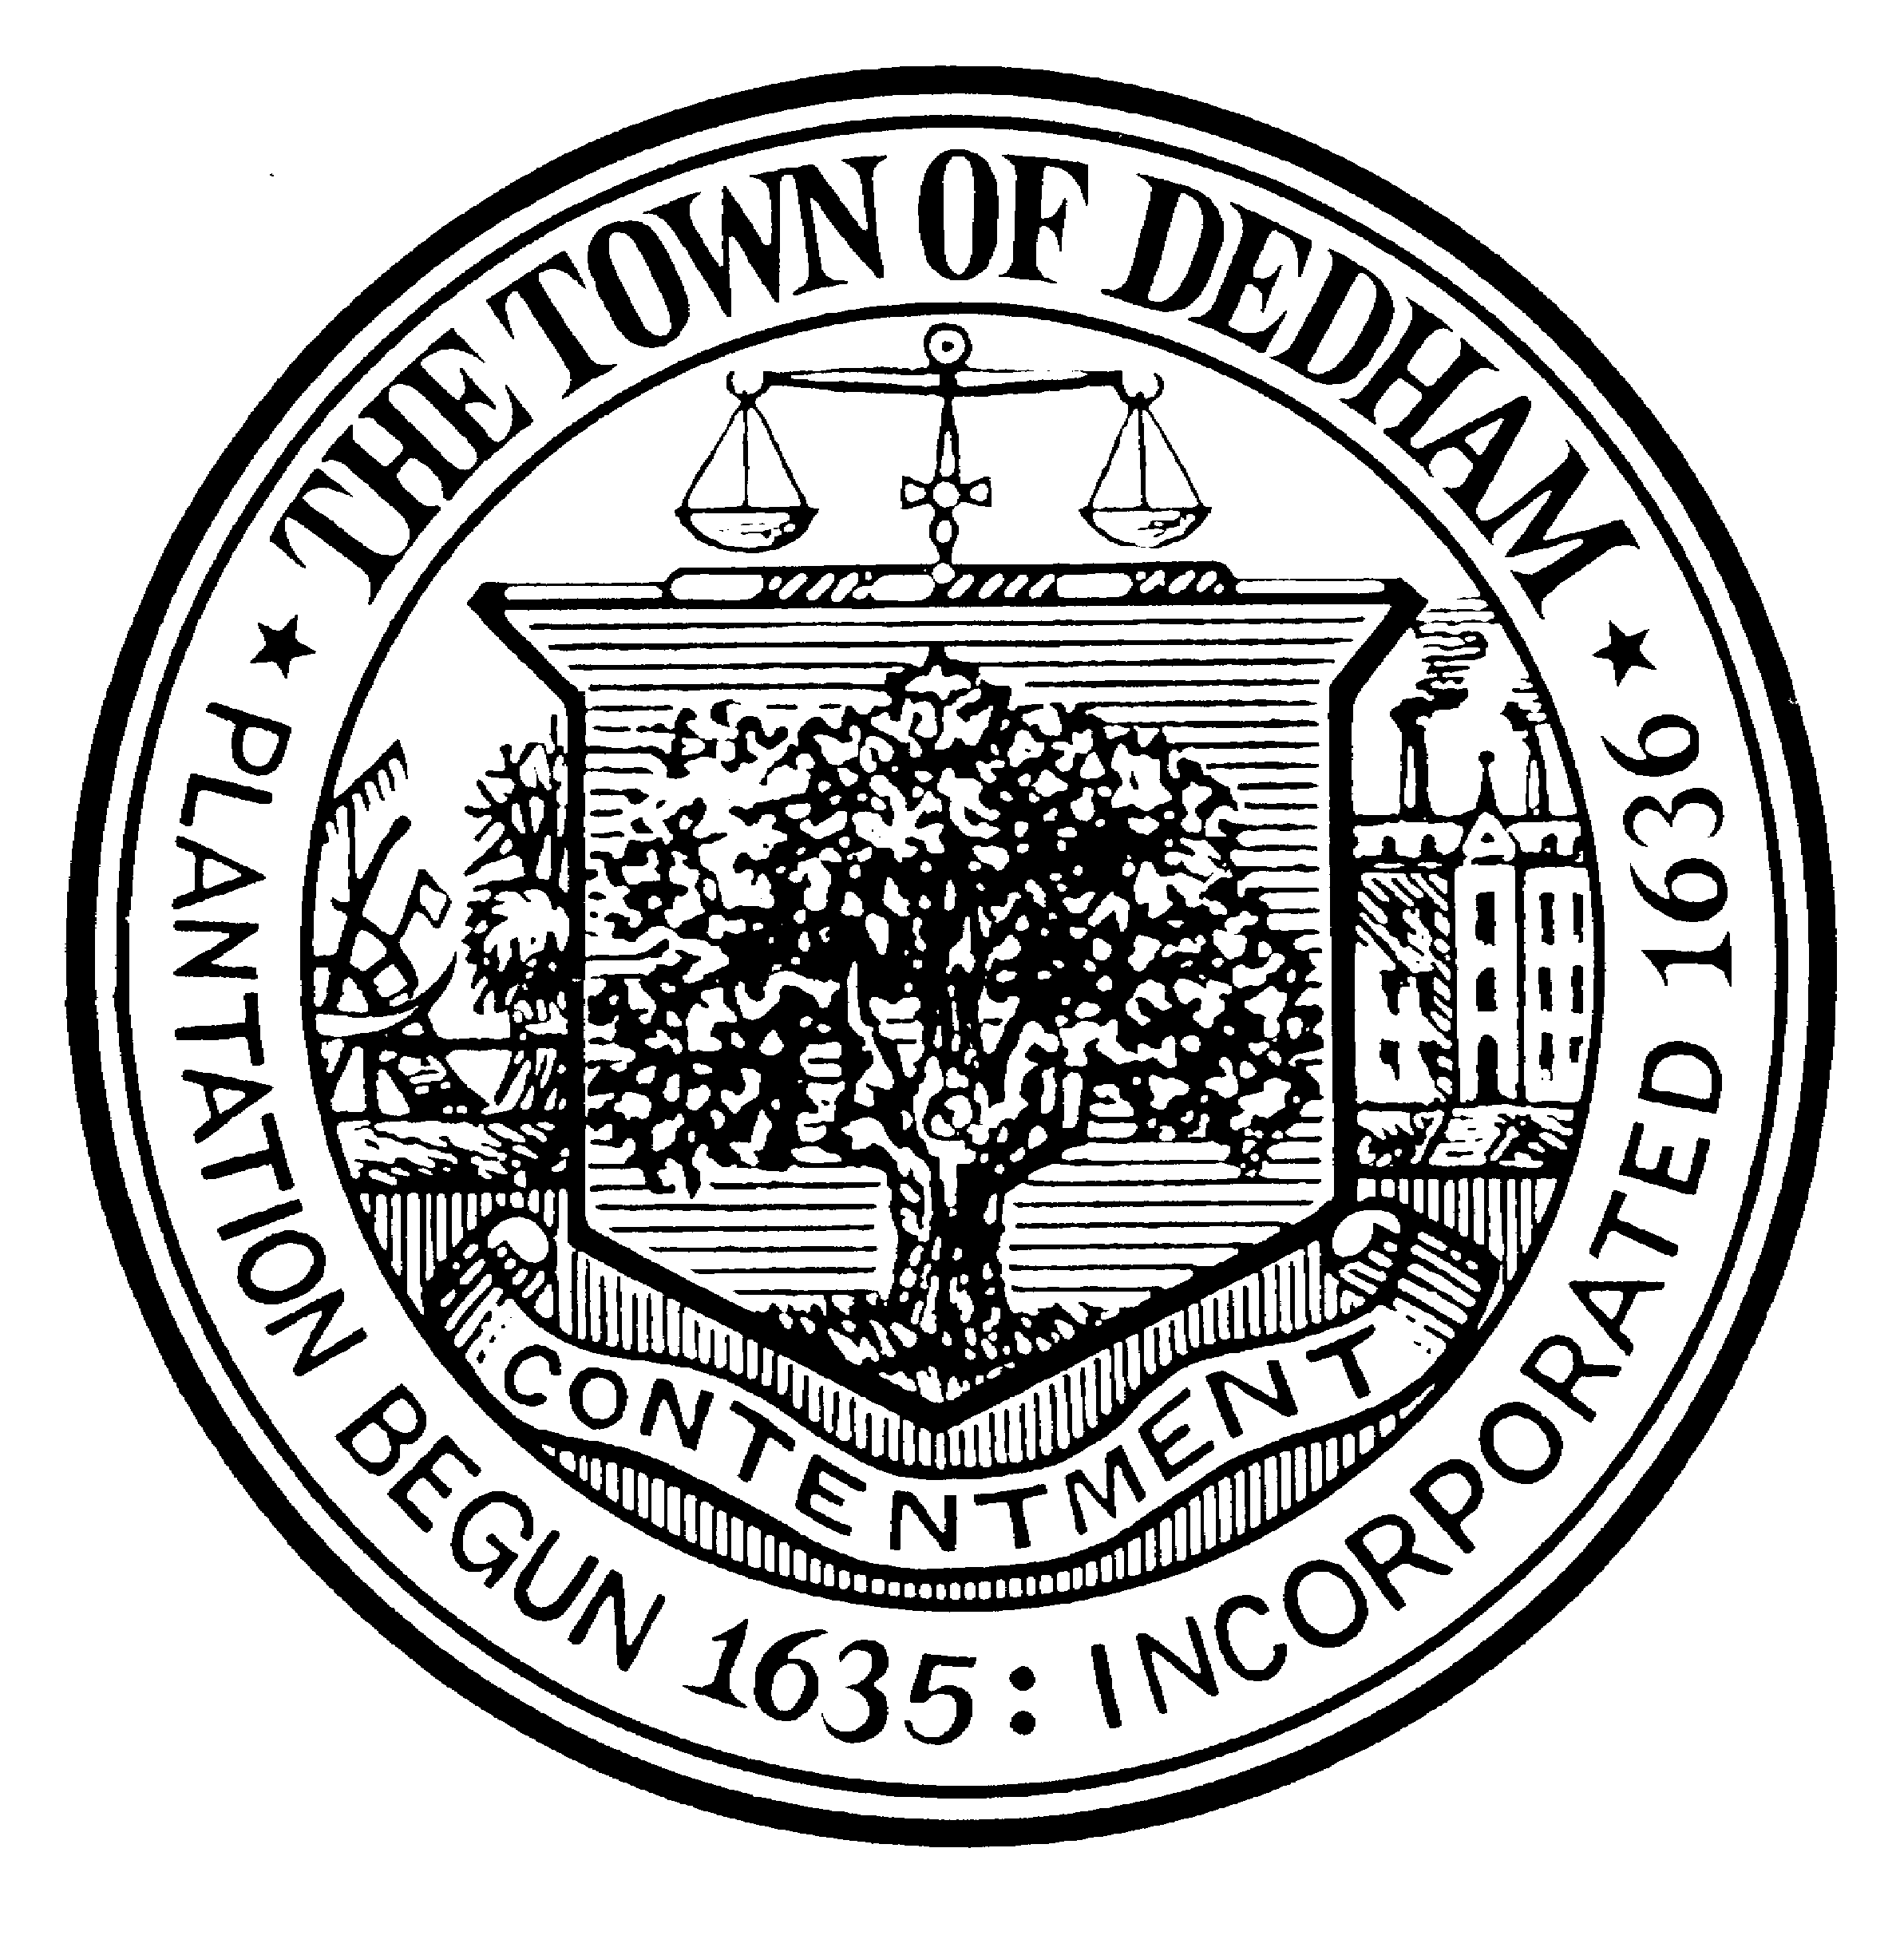DANIEL J. DRISCOLL DEDHAM TOWN HALL
MODERATOR P.O. BOX 306
DEDHAM, MA 02027

TOWN OF DEDHAM
(COMMONWEALTH OF MASSACHUSETTS)

September 9, 2020

Hon. Dennis J. Teehan, Jr.
and members of the Select Board
Dedham Town Hall
26 Bryant Street
Dedham, MA 02026

Re: Notice of Intent to Request Remote Fall Annual Town Meeting

Dear Members of the Select Board:

Having determined, after careful deliberation, that it is not possible to safely assemble the Town Meeting Representatives and interested members of the public in a common location, in accordance with Section 8 of Chapter 92 of the Acts of 2020, for the Fall Annual Town Meeting to be held in November, this is to inform you that I intend to formally request that the Fall Annual Town Meeting be held through remote participation, including, but not limited to, by means of a video or telephone conferencing platform.

I am currently identifying the details for the proceedings in order to comply with all statutory requirements, including finalizing plans as to use of an appropriate video or telephone conferencing platform. I will be consulting with the Town, Library and School IT personnel, the Commission on Disability or its designee, the Board of Health or its designee, as well as the Town Manager, Select Board and Finance Committee to ensure that we have a plan that will effectively and efficiently accommodate all those that wish to participate. I am hard at work on the specifics of creating an infrastructure that will ensure that Town Meeting will be conducted in substantially the same manner as if the meeting occurred in person, and in accordance with the operational and functional requirements required by law.

For your information, and for the information of the Town Meeting Representatives, please be informed that I have been working cooperatively with various Town officials to prepare for this new challenge. Similar to the preparation prior to the Spring Annual Town Meeting (held on August 10, 2020), we are considering ways to use the Town’s website and technology to present substantive information to Town Meeting Representatives as soon as possible. To that end, we are once again requesting that all Town Meeting Representatives forward their e-mail addresses to the Town Manager so that we can communicate quickly and efficiently. Further, I am hopeful that the Town will be able to put together appropriately detailed presentations on the various articles, which can be posted on line for Representatives to watch at their leisure, as well as run several live “Zoom” sessions to answer questions from Town Meeting Representatives. The so-called “mini-Town Meeting” will be a good opportunity to review generally the use of the remote application and do a few test run votes to practice. While a remote town meeting will, of course, allow for deliberation on the warrant articles, we want to ensure that everyone “arrives” for the meeting with their questions answered.

Finally, we are working to schedule a number of training opportunities for all Town Meeting Representatives to ensure that people are comfortable with platform and the processes to be used for typical Town Meeting actions such as making of motions, raising points of order and voting. We are mindful that people have differing levels of familiarity and comfort with Zoom, and with computers generally, and will be providing support services to all that need them. We will have a plan to assist any Representatives that cannot participate electronically, and will ensure that such opportunity is made widely known.

I am confident that we can hold a successful remote town meeting with everyone’s help and commitment to being prepared, informed, and, perhaps most importantly, patient.

Accordingly, this is to inform you that I will be formally submitting a Request for a Remote Fall Annual Town Meeting and looking for the Board to act on that request at its next meeting on September 24, 2020. I look forward to providing the Select Board with the certifications required under said Chapter 92, and am anticipating to your favorable response to this request in the interest of preserving our democratic process while protecting public health and safety.

Respectfully submitted,
Daniel J. Driscoll
Town Moderator

