A virtual Meeting of the Select Board was held on Thursday May 21, 2020, at 6pm

Present were:

Dennis Guilfoyle - Chair

Dr. Dennis J. Teehan - Vice Chair

James A. MacDonald

Sarah E. MacDonald

Dimitria Sullivan

Meeting brought to order at 6:02 pm

**Pledge of Allegiance**

**Dedham Citizens – Open Discussion**

None.

**Discussion w/ Planning Board & Board of Health Re: Re-Opening Assistance &**

**Guidance for Business Community**

Mr. Bethoney called the Planning Board meeting to order.

Ms. Jasset called the Board of Health meeting to order

Mr. Bethoney asked if he could have a roll call for the Planning Board.

Mr. McGrail – Yes

Ms. Porter – Yes

Mr. O’Brien -No

Mr. Podolski – Yes

Sarah Smeagle – 150 Monroe street – asked when and how the election will be held.

Mr. Guilfoyle stated that the decision as to how and when will take place at the Select

Board’s meeting on June 4th, we are looking at June 27.

Kevin Preston – Chair, Finance & Warrant Committee, called his meeting together at

6:10pm.

**Roll Call:**

John Heffernan – Yes

David Roberts - Yes

Susan Fay – Yes

Kevin Hughes – No

Marty Lindemann – No

Michele Reilly – Yes

Beth Pierce - Yes

Michael Leahy - Yes

Leanne Jasset – Chair, Board of Health – Called meeting to order at 6:11pm.

**Roll Call:**

Mary Ellard – Yes

Kathy Reda – Yes

Mr. MacDonald stated that what he is focusing on for tonight’s discussion are the

establishments that hold All Alcoholic Common Victuallers licenses as well as beer and

wine licenses.

Mr. MacDonald added that the goal is to communicate with our business owners.

Mr. MacDonald informed all that an email from the Select Board, Planning Board and

the BOH will go out tomorrow to the All Alcoholic Common Victuallers license holders

and beer and wine CV license holders. Mr. MacDonald stated that the license holders

can get guidelines from the ABCC’s website which answers questions, such as how do

I do this. Mr. MacDonald added that there is an application included which carries a

$200 fee, which the ABCC is waiving. Mr. MacDonald stated that the application

process is as follows:

Fill out the application - Email it to Assistant Town Manage, Nancy Baker.

Once received, completed form and supporting documents will be sent to the Planning

Board, the Board of Health, the Building Department and the Police Department.

Mr. MacDonald informed all that this expansion of outdoor seating is valid until Nov.

1, 2020.

Mr. MacDonald stated that the Planning Board will be holding a virtual forum on May 27,

2020 from 10am – 11am – called Dedham back to business.

Mr. Bethoney stated that this forum would allow local businesses to discuss what they

truly believe would be helpful to get back on their feet and provide some feedback.

Ms. Jasset stated that their guidelines come from the DPH almost daily. Ms. Jasset

added that they are gathering as much information as they can to help and guide these

restaurants and businesses.

Bridgett Sweet – Interim Health Director – stated that they need to be proactive in their

thinking and in their actions. Ms. Sweet added that talking with other communities to

see if we could incorporate any of their ideas into our plans.

Ms. MacDonald asked if the forum on the 27th is for businesses in general and not just

establishments with a liquor license.

Mr. MacDonald stated that he will be attending the forum next week and will answer

questions, as they come up. Mr. MacDonald added that it is his understanding that the

Planning Board will have a broader agenda.

Mr. Bethoney informed all that the agenda for the meeting on the 27th is broader in scope

and is for all businesses.

Ms. Jasset stated that the Board of Health and Ms. Sweet will take part in the forum.

Ms. Sullivan asked if all the businesses have been notified, especially the small ones.

Jeremy Rosenberger – Planning Director stated that usually, they would be going door

to door to reach all the businesses but obviously we cannot do that now. Mr.

Rosenberger added that we will be counting on email lists, word of mouth, etc.

Jay O’Brien, Planning Board Member, asked how they are going to make this meeting

more fluid and not so bumpy.

Mr. MacDonald stated that the process is really streamlined. Mr. MacDonald continued,

saying that after the documents arrive at the Town Manager’s Office they will be

immediately distributed to everyone who needs to weigh in. Mr. MacDonald stated that

there are only 2 votes needed – the Select Board, for establishments to have outside

service and relief from the Planning Board.

Ms. Sullivan asked if we were to set up chairs and tables by School Street, the green

Area, who would that fall under.

Mr. Goodwin answered, that is Town property, so you could go through the Board.

Ms. Porter moved to adjourn the Planning Board meeting; seconded by Mr. McGrail.

**On the Vote:**

Mr. McGrail – Yes

Ms. Porter – Yes

Mr. O’Brien -Y es

Mr. Podolski – Absent

Mr. Bethoney - Yes

Kathy Reda moved to adjourn the Board of Health meeting; seconded by Ms. Ellard.

**On the Vote:**

Mary Ellard – Yes

Kathy Reda – Yes

Leanne Jasset – Yes

**Discussion & Vote Re: FY’20 Alternate Year End Transfers**

Mr. Goodwin stated that there are a few Alternative year end transfer forms.

Mr. MacDonald asked if it was a single inter transfer from facilities Town to facilities.

Mr. Goodwin stated there was a total of 3 transfers from facilities.

Michele Reilly – Finance and Warrant Committee – stated that there were several

transfers related to the Library and Library assistance and was curious as to why there

was that extra money.

Mr. Goodwin explained that was unexpended salary items for Library assistance

positions that were not filled.

Ms. MacDonald stated that it seems like some of the expenses that we are transferring

money to are COVID related. Ms. MacDonald added that Mr. Goodwin had referenced

that the Town is eligible to have some expenses that are triggered by the pandemic

reimbursed through either State or Federal funds. Ms. MacDonald asked Mr. Goodwin

to explain how the department is tracking it.

Mr. Goodwin explained that through MEMA, FEMA and the Cares Act, there are

opportunities for us to keep track of. Mr. Goodwin added that they have created a

spreadsheet and we have asked departments to keep track of those expenses. Mr.

Goodwin continued, saying then we will determine which agency is appropriate to

seek the reimbursement from. Mr. Goodwin informed all that the deadline for the initial

CARES Act is June 5, 2020. Mr. Goodwin stated they are tracking them at the

department level and centralizing them in finance and then submitting them as a group.

Mr. MacDonald moved to authorize the inter fund transfers as authorized and

recommended; Seconded by Dr. Teehan.

**On the Vote:**

Ms. MacDonald - Yes

Dr. Teehan - Yes

Ms. Sullivan - Yes

Mr. Guilfoyle - Yes

Mr. MacDonald – Yes

Mr. Leahy - Finance and Warrant Committee - stated that he would like more

information regarding the Ames Project $100,000 transfer from electricity/utility to

facilities/other.

Mr. Goodwin asked Denise Maroney, Director of Facilities, to answer Mr. Leahy’s

question. Ms. Maroney stated that she incurred additional fees for the installation of the

security upgrades, due to the delays with the project. Ms. Moroney added that the spent

$70,000 in change orders for the security install Ms. Maroney stated that is a portion of

the $100,000.

Mr. Leahy stated that It looks like this was not anticipated.

Ms. Maroney stated that this was not budgeted for in her operating budget and

happened solely because of the now 3-year delay caused by CTA.

Ms. Fay (Finance & Warrant Committee) – asked Ms. Maroney if we were getting more

value on our finished product or is this totally a result of the delay.

Ms. Maroney stated that during the almost 3yr. delay the technology changed, so some

of that change order is an upgrade of cameras but the good portion of it is due to the

construction delay by CTA.

Mr. Heffernan moved to approve the line item transfers as requested; Seconded by

Ms. Reilly.

**On the Vote**

John Heffernan – Yes

David Roberts - Yes

Susan Fay – Yes

Michele Reilly – Yes

Beth Pierce - Yes

Michael Leahy - Yes

Kevin Preston - Yes

**Joint Discussion w/ Town Manager, Finance & Warrant Committee & Interim**

**Director of Finance Re: FY’20 & FY’21 Budgets**

Mr. Goodwin stated that he was unable to present his budget to the Finance & Warrant Committee because of COVID19. Mr. Goodwin added that the pandemic has had a significant impact on several of the assumptions that were made with the budget. Mr. Goodwin and the Interim Finance Director have gone back and looked at a few things.

Mr. Goodwin stated that he would like to make a presentation and will touch on the following:

* Updated revenue estimates
* updated general fund expenditures
* proposed revisions to the FY21 budget
* some updated capital proposals
* proposed new tax levy rate impact
* Robin Reyes capital fund update

Mr. Goodwin gave the following power point presentation:

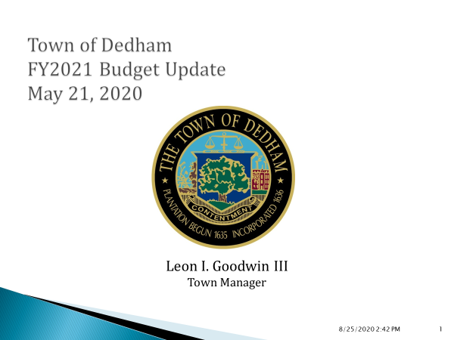

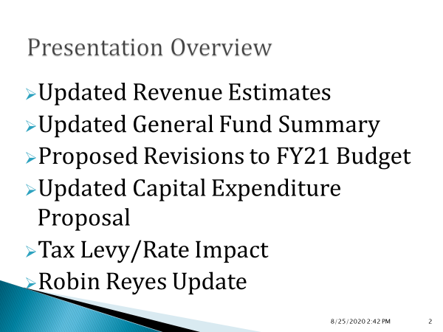

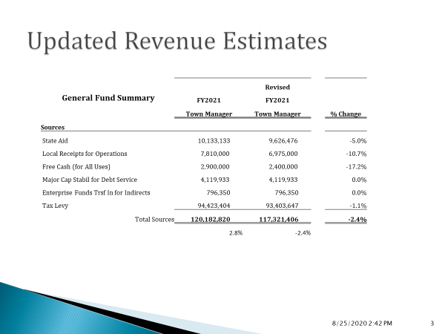

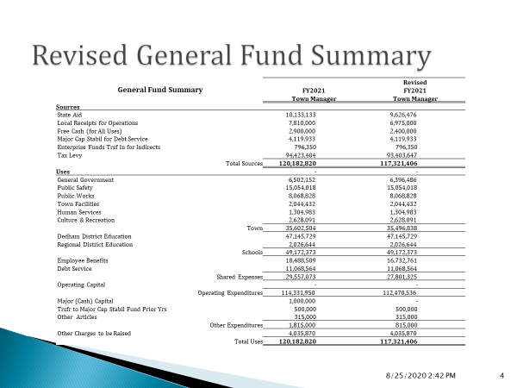

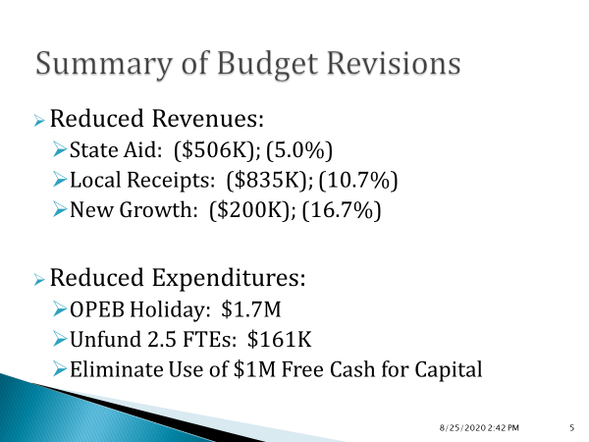

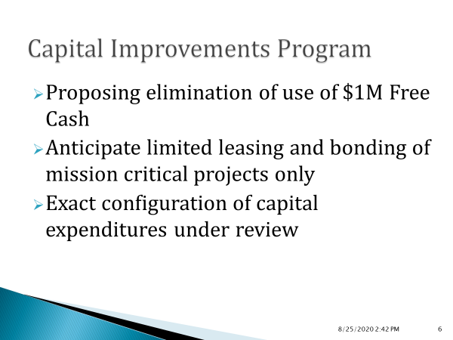

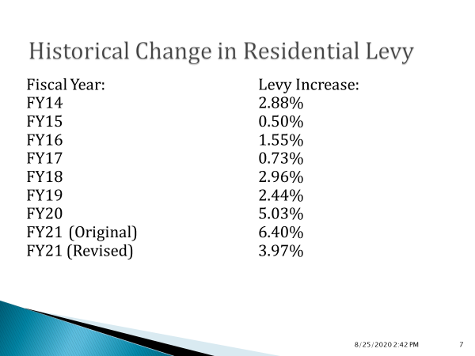

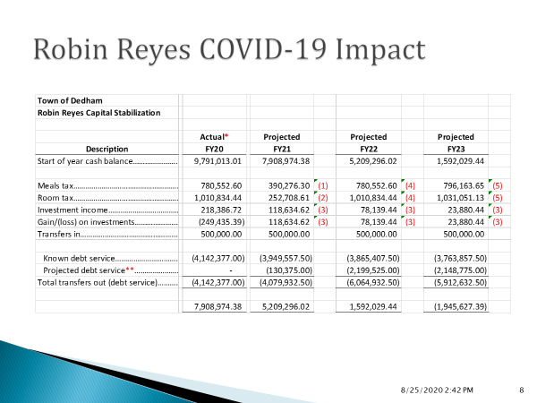

Ms. MacDonald asked Mr. Goodwin to explain the FTE cuts as to what positions we are un-funding or changing.

Mr. Goodwin informed all that there is an open Clerk position in the Finance Department. Mr. Goodwin, along with Interim Finance Director Sean McGoldrick, made the decision to not fill that Clerk position in FY21 but the Town is holding that position un-funded.

Mr. Goodwin stated that there a position for a Network Administrator that we are not going to seek funding for. Mr. Goodwin continued, saying that there is a Communications position that he proposes to start funding it on January 1, 2021.

Ms. Sullivan asked Mr. Goodwin if he could talk about whether there have been discussions regarding furloughing employees. Ms. MacDonald stated that many communities who have furloughed seasonal and part time employees.

Mr. Goodwin answered, saying that the Town has not hired any of the seasonal employees, which is based on the lack of need for those positions right now.

Ms. Sullivan asked Mr. Goodwin if the plan was to continue with outsourced IT or how we think we can support the new reality.

Mr. Goodwin stated that the long-term goal is to move away from purely outsourced IT and move towards a hybrid. Mr. Goodwin added that he would like to see at some point having outsourced IT plus an on-site person to manage all of that.

Michele Reilly asked if there have been any decisions regarding timing for the process going forward and how are union contracts affected by the 1/12 budget.

Mr. Goodwin informed the Board about the idea behind a 1/12 budget.

**Robin Reyes COVID-19 Impact.**

Mr. McGoldrick stated that COVID19 is going to impact room and meals. Mr. McGoldrick added that the way we best tried to estimate for FY21 was to take a hard hit on the rooms and meals tax: we assumed a 50% reduction for meals and a 75% reduction on the rooms tax. The fund started showing a rebound in 22 and going forward. Mr. McGoldrick stated

that they saw the same thing with investment income and gains and losses, they did a

very conservative 1.5% increase on the start of year cash balances.

Mr. Preston asked if the Select Board had received an update on the status of the Retirement Fund.

Mr. Goodwin stated that he has not received an update from the Retirement Board and he does not anticipate getting one right now.

Mr. Heffernan moved to adjourn the Finance and Warrant Committee Meeting; Seconded by Ms. Reilly.

John Heffernan – Yes

David Roberts - Yes

Susan Fay – Yes

Michele Reilly – Yes

Beth Pierce - Yes

Michael Leahy - Yes

Kevin Preston - Yes

**Discussion & Vote Re: Approval of Alteration of Elm Street Layout**

Mr. Goodwin stated that there should be an email from the Town Engineer in your packet. Mr. Goodwin added that this is an alteration of Elm Street and it is being asked of us by the State Right of Way Bureau as part of the Rustcraft Road Street Sidewalk Improvements.

Ms. MacDonald moved that the Select Board vote their intension to alter the layout of Elm Street to include the area depicted as “Proposed Permanent Roadway/Sidewalk Easement, National Amusements, Inc., area about 186 Square feet” as depicted on the plan entitled “Sidewalk Layout Plan” as prepared by Alpha Surveying & Engineering, Inc., with a date of March 2020 and refer the layout plan to the Planning Board for its report; Seconded by Mr. MacDonald.

**On the Vote**

Ms. MacDonald - Yes

Dr. Teehan - Yes

Ms. Sullivan - Yes

Mr. Guilfoyle - Yes

Mr. MacDonald – Yes

**Discussion & Vote Re: Approve Waiver of Permit Fees for Public Safety Building**

Mr. MacDonald moved that the Select Board waive the fees as outlined on the agenda, for the public safety building; Seconded by Ms. MacDonald.

**On the Vote:**

Ms. MacDonald - Yes

Dr. Teehan - Yes

Ms. Sullivan - Yes

Mr. Guilfoyle - Yes

Mr. MacDonald – Yes

Mr. Goodwin clarified that these permits are for Plumbing, Electrical and Gas fitting. The Board had previously voted to waive the fees for building permits.

**Town Manager’s Report (including Ames Update)**

* Furniture install started last Monday
* Continuing to work on the punch list
* Still hoping to move in mid-June

**Update Re: COVID19 Operations & Relief Task Force(s)**

Task Force met on Tuesday to discuss the Governor’s 4 phase plan.

**Action by SB**:

Drainlayers Applications:

**NCCL Enterprises, LLC**

**27 Water Street**

**Wakefield, MA 01880**

**Canesi Bros Construction Inc**

**801 Upper Union St**

**Franklin, MA 02038**

**On the Vote**:

Mr. MacDonald - Yes

Dr. Teehan – Yes.

Ms. Sullivan - Yes

Mr. Guilfoyle - Yes

Ms. MacDonald – Yes

**Old/New Business\***

Ms. Sullivan stated that she has been contacted by residents around the Washington Street area regarding a proposed bus stop in front of their homes. Ms. Sullivan added that this is a section of town that does not utilize the bus that much and about 1000 feet up the street there is another bus stop.

DPW Director, Joe Flanagan, has written some letters to the MBTA to ask them to re-think this plan and not in the proposed residential area.

Mr. Goodwin stated that this is near the New Town Hall and is one of the proposed covered bus stop, which requires a bigger pad/footprint and the location where the MBTA had initially proposed, would be feet from somebody’s front porch. Mr. Goodwin informed all that he reached out to the MBTA with our concerns and some suggestions about where we think it could be modified.

Ms. Sullivan stated that the Planning Board is writing a letter in support of the residents and asked if the Select Board could do the same.

Mr. MacDonald stated John Regan from Senator Rush’s Office has been extremely helpful in situations like this.

Mr. Goodwin informed all that Senator Rush as well as Rep. McMurtry have been contacted and have both reached out on behalf of the resident.

Ms. MacDonald stated that after the 5/14/2020 meeting’s Open Discussion, Mr. LoPordo sent an email and she did not see a response.

Mr. Goodwin stated that he responded to Mr. LoPordo’s email.

Dr. Teehan moved to adjourn the meeting; Seconded by Ms. Sullivan.

**On the Vote**:

Ms. MacDonald - Yes

Dr. Teehan - Yes

Ms. Sullivan - Yes

Mr. Guilfoyle- Yes

Mr. MacDonald – Yes

The open meeting was adjourned at 8:10pm.

The next Meeting is scheduled for Thursday June 4, 2020. This is to certify that the above is a true and accurate record of the minutes of the Selectmen’s Meeting held on May 21, 2020 which minutes were approved on September 24, 2020.

________________________

Dennis J. Guilfoyle. – Chairman