**BALLOT RETURN CHECKLIST**

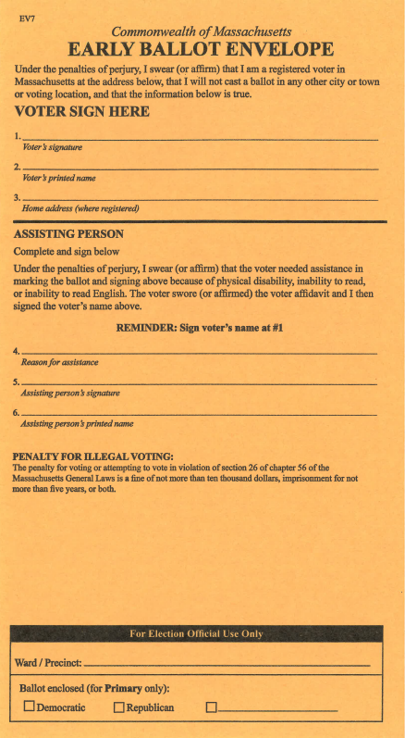

 MARK YOUR BALLOT

 SEAL YOUR COMPLETED BALLOT

IN MANILA BALLOT ENVELOPE

 SIGN – REQUIRED!!

AT “VOTER SIGN HERE”

 DEPOSIT YOUR SIGNED & SEALED

ENVELOPE IN DROP BOX

TRACK YOUR BALLOT: [WWW.TRACKMYBALLOTMA.COM](http://WWW.TRACKMYBALLOTMA.COM)

**(Please allow enough time for processing before checking your ballot received status)**