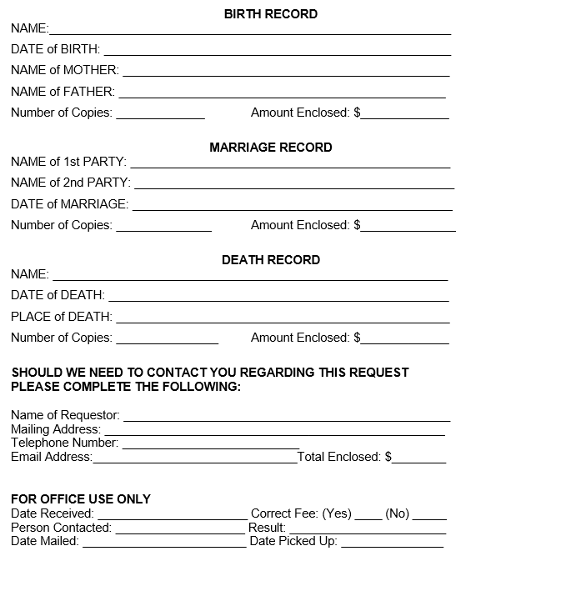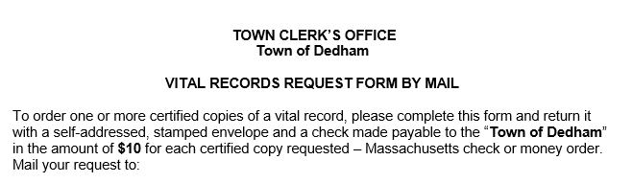

**Town Clerk**

**450 Washington St**

**Dedham MA, 02026**