A Virtual Meeting of the Select Board

Thursday June 25, 2020, 6pm

Present were:

Dennis Guilfoyle - Chair

Dr. Dennis J. Teehan - Vice Chair

James A. MacDonald

Sarah E. MacDonald

Dimitria Sullivan

Meeting brought to order at 6pm

**Pledge of Allegiance**

**Dedham Citizens – Open Discussion**

None.

**AGENDA:**

**Discussion & Vote Re: 1/12th Budget (Aug), Alternate Year End Transfers & Budget Update**

Mr. Goodwin stated that they are ready to present the August 1/12 budget that will cover us for the first 10 days of August.

Mr. Sean McGoldrick, Interim Finance Director, stated that this is just a legal requirement to gain authorization from the DOR to deficit spend before a full budget is voted.

Dr. Teehan moved approval; Seconded by Ms. Sullivan.

**On the Vote**:

Ms. MacDonald - Yes

Dr. Teehan - Yes

Ms. Sullivan - Yes

Mr. Guilfoyle - Yes

Mr. MacDonald – Yes

Mr. McGoldrick stated that there are 4-year end transfers. The first is allocating some

additional money needed for postage. Mr. McGoldrick added that there is an

encumbrance that would push this into a deficit. Mr. McGoldrick continued, saying that

the second one is adding money to the Assessors Department for revaluation work. Mr.

McGoldrick Stated that the third is for snow and ice in the amount of $604.18. The last

transfer involves Parks and Recreation to cover costs by moving money from expense

line over to personnel to cover costs within this department.

Ms. MacDonald asked Mr. McGoldrick if he could explain further why these Park & Rec.

funds are being transferred to salary accounts and if this has anything to do with the

hiring freeze.

Mr. McGoldrick stated that typically what happens with Park & Rec is that all salary

costs get charged off the General Fund and then towards year end we will move

some of those costs to the revolving fund but the issue is with all the refunds and

lack of revenue not coming into those revolving funds, the Town could not transfer some

of those salary amounts over to those funds.

Ms. Sullivan moved to approve the alternate year end transfers as presented, subject to

approval by the Finance & Warrant Committee; Seconded by Ms. MacDonald.

**On the Vote**:

Ms. MacDonald - Yes

Dr. Teehan - Yes

Ms. Sullivan - Yes

Mr. Guilfoyle - Yes

Mr. MacDonald – Yes

Mr. Goodwin gave a brief Budget presentation:



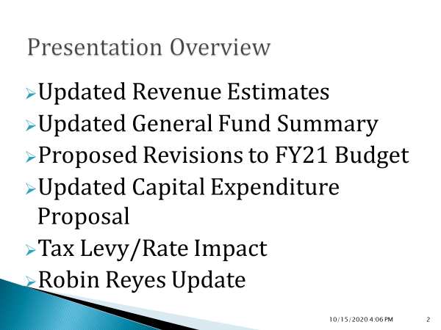

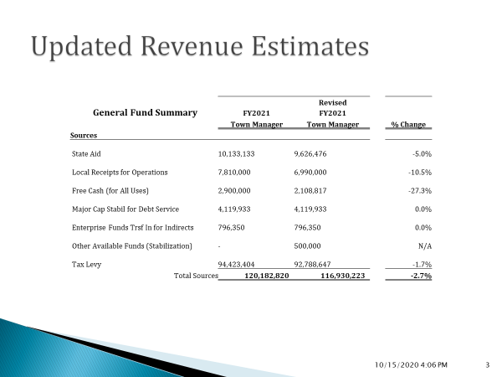

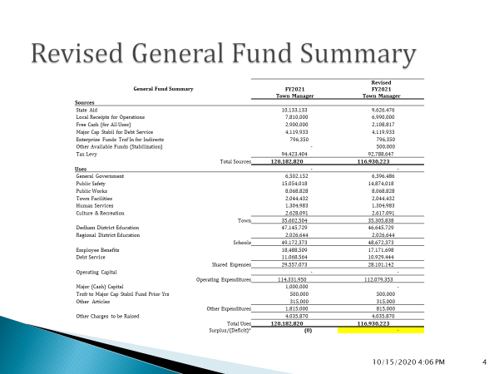

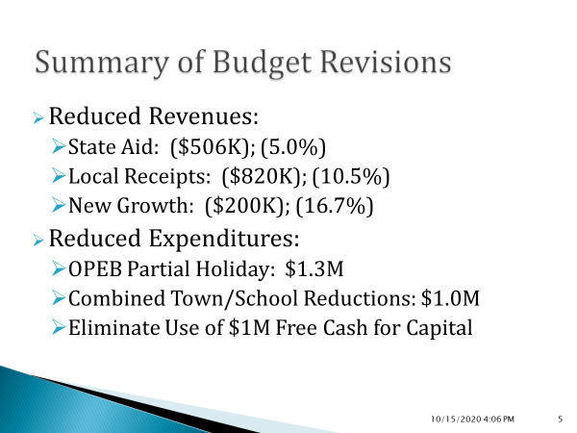

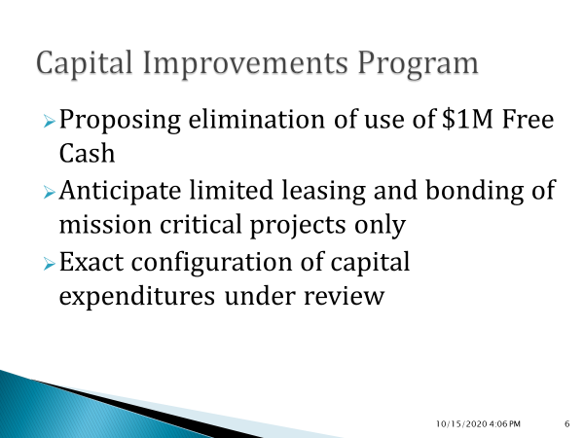

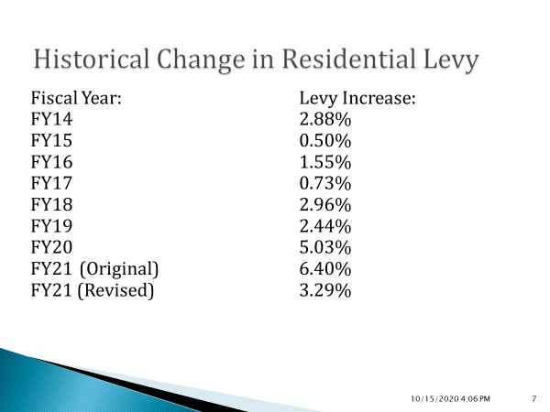



Dr. Teehan stated that he believes the State average tax increase every year is about 4% and given the financial challenges working against us, to get our tax increase to the low threes is excellent.

**Discussion & Vote Re: Liana Lane Layout & Elm Street Alteration**

Jason Mammone – Town Engineer, was present.

Mr. Mammone stated that he was just following MGL protocol for alterations of layout or changing a layout from Private to Public. Mr. Mammone added that this is the last step where you accept the report issued by the Planning Board for both layouts in front of you. Mr. Mammone informed all that they have a secondary motion which basically puts your vote and a copy of the plan at the Clerk’s office.

Ms. MacDonald moved to accept the Planning Board’s report for the layout of Liana Lane, dated March 5, 2020; Seconded by Mr. MacDonald.

**On the Vote**:

Ms. MacDonald - Yes

Dr. Teehan - Yes

Ms. Sullivan - Yes

Mr. Guilfoyle - Yes

Mr. MacDonald – Yes

Ms. MacDonald moved that the Select Board lay out Liana Lane as a public town way in the location shown on the plan entitled: “Liana Estates Definitive Subdivision Plan of Land, 1056 East Street, Dedham , Massachusetts” as prepared by Norwood Engineering Company, Inc., with a date of October 20, 2015 and file a copy of its vote and the layout plan with the Town Clerk forthwith; Seconded by Mr. MacDonald.

**On the Vote**:

Ms. MacDonald - Yes

Dr. Teehan - Yes

Ms. Sullivan - Yes

Mr. Guilfoyle - Yes

Mr. MacDonald – Yes

Ms. MacDonald moved to accept the Planning Board’s report for the alteration to the layout of Elm Street, dated June 15, 2020; Seconded by Ms. Sullivan.

**On the Vote**:

Ms. MacDonald - Yes

Dr. Teehan - Yes

Ms. Sullivan - Yes

Mr. Guilfoyle - Yes

Mr. MacDonald – Yes

Ms. MacDonald moved that the Select Board alter the layout of Elm Street to include the

area depicted as “Proposed Permanent Roadway/Sidewalk Easement, National

Amusement: “Proposed Permanent Roadway/Sidewalk Easement, National

Amusements, Inc., Area About 186 Square Feet” as depicted on the plan entitled

“Sidewalk Layout Plan” as prepared by Alpha Surveying & Engineering, Inc., with a date

of March 2020 and file a copy of its vote and the layout alteration plan with the Town

Clerk forthwith. Seconded by Ms. Sullivan.

**On the Vote**:

Ms. MacDonald - Yes

Dr. Teehan - Yes

Ms. Sullivan - Yes

Mr. Guilfoyle - Yes

Mr. MacDonald – Yes

**Discussion & Vote Re: Date for 2020 Spring Annual Town Meeting**

Mr. Goodwin stated that the basics are what was discussed at the last meeting. Mr.

Goodwin added that it is going to be outdoors on a proposed date of August 10 to allow

us to meet our statutory and local timeline, to get the warrant posted and books mailed

out. Mr. Goodwin continued, saying that the suggested location is veteran’s field at

Stone Park (Dedham HS Field) and we are suggesting a 6pm start time.

Mr. MacDonald moved that the 2020 Spring Annual Town Meeting be held on Monday,

August 10, 2020 6pm at Veteran’s field at Stone Park (also known as the Dedham High

School Athletic Field; Seconded by Ms. Sullivan.

Mr. MacDonald stated that this is the first step. There is a group that has been put

together by the Town Moderator to work out logistics.

**On the Vote**:

Ms. MacDonald - Yes

Dr. Teehan - Yes

Ms. Sullivan - Yes

Mr. Guilfoyle - Yes

Mr. MacDonald – Yes

**Discussion & Vote Re: Acceptance of Select Board Goals**

Mr. Goodwin stated that back on February 7, the Select Board met at the Endicott

Estate and workshopped to create goals for the Board.

Dr. Teehan suggested voting on the goals at the first meeting with the new Board.

Mr. MacDonald stated that he will go a long with the wish of the Board. Mr. MacDonald

suggested that some time over the Summer the Board updates the goals.

Ms. Sullivan stated that with a new member coming onboard they should wait to vote

until the next meeting. this will allow the new member to give their opinion.

Ms. MacDonald stated that it is a lot to ask a new Board member to weigh in on the

current Board’s goals.

Mr. MacDonald stated that he would rather get this done now but as long as it is on the

agenda at our next meeting for a vote.

Ms. Macdonald moved that the Board approve the goals as they exist and bring them

up in two weeks for review and updates that the new member and the environment we

are in now allow; Seconded by Jim MacDonald.

Mr. MacDonald pulled his second.

Mr. Goodwin stated that he will make sure the goals are on the Town’s Website.

**Town Manager’s Report** (including COVID Task Force(s) & Ames Updates)

Successfully moved into new Town Hall

Rotation plan to keep the employees safe

Reentry plan – today or tomorrow

Phase 2B of re-reopening (indoor seating in Restaurants)

Focus is on helping businesses with the new guidelines

Mr. Goodwin informed all that DPW Director, Joe Flanagan, recently graduated from MMA in Local Government Leadership.

**Action by SB**:

Approval of Drainlayers

Wayland Excavating, LLC

19 Winter Street

Wayland, MA 01778

Dr. Teehan moved approval; Seconded by Mr. MacDonald.

**On the Vote**:

Ms. MacDonald - Yes

Dr. Teehan - Yes

Ms. Sullivan - Yes

Mr. Guilfoyle - Yes

Mr. MacDonald – Yes

**Old/New Business\***

Dr. Teehan suggested getting Social Workers onto Police Forces as the job has really changed. Dr. Teehan stated that he feels that the Town should take meaningful action.

Dr. Teehan added that we moved into Ames Schoolhouse last week. Dr. Teehan would like to have an Executive Session so we can look into the legal implications and discuss the active lawsuit.

Ms. MacDonald stated that she watched a Parks and Rec. meeting recently. Ms. MacDonald added that one of the statements the P&R Board approved in their meeting, was calling on the Select Board, as well as the Town Administration, to require Discrimination and Sexual Harassment training for all elected and appointed Boards.

Mr. MacDonald reminded all that Saturday is Election Day and the polls open at 7am and close at 8pm.

**Presentation to Chairman Guilfoyle**

Mr. Goodwin read and presented a plaque to Mr. Guilfoyle.

The Board members each praised and thanked Mr. Guilfoyle and wished him luck on his campaign for Norfolk County Commissioner.

Mr. MacDonald moved to adjourn the meeting; Seconded by Dr. Teehan.

**On the Vote**:

Ms. MacDonald - Yes

Dr. Teehan - Yes

Ms. Sullivan - Yes

Mr. Guilfoyle - Yes

Mr. MacDonald – Yes

The meeting adjourned at 7:22 pm

The next Meeting is scheduled for Thursday July 9, 2020. This is to certify that the above is a true and accurate record of the minutes of the Select Board Meeting held on June 25, 2020 which minutes were approved on October 22, 2020.

_________________________ Dennis J. Guilfoyle. – Chairman