A joint meeting the Dedham Board of Selectmen, The Westwood Board of Selectmen and the Dedham-Westwood Water District was held on Wednesday March 16, 2016, at 7p.m., in the Lower Conference Room of Town Hall, 26 Bryant Street, Dedham, Massachusetts. Present were:

Michael L. Butler

Dennis J. Guilfoyle

James A. MacDonald

Dr. Dennis J. Teehan, Jr.

Brendan G. Keogh

Westwood BOS:

* Michael F. Walsh – Chairman
* Patrick Ahearn – Clerk
* Michael Jaillet – Town Administrator

Dedham Westwood Water District:

* Eileen Commane – Executive Director

Dedham Westwood Water District Board of Water Commissioners:

Town of Dedham:

* Steven Mammone
* Ronald Wiley - Clerk
* John Miller

Town of Westwood:

* Robert McLaughlin, Jr. – Chairman
* James Galvin
* Joseph Cantor

Mr. Butler called the meeting to order at 7p.m.

**PLEDGE OF ALLEGIANCE**

Led by Mr. Butler

Westwood Board of Selectmen did not have quorum to open their meeting.

The Board of Water Commissioners called their meeting to order and announced that they are making a video and audio recording of the meeting.

Mr. Butler asked for a moment of silence for State Police Officer Thomas Clady, who was killed in an accident on the Mass Turnpike, leaving a wife and 6 children. The room stood in honor of the fallen Trooper.

**BRIDGE STREET TREATMENT PLANT MODERNIZATION – PROJECT NEED, TIMELINE AND SRF FUNDING**

Mr. Butler stated that the Westwood Board of Selectmen hosted a meeting similar to this one a few years ago. He added that the Board of Water Commissioners contacted him a few months ago to suggest a meeting as they have some major projects going on and it's a good idea to share that information with the two Boards and the public. Mr. Butler mentioned that Chairman McLaughlin has brought pretty much his entire team with him.

Chairman McLaughlin stated his thanks to the Boards for having them this evening. He then gave an overview of the projects he would cover this evening.

* The Bridge Street treatment plant will be upgraded in the coming year or two
* Water quality update
* Finances

Tim McLaughlin gave the following PowerPoint presentation;

**Bridge Street WTP Modernization Project**

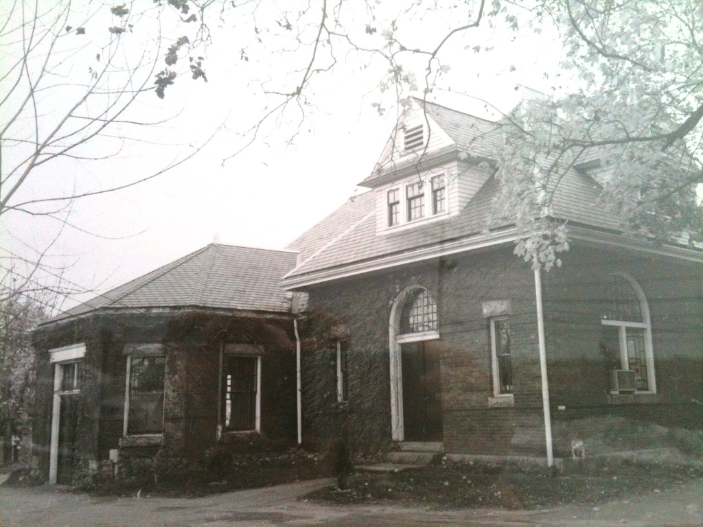

**Bridge Street WTP History**

* 1881 - Original construction of facility
* 1959 - Coal Fired Steam pumps replaced with Electric Motors
* 1990 – Filtration added
* 1995 – Pumping upgrades
* 2002 – Aeration system installation
* 2003 - Well improvements
* 2015 – Well improvements

Mr. McLaughlin informed all that with all the additions and improvements in such an old building that they have just outgrown it and the equipment has reached the end of its useful life. They plan on keeping the structure and will go into the plan in more detail in a moment.

**Bridge Street WTP Process**

* Wells – 11 Groundwater Wells
* Water Treatment

- Aeration

- Oxidation

- pH adjustment

- Slow Mixing-iron and manganese particles will

be formed for filtration

* Pressure Filtration
* Post Filtration-final pH adjustment, corrosion control, disinfection and fluoridation

Groundwater source is water that has a lot of minerals in it, relative to a service water source. The water comes in to the plant and is treated for the heavy metals in it.

Michael Jaillet, Westwood Town Administrator arrived, so the Westwood Board of Selectmen called their meeting to order.

Chairman McLaughlin, then give a brief overview of the water treatment procedure.

**Project Goals**

* + Modernize and rehabilitate the facility/treatment process
* equipment is quite old and the facilities are crowded
  + Automate treatment process
  + Reduce operation and energy costs
  + Maintain features of the site and buildings
  + Minimize disruption during construction

Mr. McLaughlin stated they have been looked at this project for 10 years and look at all aspects of the job. They considered knocking the whole building down to put up a prefab building, but they like the building and it was more cost effective to keep it. Mr. McLaughlin also pointed out that this is an historical neighborhood and the building fits in quite well. Mr. McLaughlin added that like to keep disruption to a minimum.

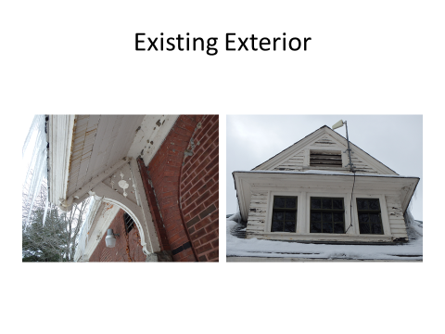

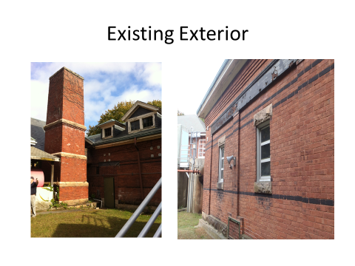

Chairman McLaughlin pointed out some areas that need updating on the existing building. Chairman McLaughlin added that it is a brick building, very solid, but it needs to be re-pointed.

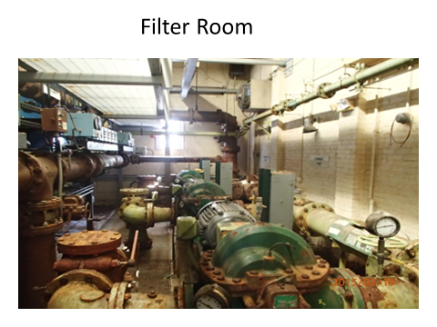

Mr. McLaughlin stated that this slide shows how much the additional equipment has outgrown the building. Mr. McLaughlin continued, saying that the pumps need to be changed out every five years and there is not much room to operate. Remodeling and upgrading the equipment will help deal with the rust issue.

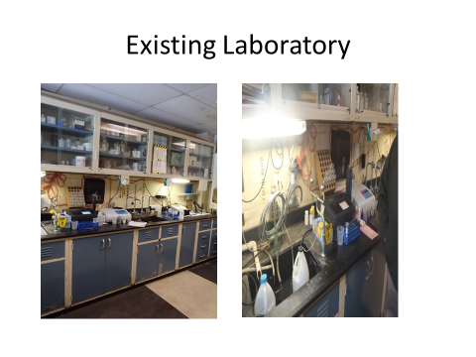

Chairman McLaughlin stated that when he came on the Board he toured the Bridge Street facility and was amazed at the poor working conditions. Chairman McLaughlin added that the picture does not do justice to how cramped the working space is.

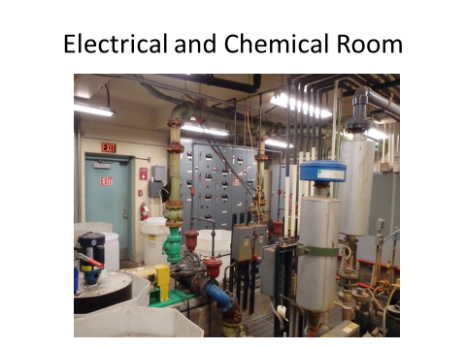

Mr. McLaughlin pointed out that the electrical components are in with the rest of the equipment in the building. This is another example of how cramped the space is. Mr. McLaughlin added that the plan on building another structure to house electrical components. This will address space and maintenance issues.



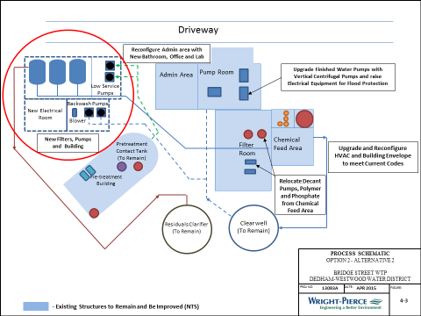

Mr. McLaughlin stated the next slide was a schematic that an engineer mocked up. The circled area is the proposed new building housing a new electric room and filters which will create more space and help deal with the humidity issues.

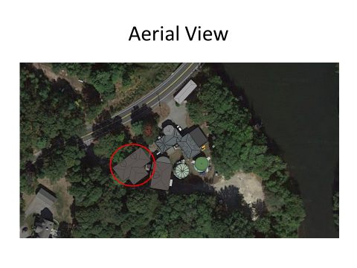

Mr. McLaughlin stated the next slide showed an aerial view with the proposed new structure circled in red. Mr. McLaughlin informed all that keeping the existing building and building the new structure will allow them to stay online with minimal shutdown time.

**Costs**

* Construction Cost Opinion = $8 MM
* Drinking Water State Revolving Fund (DWSRF)
  + Applied and competitively selected for funding
  + 2% interest over 20 year borrowing period
* Local funding/bonding options
* Rate Impacts

Mr. McLaughlin stated that they have working figure of $8 million for the construction cost. Dedham Westwood water district has about $13 million in hand, mostly coming from access fees over a period of years. The drinking water State revolving fund has accepted our project and will be funding it through its full cost.

**Bridge Street Construction Schedule**

* Anticipate Plans and specifications delivered to DEP for approval October 2016
* Construction bids early 2017
* Construction starts Spring 2017
* Completion mid 2018

Mr. Lawson stated that they have reached out to the neighbors that they think will be affected by noise and will meet with them when their plans about 30% done.

**Water Quality and Quantity**

* In compliance with all Drinking Water Standards
* DEP Public Water Supplier Award in 2014
* Water Management Permit may make mandatory restrictions routine
* MWRA supplement available for peaking and emergencies
* Unaccounted for water –still an area of concern

Mr. Galvin stated that Mike Powers was a commissioner for the DDWD and a driving force behind getting this project to where it is today. He was not reappointed to his position by the Dedham Board of Selectmen but was hired as a consultant by the Board of Commissioners.

Mr. McLaughlin stated, regarding their rates, that two years ago, the Board voted a 2% annual increase and at this point they do not expect a rate increase, so they will continue with the 2% annual.

Mr. Walsh asked how automating the process and going from 3 shifts to 2 will impact the union and employees and have they been made aware of these plans.

Mr. McLaughlin stated yes, it has been discussed with the employees and it allows them to free up a guy that they need. There will be no change in staff but it will allow us to use that guy more intelligently.

Mr. Ahearn asked Mr. McLaughlin how much contingency is being held with the $8 million.

Mr. McLaughlin stated it's still early on in and they are not at that point yet.

Mr. Kern stated that in his experience in Westwood you need a healthy contingency.

Mr. Guilfoyle asked how many shifts ran at the Westwood pumping station.

Mr. McLaughlin answered one.

Mr. Guilfoyle asked if that was all week long.

Mr. McLaughlin answered yes seven days a week.

Mr. Guilfoyle asked if a similar system will be put in at Bridge Street.

Mr. McLaughlin answered yes but a bit more updated.

Dr. Teehan stated that a few of the abutters of this project have reached out to him in the last two days with some of the typical concerns. Dr. Teehan asked Mr. McLaughlin how they were planning to engage the neighbors and hear their concerns.

Mr. McLaughlin stated that they're still early in the process but they have begun to reach out to residents. Once the project gets to 30% design they will reach out to them again and schedule a meeting.

Dr. Teehan stated that looks like the DWWD is going to start construction about a year from now, so that's not that early on in a neighborhood meeting is a very good idea. Dr. Teehan clarified that the DWWD is going to finance the project and used a $13 million you have in pocket for other capital expenditures.

Mr. McLaughlin answered yes.

Mr. Keogh asked what would happen to the other two workers when they automate and go down to one shift.

Mr.Eibenanswered that they have a couple people that planned to retire and even though there is only one full time shift they still need relief to fill the other days.

Mr. Guilfoyle asked if the intent was to fill those positions of the retirees.

Mr. Eiben answered that they are not quite sure what they will do, but the intent is not to lay anybody off.

John Wright, a Dedham resident and abutter to the project, stated his appreciation of the willingness to meet with residents when the time comes. Mr. Wright asked Mr. McLaughlin to explain some of the other options they considered for the building.

Mr. McLaughlin explained that they had many discussions on many choices, ranging from tearing down the whole building, to putting up a prefab, but in the end decided on adding on to the existing structure, and repairing and maintaining it.

Mr. MacDonald thanked Mr. McLaughlin for all the updates. Mr. MacDonald added that he is glad to see that the DWWD is taking advantage of the clean water trust. Mr. MacDonald continued, saying, regarding the finances, back in 2013 the DWWD established a policy of continuous 2% increases. Saying that you have money in the bank, is there any consideration of giving rate relief to your customers. It seems the thing to do when you have that much money in hand you can borrow at such a low rate.

Mr. McLaughlin asked if there any more questions on the Bridge Street project. Seeing as there were none, he handed the podium to Ms. Eileen Commane, Executive Director, DWWD.

**WATER QUALITY AND WATER QUANTITY; COMPLIANCE WITH DRINKING WATED REGULATIONS; DEP PUBLIC WATER SUPPLIER AWARD; STATE WATER MANAGEMENT REGULATIONS; MWRA SUPPLEMENTAL PURCHASE LIMIT; REDUCED SALT ZONE REQUEST; UNACCOUNTED FOR WATER**

Ms. Commane stated that each Board has in front of them DWWD’s annual Water Quality Report. Ms. Khamenei added that on the whole it gives very good news regarding water quality the DWWD provides for its customers.

**Water Quality and Quantity**

* In compliance with all Drinking Water Standards (2015 - state and federal)
* DEP Public Water Supplier Award in 2014
* Ms. Commane recognized the staff members that put in a lot of hard work to make this work possible.
* Ms. Commane added that the DWWD is out inspecting all the commercial and municipal buildings to make sure there are no unprotected connections between non-potable water and the drinking water system
* Water Management Permit may make mandatory restrictions routine
* MWRA supplement available for peaking and emergencies
* Unaccounted for water –still an area of concern

Ms. Commane added that the situation in Flint, Michigan, has led the DWWD to take a closer look at its lead and copper control programs. Ms. Commane informed the Boards that they've been in compliance with the federal lead and copper program for the 20 or so years it has been in effect. Ms. Commane went on to describe the program in more detail. Ms. Commane continued, saying that the state has put the DWWD is on a reduced monitoring program because the results have been so favorable. So they do the monitoring every three years. Ms. Commane added that of all the testing they did only one home came back with the results over the action level. The DEP then gives the DWWD, guidelines to pass along to such customers as to how to assist them.

Ms. Commane described an effort by the DWWD to remove lead goose necks from the system. There are roughly 1000 of them currently in the system and they replace approximately 50 per year. As the DWWD works on a project and comes across one of these lead goose necks, they replace it.

Ms. Commane stated that she expects that in light of Flint, Michigan, there will be likely be new regulations coming out of Washington

Ms. Commane asked if there were any questions.

Mr. Butler asked if the DWWD knew the date after which they stopped using the lead goose necks.

Ms. Commane answered that they do not have a date certain but the transition to copper probably happened in the late 30s.

Mr. Butler asked if it was safe to say to a homeowner whose house was built after World War II that they would not have lead goose necks.

Ms. Commane stated that the DWWD has no record on the portion of the service line that's on the homeowner’s property.

Mr. Keogh asked Ms. Commane to speak a little bit more to the Beacon Street in review section.

Ms. Commane stated that they are planning to replace water mains on Riverview, Fairfield and Beacon.

SteveLockeinformed all that the DWWD tries to stay in tune with the paving schedules and fix/replace out-of-date equipment where the water main would be likely to have problems or where we find iron/lead service.

Mr. Butler asked Ms. Commane if the DWWD ever did blind taste tests or if they have ever had complaints over the taste of the water and if so, how do you respond to that.

Ms. Commane answered, certainly if we received a complaint from a resident about the taste or water quality, Tabitha Maccalous, DWWD water quality supervisor, would meet with the customer to address the issue.

Ms. Commane described the difference between Dedham Westwood water and MWRA water, stating that they are fundamentally different. DWWD’s water is entirely groundwater that needs to be treated at the plant. MWRA's water is a surface water. It's an impoundment with a dam, kind of a still lake.

Mr. Keogh asked if the difference in taste is due to the method in which the waters treated.

Ms. Commane answered that is not only the treatment. But the fact that the water is retrieved from the ground and mineral content is much higher and isn't completely removed in the filtration process. Ms. Commane informed all that it is a harder water then the MWRA's water. The MWRA adds baking soda to their water to add hardness back into their water

Ms. Commane stated that she wanted to bring the Boards up to speed regarding the State Water Management Act. Ms. Commane stated that the DWWD takes their water out of two river basins; the Charles and the Neponset. Neponset is currently in the review process for twenty-year permit. Ms. Commane continued, saying that the state redid its Water Management Regulations by doing an evaluation of every stream in the Commonwealth and they characterized each stream in terms of its flow in such things. The DWWD will have to make mandatory restrictions in order to get this permit.

Mr. Kern asked what volume of water those two permits allow you to withdraw.

Ms. Commane answered that it is 1.9 million gallons a day for the Charles and Neponset has a registered right of 2.7 million gallons a day in the permit allows for an additional 1.4. Future permits will be for no greater water than we are using now.

Mr. Butler clarified that the DWWD is pulling water from the Aquaphors not directly from the rivers.

Ms. Commane informed the Board that the DWWD supplemented with the right to purchase an additional 100,000 gallons of water a day from the MWRA last year. Ms. Commane added that contractually they can purchase 200,000 gallons a day from MWRA. Ms. Commane stated that the DWWD’s average days is about 4,000,000 gallons. Ms. Commane continued, saying that this is a great partnership with the MWRA and if needed, additional resources will be under contract soon.

Ms. Commane stated, as you know the DWWD has for many, many years has been requesting that the Mass DOT reduce the amount of salt that they apply to the highways near water sources. Ms. Commane informed all that they have not agreed to implement a reduced salt district but they have undertaken many steps to reduce the amount of salt that they are adding. They removed a salt storage barn and have reconfigured their salting routes so there's no overlapping. They also pre-wet the roads, which allows them to use less salt. Ms. Commane stated that they will continue to work with Mass DOT to reduce the amount of salt on the roads.

Ms. Commane spoke about the amount of unaccounted for water. Unfortunately, this is been a long-standing and unresolved problem. The DWWD is losing 25% of its water. The state’s target number from the conifer water is 15%. The DWWD continues to do every single thing that the DEP and other experts are recommending to address this problem. Despite all their efforts, they have not been able to reduce this number.

James Galvin stated that the reduced salt zone is a major issue for the DWWD. Ms. Commane has reached out to Senator Rush and State Representative McMurtry. Mr. Galvin added that the Mass DOT does not want to help them and by not helping them they're not helping the customers in both Dedham and Westwood. This issue may require us going straight to the Governor.

Mr. Ahearn asked if there was a reason Mass DOT does not want to help.

Mr. Galvin answered, because it's a State.

Mr. Ahearn asked if Mass DOT give an explanation as to why they do not want to help.

Ms. Commane stated that she thinks they do want to help, but unfortunately the methods they thought would help have not been as successful as they thought they would be.

Mr. Ahearn, stated so they have given you cures that are not curing the problem.

Ms. Commane answered correct.

Mr. Butler stated they need support from either Board just let us know.

Mr. Galvin, stated they need all the support they can get. But this needs to go to a higher level, someone over the DOT.

Mr. McLaughlin informed all that every one of DWWD’s customers has a meter. The majority of which are analog meters, which had to be read individually. This took an enormous amount of time. The DWWD started changing out the analog meters to radio meters. Mr. McLaughlin added that there are about 100 analog meters left to be changed out. Mr. McLaughlin continued, saying the advantage to having the radio meters is that they now a meter reader has a device, like a laptop, drives the route and it populates the device for him. Now they can do the entire system in a week to a week and a half. This has allowed the DWWD to move to a monthly billing system. Up to two years ago, the DWWD’s billing system was based in DOS. They had to hire a programmer to design a new billing system. One of the real advantages we see out of the monthly billing system is when somebody has a leak, they don't have to wait three months for a bill. An issue show up on the monthly bill.

Mr. MacDonald stated that back in 2009 the DWWD developed the policy of charging $40 per quarter for those that have not switched out their analog meter. Mr. MacDonald asked. Mr. McLaughlin how many have not switched out and how much money has the DWWD collected, if any, since the policy was put in place.

Mr. McLaughlin stated that 100 have not switched out. Mr. McLaughlin added that the $40 charge really brought out customers that needed to switch.

Mr. Guilfoyle asked if the money collected went into a separate account and what is it used for.

Michael Thornton, Business Manager-DWWD, answered that it goes right into a general fund. Mr. Thornton added that they say to the customers that they really do not want to collect the $40 fee, what they want is to get that meter switched out. Mr. Thornton continued, saying that as soon as an agreement is made to switch out the meter, the $40 fee stops. Mr. Thornton added that their intent from day one was not make any money off of this.

Mr. Jaillet informed all that Westwood has switched out other lightbulbs to LED fixtures. These fixtures have the ability to give meter readings. They would be mounted on a light pole and have the ability to be read 24/7.

Mr. McLaughlin stated in order to have a meter reading travel all the way back to its hub, there needs to be an intermediate relay. The light poles that Mr. Jaillet is referring to, have the ability to install a relay so you can get real-time information. An advantage of this is that if somebody uses 50% more water than they were using the previous week, the system will flag it and the customer can be called to inform them that they may have a leak. Mr. McLaughlin added that they have had talks about a system like this but it's not in their immediate future.

Mr. McLaughlin handed the podium to Michael Thornton, Business Manager - DWWD, who will speak about the conversion to a lockbox.

Water Bills

* Water rate surveys are historically based used 90,000 gallons for the annual basis for comparison.
* The average DWWD residential customer uses 63,000 gallons a year

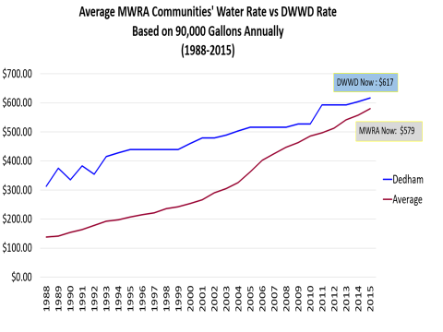

Mr. Thornton stated that in order to have a strong vision, the Board as a group has to look back historically. When Mr. Thornton first started at the DWWD, he noticed that they were losing 33% of their water supply to contamination of wells in Westwood. Mr. Thornton described the financials in the slide above, pointing out that the cost gap has closed. Mr. Thornton pointed out that residents of some other communities are paying well over $1000 a year while the average in Dedham is $617. Mr. Thornton continued, saying that in the late 80s, the DWWD was at the top of the pack in terms of water rates.

**Financial**

* DWWD adopted a financial policy in 2013 of adjusting rates annually 2% for rate stability and to fund operating increases and capital programs
* Current cash on hand 13$MM
* Annual 2016 Operating budget of $9.2MM
* Annual 2016 Capital Budget of $4.6MM

**Capital Plan 2016-2019**

* Capital spending plan $22MM (60% of which are small projects)
* SRF Bond new debt 2017 for $8MM
* Cash on hand expected 12/31/2019 $5.24M
* Assume 2% annual Rate increases and 2-3% increases in operating expenses

Mr. Thornton informed all that from 2001 – 2015, the DWWD collected $6.1 million in access fees. Some years the access fees are $O and some years when large projects are in the works that money is significant. The purpose of these access fees is to deflect cost from residential customers, which make up 90% of our customer base.

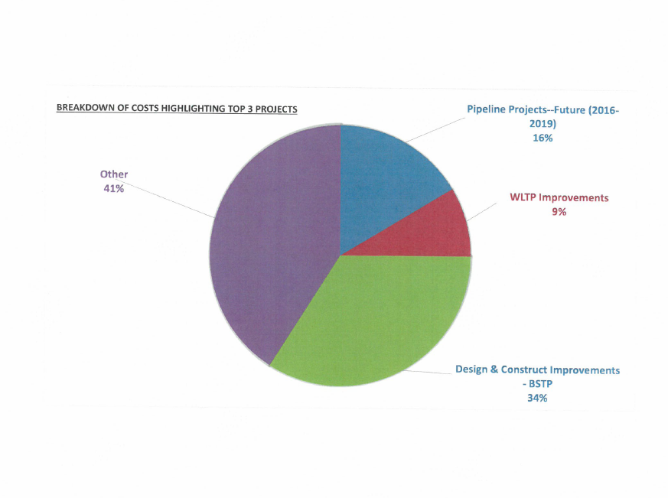

Mr. Thornton stated that pipeline projects, WLTP improvements in design and construction improvements make up about 59% of all combined expenditures over the next four years.

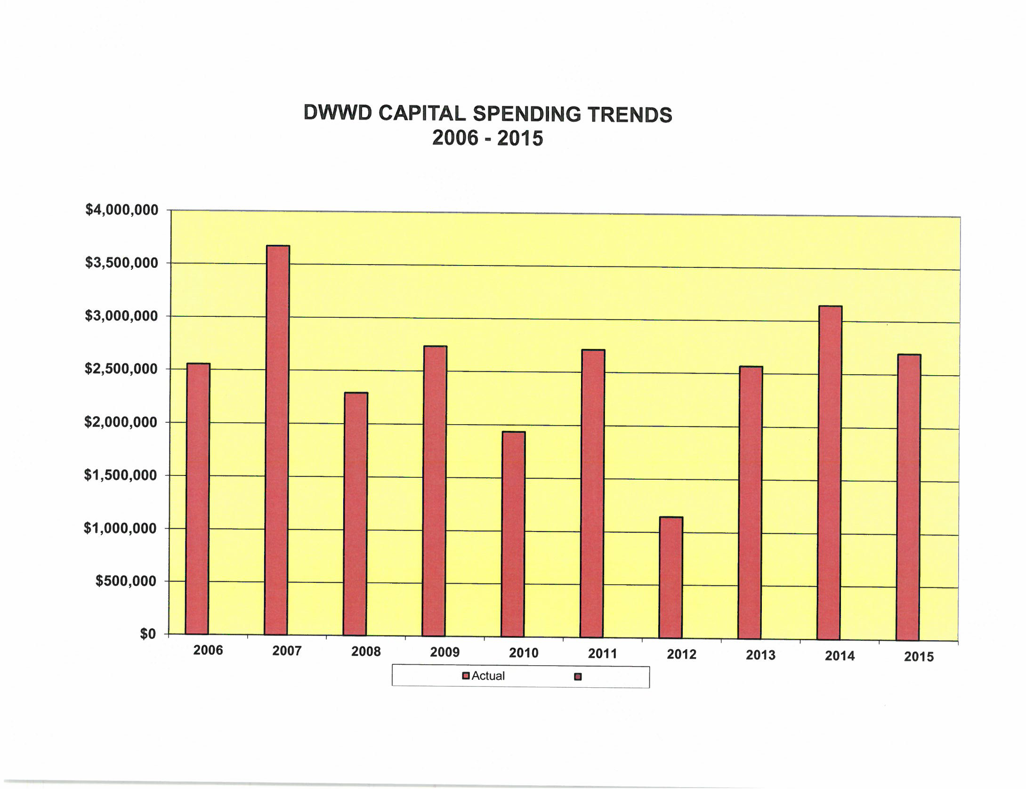

Mr. Thornton stated, looking at the capital spending trends, in 2007 the DWWD spent over 3 1/2 million dollars on infrastructure prevents. Mr. Thornton added that between 2006 and 2015 the Board has spent $25 million on capital improvements. Looking forward, Mr. Thornton stated that they're looking at spending $22 million just in the next four years. Mr. Thornton stated that obviously the biggest hit is the Bridge Street treatment plant.

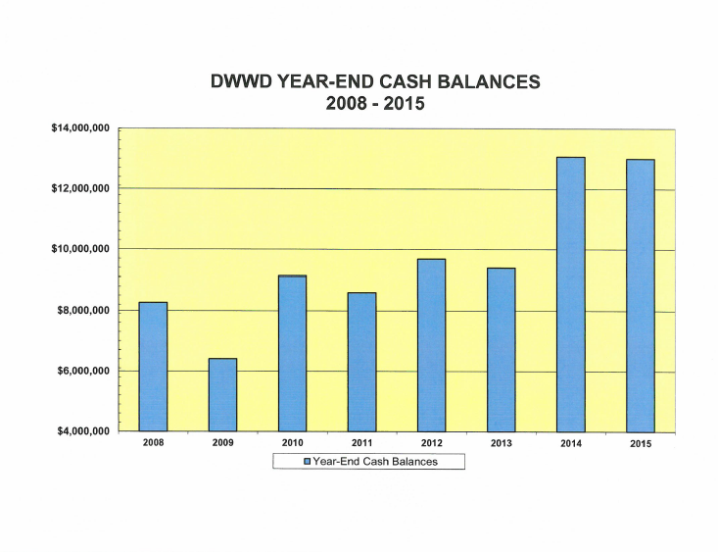

Mr. Thornton explained that back in 2009 they had just over $6 million and in the last couple of years, cash balances have been significant, around $12-$13 million.

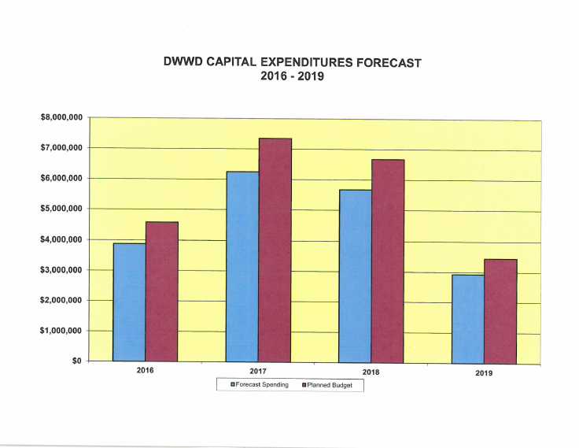

Mr. Thornton pointed out that what the Board is done is to set money aside, knowing that these big projects that are coming online. The above graph shows $22 million in capital managers over the next four years but the plan is to spend out about $18 million over the same four year period.

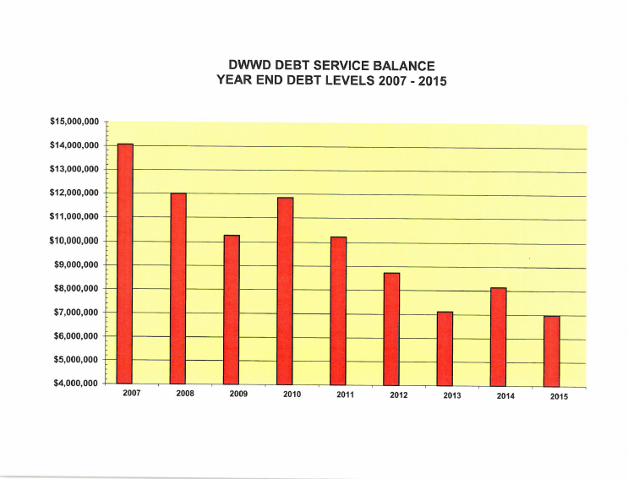

Mr. Thornton stated that in the year 2013, based on the current debt levels that we have right now, one of the options that the Board can consider is paying off all of the existing debt, which would be about $4.1 million. Mr. Thornton added that by the end of 2019, using the format that we talked about here, the cash balance will probably be in the neighborhood of $5.4 million. Mr. Thornton continued, saying that the Board has taken an aggressive stance in the last few years, on the operations side, with paying off OPEB expenses on an accelerated basis. Mr. Thornton added that for the year 2015, the DWWD will be looking for the first time at responding to the North County Retirement System unfunded liability, of which the district has a piece of that and as of right now, that number is about $4.4 million. The Board has looked at the cash and said we do have a plan for that money.

Mr. Thornton stated that he recalls in the late 1990s, the DWWD, wound up doing double-digit rate increases, which were horrifically painful. Not only for the customers in Dedham and Westwood, but also for the staff. Mr. Thornton added that he believes this Board has been very successful and has created a very healthy financial picture here by following the policy that was set in 2013 and by taking a look into the past, as well as into the future. Mr. Thornton continued, saying that analyst at Moody's have told him that the DWWD’s Big A, little a2 rating is good as any water district in this area is going to get.

Mr. Thornton stated that they have established is a sound one. Moodys and our auditors have indicated that the Board has done everything that it could do to drive costs down. Mr. Thornton added that this Board has created a very bright financial future for the DWWD.

**Ten Largest Customers**

* Legacy Place
* Norfolk County Jail
* NewBridge on the Charles
* Dedham Hilton
* Foxhill Village
* Archstone Apartments
* Jefferson Crossing Apartments
* Highland Glen
* Dedham Nursing
* Traditions
* Dedham Racketball
* Boch Ice
* Millenium Graphics
* Westwood Lodge

Mr. Thornton stated that these may be thought of as our 10 largest customers, but the real largest customer is residential customer base. Mr. Thornton added that they do have a plan in place to handle their debt, upcoming Capital expenditures, OPEB expenses and pension costs.

Mr. MacDonald asked Mr. Thornton if the DWWD had hired a financial advisor to advise them.

Mr. Galvin asked do think we need one.

Mr. MacDonald responded, yes I do.

Mr. Galvin asked what gives rise to that.

Mr. MacDonald responded by stating that with all the questions they had regarding their debt and reiterated that an advisor would help them.

Mr. Thornton responded no, they do not have a financial advisor.

Mr. MacDonald again suggested that they get a financial advisor as this is a sizable amount of work they're looking to do. Mr. MacDonald asked if the Board had a policy on dealing with reserves.

Mr. McLaughlin stated that the way they look at it in the last 10 years is they have enough cash and we have a lot of projects coming online, including a very large expense in Bridge Street, they preferred to put that money away.

Mr. MacDonald asked Mr. McLaughlin if they were intending to use the cash they have on hand to help pay some of the capital expenses upcoming instead of borrowing and is that the best use of the money.

Mr. McLaughlin stated that the cash came from the access fees. Mr. McLaughlin explained that when a resident does not want to buy into a water program and the water program spends millions of dollars setting up a system and then the resident says they would like to buy in, they should pay (buy in) an access fee. Mr. McLaughlin added that part of keeping that infrastructure in place is upgrading the treatment center. When an access fee comes in, it should go directly to increase that capital improvement.

Mr. Ahearn, stated that the DWWD said they have an unfunded liability with the county retirement Board and asked if they could give that number.

Mr. Thornton answered that the estimate they got was about $4.4 million. These numbers will get revised for the 2015 financials. Mr. Thornton added that the counties funded portion is about 55 to 60% so DWWDs unfunded liability is about 40%.

Mr. Ahearn asked Mr. Thornton what their unfunded liability was relative to OPEB.

Mr. Thornton answered that they have a UAAL of a little higher than $500,000.

Mr. Ahearn suggested that the DWWD think about making small increases every year going forward.

Mr. Thornton stated that the Board has opted to pay out an additional hundred $125,000 annually over the past few years. Mr. Thornton continued, saying that if they paid off the $520,000 UAAL today, that liability not only goes to zero it actually becomes a positive number, which is an asset. It's something that the Board keeps an eye on every year with the understanding that if they spend that money, they're not getting it back.

Mr. Galvin, stated that this July will be 10 years in the Norfolk Pension System and asked Mr. McLaughlin to share some thoughts about that.

Mr. McLaughlin stated that the Norfolk Pension System was happy to have the DWWD. As of a few years ago Norfolk Pension System has to show their unfunded liability and they have to tell the DWWD what it is. Mr. McLaughlin continued, saying that NPS told them that even though we were paying what we were told to pay and even though we had only been in the system a few years, we owed them $4 million. They explained that this was our piece of the unfunded liability for the past 50, 60 or 70 years. Mr. McLaughlin stated that they think it is grossly unfair that the DWWD was brought into a system that never disclosed to us that they had unfunded liability and we were handed a bill for somebody's underpayment. Mr. McLaughlin added that that is an issue they're looking into and we are going to address it.

Mr. Kern asked Mr. McLaughlin if he knew when their unfunded liability is scheduled to be paid off.

Mr. Thornton answered that 2026 is the last number he heard.

Mr. Galvin stated that they just kicked the can down another two years.

Mr. Kern asked what DWWD’s target date to retire their OPEB obligation is. As you talk about your OPEB plan. It helps to have that kind of answer in it. Mr. Kern added that those unfunded liabilities have been around for decades but now has to show on a balance sheet and it is going to show in red. That is what has changed.

Mr. Thornton stated that GASBY 68, is the requirement.

Mr. McLaughlin stated that the DWWD looked at what it would be if we simply had other postemployment benefits and the number was astronomical. We then negotiated a closed loop system with the union so that the current employees get the postemployment benefits. Mr. McLaughlin stated that with that, we brought that liability down significantly. Mr. McLaughlin continued, saying that they set up a trust and they do not want to overpay in the trust. Mr. McLaughlin added that Dedham has a never-ending liability for now, so you can really never overpay. The DWWD could overpay and that is our concern. Mr. McLaughlin continued, saying that they find themselves being very careful meeting the number on the funding schedule but not going too far. Mr. McLaughlin added that this is something they look into every year.

Mr. McLaughlin stated that they currently have a two-tier system for the union.

Mr. MacDonald asked Mr. McLaughlin to explain what that is.

Mr. McLaughlin explained that they did a study and discovered that their employees were paid very well, so the DWWD has gone to a two-tiered system. This means that new hires will come in at a lower rate with pension benefits, but no OPEB. When the older employees retire, that will put them back closer to market rate for their employees.

Mr. MacDonald clarified that the new hires are not eligible for OPEB but are for pension benefits.

Dr. Teehan asked when the investment in your capital improvements will affect rates and water waste.

Mr. McLaughlin replied finding solutions to water waste is a continuing problem it seems never-ending. The more capital improvements and maintenance we can do the better we can control this problem. Mr. McLaughlin added that in the short term, they don't anticipate any rate increases

Dr. Teehan asked Mr. McLaughlin and further investment in capital projects would benefit rates down the road.

Mr. McLaughlin stated that these investments will reduce energy costs and improve efficiency. Mr. McLaughlin added that the water needs to be treated in a Bridge Street plant needs to be updated to do this. This will significantly reduce maintenance costs over the next 10 to 15 years.

Mr. Jaillet asked if they could get water loss down to 0%, would that mean you have more water within the system and less need for supplementing from MWRA, resulting in benefits to ratepayers.

Mr. McLaughlin stated that this is a huge issue for the DWWD regarding cost. If we spend time and money pulling the water out of the ground and treating it and it doesn't get to customers, that's a real issue. Another concern is that the MassDEP may someday require us to get down to the 15% threshold and as they say, you're just going to have to figure it out.

Mr. Thornton stated that another thing that needs to be considered is because the district has so aggressively chased the infrastructure problems for long period of time, it isn't necessarily old pipe that is the problem. It could be something else, so the effort asked to be there constantly to be diligent and find the leaks.

Mr. MacDonald asked if there were any plans in the capital budget to extend any lines. Mr. MacDonald added that currently there are businesses in Dedham that are not serviced by the DWWD but they pay property taxes in Dedham, they're located in Dedham and are probably decent users.

Mr. McLaughlin answered that they want everyone on their system. Mr. McLaughlin added that they look at the Dedham Mall and think what can we do to get them on our system. Mr. McLaughlin continued, saying that the cost of running pipe there, by the time we recapture it over the course of charging them, is too high and doesn't make sense. Mr. McLaughlin added where it makes sense for us to extend, we would like to.

Mr. MacDonald asked how far the distance is it from Dedham Health even just to the Stop & Shop.

Mr. McLaughlin stated it's a lot farther than you think but the way the pipes are laid out, it turns out to be very expensive investment.

Mr. Guilfoyle asked if the DWWD was ever going to reconsider giving OPEB to its new employees. Mr. Guilfoyle added that he doesn't understand the two-tier system and how two guys can be doing the same job for different pay. This is something you'll be looking into.

Mr. McLaughlin answered that with regard to the two-tier system. It was a compromise to get the rate pay adjusted. As far as OPEB is concerned, we just couldn't sustain it financially.

Mr. Thornton added that they would've had to have double digit rate increases at infinitum to keep up with the cost.

Mr. McLaughlin added that the employees coming in will be younger and will know what they're getting into and it will plan accordingly.

Mr. Keogh stated that the two-tier system has proven to foster discontent between the workers and you are risking low morale. Mr. Keogh added that the DWWD should be looking at their own employees regarding this.

Mr. Galvin stated, we are. The wage study brought to the hour attention was that on average, our employees were overpaid by 30%.

Mr. Keogh asked Mr. Galvin what wage study that was and is it something we can look at.

Mr. McLaughlin responded, yes. It was King Bishop who perform the study and we can get you a copy.

Mr. Keogh asked how many union employees the DWWD currently has.

Mr. Thornton answered 18.

Mr. Keogh stated, you think they're all overpaid?

Steve Mammone stated that these employees came from private companies and run a totally different wage structure. They did not command a low wage structure and work their way up. So the idea was to bring them more in line with typical municipal workers.

Mr. Keogh again asked if they thought the 18 employees were overpaid.

Mr. McLaughlin stated yes they are paid above market.

Mr. Thornton stated this applies to the older workers not the three new hires.

Dr. Teehan clarified that the 30% was relative to other water employees

Mr. Thornton answered correct. Mr. Thornton added that that market included other municipal entities. Mr. Thornton continued, saying that he is working with the union for 3 1/2 decades and they are great group. To be honest with you there is not a morale problem. Many of them would say that they're well-paid, they get a lot of overtime. The benefits are excellent and they are a happy group.

Mr. Keogh stated that is all well and good, but the system hasn't started yet.

Mr. Thornton stated that the two-tiered system started in 2013 and there are three people in it currently and a new contract was just renegotiated. Mr. Thornton added that there were no contentious issues regarding wages. There were other issues to deal with and they were dealt with to the satisfaction of both parties. Employees have overtime available to them and are being paid on market basis.

Mr. Keogh stated that he thought Mr. Galvin’s statement earlier that the employees were overpaid was reckless.

Mr. Galvin stated that he said the employees were 30% over the market.

Mr. Keogh stated that he asked his employees were overpaid.

Mr. Galvin stated that he does not think he did. Mr. Galvin added that he stated that some employees were overpaid by 30% as compared other municipalities.

Mr. Guilfoyle stated that they would really like to see that wage study.

Dr. Teehan asked if the new second-tier employees were 30% below the first tier employees.

Mr. McLaughlin answered no more like 12%.

Mr. Butler stated that they would move onto questions, and general discussion.

Mr. MacDonald asked if there was a project that has reached into Norwood that will be using Dedham- Westwood water.

Mr. McLaughlin answered yes.

Mr. MacDonald asked Mr. McLaughlin to explain what policy the Board has established for this development that is taking water from our district and giving it to Norwood.

Mr. McLaughlin answered, they came to us and they had access to water for their domestic service component, but they needed, fire code water. They asked if we could provide water for them for this service. The DWWD decided that if they were to provide the service, why don't we get some sort of payment for it.

Mr. MacDonald asked approximately how many gallons will they be using to help the developments.

Ms. Commane answered 10,000 gallons a day

Mr. MacDonald stated that on one hand you're having to buy water from the MWRA because you don't have enough, and on the other hand, you are supplying water to Norwood, which will have an impact on the Dedham and Westwood residents. Mr. MacDonald added that there was a case in Readville where we had somebody that was going to use MWRA water and reduce our flow, the DWWD goes and charges them a 50% markup on that water. There is no consistency.

Mr. McLaughlin stated that at the end of the day they are a for-profit business and we need to generate revenue. We also need to have fireplug protection for all of our customers. Mr. McLaughlin informed all that one way they do this is to have an MWRA connection. DWWD buys it at wholesale and sells it at a margin to make money on it. Mr. McLaughlin continued, saying that the DWWD is at its most efficient when it's pumping a lot of water. So we can bring on a customer who is a year-round large user that is outside of our district like this user in Norwood and make money. Where is the problem with that user, it's in the summer months. We can't tell our business customers that they have to work under restrictions because we gave water to someone else. So we narrowed that gap.

Mr. McLaughlin stated that as far as MS Walker goes, they are water users and would be contributing to the overall system, sharing the cost. Mr. McLaughlin informed all that the cost of producing 1 gallon of water is extraordinary. The cost to produce that 6,000,000 gallon of water that day is not very much. MS Walker is a great water user and if we let them off our system, we are effectively letting revenue walk out the door. The DWWD came up with a solution that would let MS Walker go, but get some recoupment for this. The proposal was to charge MS Walker 50% markup above the water.

Mr. MacDonald asked if there is a premium being added to the Norwood users.

Mr. Galvin answered that they would charge them an access fee.

Mr. MacDonald asked what about the actual rate.

Mr. McLaughlin stated that if someone is coming onto our system, they are providing us with revenue. If someone is going off our system, then we are losing revenue and we have the right to say you can't go. Should we let them simply walk away to the detriment of every ratepayer or should we get something in return for that. The DWWD thought it best to have a policy that states there is some cost to leave our system.

Mr. MacDonald asked if DWWD charged these buildings in Norwood, similar to what they did with MS Walker. Was there some sort of agreement as to how the payments are made or did they just say, hook us up?

Mr. Galvin stated that Norwood wanted us to supply them with water, but he doesn't think they could have gotten water from somewhere else without incurring tremendous cost.

Mr. Ahearn informed Mr. MacDonald there were a number of issues with that development, including sewage. Mr. Ahearn added that the only place they could get sewage was through Westwood's system. There were also significant traffic concerns that needed to be addressed. Mr. Ahearn remembers there were significant legislative issues trying to get Norwood sources to that property. But everything that they had and we had was right on **Clapboardtree Street. Mr. Ahearn informed all that was about a month with the negotiations trying to get that resolved and that was just for the town of Westwood in the town of Norwood.**

Mr. Guilfoyle stressed his concerns over a nonprofit such as the DWWD, concerned with making such a profit and raising the customer rates 2% every year.

Mr. Thornton stated that back in the late 1980s there were horrific problems and we were facing double-digit rate increases. It was a horrible, horrible situation. Mr. Thornton continued, saying that in recent years when the DWWD has had rate hearings, we use our customer as a point of demarcation. Mr. Thornton added that in the past several years. They have had either zero customers coming to the rate hearing, or one individual. Mr. Thornton continued, saying that this Board is sensitive to keeping rates as low as possible.

Mr. Guilfoyle stated, as Mr. MacDonald proposed, about a one-year freeze.

Mr. Thornton stated that if you go to the DWWD website and look at the history of rate increases, over the last several years the average is been 1.4%. The reason for this is that several of those years we have a 0% increase. Mr. Thornton added that when you look at the MWRA's annual assessments over that same time period, you're looking at about a 5.9% average increase.

Mr. Guilfoyle stated there was policy set for MS Walker. How is Stop & Shop enjoying the policy change?

Mr. McLaughlin stated that Stop & Shop has been off their system for years and years because we can't provide water to them. The cost to provide water to Stop & Shop in the return being so long, it just doesn't make sense. Mr. McLaughlin informed all that MS Walker had a pipe sitting right on the property line ready to go.

Mr. Butler suggested that the DWWD work with both Town Managers regarding the value of a financial advisor. Mr. Butler stated that the district has worked very hard over the last 10 years to get into the enviable position. It is in compared to other water districts. Mr. Butler added that it's probably a once in a Commissioner Term opportunity to really get it right for the next four years. Mr. Butler informed the DWWD that Dedham has been in a position to have a lot of free cash. Working with our actuary and the Dedham finance team, we found that we would get more bang for our buck paying early on, your unfunded pension liability.

Mr. Butler stated that it is good to see that you are not kicking the can down the road. Mr. Butler added that he was on the water commission for the first seven years of its existence and those rate increases were painful. Mr. Butler continued, saying that, in fact it took them only five years to go from $300-$400 a year average bills and it took the 10 more years to go from $400-$500 and it took the last 10 years to go from $500-$600.

Mr. Butler stated that they had to do something about the waste. Mr. Butler added that were pumping 5,000,000 gallons a day to bill 3.8

Mr. Butler informed the audience that the water district is unique in the fact that it is independent from the two municipalities. It was formed under an act of legislature in the early 1980s. It is led by six commissioners three from each town. Mr. Butler added that each commissioner is appointed to three-year terms. Mr. Butler thanked the commissioners for their service. The DWWD is empowered to do the things they're doing independent and separate from any authority of either municipality. Mr. Butler added that both the DWWD and the MWRA to a great job.

Mr. MacDonald stated that two gentlemen from St. Vincent De Paul are at the meeting and have raised questions concerning some of the multi-unit buildings in Dedham.

Bill Gorman, residents of Dedham - 161 Ledgewood Road, and a member of St. Vincent De Paul, stated that they have had occasion to help some people in the Jefferson Avalon complexes. We hear complaints from many of them regarding how much they're paying for the water and sewer. Mr. Gorman met with Eileen Commane to compare pricing between residential and corporate buildings.

Mr. Gorman asked for an explanation as to why the residential rate was higher than the commercial rate.

Mr. Butler summarized that commercial customers once they get beyond a certain point (the second tier) is paying less per gallon of water, then a residential customer.

Mr. Guilfoyle asked the Board why they aren't charging the apartment buildings at residential rates, as it would be more money coming in.

Ms. Commane stated that we could but the intent was to set a rate that would reduce the amount of water usage in the summer for irrigation. Ms. Commane added that the residential rate is the same as the commercial rate up to a certain point. Up to 2400 ft.³ and a quarter they pay the same rate and most single-family home stay within that range. Homes with larger lawns that use irrigation will bump up to that second or third tier.

Mr. Guilfoyle asked Ms. Commane if the commercial rate was higher at the larger gallons than the residential at larger gallons.

Ms. Commane answered that it's lower at the larger gallons. The commercial rate is a fixed rate.

Mr. McLaughlin stated that the two-tier system was to go after individuals that were watering their lawns. They would have to pay for more access to have water all summer long, which is the higher residential rate. Mr. McLaughlin continued, saying, when you look at an apartment complex, that person is not going to be watering outside, so the DWWD and treat them like a regular first-tier customer.

Mr. McLaughlin stated that the density relative to the outdoor water is extremely low relative to the density of a single-family home. They don't have the volume of outdoor water that apartment building does.

Ms. Commane stated that there was only one occasion where the system was dry and we were contacted us to fill it. We had the water at the time, so we did fill it, but they paid the highest residential rate of all.

Mr. Gorman stated that when he takes his actual bill and he does the math, he discovers that we, as a resident are clearly paying a lot more for the same general gallon usage of water that apartment does and it's just not fair.

Joe Griffiin, 15 Lindale Avenue, stated that as a member of St. Vincent De Paul Society we have a mission to help the poor. Mr. Griffin added that they visit people and make a home assessment regarding their expenses. Mr. Griffin, found that some single residents were paying more per month than a single household was. Most of these individuals are on fixed incomes and can afford their monthly bills. Mr. Griffin saw water bills from as much as $175-$200. Mr. Griffin emphasized that this was just the water bill.

Mr. Butler stated that the Board has heard directly and ask them to make a commitment to work with your team and the reps from St. Vincent De Paul to look into this situation more closely for the individuals and also relative to the commercial versus residential use regarding the overall billing.

Ms. Commane stated that she had suggested to the St. Vincent De Paul reps was if they could get from the apartment managers could show us the readings in the billings for all of the units then they would have something to work with.

Mr. Butler stated he's just asking them to follow-up with the reps.

Ms. Commane stated that they're happy to do it.

Stephanie Costa, customer service, superintendent – DWWD, stated that she has done a lot of customer analysis with the Avalon and Jefferson crossing. Ms. Costa stated that the DWWD does not sub meter each apartment. So there may be an issue there.

Mr. Kern stated that he lives in Avalon Apartments and he has spoken to management. They do have the data that is sub metered for water and they monitor and audit it regularly and they put you on a watch list. If you come in low or high. There is also a cap that they won't charge above.

Mr. Kern stated that what he thinks were going to find is the same things we find in single residences and that is that you have a problem and it's going to cost you more until you solve the problem. Mr. Kern added that there are circumstances where people are using more water than they think they are.

Mr. Butler asked Mr. Walsh if he had any closing remarks.

Mr. Walsh stated no.

Mr. MacDonald moved to adjourn the meeting; seconded by Mr. Guilfoyle. **On the Vote:** Mr. Keogh, yes; Dr. Teehan, yes; Mr. Butler, yes; Mr. Guilfoyle, yes; Mr. MacDonald, yes.

The next meeting is scheduled for Monday, March 28, 2016 at 7p.m.

This is to certify that the above is a true and accurate record of the Minutes of the Board of Selectmen’s Meeting held on March 16, 2016, which minutes were approved on May 11, 2016.

_________________________________________

Michael Butler – Chairman