A regular meeting of the Board of Selectmen was held on Thursday April 14, 2016, at 7p.m in the Francis O’Brien Meeting Room, 26 Bryant Street, Dedham, Massachusetts. Present were:

Dennis J. Guilfoyle

Dr. Dennis J. Teehan, Jr.

James A. MacDonald

Michael L. Butler

Brendan G. Keogh

Mr. Butler called the meeting to order at 7:05 p.m.

**PLEDGE OF ALLEGIANCE**

Led by Mr. Butler

Mr. Butler reminded all that the meeting was being shown on Dedham TV, streamed over the internet and recorded for future broadcasts.

**REORGANIZATION OF THE BOARD OF SELECTMEN**

Mr. Butler informed all that every year immediately after Spring Town elections the Board will reorganize. Traditionally the Chair serves for one year. Mr. Butler added that he will ask for nominations from the floor and then close the nominations. The Board will take a vote and whoever is elected Chair, will take over the Chair seat. The new chair will then call for nominations for Vice-Chair. Mr. Butler continued, saying that he will then make a few remarks about the year that just finished.

Mr. Butler stated that he would accept a motion to open the floor for nominations for Chairman. Dr. Teehan moved to open the floor to nominations for Chairman; seconded by Mr. Keogh. **On the Vote:** Mr. Keogh, yes; Dr. Teehan, yes; Mr. Butler, yes; Mr. Guilfoyle, yes; Mr. MacDonald, yes.

Mr. Butler stated that he would accept any nominations for the position of Chair. Dr. Teehan nominated Selectmen Guilfoyle for the position of Chair; seconded by Mr. MacDonald.

Mr. MacDonald moved to close the nominations; seconded by Mr. Keogh.

On the motion to have Dennis Guilfoyle become Chair; **On the Vote:** Mr. Keogh, yes; Dr. Teehan, yes; Mr. Butler, yes; Mr. Guilfoyle, yes; Mr. MacDonald, yes.

Mr. Guilfoyle thanked everyone for the honor of being able to sit on the Board of Selectmen, especially the honor of being Chair. Mr. Guilfoyle asked Mr. Butler if he would like to reflect on the year that just passed.

Mr. Butler stated that he would like to recap the past year. Mr. Butler added that he gathered the agendas from the previous year and he was surprised that there were over 30. Some of the items that the Board worked on over the past 12 months were pretty significant and others were less so, but still important. Mr. Butler pointed out some of the compliments of the Board. During his tenure as Chair:

* The Board spent quite a bit of time on the Algonquin Pipeline.
* The Board endorsed Jim Kern’s recommendation to adopt the Energy Aggregation Program.
* The Board also took time on a few different occasions to recognize the fine work done by Police Officers and Firefighters in some exceptionally difficult situations.
* The Board also held a number of joint meetings with the Board of Assessors, the School Committee and Library Trustees to fill vacancies.
* The Board also met with the Westwood Board of Selectmen and the Dedham Westwood Water District Commission.
* The Board implemented a redesigned to the local bus route.
* Continued planning for the municipal campus and the interior demolition is nearly complete at the Ames building.
* The Board supported the launch of the Livable Dedham Program.
* In December the Board held a valuable informative public meeting on options for the use of the Town’s free cash.
* Many of the Board's agenda items are about the regulation of alcohol licenses and Common Victualler licenses but that is not the Board's favorite work. The Board's favorite work is when they get to talk to people who are asking for the Boards support for local fundraising events.
* The Board approved 13 block parties last year.

Mr. Butler stated that he would like to thank the other members of the Board for their support over the past year. It is a pretty fast-moving environment. Mr. Butler thanked. Mr. Kern, Ms. Baker, Bill Eddy, Doreen LaBrecque, Marie David and Marion Power for their support throughout the year, on top of helping the Board efforts many meetings, the office staff works to answer thousands of resident inquiries every year and he appreciates the standards of customer service they deliver. Mr. Butler continued, saying that he would like to thank supporters that came out to vote and support his reelection to his fourth term. It is a real honor to serve this Town, and he looks forward to the next three years.

Mr. MacDonald stated, that on behalf of the other Selectmen, he would like to thank Selectmen Butler for a great year. Mr. MacDonald stated that being an all-volunteer Board, it takes a lot of time and effort. Most residents do not see the amount of work that goes on behind the scenes and the Chair dose five or six times the amount of work of the other members. Mr. MacDonald went on to thank Mr. Butler for his leadership and his personal sacrifice, it does not go unnoticed or unappreciated.

Mr. Keogh stated that he would like to thank all the voters that came out this past Saturday. He is both humbled and appreciative of their trust. Mr. Keogh added his thanks to Mr. Butler for the work he did this past year. Mr. Keogh continued, saying he would also like to thank his family who was there for him from the beginning to the end. Mr. Keogh stated that he is very happy to be elected to his first full term and looks forward to the challenges of the next year. Mr. Keogh added that he looks forward to continuing to work with his colleagues and is proud to be part of this Board.

Dr. Teehan stated his congratulations to Mr. Keogh and thanked Mr. Butler for all the work he does and stated that he really sincerely appreciates the dedication. Dr. Teehan added that there are a lot of good things happening in Dedham right now and much of that is due to the expertise that Mr. Butler brings to the table regarding municipal finance. Dr. Teehan stated he is happy to be part of this Board.

Mr. Guilfoyle asked if there were any nominations for Vice-Chair.

Mr. Keogh stated that he would be honored to nominate Selectmen Teehan for the position of

Vice-Chair: seconded by Mr. MacDonald.

Mr. MacDonald moved to close the nominations; seconded by Mr. Butler. On the motion to have Dr. Teehan become Vice-Chair; **On the Vote:** Mr. Keogh, yes; Dr. Teehan, yes; Mr. Butler, yes; Mr. Guilfoyle, yes; Mr. MacDonald, yes.

**DEDHAM CITIZENS - OPEN DISCUSSION**

Mr. Guilfoyle stated that many people are here to talk about the Rail Trail, so he will open up discussion for about 15 min. before that agenda item, so as to keep the meeting on time.

**Russ Poole – 4 Hillside Road**

Mr. Poole stated that in regards to Mr. Butler's comment regarding the difficulty of being in two places at once, that in Mr. Butler’s case, there is a great deal of truth to that, as it is difficult to be in jail and someplace else at the same time.

**DISCUSSION AND VOTE RE: INTERFUND ADVANCED BORROWING REQUEST**

Andrea Terkelsen, Director of Finance, was present before the Board. Ms. Terkelsen stated that she is here in place of Town Treasurer Jane Lepardo. Ms. Terkelsen stated that the Board has been provided with a copy of the inter fund borrowing. Ms. Terkelsen informed all that this is the third inter fund borrowing they have done in the past year. Ms. Terkelsen stated that the request tonight is to increase the amount of available funding for the Ames property renovation. Ms. Terkelsen continued, saying that typically what they like to do is come to the Board throughout the year asking for specific inter fund borrowing as the needs for projects change and things get underway. Ms. Terkelsen stated that tonight they are asking for the advance of $1 million. This will take us almost to the end of this fiscal year and they will be issuing a bond for the majority of the Ames project as well as a few other things. Ms. Terkelsen added that in the meantime they are allowed to borrow based on the information provided.

Mr. MacDonald moved to approve the inter fund advanced borrowing request presented this evening; seconded by Mr. Keogh. **On the Vote:** Mr. Keogh, yes; Dr. Teehan, yes; Mr. Butler, yes; Mr. Guilfoyle, yes; Mr. MacDonald, yes.

**OFFICIAL SWEARING-IN OF POLICE OFFICER JAMES QUIGLEY**

Chief Michael D’Entremont was present before the Board. Chief D’Entremont stated he was in front of the Board to introduce Officer James Quigley. Chief D’Entremont added that Officer Quigley is in field training at this time. He is a 2002 Dedham High School graduate and has attended several colleges with his education in fields associated with engineering and nuclear technology. He was active in sports when he was in High School, was in the National Honor Society and received the Principals award for community service. Chief D’Entremont continued, saying that his past work experience was most recently as a Manager in a Field Operation, overseeing a crew workers. Chief D’Entremont stated that Officer. Quigley attended the MBTA Police Academy, which started August 31, 2015 and he graduated March 9, 2016. Since then he has graduated from field training. Chief D’Entremont added that Officer Quigley is fluent in Spanish. Chief D’Entremont continued, saying that while he was in the Academy he earned his classes Academic Achievement Award. Chief D’Entremont stated that when they interviewed Officer Quigley, he displayed a very strong understanding of the whole community policing and engagement concept.

Paul Munchbach, Town Clerk, swore in Officer Quigley

Mr. MacDonald stated his congratulations to Officer Quigley. Mr. MacDonald added that the Academy is a competitive process. Mr. MacDonald continued, saying that his wish for Officer Quigley is that he utilize all the equipment and training the Town has to offer and then in 30 years you retire and have a long and healthy retirement. Mr. MacDonald stated that Officer Quigley will see people at the worst time in their life and you will have to be a social worker. People will look to you for leadership and it takes time to learn those skills. Mr. MacDonald continued, saying congratulations and thank you.

Mr. Keogh stated his congratulations to the Officer Quigley and added that his qualifications are unbelievable. Mr. Keogh continued, saying that he thanks Officer Quigley for taking on this job and thanks his family for supporting him. Congratulations.

Mr. Butler stated welcome to the force. Mr. Butler added that growing up in Dedham in all the nooks and crannies of the Town and you know what pride the Town takes in its police force. Mr. Butler continued, saying that he was impressed that throughout the six-month Academy training, Officer Quigley was able to achieve academic award. Mr. Butler stated this speaks to the selection process. The Dedham police force has. Mr. Butler added that the community looks to the police to help with and solve a lot of problems. Mr. Butler stated that there a lot of things you will do that will never make it into a police report. Mr. Butler advised Officer Quigley to take the advice of the veteran Officers and learn from them. Mr. Butler stated that he looks forward to hearing more about Officer Quigley. Congratulations.

Dr. Teehan stated his congratulations to Officer Quigley and added that it is great to see someone who's from Dedham and has been a positive influence in the community their whole life, sign up for a lifetime of service to community. Dr. Teehan continued, saying that when you're police officer, your life and career is about service to others. Dr. Teehan stated that he thinks the job has never been harder and he continues to have more and more challenges. Dr. Teehan wished Officer Quigley the very best of luck going forward.

Mr. Guilfoyle thanked Officer Quigley for dedicating his career to the Town. Mr. Guilfoyle added that Officer Quigley's background is very impressive. Mr. Guilfoyle continued, saying that Officer Quigley has a great command force and he should listen to them and learn from them. Congratulations and thank you.

Officer Quigley thanked everyone for the warm welcome and stated it is an honor to have the opportunity to serve the Town of Dedham. It is a great community that has given him a lot over the years and he looks forward to giving back.

**DISCUSSION & VOTE WITH TOWN CLERK RE: APPOINTMENT TO BOARD OF REGISTRARS AND BOS DESIGNEE TO COMMITTEE TO REVIEW BOUNDARY LINES FOR 2020 CENSUS**

Mr. Munchbach stated that he would like to talk about the block boundary lines for the 2020 census. The Secretary of State's office, which oversees and works with the federal government and US Census Bureau on defining our block boundary lines that will then define our precincts has asked the Town, and all other municipalities to start working on block boundary suggestions for the 2020 census. Mr. Munchbach added that he has already met with the Town Planner, the GIS Director, the Town Engineer and the Building Inspector to go over plans for some initial submissions to the State. Mr. Munchbach continued, saying that he is looking for an appointment of a liaison from the Board of Selectmen for this Working Group.

Mr. Guilfoyle stated that he would be very interested in being appointed to this working group for a third time.

Mr. Butler moved to designate Mr. Guilfoyle to the Committee to review boundary lines for the 2020 census; seconded by Mr. Keogh. **On the Vote:** Mr. Keogh, yes; Dr. Teehan, yes; Mr. Butler, yes; Mr. Guilfoyle, abstained; Mr. MacDonald, yes.

Mr. Munchbach stated that with the election the just passed on April 9, one of the members of the Board of Registrars, Tracey White, resigned she could take her appointment as a member of the School Committee. Mr. Munchbach added that state law requires two members from each party, Republican and Democrat, must be represented. So, the Board of Registrars is in need of an appointed Republican. Mr. Munchbach continued, saying that state statute requires that the Town Committee meet and submit three names to the Board of Selectmen , then the Board would make their determination who will best represent the Committee to serve the Town as an Election Official for a three-year term.

Mr. Guilfoyle stated that the Board had in front of them, a resignation letter from Tracey White and a letter submitted by the Chair of the Republican Committee party, Adrienne Albani, with the three candidate’s names: Robert Zahka, Adrienne Albani and George Writer.

Ms. Baker stated that two of the three candidates were present, and were invited to make a statement if they chose to.

Adrienne Albani thanked the Board for the opportunity to speak and read her letter of intent which she previously submitted for consideration. The letter stated that she is a lifelong registered Republican in the State of Massachusetts, and a 23 year resident of the Town of Dedham. Ms. Albani has been active with the Dedham Republican Town Committee for the past six years and is currently the Committee's Chair. Ms. Albani has worked in Municipal Government with the Town of Dedham for the past 12 years. Ms. Albani worked in the Town Clerk's office on many elections, so she does have firsthand knowledge of the election process. Prior to Ms. Albani's municipal work she owned and operated a licensed premises in the city of Boston's financial district.

Ms. Albani stated that her qualifications coupled with her related work experience would make her a suitable candidate for the Board of Registrars. Ms. Albani added that Robert Zahka brought her and her son into the Dedham Republican Town Committee and thanked him for his guidance over the years. Ms. Albani also thanked the Board for their consideration.

Robert Zahka stated that he was born and raised in Dedham and has been on the Republican Town Committee since he was 18. Mr. Zahka was the chairman for about six years. Mr. Zahka stated that he's worked on the campaigning side of things in the trenches and is moving away from that and asked for the Board’s consideration.

Mr. Guilfoyle stated that they will put all three names into nomination and take a roll call vote. He then asked for a motion.

Mr. MacDonald moved to put all three names in denomination; seconded by Dr. Teehan. **On the Vote:** Mr. Keogh, yes; Dr. Teehan, yes; Mr. Butler, yes; Mr. Guilfoyle, yes; Mr. MacDonald, yes.

The votes were as follows:

Mr. MacDonald - Mr. Zahka

Mr. Keogh - Mr. Zahka

Mr. Butler - Mr. Zahka

Dr. Teehan - Mr. Zahka

Mr. Guilfoyle - Mr. Zahka

The Board appointed Mr. Zahka with a unanimous vote.

**DISCUSSION AND VOTE RE: REQUEST BY DEDHAM SQUARE CIRCLE FOR THE 3RD ANNUAL DEDHAM SQUARE COLLEGE FAIR AND BLOCK PARTY – SUNDAY MAY 15, 2016 FROM 2-4PM**

Ms. Baker stated that this event will include over 50 colleges and it has been very successful in the past. Ms. Baker added that they're looking to use the Town parking lot as well as blocking off a section of the Square from High Street to Washington Street and Eastern Avenue to High Street just before the entrance of the Keystone Lot.

Dr. Teehan moved to approve the request; seconded by Mr. Keogh. **On the Vote:** Mr. Keogh, yes; Dr. Teehan, yes; Mr. Butler, yes; Mr. Guilfoyle, yes; Mr. MacDonald, yes.

**DISCUSSION & VOTE RE: REQUEST FOR OUTDOOR SERVICE BY THE AMERICAN LEGION RIDERS - AUGUST 21, 2016**

Mr. Keogh moved to approve the request; seconded by Dr. Teehan. **On the Vote:** Mr. Keogh, yes; Dr. Teehan, yes; Mr. Butler, yes; Mr. Guilfoyle, yes; Mr. MacDonald, yes.

**DISCUSSION AND VOTE RE: REQUEST FOR OUTSIDE SERVICE BY THE AMERICAN LEGION – HORSESHOE TOURNAMENT TO BENEFIT CYSTIC FIBROSIS – SATURDAY JUNE 25, 2016**

Dr. Teehan moved to approve the request; seconded by Mr. Keogh. **On the Vote:** Mr. Keogh, yes; Dr. Teehan, yes; Mr. Butler, yes; Mr. Guilfoyle, yes; Mr. MacDonald, yes.

**DISCUSSION & VOTE RE: REQUEST BY THE MBACC TO PLACE STAKED SIGNS AND SANDWICH BOARDS ADVERTISING THEIR 3RD ANNUAL ARTIST OPEN STUDIOS, MAY 7 & 8, 2016**

**Staked signs** from 4/19/16 – 5/8/16

* Off 16A: Toward Dedham; on right in proximate area of the “Little Sprouts” entrance
* Corner of Eastern Avenue and Providence Highway
* High Street in East Dedham Square
* Endicott Rotary
* Corner of Washington St. and Court St.
* Corner of Common St. and Bridge St. Next to utility box (diagonally across from the Common)
* Corner of High St. and Harris St. in Dedham Square Crossing
* On the grass in front of Town Hall (for only 1 week prior to the event)
* West St. at the intersection of Great Meadow Road

**Sandwich Boards** (days of events only)

* On the sidewalk at the entrance to the Keystone Lot
* On the corner of High and Washington Streets near Police Station
* On the corner of High and Bussey Streets in East Dedham

Mr. Keogh moved to approve the request; seconded by Mr. MacDonald. **On the Vote:** Mr. Keogh, yes; Dr. Teehan, yes; Mr. Butler, yes; Mr. Guilfoyle, yes; Mr. MacDonald, yes.

**DISCUSSION & VOTE RE: REQUEST FOR 1 DAY LIQUOR LICENSE BY DEDHAM SCHOOL OF MUSIC – April 23, 2016, 5-10PM AT THE MOTHER BROOK ARTS AND COMMUNITY CENTER, 123 HIGH STREET**

Mr. MacDonald moved to approve the request; seconded by Dr. Teehan. **On the Vote:** Mr. Keogh, yes; Dr. Teehan, yes; Mr. Butler, abstained; Mr. Guilfoyle, yes; Mr. MacDonald, yes.

**DISCUSSION AND VOTE RE: TRANSIENT VENDOR LICENSE FOR JACK & ERIC’S PIRATE LEMONADE STAND**

Jack and Eric Lunari were present before the Board.

Jack Lunari stated that this is their eighth year raising money for charity through their lemonade stand. Eric Lunari stated that their stand is located out of the Dedham Farmers Market.

Mr. MacDonald asked the boys to inform the Board as to which charity they have selected.

Jack stated that the charity they have selected is called the Teddy Bear Club, which is a student group at Nobles that raises money to buy teddy bears for kids in orphanages and hospitals around the world.

Mr. Butler says it is very gratifying to see the boys come back every year. It sets a great example for a lot of but he is going to ask it again this year anyway. What are the ingredients to your lemonade?

Jack and Eric would not tell.

Mr. Butler stated that the Board appreciates the work they do. Mr. Butler added that they have a steady stream of customers at the farmers market during the summer, at a time of the year when you guys might think you could be doing other things rather than working a lemonade stand on a nice day. Mr. Butler continued, saying that Jack and Eric are great examples and a great tribute to families, so keep up the good work.

Mr. MacDonald stated welcome back. Mr. MacDonald added that every year at this time he wonders if Jack and Eric are going to say that's enough, we have other things to do, but year after year after year you come back. Mr. MacDonald continued, saying it's been eight years and asked how old they were now.

Jack stated he was 15 and Eric stated he was 12.

Mr. MacDonald stated that this is a wonderful thing the two of you are doing and he would be remiss if he did not recognize your parents, who have been your role models and you have become a reflection of your parents. Mr. MacDonald added that they have taught you to give to those that need help. Mr. MacDonald continued, saying that it looks forward to seeing the stand and getting an update.

Mr. Keogh stated this is the second year he has seen them come before the Board for this request. Mr. Keogh added that kids today have very busy lives but you to take time out to help others. Mr. Keogh commended the two boys for their efforts.

Dr. Teehan stated that he looks forward each year to see what charity the boys are going to support. Dr. Teehan added that the boys are doing great work and this is community activism at its core. Dr. Teehan continued, saying, thank you for all you have done, all you will do and keep up the good work.

Mr. Guilfoyle stated that he enjoys the stand when he goes to the farmers market and he looks forward to seeing them this year.

Scott Lunari stated that he invited some of the other “Dedham Pirates” who have helped with the stand.

Quinn Kelly stated he helps out by putting lemonade and cups and asking people to make donations.

Georgia Shumway started helping three years ago. Georgia added that she heard that Jack and Eric were doing something for charity and decided to help out.

Lilly Zahka stated that she helps to raise money by making things for Jack and Eric to sell.

Aidan Kelly stated that he has known Jack and Eric since kindergarten and it is always been great to give back to the community by helping them with the stand.

Mr. Keogh moved to approve the request; seconded by Mr. MacDonald. **On the Vote:** Mr. Keogh, yes; Dr. Teehan, yes; Mr. Butler, yes; Mr. Guilfoyle, yes; Mr. MacDonald, yes.

**DISCUSSION WITH COUNCIL ON AGING DIRECTOR LAURA LEVENTHAL AND ENDICOTT ESTATE DIRECTOR ERIN PERRON RE: ANNUAL UPDATE AND FUTURE PLANS**

Laura Leventhal, Director – Council on Aging (COA), was present before the Board.

Ms. Leventhal stated that there are about 25,000 citizens in Dedham with 5,800 being 60+ years of age. Of those 5,800, 1,600 use the senior center. Ms. Leventhal, read the Council on Aging's Mission Statement.

The mission of the Council is to serve the citizens of Dedham age 60 over as follows:

* Assess and respond to their needs, issues, interests and preferences.
* Design and implement programs and services that promote independence, well-being, safety and dignity.
* Provide information and referrals about available resources and assist citizens to benefit from such resources.
* Educate the community at large about issues unique to older adults.

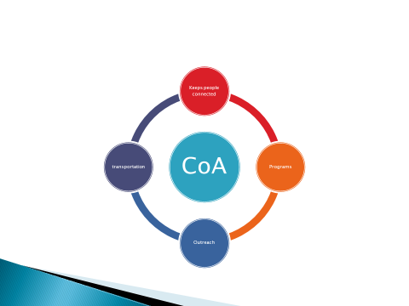

Ms. Leventhal stated that the COA keeps people connected through its programs, outreach and transportation. Ms. Leventhal added that the outreach department currently provide service for 775 clients through 1100 units of service per year. Net includes home visits office visits and phone consultations.

Ms. Leventhal informed all that the COA provides about 1,400 round trips to doctors’ appointments and errands and about 2,100 round trips to grocery stores. The COA has been using the results of its 2011 survey to program and target what people want from the senior center. Ms. Leventhal continued, saying that the message they received was to target a younger cohort of seniors, aged 60 to 75 years old. The preferences gathered from the survey were as follows:

1. Fitness, health and wellness
2. Social and recreation in the arts
3. Planned trips
4. Legal concerns
5. Transportation

Following are some pictures from activities throughout the year:

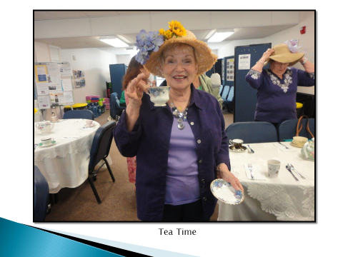

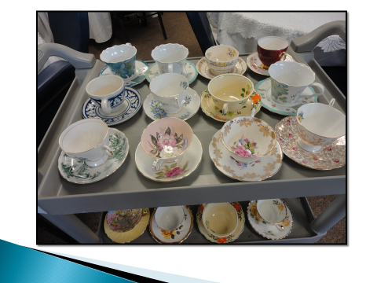



Ms. Leventhal stated that the ceramics class is very popular.

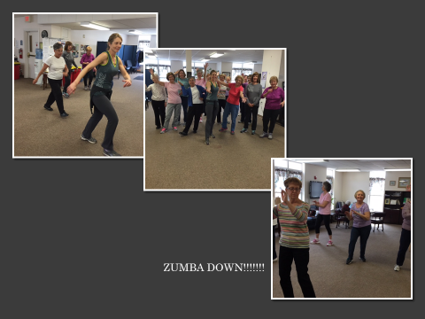

Ms. Leventhal stated that about 15 people attend the Zumba class.



Ms. Leventhal informed all that Britney Butler, daughter of one of seniors, who appeared on the TV show the voice played to a packed and enthusiastic house.

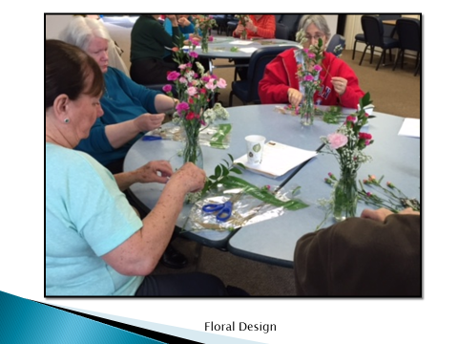

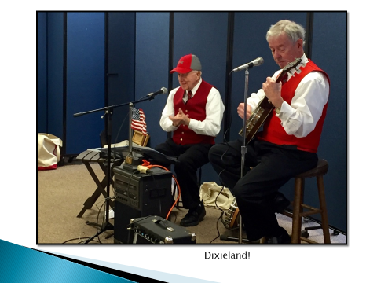

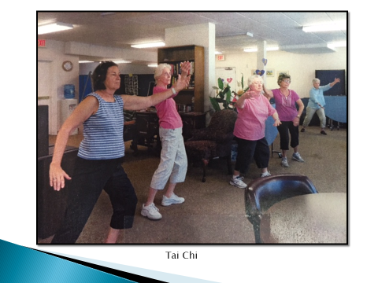

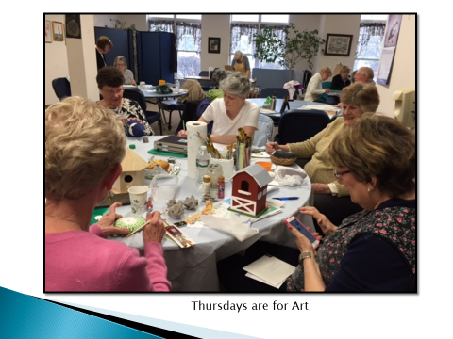

Ms. Leventhal stated that Thursday's they have three art classes.

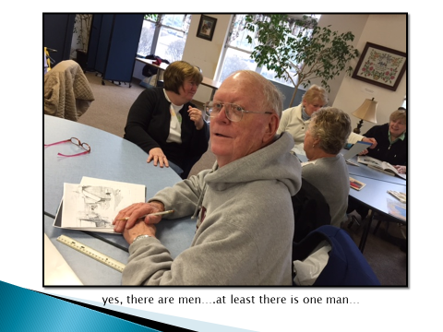

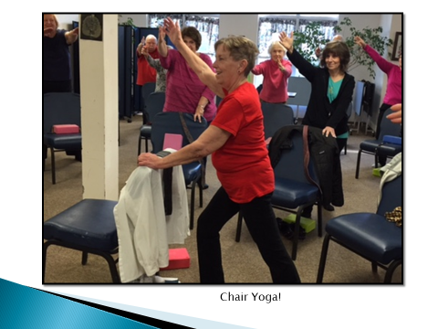

Ms. Leventhal informed all that the chair yoga classes very popular with about 35 people in each class.

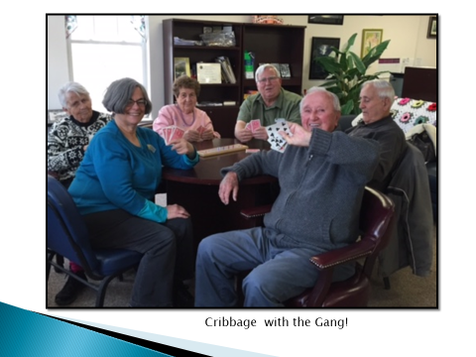

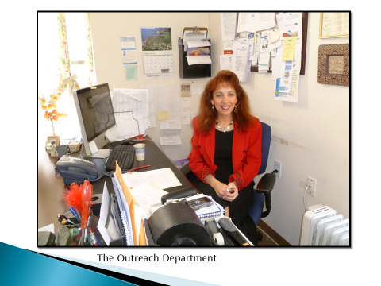

Tami Allen – Outreach Department at the COA.

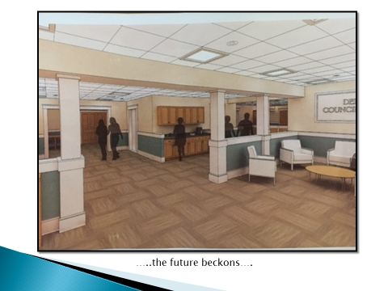

Ms. Leventhal stated that this is a drawing of their space in the new Senior Center.

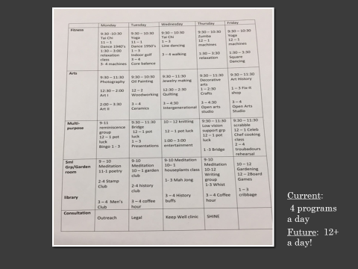

Ms. Leventhal stated that presently they have 2400 ft.² of space. In the new Senior Center they were 4 to 5 rooms to program. They will go from about 4 programs a day to 12+ programs.

Ms. Leventhal stated to be glad to answer any questions the Board may have.

Dr. Teehan stated that this is an exciting time for the senior center. Dr. Teehan stated that he knows how important Ms. Leventhal's job is, connecting seniors to each other, to the community into things that will keep them healthy and well. When this happens it really makes a tremendous difference to the quality of their life and to their overall health. Dr. Teehan continued, saying, thank you for what you do. This is an exciting time for the COA, the Town and the seniors.

Mr. Butler stated this is good timing as you have been in the community for several years and you understand what seniors need. Mr. Butler added that we should be cutting the ribbon on the new Senior Center, hopefully next May. Mr. Butler continued, saying that maybe we will expect a slightly larger budget request from the COA for the following fiscal year.

Ms. Leventhal stated that she'd like to thank the Board, Mr. Kern and Ms. Baker for voting to have the senior center. It's a great step for the Town of Dedham and she is very grateful.

Mr. MacDonald asked Ms. Leventhal, what challenges she sees that we, as a community, will be facing.

Ms. Leventhal stated that she believes there are two major challenges. First, is the structure of real Estate taxes. The COA has seen so many people that are just not able to pay their taxes in Dedham. The second major challenge is transportation.

Dr. Teehan asked Ms. Leventhal, what she thinks of the new bus service in Town.

Ms. Leventhal stated that she believes is still a work in progress. Ms. Leventhal added that Rich McCarthy has done heroic work on all the logistics. Ms. Leventhal continued, saying that it needs to be improved, a little more fine-tuned so someone from O'Neal drive doesn't have to go all around Town to get to the Square. This is a great move for the seniors in Town.

Mr. Keogh complemented Ms. Leventhal and her staff regarding their handling a few questions he had.

Ms. Leventhal stated how wonderful her staff is – Tami Allen, Maureen Renehan and interim bus driver, John Butler. Ms. Leventhal stated they are very devoted to the seniors in the Town.

Mr. Guilfoyle stated that seniors are big part of this Town, and he thanked Ms. Leventhal and her staff for all they do. Mr. Guilfoyle thanked Ms. Leventhal for continuing to look to the future.

Erin Perron, Endicott Estate Director, was present before the Board.

Ms. Perron stated that she would like to give an overview of the capital improvement projects that have happened that the Estate.

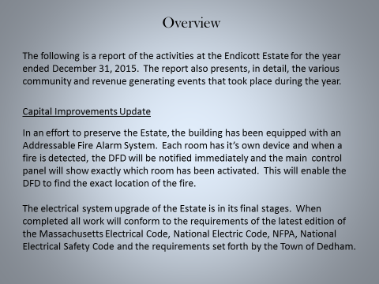

Ms. Perron discussed the addressable Fire Alarm system and the electrical system upgrade at the Estate. Ms. Perron added that the front porch of the Estate is rotted and improvements on it will begin this summer and should be completed by October.

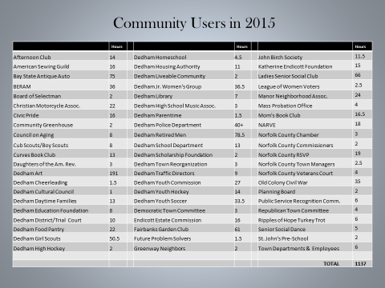

Ms. Perron stated that the goal at the Estate is to operate efficiently and effectively, while trying to get as many community users and there as possible and still accommodating paid events to cover the maintenance and running costs.

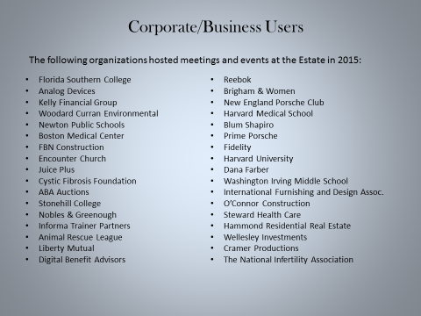

Ms. Perron stated that they've attracted many top-notch companies to hold their social event, holiday event or business meeting. Ms. Perron added that all of these users are repeat customers.

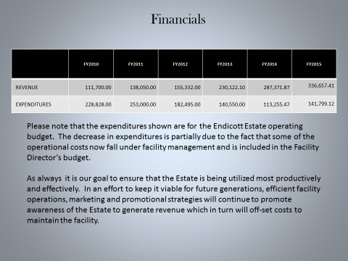

Ms. Perron stated that the expenditures shown here are just for her operating budget of the Estate and does not include the facilities part of it which is under Denise Maroney's facilities budget. Ms. Perron added that the estimated budget to operate the Estate on a day-to-day basis, yearly is $260,000.





Ms. Perron stated that the next slide showed some community events that took place at the Estate.

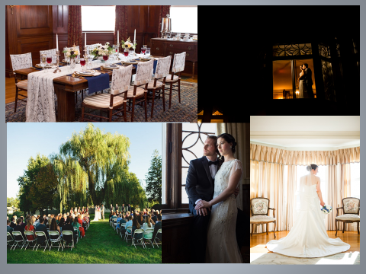

Ms. Perron stated the next slide shows a few more formal events that took place at the Estate.

Mr. MacDonald thanked Ms. Perron for the work she does and stated that the difference having a professional run the Estate is clear. Not only in the revenue numbers, but in the community and corporate use of the Estate. Mr. MacDonald added that Ms. Perron is really made a difference in the way the building is run and kept up. It looks beautiful.

Mr. Keogh stated that the Estate looked beautiful when the Board had its meeting there back in December. Mr. Keogh asked Ms. Perron how many staff members she had. Ms. Perron answered that she had two; a full-time caretaker and a full-time office worker. Mr. Keogh added that he thinks. Ms. Perron and her staff do an excellent job.

Mr. Butler asked Ms. Perron if she could talk about her priorities for the next year.

Ms. Perron answered that one priorities to get the electrical work finished. She added that another would be to get the porch repaired. Ms. Perron continued, saying that keeping up on capital improvements is very important. Ms. Perron stated that the goal should be to keep the Estate open for the community users while continuing to create revenue. Ms. Perron informed the Board that they planted 500 daffodils in the fall and they do have a number of trees that need to be replaced. Ms. Perron continued, saying that if the Town were to invest either in a rental tent or the purchase of one it would greatly increase revenue.

Dr. Teehan stated that Ms. Perron is obviously doing a great job as the revenues have gone up consistently every year. Dr. Teehan added that the Endicott Estate was booked up when he inquired about having his wedding there, which speaks to the demand. Dr. Teehan continued, saying that the Endicott Estate has become one of the most coveted destinations to have a wedding in the Boston area.

**DISCUSSION & VOTE RE: ACCEPTANCE OF GIFTS FOR DEDHAM HERITAGE RAIL TRAIL**

Mr. Guilfoyle stated the Board would give about 15 min. of discussion to this topic and laid out some guidelines for the speakers.

Mr. MacDonald stated that they should allow Virginia LeClair, Environmental Coordinator, to speak first to “set the table” for the discussion.

Ms. LeClair stated that she was before the Board this evening to accept gifts for a Rail Trail Feasibility Study. Ms. LeClair informed all that there were donations made toward this feasibility study. The feasibility study came about after there was a 2014 conceptual plan done by the Rails Trails Conservancy. Ms. LeClair continued, saying they've held public meetings over the past two years and have addressed concerns and questions. Ms. LeClair added that Town Planner, Richard McCarthy, feels that expertise is needed to address some more complex questions. Ms. LeClair stated that they are at the point where they need a feasibility study conducted so they can address the concerns of the school Committee, abutters and the needs of the trail as a whole.

Ms. LeClair informed all that a donation of $2000 was given by the Dedham Land Trust in support of the feasibility study. Ms. LeClair added that a donation of $2500 was given by the Friends of Dedham Heritage Rail Trail for direct abutter meetings. Ms. LeClair continued, saying that Dedham Savings Bank made a donation of $2500 as well. Ms. LeClair informed the Board that they're asking for the acceptance of $7000 in gifts.

Dr. Teehan asked Ms. LeClair if they would be able to meet with every single abutter during the Feasibility Study.

Ms. LeClair responded by saying that not all of the abutters will want to meet with the consultants. There are 118 properties that abut the Trail and all of them will have the opportunity to meet and have their questions and concerns answered if they so desire.

Dr. Teehan asked Ms. LeClair if the study would be comprehensive, looking at all options from beginning to end.

Ms. LeClair answered that this study will dive more into the costs of the bridges and of the tunnel. It will also address the concerns raised by the schools in terms of traffic and alignment of going through the schools. Ms. LeClair continued, saying it will address screening concerns for abutters. Ms. LeClair informed all that it is a comprehensive study that goes the whole entire length of the trail.

**Georganna Woods – 4 College Place**

Ms. Woods stated that she moved to Dedham in 2014 from a Town that had a rail trail and it was a great thing to have for the Town. Ms. Woods added that she started the “Friends of the Dedham Heritage Rail Trail” project when she heard about the potential of a rail trail in Dedham and she was surprised at how many people were excited by it. Ms. Woods continued, saying that if had not been such excitement about it, it probably would've fizzled out.

**Robert Falvey – 29 Mount Vernon Street**

Mr. Falvey stated that he lives right next to the proposed trail and he is an abutter. Mr. Falvey added that he is representing an organization formed recently called the “Dedham Taxpayers for Responsible Spending”. Mr. Falvey stated that they have a great deal of concerns over this project. His group attended the Parks and Recreation meeting this past Tuesday night where the subject of the feasibility study was on the agenda. Mr. Falvey continued, saying that Town Planner, Richard McCarthy, spoke about some of the specifics of what the feasibility study would cover. Mr. Falvey stated that they were not satisfied with the answers Mr. McCarthy provided. Mr. Falvey added that he raised some legitimate questions and felt they were not answered to his satisfaction. Mr. Falvey pointed out that he feels like the company that will be doing the feasibility study, Weston & Sampson, is more interested in just putting in the trail and not interested in the questions and concerns or the pros and cons. Mr. Falvey continued, saying that the abutters feel like they're being steamrolled by this project. Mr. Falvey added that they are fighting for their lives.

**Robert Wong – 11 Woodlawn Street**

Mr. Long stated that he's a fairly new resident to Dedham, relocating from Portland, Oregon and previously from Seattle. Mr. Wong added that he is a cyclist and in both of those communities there is quite a bit of cycling on rails to trails facilities. Mr. Wong added that what Portland has found is the potential for business to increase. Mr. Wong informed all that Oregon has invested a lot into bicycle tourism. Mr. Wong stated that he and his wife have visited a half dozen or so rails to trails in the New England area and they spend money at restaurants and commercial properties along the trails. Mr. Wong added that he sees this as an advantage to the business community. Mr. Wong stated that this would be a safe environment for seniors and families to be able to ride their bikes. Mr. Wong encouraged the Selectmen to accept the gifts and when it comes time, to vote for the feasibility study, which will address the concerns we've heard this evening, which are valid. Mr. Wong added that the study will also address the concerns of maintenance of the trail. Mr. Wong continued, saying that the feasibility study is really to find out if this project is even possible or doesn't make sense.

**Anthony Demusis – 61 Clark Street**

Mr. Demusis stated that he is a direct abutter. Mr. Demusis added that he wanted to confirm receipt of an environmental report that was done by the MBTA dated February 13, 2013 regarding contamination of the property. Mr. Demusis continued, saying that this document was e-mailed to the Board and he would like it on record.

**Alex Kraus – 28 Flanagan Place**

Mr. Kraus stated that he is a direct abutter and that he has over 200 feet of property line directly abutting the proposed project site. Mr. Kraus added that he urges the Board to accept the gift. At this point, the feasibility study does not guarantee that the project will go forward. Mr. Kraus continued, saying that as a direct abutter he shares many of the concerns of the opponents of the project, even though he is a pro proponent of the project. Mr. Kraus stated that he thinks the feasibility study is important so the community can do a proper cost-benefit analysis of the proposed project. Mr. Kraus added that he does have concerns regarding contamination, privacy and security. Mr. Kraus continued, saying that it would be irresponsible to not accept the gift that has already been fully funded and will not cost the taxpayers any money to allow the project to go forward.

**Clarissa Robyn – 278 Whiting Avenue**

Ms. Robyn stated that she is a direct abutter to the proposed trail. Ms. Robyn added that she is very excited for this project and they are a very active family. This trail would move Dedham forward and give opportunities to families who want to be active with their children. Ms. Robyn continued, saying that it will be amazing to go from one side of the Dedham to the other safely and run into people along the way. Ms. Robyn stated that this will bring the community together that much more. Ms. Robyn urged the Board to accept the gift to allow the feasibility study to go forward and discover whether it is can be done or not.

**Mark Whalen – 18 Elm view lace**

Mr. Whelan asked if, Town Planner, Mr. McCarthy could explain how the company was picked, what went into the selection process and how we as abutters/concerned citizens can understand that it will indeed be an objective third-party evaluation.

Mr. McCarthy stated that the process by which Ms. LeClair and he went through, was to solicit three quotes in writing: Alta Design, Weston Sampson and Beals and Thomas. Mr. McCarthy added that they were looking for someone with experience in this discipline. Mr. McCarthy informed all that they took each consultant out on the trail the walked it with them before they submitted bids. The feasibility study needs to include the concerns by direct abutters. Weston Sampson came back to us and said we should do one-on-one meetings with direct abutters. Mr. McCarthy made some points regarding what the feasibility study will look at. Mr. McCarthy continued, saying that they need experts to look at and explain things like how and if the bridge and tunnel can get done. What the landscape architect will have to do you not even areas.

Mr. McCarthy stated that Weston Sampson had people who are well-informed and know how to do this type of work. This, in part, led us to choose them. Mr. McCarthy added the goal of this study is to get these questions answered, not skirt them and also to make it comprehensive.

**Dan Hart – Parks & Recreation**

Mr. Hart stated he would like to inform the Board of how their meeting proceeded the other night. Mr. Hart informed all that about 24 hours before their meeting they received some information from Town Council regarding jurisdiction over the parcel. This added a level of complexity to the discussion that they did not anticipate. Mr. Hart continued, saying that after a lengthy discussion, the Park and Rec Board voted 4-1 to support the acceptance of the gift and moving forward with the feasibility study, based upon the Board of Selectmen's acceptance and the School Department's role in acceptance with the study itself. Mr. Hart added that he is a fair amount of questions, the main one being who is responsible for maintenance. Would it be Dedham Civic Pride, does another group need to be formed, does it fall on Parks and Rec or on facilities. Mr. Hart continued, saying he can’t form any type of an educated opinion without these questions being answered and he believes this feasibility study will answer those questions and let us know, does it fit, where does it is a fit, is it a priority, what's the timeframe on it, etc. The Parks and Rec Board came to the conclusion that they need to be involved in the discussions to get the questions answered, both pro and con.

Mr. Whalen had a follow-up question for Mr. McCarthy. Mr. Whalen asked if the same company that does this feasibility study be allowed to bid for the job.

Mr. Kern informed all that they would be eligible just as if we hired a firm to give us a due diligence study or any number of other studies, relative to repairing or removing a dam.

Mr. Guilfoyle asked Mr. Kern, if he wanted to speak briefly on the information received regarding the three Boards that are involved with this parcel.

Mr. Kern stated that it's been an important part of the last six weeks or so to try to make clear the care, custody and control of the particular segment of the property we are talking about. The property, which is González field and an adjoining parcel, was transferred from the MBTA to the Town in 1998. There've been subsequent votes in 2006 and 2008, relative to looking into the Avery School on that property.

Mr. Guilfoyle stated that it's the Board of Selectmen, Parks and Rec Commission and the School Committee, as of right now. Mr. Kern stated that it's really School and Board of Selectmen but as the Town Manager he thinks this is fundamentally a Parks and Rec asset.

Mr. Guilfoyle stated he would take one more speaker from the audience.

**Ryan Murphy – 14 Indian Path**

Mr. Murphy stated he is the vice chair the Master Plan and Implementation Committee. Mr. Murphy added that for the record, his Committee voted informally, due to lack of a quorum, to support the acceptance of the gift and the moving forward of the feasibility study.

Mr. Guilfoyle stated that the only way that he could vote for this is if the proposal could be extended with input from the Board of Selectmen to the Town Manager, Parks and Rec. input through their Director, Bob Stanley and the School Committee’s input through the Superintendent. Mr. Guilfoyle asked Mr. Kern if this is something he thought was possible. Mr. Kern answered, that he thinks it is.

Mr. Guilfoyle asked that the RFP deadline be extended a little longer so more information could be gathered. Mr. Guilfoyle added that it may cost a little more but he would rather get it right.

Ms. LeClair stated that prior to creating this bullet point list of guidelines for the feasibility study, they did have abutter meetings, they did have two years’ worth of public meetings and they also met with members of the School Committee, Kevin Coughlin, Susan Butler Walko and the superintendent, as well as Bob Stanley. Ms. LeClair added that they been in conversations with Bob Stanley for the past several years. They did influence what went into this feasibility study.

Dr. Teehan asked for clarification regarding the funding being partially made up of taxpayer money.

Mr. Kern stated that the Town will not ask for additional taxpayer money. Mr. Kern added that they are allocating professional service and technical service money that is in two budgets already that would be available to do other things.

Dr. Teehan stated that he wanted it to be on record that there will be no additional resources being asked from the taxpayers.

Mr. Valby stated that the Friends of the Trail have made it known that a year from now when they look for money for design of the trail that they would be looking for matching funds from Town Meeting in the neighborhood of $150,000. Mr. Valby added that down the road there's a possibility of taxpayer money being used for the design.

Mr. MacDonald stated that he would have liked to have seen more detail of what is expected from the company in the quote. Mr. MacDonald added that he is in favor of this feasibility study, but he thinks that more detail should have been in the response. Mr. MacDonald continued, saying that he feels there needs to be an amendment with more specifics about some of the issues that he's heard about this evening. Mr. MacDonald stated he believes there needs to be more clarity and detail. Mr. MacDonald added that he's going to be in favor of accepting the gift with the condition that an amendment be made to the quote with more specifics. Mr. MacDonald stated that ultimately it's up to Town Meeting whether this goes through or not.

Mr. Butler stated that the feasibility study was not going to be discussed this evening, until they found out on Monday that potentially the Board of selectmen are responsible for some of this property. Mr. Butler added that he would venture a guess that the majority of people in this room are at the point where they need the feasibility study because there are so many questions that need answering by a third-party that has expertise in the field. Mr. Butler stated that at first glance the RFP seemed thin

compared to the number of questions the Board was receiving via e-mail and phone. Mr. Butler informed all that they've created an FAQ list from previous projects they have worked on. Mr. Butler stated that he would like to see a list of the FAQs from proponents and opponents given to the company doing the RFP and have them answered. Mr. Butler continued, saying that he would also like to see examples of previous feasibility studies that the selected vendor has done.

Mr. Kern stated that the vote on the agenda is the one they are looking for, which is to accept the gifts. Mr. Kern added that we should accept the gift with the caveat that the RFP be extended and made more substantive.

Mr. MacDonald stated for the sake of discussion that the motion should be to accept the gifts contingent upon a supplement to the current RFP based on feedback from the School Committee, Parks and Rec and the Board of Selectmen.

Mr. Keogh stated that this a lot happening way too fast and we are seeing a lot of unanswered questions.

Dr. Teehan stated that we asked if the study was to be comprehensive. Dr. Teehan asked Ms. LeClair at the beginning of the study if it was going to be comprehensive, she said yes and I trust that it will be comprehensive. Dr. Teehan stated that if the other Board members feel this motion is the way to go, he would support it. Dr. Teehan continued, saying that it can't hurt to have more input and feedback, but he expects it to be a professionally done study.

Mr. Butler asked Mr. Kern if the Town Manager's office is ready to accept questions from residents.

Mr. Kern stated yes and we will incorporate them into a request for quotes.

Mr. Butler asked Mr. Kern when he would like those questions.

Mr. Kern responded Friday, April 22.

Mr. Butler asked the residents in attendance if that was enough time for them to compile the list.

Mr. Guilfoyle clarified that residents should get there questions into the Town Manager’s office. The Parks and Rec Board will get there questions into Bob Stanley and the School Committee will get their questions to the Superintendent.

Mr. MacDonald moved to accept the gifts for the Dedham Heritage Rail Trail contingent upon a supplement to the RFQ, based on input from the School Committee, Parks and Recreation and the Board of Selectmen that addresses concerns of abutters and others, also to include answers to FAQs that will be submitted; seconded by Mr. Butler. **On the Vote:** Mr. Keogh, yes; Dr. Teehan, yes; Mr. Butler, yes; Mr. Guilfoyle, yes; Mr. MacDonald, yes.

**DISCUSSION & VOTE RE: ACCEPTANCE OF DEED OF SEWER EASEMENT FOR LIANA ESTATES**

Ms. Baker stated that as has been done in the past, the Board is being presented with a deed of sewer easement for the development known as Liana Estates subdivision at 1056 East Street. Ms. Baker added that there is a deed of sewer easement and a subrogation of mortgage that have gone through the approval process with attorney Zahka representing the developer and attorney, Eichman representing the Town.

Dr. Teehan moved approval; seconded by Mr. MacDonald. **On the Vote:** Mr. Keogh, yes; Dr. Teehan, yes; Mr. Butler, yes; Mr. Guilfoyle, yes; Mr. MacDonald, yes.

**DISCUSSION & VOTE RE: APPOINTMENTS TO MASTER PLAN IMPLEMENTATION COMMITTEE**

Ms. Baker stated that as discussed at our last meeting, there was a re-structuring of the Master Plan Implementation Committee and there were changes made, so the Board of Selectmen and the Planning Board now each have two at-large positions to appoint to the MPIC. The openings were posted and six applications were received. Ms. Baker continued, saying that the Planning Board appointed Shaw McDermott and Michelle Persson Riley at its last regular meeting. Ms. Faye has withdrawn her name from consideration. Ms. Baker stated that before the Board this evening for consideration were Jessica Porter, Ryan McDermott and Mac Sterling. Ms. Porter and Mr. McDermott are the incumbent members of the MPIC.

Mr. Guilfoyle asked if any of the candidates would like to speak.

Mr. Sterling stated that he moved to Dedham from Norwood about 13 years ago. Mr. Sterling added that he was on the Handicap Commission in Norwood for about five years. Mr. Sterling stated that he got really involved with the dog park, and was on the dog Committee. He is currently Co-Chairman of the Handicap Commission and is on the Parks and Recreation Master Plan Committee. Mr. Sterling continued, saying that he was on the Bus Committee when that was still going. Mr. Sterling stated that he would like to be on the MPIC as a representative of the handicap commission.

Mr. McDermott stated that he's currently the Vice-Chair for the MPIC and when he originally joined the Committee it was his first kind of involvement in municipal planning. Mr. McDermott added that he's been in the Town for about 10 years now and over the last six years of being on the Committee has been a total awakening regarding planning. Mr. McDermott continued, saying it has been interesting to see how the choices we make today affect the Town 10 or 20 years down the road. Mr. McDermott has found the work fascinating and has enjoyed working with his colleagues on the Committee. Mr. McDermott added that he is energized and excited to continue the work they have begun.

Ms. Porter stated she has been on the MPIC for three or four years and believe she brings a unique perspective because she's also an alternate on the Zoning Board of Appeals. Ms. Porter added that she has become a planning nerd herself. She gets excited by planning issues, community engagement and all the things that they have to think about. Ms. Porter stated that the big reason she's plugging for reappointment is because they're right in the middle of an intricate project and she thinks it's useful to retain continuity on the Board to continue this.

Mr. MacDonald moved to put all three names in nomination; seconded by Dr. Teehan. **On the Vote:** Mr. Keogh, yes; Dr. Teehan, yes; Mr. Butler, yes; Mr. Guilfoyle, yes; Mr. MacDonald, yes.

Mr. MacDonald voted for McDermott and Porter.

Mr. Keogh voted for McDermott and Porter.

Mr. Butler voted for McDermott and Porter.

Dr. Teehan voted for McDermott and Porter.

Mr. Guilfoyle voted for McDermott and Porter.

Ryan McDermott and Jessica Porter were re-appointed to the MPIC.

Mr. Guilfoyle thanked Mr. Sterling for putting his name in and reminded him that there are talks of putting an alternate on the Board and he looks forward to seeing his application.

Mr. Butler stated that the MPIC should not wait until 2020 to revise the plan. Mr. Butler added that there has been as much done as we are going to get out of the Master Plan. Mr. Butler continued, saying that we should start sooner than later.

**TOWN MANAGER’S REPORT**

Mr. Kern stated that he attended the meeting of the MAPC Committee that prioritizes and ultimately votes on construction projects. Mr. Kern added that we are supporting the Rustcraft – Elm Street sidewalk project. Mr. Kern continued, saying that this project doesn't score particularly well sometimes when compared to intersections where there are greater safety concerns. Tom O'Rourke, head of the Neponset Valley Chamber of Commerce, sits on the MPAC Board and his sense was that the arguments that were made were received positively and the impression was that they would be considered significantly. Mr. Kern informed all that after the meeting it was indicated that our score had been adjusted upward by the Committee. Mr. Kern added that the vote is in early May and then we will know whether the project gets accepted or not.

**OLD/NEW BUSINESS**

Mr. Keogh stated that school vacation is coming up and he hopes that everyone enjoys their travels and that people are safe.

Dr. Teehan stated that he also serves on the MPIC and he looks forward to serving with Ms. Porter and Mr. McDermott. He added that they are working on the update to the plan. Dr. Teehan continued, saying that he attended the Fin Comm. meeting Tuesday night and was happy to see Mr. Kern's proposal for the free cash surplus approved 8-1. Dr. Teehan added that the Mother Brook annual meeting was last night and it was nice to see that great community organization go through everything they do.

Mr. Guilfoyle stated that he was at the Mother Brook meeting last night and that group, as always, is doing a wonderful job down in East Dedham. Mr. Guilfoyle added the American Legion did the first barbecue smoke off, with 10 people smoking the barbecue and about 180 people come to support the post. Mr. Guilfoyle continued, saying that for the last six years Legion baseball has been gone from Dedham, but it will be starting back up soon through the American Legion Post 18.

Dr. Teehan moved to adjourn the meeting; seconded by Mr. Butler. **On the Vote:** Mr. Keogh, yes; Dr. Teehan, yes; Mr. Butler, yes; Mr. Guilfoyle, yes; Mr. MacDonald, yes.

The next meeting is scheduled for Thursday, April 28, 2016 at 7p.m.

This is to certify that the above is a true and accurate record of the Minutes of the Board of Selectmen’s Meeting held on April 14, 2016, which minutes were approved on June 9, 2016.

_________________________________________

Dennis Guilfoyle – Chairman