A meeting of the Board of Selectmen was held on Thursday February 7, 2019 6pm, in the Francis O’Brien Meeting Room, 26 Bryant Street, Dedham, Massachusetts.

Present were:

James A. MacDonald – Chair

Brendan G. Keogh - Vice Chair

Dr. Dennis J. Teehan Jr.

Michael L. Butler

Dennis J. Guilfoyle

Mr. MacDonald called the Meeting to order at 6:02 pm

**Pledge of Allegiance**

Led by Mr. MacDonald

**Dedham Citizens Open Discussion**

None.

**Discussion w/ Representatives from Alcoholic Beverages Control Commission**

Jean M. Lorizio, Commission Chairman and Ted Mahoney, Chief Investigator, were present before the Board.

Mr. MacDonald pointed out that Sgt. Clements, Deputy Chief Buckley and Chief D’Entremont were present.

Ms. Lorizio stated that she was going to give a brief overview of the Agency’s Mission.

Ms. Lorizio informed all that the ABCC strives to provide uniform control over the Alcoholic Beverage Industry throughout the Commonwealth and that includes the sale, transportation, possession, purchasing and manufacturing of alcoholic beverages. Ms. Lorizio stated that they oversee 37,000 licenses consisting of retail licenses and 25,000 State licenses. Ms. Lorizio added that they work with the license holders, the applicants and the businesses to help answer questions and process applications. Ms. Lorizio continued, saying that they also work very closely with the Local Licensing Authorities each City and Town.

Chief Mahoney stated that he has been Chief Investigator for about 20 years. Chief Mahoney informed all that the first Liquor Enforcement Officer was appointed by the Massachusetts Bay Colony in 1698 and their duties included were to assess drunkenness and disorders in the public houses of the company. Chief Mahoney continued, saying that he realizes he is doing the same job in the same streets as they did way back then. Chief Mahoney stated that intoxication has been a huge problem for the Commonwealth. Chief Mahoney informed all that 85% of the arrests today are alcohol-related offenses and 95% of sexual assault cases on or near college campuses are alcohol related. Chief Mahoney added that governing bodies have been wrestling with the issue of alcohol licensing and regulations since 1628. Chief Mahoney continued, saying that when prohibition ended there was a special legislative committee that was put together and they found that a strong State and local governing body was needed. Chief Mahoney stated that one of the most important things is having a reasonable law and regulation to control alcohol distribution. Chief Mahoney informed all that too strong a law or an unreasonable law results in noncompliance. Chief Mahoney stated that one of the key things was to get everybody operating on an even playing level. Chief Mahoney laid out the three-pronged strategic plan:

**Compliance Checks**

* Baseline program
* Somewhat educational, to raise the standard
* More people checking IDs
* Before Compliance Checks, failure rate was at 15%-20%
* After Compliance Checks failure rate of 3%
* National failure rate about 15%

**Targeted Enforcement Program**

* Address information provided through data or phone call
* Use information to target resources
* Targeted data driven approach extremely successful

Chief Mahoney stated, for the bars that served intoxicated clients repeatedly, being charged once or twice dropped the rate of intoxicated patrons being served by 95%.

**Enhanced program**

* Look at seasonal times
* Spring - problems, graduations
* Get the alcohol out of the kids hands
* Work with the stores
* Intercept kids in the parking lot, take the alcohol
* Parent modification program
* Call the parents - they come pick up their child

Chief Mahoney stated that penalty for noncompliance is very important. Chief Mahoney added that the first time usually goes unpunished but shortly thereafter if another compliance failure happens it’s indicative of a problem. Chief Mahoney informed all that if a store has repeated compliance failures he will usually station agents outside the store. Chief Mahoney continued, saying that for these repeat offenders the penalty is much more serious.

Deputy Chief Buckley stated that Chief Mahoney and his staff do a great job. Deputy Chief Buckley added they work together with the ABCC on these cases, especially with investigator Teehan who is right over in Hyde Park.

Sgt. Clements informed all that the first compliance check he was involved in yielded eleven failures. Sgt. Clements added that even after free TIPS certification classes and working with the police there were 12 failures.

Chief Mahoney stated that IDs in general have gotten to the point where he could get one in two weeks, maybe one week and it would pass 80% of the scanners out there. Chief Mahoney added that it’s a whole different situation we are dealing with, not only with compliance checks but for dealing with bars and restaurants as well.

Chief Mahoney informed all that they are currently using a scanner produced by ID Science, they are used more in larger venues. Chief Mahoney added that they’re using a phone app from IntelliCheck that is very portable and can be carried on oneself into a bar to check IDs easily.

Chief Mahoney stated that Iowa has recently come out with a very good app which they provide to all the licensees and they check any ID for free.

Mr. Butler stated that this Board encourages license holders to card everyone.

Chief Mahoney added that it really comes down to common sense when checking an ID. Chief Mahoney added that if the person looks 17 they probably are 17.

Mr. Keogh asked Chief Mahoney if the Iowa app stores the fake ID information.

Chief Mahoney answered that the Iowa ABCC specifically stated that that they will not be storing information.

**Compliance Failure Violation Hearing – Packaging Center, Inc., d/b/a Stop & Shop Supermarkets #416, 160 Providence Highway; Ralph Bellegarde, Manager**

Ms. Baker swore in all who would be making statements during this hearing.

Mr. MacDonald asked Mr. Bellegarde if he would like to stipulate to the facts of the police report.

Mr. Bellegarde stated that the facts are accurate.

Sgt. Clements gave a brief overview of what happened.

Sgt. Clements informed all that ona little before 8pm on December 6, 2018, he was working with Ofc. Ford performing compliance checks. Sgt. Clements added that the underage operative entered Stop & Shop with the orders of trying to buy a six pack of Bud Light. Sgt. Clements continued, saying that after a few minutes they received a text that he was able to purchase the six pack of Bud Light. Sgt. Clements added that Ofc. Ford then entered Stop & Shop, spoke to the Store Manager, identified the store clerk and confirmed that the sale was made.

Mr. Bellegarde informed all that they use the Fenway Park rule of carding everyone. Mr. Bellegarde stated that the cashier failed to put the ID through the scanner and then she typed in the wrong date. Mr. Bellegarde added that the cashier was suspended and was terminated the next day. Mr. Bellegarde continued, saying that he takes this very seriously as the license is in his name.

Mr. Butler asked Mr. Bellegarde if his employees are shown examples of a vertical license when they go through training.

Mr. Bellegarde answered yes when they go through TIPS training.

Mr. Keogh asked Mr. Bellegarde if the employee was TIPS certified.

Mr. Bellegarde answered no, he usually waits until they have reached 90 days as most employees, unfortunately don’t last that long. Mr. Bellegarde informed all that he has since started offering, TIPS training once a month.

Sgt. Clements informed all that on his follow-up he spoke to Mr. Bellegarde and the Assistant Manager. Sgt. Clements added that they were very helpful and accommodating. Sgt. Clements informed all that he was able to get a timestamped printout from the register and it shows that the cashier did indeed enter the wrong information.

Mr. MacDonald asked Mr. Bellegarde if he feels he had a fair hearing.

Mr. Bellegarde answered yes.

Mr. MacDonald asked if there was a motion to close the hearing.

Mr. Guilfoyle moved to close the meeting; seconded by Mr. Butler. **On the Vote:** Mr. Keogh, yes, Dr. Teehan, yes, Mr. Butler, yes, Mr. Guilfoyle, yes, Mr. MacDonald

Mr. MacDonald informed Mr. Bellegarde that the Board will make a determination at a future meeting.

**Compliance Failure Violation Hearing – Shree Sadan, Inc. d/b/a Plaza Liquor Mart, 761 Providence Highway; Parimal Amin, Manager**

Ms. Baker swore in all who make statements this evening.

Edward J. Richardson, was appearing on behalf of Mr. Amin. Atty. Richardson stated that they stipulate to the findings of the police report.

Sgt. Clements stated that on December 6, 2018, an underage operative entered the Plaza Liquor store at approximately 2114 hours, they were advised to try and purchase a six-pack of Bud Light. Sgt. Clemens added that several minutes later they exited the liquor store with a six-pack of Bud Light. Sgt. Clements continued, saying that Ofc. Holland entered the liquor store and identified the clerk and indicated it was a violation of a compliance check. Sgt. Clements stated that several weeks later he followed up on the violation and spoke to the Manager and Co-Owner, Amixa Parimal Amin. Sgt. Clements continued, saying Ms. Parimal Amin expressed frustration over the incident and showed that they owned card scanner.

Atty. Richardson stated that employee in question was STOP certified and this was a straight negligence and a onetime thing. Atty. Richardson added that this is the first time something like this has happened, Mr. Amin has no interest in seeing anything hazarding that license. Atty. Richardson continued, saying that whatever the Board decides, Mr. Amin will carry it out.

Dr. Teehan asked Atty. Richardson if he could clarify what STOP certified is.

Atty. Richardson stated that no one can answer that question.

Deputy Chief Buckley informed all that Mr. Amin owns the expensive scanner that Chief Mahoney was talking about.

Dr. Teehan stated that he feels that all chapter 15 license holders and their employees should be TIPS certified as the little mistakes that have been made in the first two cases might’ve been avoided.

Atty. Richardson informed the Board that Mr. Amin has counseled that employee and he has no problem if the Board requires all Plaza Liquors employees to be TIPS certified.

Mr. Butler asked Mr. Amin how many years he has been the license holder.

Mr. Amin answered four and half years.

Mr. Butler asked Mr. Amin that this was his first violation.

Mr. Amin answered yes.

Mr. MacDonald stated that just as Chief Mahoney said, this is about common sense. Mr. MacDonald added that whether you have a scanner or not you have to check the IDs and know what you are looking for. If you don’t do this it doesn’t matter if you have a $5000 scanner or not.

Sgt. Clements informed all that Deputy Chief Buckley arranged free TIPS classes for every establishment in Dedham that serves alcohol. Sgt. Clemens added that an invitation was hand-delivered to every establishment. Sgt. Clements pointed out that no employees from Plaza Liquors attended the training.

Mr. MacDonald asked Mr. Richardson if he feels this was a fair hearing.

Mr. Richardson stated yes.

Mr. MacDonald asked for a motion close the public hearing.

Mr. Guilfoyle moved to close the public hearing; seconded by Dr. Teehan. **On the Vote:** Mr. Keogh, yes, Dr. Teehan, yes, Mr. Butler, yes, Mr. Guilfoyle, yes, Mr. MacDonald, yes.

Mr. MacDonald informed Atty. Richardson and Mr. Amin that they will come out of their findings at a future meeting.

**Compliance Failure Violation Hearing – National Amusements, Inc. d/b/a Showcase Cinema DeLux & Studio 3 Restaurant & Bar, 670 Legacy Place; Alicia Cataldo, Mgr.**

Ms. Baker swore in all who would be making statements this evening.

Paul Valerio, Assistant Vice President and head of US Operations for National Amusements, Alicia Cataldo, Managing Dir. of Showcase Cinemas and Julie Heinzelman Associate General Counsel for National Amusements, were present before the Board.

Ms. Heinzelman stated that they stipulate to the facts and the report.

Sgt. Clements stated that on December 6, 2018, at approximately 7:30 PM, two underage operatives working with the Dedham Police Department under the supervision of Ofc. Holland and Detective Quigley, entered the Showcase Cinema establishment seeking to purchase alcohol. Sgt. Clements added that a short time later Ofc. Holland received a text message from an operative, stating that they each had been served beer at the upstairs Cinema deluxe. Sgt. Clements continued, saying that Ofc. Holland entered the establishment and the operatives pointed out the bartender responsible for serving them alcohol. Sgt. Clements stated that on December 17, 2018 he followed up with Ms. Cataldo and Manager John Sporjic Sgt. Clemens added that Mr. Sporjic had just held an in-house alcohol training period the day before the most recent incident. Sgt. Clements stated that Mr. Sporjic informed him that the in-house video showed that the employee did check the ID.

Ms. Heinzelman stated that first off, they’re very frustrated and embarrassed to be back in before the Board again. Ms. Heinzelman added that they take their responsibilities as a license holder very seriously. Ms. Heinzelman continued, saying that the situation has brought to light the need to add additional layers in our policies and procedures to prevent this from happening again. Ms. Heinzelman informed all that they have taken to the Fenway approach of carding everyone. Ms. Heinzelman stated that they just rolled out a revised and updated their Alcohol Policies and Procedures to all our locations, including Legacy Place. Ms. Heinzelman informed the Board that they are in the middle of finalizing an agreement to get state-of-the-art ID scanning technology and the goal is to have a scanner at the Lux level bar, one at the lobby bar and one at usher’s stand. Ms. Heinzelman stated that they are maintaining the TIPS Training Seminars, which we host in-house. We just had one in January and roughly 15 employees attended.

Mr. Butler asked if this was the third occasion in the last three years that they have failed compliance check.

Ms. Baker answered yes

Mr. Butler asked Ms. Heinzelman if the in-house training discusses vertical licenses.

Ms. Cataldo answered yes.

Mr. Butler asked Mr. Valerio if the Vice President he reports to is aware of the situation.

Mr. Valerio answered yes, all the Executives in the Company are aware of the situation.

Mr. Butler asked Mr. Valerio if the Risk Management Department is aware of all three instances.

Mr. Valerio answered yes.

Mr. Butler asked Mr. Valerio what the Risk Management team had to say.

Mr. Valerio stated that this Risk Management Department realizes that this puts our license in jeopardy, we all do.

Mr. Keogh asked Mr. Valerio how long National Amusements has had the license.

Mr. Valerio answered that they have owned the license since they opened in August 2009.

Mr. Keogh stated that he agrees with Selectman Butler as this issue lies with Management.

Dr. Teehan asked Mr. Valerio if there having similar issues at other Showcase Cinema locations and asked if there was something about a theater that makes it intrinsically difficult to serve alcohol in compliance with rules and regulations.

Mr. Valerio answered that he doesn’t think so. Mr. Valerio informed all that they have 28 locations and the majority of them serve alcohol. Mr. Valerio stated that there has been only one incident outside of the legacy place location.

Dr. Teehan asked Mr. Valerio what makes Dedham different than any other locations.

Mr. Valerio answered that he thinks part of it is the people that we have chosen to do this job and how they are supervised. Mr. Valerio stated that Ms. Cataldo is doing a good job at turning over the staff making sure that they better prepared for situations like this.

Dr. Teehan stated that if we have three incidents like this, the problem is systemic and needs to be fixed by Management. Dr. Teehan added that he wants to see Showcase Cinemas keep their license and do well as it benefits the Town as well.

Mr. MacDonald stated that he is glad that National Amusements is putting all this work into training to avoid another situation like this. Mr. MacDonald added that he thinks these changes and effort should have taken place after the first incident. Mr. MacDonald continued, saying that these compliance checks are meant to be educational and to point out flaws in your policies. Mr. MacDonald stated that this Board wants you to succeed and not serve alcohol to kids. Mr. MacDonald added that he does not care that had nine years with no violations, the last two years have more than made up for that. Mr. MacDonald continued, saying that if this Board sees you again it will be a different ballgame.

Sgt. Clements stated that one of the operatives made it up to the Lux level without being carded. Sgt. Clemens asked Mr. Valerio if he could speak to that.

Mr. Valerio stated that regardless of whether the person was ID’d at the bottom or not, the bartender at the top, when receiving an alcohol order, would ID the patron. Mr. Valerio added that the downstairs is to control who goes upstairs.

Mr. MacDonald asked Ms. Heinzelman if she feels this was a fair hearing.

Ms. Heinzelman answered yes.

Mr. MacDonald asked if there is a motion to close the hearing.

Mr. Guilfoyle moved to close the hearing; seconded by Dr. Teehan. **On the Vote:** Mr. Keogh, yes, Dr. Teehan, yes, Mr. Butler, yes, Mr. Guilfoyle, yes, Mr. MacDonald, yes.

Mr. MacDonald stated at the next meeting of the meeting after that the Board will make a determination.

**Compliance Failure Violation Hearing – GC Friday’s Boston, LLC d/b/a**

**Friday’s, 750 Providence Highway; Thomas Wright, Manager**

Ms. Baker swore in those who would be giving testimony during the hearing.

Ms. Caroline O’Connell, Counsel for the licensee and Tom Wright Operations Manager

were present before the Board.

Mr. MacDonald asked Atty. O’Connell if she would like the police report read in its

entirety.

Ms. O’Connell stated that they stipulate to the findings.

Sgt. Clements stated that on December 6 2018, at approximately 9 PM two underage

operatives, working under the direction of Ofc. Holland and Detective Quigley, entered

TGI Friday’s. Sgt. Clements added that the two operatives were asked to try and

purchase a beer at the bar. Sgt. Clements continued, saying that several minutes later

Ofc. Holland received a text stating that each of them had been served a beer at the

bar. Officer Holland entered TGI Friday’s and saw the bar tender responsible for

serving the underage operatives. Sgt. Clements stated that on Monday December 17,

2018, at approximately 12:30 PM he made a follow-up visit and spoke to Thomas

Wright the Operations Manager. Sgt. Clemens continued, saying that Mr. Wright was

not happy with the latest incident and informed Sgt. Clements that the Bartender and

Manager have subsequently been fired. Sgt. Clements informed all that Mr. Wright has

updated all his employees records. Sgt. Clements added that Mr. Wright attended TIPS

training that is offered by the police department. Ms. O’Connell stated that TGI

Friday’s takes compliance checks and service to minors very seriously. Ms. O’Connell

added that we do have a zero-tolerance service to minors and follow that very closely.

Ms. O’Connell informed the Board that they are going to have the entire front of house

go to a TIPS certification class. Ms. O’Connell continued, saying that there is a sign at

the bar the list the date of people turning 21 that day.

Dr. Teehan asked Mr. Wright if the Bartender and the Manager that were fired were

TIPS certified.

Mr. Wright answered that the Manager was TIPS certified but the bartender was Surf

Certified (TGI Friday’s internal alcohol training course).

Ms. O’Connell stated that this particular group from TGI Friday’s takes this issue very

seriously and we are going to do all we can do to become and stay in a good neighbor

in Dedham.

Mr. MacDonald asked Ms. O’Connell she feels that she’s had a fair hearing.

Ms. O’Connell answered yes.

Mr. MacDonald asked for a motion to close the hearing.

Mr. Guilfoyle moved to close the hearing; seconded by Dr. Teehan. **On the Vote:** Mr.

Keogh, yes, Dr. Teehan, yes, Mr. Butler, yes, Mr. Guilfoyle, yes, Mr. MacDonald, yes.

**Discussion w/ Economic Development Director John Sisson Re: Dedham Square**

**Parking**

Economic Development Director, John Sisson, was present before the Board. Mr.

Sisson stated that they been working on parking since the day he was hired. Mr. Sisson

added that many restaurants have come on line the past few years. Mr. Sisson

continued, saying that they knew they had to keep track of loading zones and the

parking in Dedham Square. Mr. Sisson then went over a PowerPoint presentation.

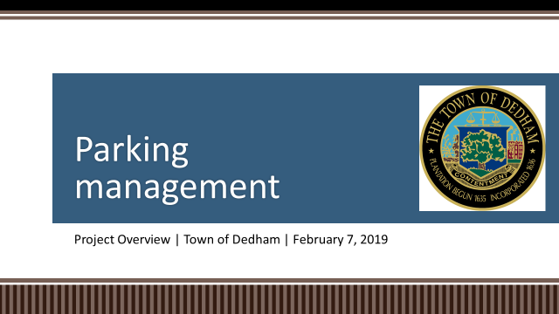

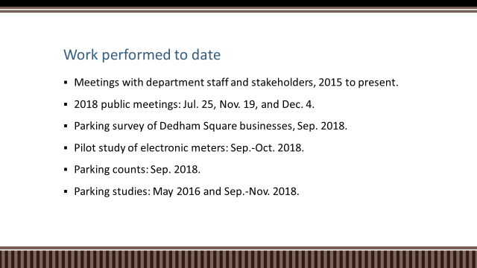

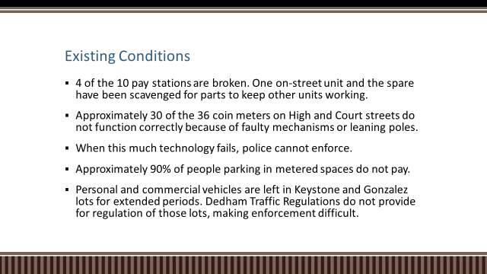

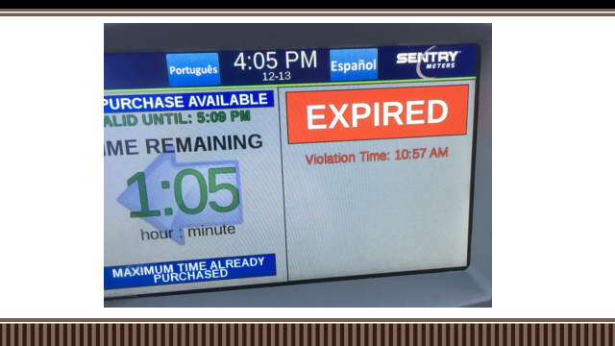

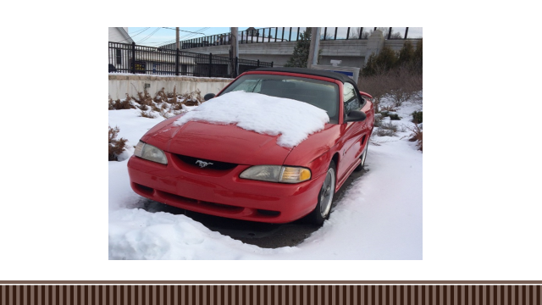

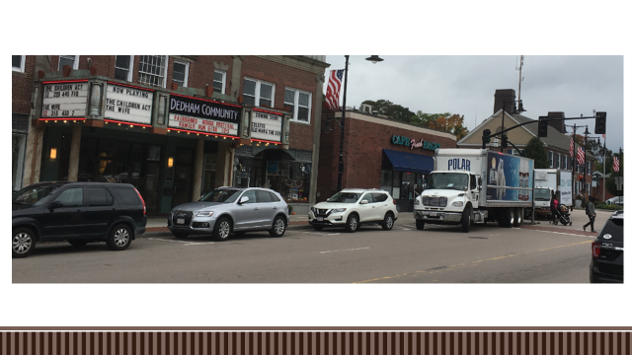

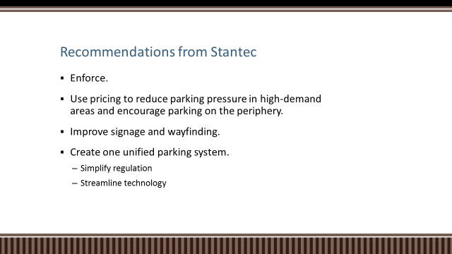

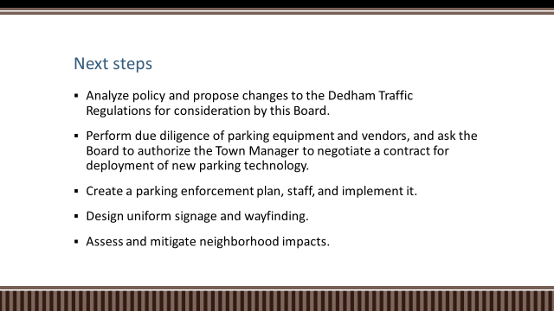

Amy Haelsen, Executive Director and Square Circle, stated that in her 12 years as Executive Director is probably spent 25% of her time talking about parking. Ms. Haelsen added that she has always believe that we do not have a parking inventory problem, we have a parking management problem.

Dr. Teehan asked Mr. Sisson why we don’t just eliminate parking fees in Dedham Square. Dr. Teehan added that clearly we need some sort of enforcement.

Mr. Sisson informed the Board that enforcing parking rules takes money and some of that money can go towards beautification, shuttle buses and things like that. Mr. Sisson continued, saying that this gives you options to better manage and maybe hopefully design and grow the inventory. Mr. Sisson added that there are two ways to manage the behavior, one is pricing and the other is time limits. Dedham businesses rely on employees and if you make it difficult for those employees to park around Dedham Square, the businesses suffer.

Mr. Butler stated that when you start advising the Traffic Regulations and the parking regulations, bring the top three regulations to the Board and we can change them.

Mr. Sisson stated that parking is a very intricate and interesting puzzle.

**Common Victualler License - Five Guys, 70 Providence Highway, Dedham**

Paul Doherty, vice president of operations for five guys was present before the Board.

Mr. Doherty stated that he’s asking for permission to transfer the d/b/a to a different company.

Dr. Teehan moved approval; seconded by Mr. Guilfoyle. **On the Vote:** Mr. Keogh, yes, Dr. Teehan, yes, Mr. Butler, yes, Mr. Guilfoyle, yes, Mr. MacDonald, yes.

**Common Victualler License – Eggs & Thai Café, 2 Kings Court, Dedham**

Mr. Guilfoyle moved approval the change in ownership for Eggs and Thai Café; seconded by Mr. Butler. **On the Vote:** Mr. Keogh, yes, Dr. Teehan, yes, Mr. Butler, yes, Mr. Guilfoyle, yes, Mr. MacDonald, yes.

**Vice Chairman’s Report**

**Double Poles Status**

* Eversource responded back to the Town
* Ms. Baker reached out to Jack Lopes, Community Relations, Eversource
* Number of double poles are out there
* Number that have been removed
* Double poles have been removed - as of January 10, 2019
* Comcast 6 transfers
* RCN - 8 transfers
* Eversource - 19 transfers
* Dedham Fire – 47 transfers
* Dedham Street Light – 40 transfers

Mr. Keogh explained that before you can take a poll down, there are 3 cables, telecommunications, Comcast and electrical. Sometimes there are Town wires there also. Each entity has to come out and remove their wires off the old pole and put them on the new pole. Sometimes there are scheduling issues so it takes some time to get this done.

Mr. Butler stated that there were 28 poles removed in the past six months. Mr. Butler reminded all that they would like to get a report like this every six months.

**Discussion Re: 2020 Charter Study Committee**

Ms. Baker informed all that in 2014 the last time a Charter Advisory Study Committee was in place, the change to the Charter was that the Town would review its Bylaws in years ending in five and review our Charter in years ending in. Ms. Baker added that Mr. MacDonald asked her to check with Counsel as to when the 2020 process could begin. Ms. Baker continued, saying that Town Counsel advised that there is no restriction on when it can begin so long as the obligation of putting out a report, with recommendations, 10 months out from the committee’s work is observed. Mr. MacDonald has asked that we consider thinking ahead and getting a Study Committee appointed and have them begin their work of a cover to cover review of the Charter.

Mr. MacDonald stated that the soliciting for a Charter Study Committee will probably take place sometime in April or May. Mr. MacDonald continued, saying that they should get the process started now regarding with the intent of forming a Charter Study Group. Some discussion about the timeframe of when the report will be ready to go before Town Meeting. Mr. MacDonald informed all that the process of posting will start soon and in April or May is when the Board of Selectmen will point members to the Charter Committee.

**Discussion Re: Town Manager Search**

Mr. MacDonald stated that most of the Board members have been through a Town Manager search, so they know that it takes quite a long time. Mr. MacDonald added that the process they used for the last Town Manager search worked really well. Mr. MacDonald explained how the group is composed..

Mr. McDonald informed all that the Committee will be made up of the following people:

The five Selectmen would select one individual, planning Board chair or designee, school committee chair, or their designee, finance committee chair, or their designee and the Town moderator.

Mr. MacDonald informed all that they would need to hire a Consultant, because in this type of work a Professional with expertise in this area will definitely help. Mr. MacDonald continued explaining the process of hiring new Town Manager.

**Town Manager’s Report**

1. The last two weeks have been filled with Budget Meetings with Department Heads. They are nearly completed.
2. Capital Expenditures Committee meets next week to consider the Capital Requests.
3. The Public Safety Building is on the docket for the Planning Board Meeting next Tuesday.
4. We begin interviews for HR Director next week.
5. Transfer Station – Joe Flanagan, DPW Dir., John Eichmann, Town Counsel and myself have been talking primarily to a T-Mobile Representative to try and finalize an agreement to put a temporary tower up so we can move the telecommunications off of the old tower and onto the temporary one.

**Action by the Board**

**Drainlayer Renewal Applications**

Susi & DiMascio Co., Inc

222 Providence Street

Hyde Park, MA 02136

Sean Farrell Excavation, Inc.

53 Gilbert Street

Quincy, MA 02169

Earthwork Industried, Inc.

6 High Street, Unit 4

Plainville, MA 02762

P.J. Hayes Construction

435 West Street

Walpole, MA 02081

Jack Malone Company, Inc.

20 Chestnut Street, #4

Needham, MA 02492

The Welch Corp.

1. Electric Ave.

Brighton, MA 02135

A Ferrara Construction Corp.

754 Foundry

South Easton, MA 02375

RJV Construction Corp

5 Lincoln Street

Canton, MA 02021

J.E.A Ferrara

176 Bryant Street

Berkley, MA 02779

Mr. Guilfoyle moved approval; seconded by Dr. Teehan. **On the Vote:** Mr. Keogh, yes, Dr. Teehan, yes, Mr. Butler, yes, Mr. Guilfoyle, yes, Mr. MacDonald, yes.

**Gift Acceptance**

From: Olde Colony Civil War Round Table

To: Endicott Estate

Amount: $500

For: The preservation, beautification and upkeep of the estate

From: The Afternoon Club

To: Endicott Estate

Amount: $1000

For: The preservation, beautification and upkeep of the estate

Dr. Teehan moved approval; seconded by Mr. Keogh. **On the Vote:** Mr. Keogh, yes, Dr. Teehan, yes, Mr. Butler, yes, Mr. Guilfoyle, yes, Mr. MacDonald, yes.

From: Dedham Trails Day Attendees

To: Environmental Department

Amount: $355

For: Maintenance of Town Trails

Mr. Keogh moved approval; seconded by Dr. Teehan. **On the Vote:** Mr. Keogh, yes, Dr. Teehan, yes, Mr. Butler, yes, Mr. Guilfoyle, yes, Mr. MacDonald, yes.

From: Michele & John Heffernan

To: Endicott Estate

Amount: $150

For: The preservation, beautification and upkeep of the estate

Mr. Guilfoyle moved approval; seconded by Dr. Teehan. **On the Vote:** Mr. Keogh, yes, Dr. Teehan, yes, Mr. Butler, yes, Mr. Guilfoyle, yes, Mr. MacDonald, yes.

**Minutes**

11/20/18 & 10/11/18

**Old/New Business**

Mr. Butler stated that Jason Mammone, Town Engineer, and his team have done a great job with the sewer lines last 10 or 12 years. Mr. Butler added that the best way to prevent infiltration is not only an issue for Town owned buildings but for private property from the home to the street. Mr. Butler continued, saying that Jason and his team would like to hold a public meeting in April. Mr. Butler stated that we chose April 1, at the middle school.

Mr. MacDonald asked everyone to stand in a moment of silence for Dennis Sulinski, a Police Dispatcher and Deputy Officer who passed away this past week.

Mr. MacDonald asked for a motion to adjourn the meeting.

Mr. Guilfoyle moved to adjourn the meeting; seconded by Dr. Teehan. **On the Vote:** Mr. Keogh, yes, Dr. Teehan, yes, Mr. Butler, yes, Mr. Guilfoyle, yes, Mr. MacDonald, yes.

The meeting was adjourned at 9:17pm.

The next Meeting is scheduled for Wednesday February 13, 2019. This is to certify that the above is a true and accurate record of the minutes of the Selectmen’s Meeting held on February 7, 2019, which minutes were approved on May 8, 2019.

___________________________

James A. MacDonald. – Chairman