A regular meeting of the Board of Selectmen was held on Thursday June 9, 2016, at 7p.m in the Francis O’Brien Meeting Room, 26 Bryant Street, Dedham, Massachusetts. Present were:

Dennis J. Guilfoyle

James A. MacDonald

Michael L. Butler

Brendan G. Keogh

Mr. Guilfoyle called the meeting to order at 7 p.m.

Mr. Guilfoyle reminded all that the meeting was being shown live on Dedham TV, streamed over the internet and recorded for future broadcasts.

Mr. Guilfoyle informed all that. Dr. Teehan will not be at the meeting this evening as he is the father of a brand-new baby girl, Rosemary Charlotte.

**PLEDGE OF ALLEGIANCE**

Led by Mr. Guilfoyle.

**DEDHAM CITIZENS - OPEN DISCUSSION**

None.

**PUBLIC HEARING RE: REQUEST FROM CELLCO PARTNERSHIP D/B/A VERIZON WIRELESS FOR A GRANT OF LOCATION ON ALLIED DRIVE**

Mr. Keogh recused himself as he is an employee of Verizon.

Chris Swiniarski, an attorney for McClane Middleton, representing Verizon, was present before the Board. Mr. Swiniarski stated that they are seeking a grant of location for Nintendo to be mounted on a utility pole at the end of Allied Drive. Mr. Swiniarski informed all that that these antennas are part of a new network that they are rolling out all over Massachusetts. It is much better than anything you have seen before in terms of wireless facilities. Mr. Swiniarski added that it consists of a single antenna, 38” tall and 12” in diameter, designed to look like a transformer and it goes on an existing utility pole. Mr. Swiniarski continued, saying that the idea behind this is to create facilities that can meet the growth in demand on Verizon's network, while hiding in plain sight. Mr. Swiniarski stated that these devices are really innocuous and are a great way for me to meet the demand of the residents of Dedham without creating a big facility that has a visual impact

Mr. Butler asked Mr. Swiniarski this was an existing pole.

Mr. Swiniarski answered yes.

Mr. Butler asked Mr. Swiniarski if there were any other utilities on the pole.

Mr. Swiniarski answered that there is nothing else on this pole. Mr. Swiniarski used a map to point out the pole in question to the Board.

Mr. Butler asked Mr. Swiniarski if a competing wireless carrier wanted to install similar equipment, could they go on the same pole.

Mr. Swiniarski answered that it is possible but it would be a side mount and he thinks they would want to go on another pole.

Mr. Butler stated that at the Board's last meeting they had someone expressing concern about double poles and added that Verizon is responsible.

Mr. Swiniarski stated that they are completely unrelated and informed the Board that Verizon Communications is a publicly traded company that owns both of those companies. Mr. Swiniarski continued, saying that there was a time in the 1980s when GM owned a controlling interest in both McDonald's and Burger King but that doesn't mean that McDonald's and Burger King worked together. Mr. Swiniarski added that they do not get any slack from them. They are a completely different company, in fact they are a bit harder to deal with, usually, than EverSource. Mr. Swiniarski stated that they have absolutely no say in that whatever.

Mr. Butler asked Mr. Swiniarski if they were a publicly traded company. Mr. Swiniarski answered no.

Mr. Butler asked Mr. Swiniarski if Verizon wireless was privately held. Mr. Swiniarski answered yes but majority ownership by Verizon Communications, the parent company.

Mr. Swiniarski informed the Board that there is no stock in Verizon Wireless, in fact, there's no corporation called Verizon Wireless. Mr. Swiniarski added that Verizon Wireless is a trade name.

Mr. Butler clarified that Verizon Wireless is a trade name underneath a parent corporation called Verizon medications. Mr. Butler added that Verizon Communications does Verizon Wireless and Verizon FIOS. Mr. Butler continued, saying that Dedham has 900 double poles and we get no service whatsoever, no plans and no response.

Mr. Swiniarski stated that he thought all the poles in Dedham were owned by EverSource. The pole in question is an EverSource pole. Mr. Butler stated that his understanding is that many of the poles in Dedham are jointly owned. Mr. Butler added that his concern is that they do not get any response regarding this issue. Mr. Butler continued, saying that there are two new buildings going up in Dedham square and they have requested FIOS and cannot get a response either.

Mr. Butler stated that he knows Mr. Swiniarski came in here tonight thinking this is just a pole on Allied Drive, but whenever he gets a chance to talk to Verizon face-to-face, he's taking advantage of it.

Mr. Swiniarski stated that he is not the same company. Mr. Swiniarski added that he has no way to compel Verizon Telecommunications to do anything. We're not in any way related we are just owned by the same parent.

Mr. Swiniarski informed the Board that the double pole issue is difficult and it can get complicated when there are several different providers on a pole. Everything has to come down and go back up in a specific order and coordinating that underlies scale was several parties is difficult.

Mr. Butler stated that he worked for two global corporations knows exactly what Mr. Swiniarski is talking about. If you raise a stink, eventually it gets to the point where the two unrelated separate entities within a global Corporation find a way to talk.

Mr. Swiniarski stated that it never happens and he has no way to make it happen.

Mr. MacDonald stated that he would like to have. Mr. Swiniarski’s client come in and talk to the Board.

Mr. MacDonald moved to take the request under advisement; seconded by Mr. Butler. **On the Vote:** Mr. Keogh, yes; Mr. Butler, yes; Mr. Guilfoyle, yes; Mr. MacDonald, yes.

Mr. MacDonald informed. Mr. Swiniarski that the Board will reach out to him in about a week or so with questions and that the next Board meeting is on July 28, 2016.

**DISCUSSION WITH THE DEDHAM COALITION FOR DRUG & ALCOHOL AWARENESS**

Mr. Butler introduced Dedham’s Public Health Nurse, Jessica Gardner.

Ms. Gardner stated that she also serves on the Dedham Coalition for Drug and Alcohol Awareness. Ms. Gardner presented the following PowerPoint slideshow.



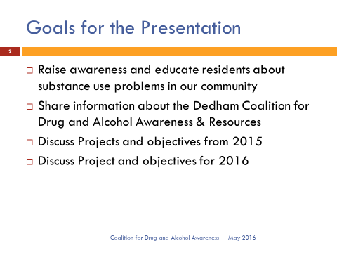

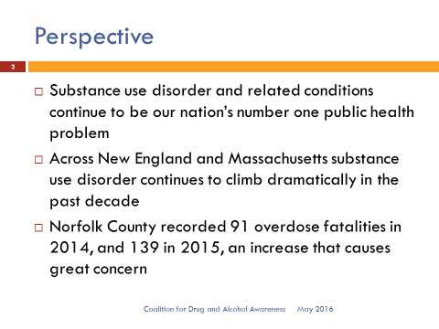

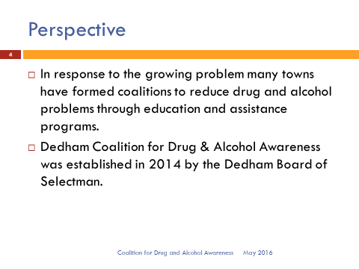

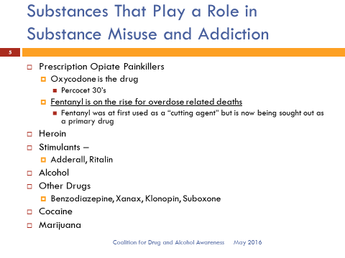

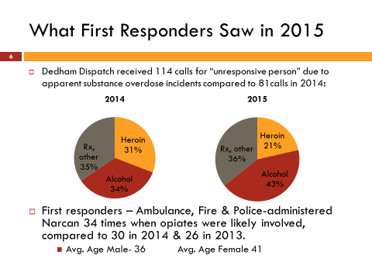

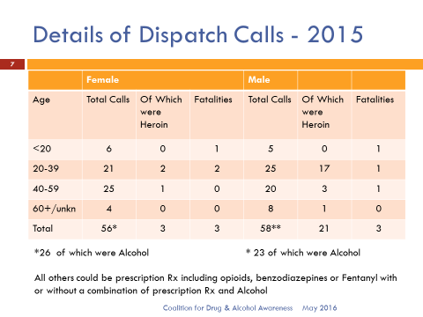

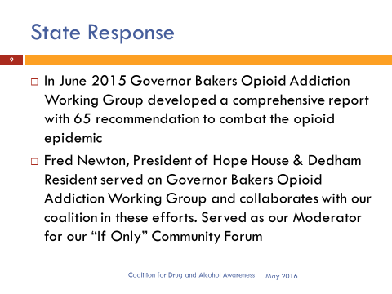 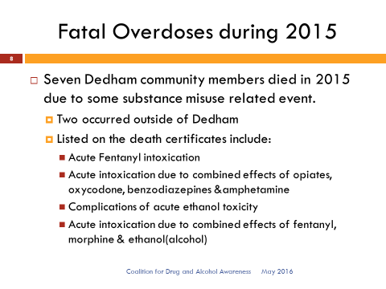



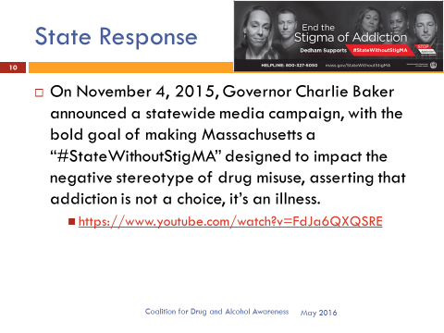

Ms. Gardner then showed a You Tube clip of a speech by Governor Baker on getting rid of the stigmas of addiction. The Dedham Coalition is adopting some of the primary messages about stigma as a community wide campaign and message.

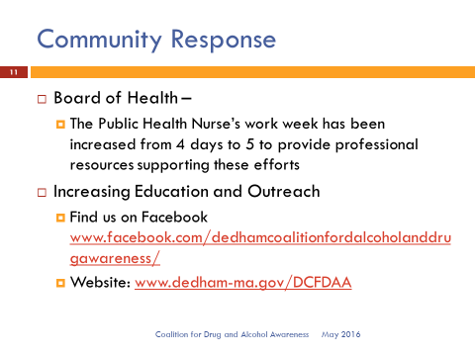

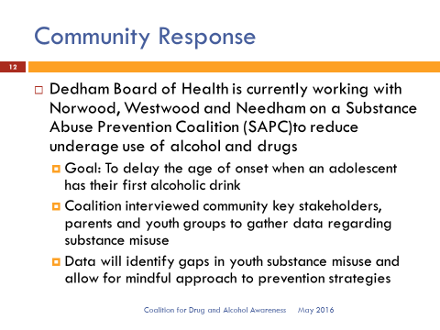

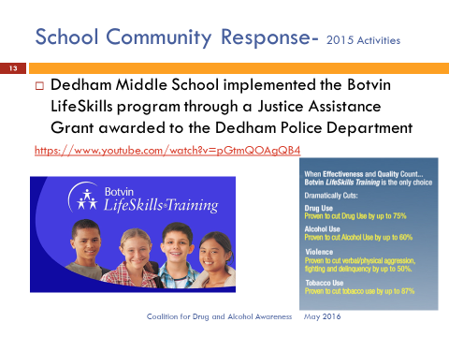

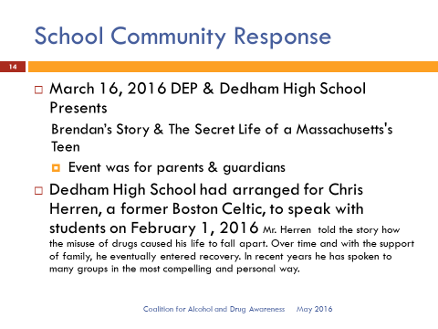

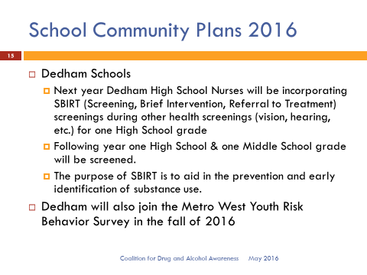

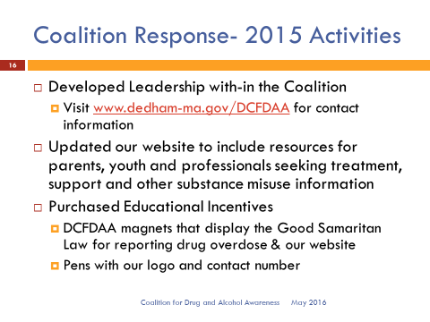

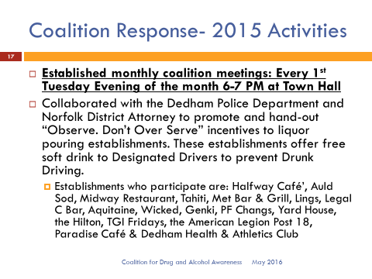 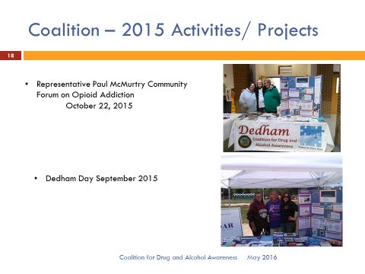

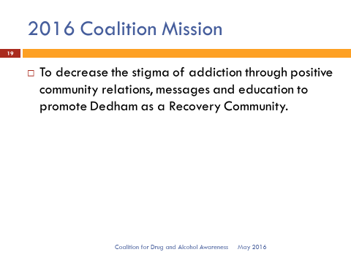 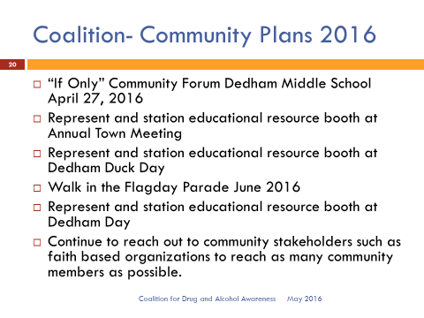

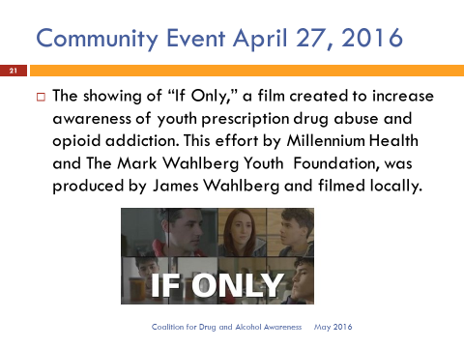 

 

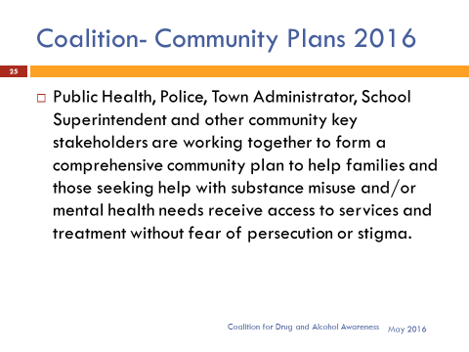 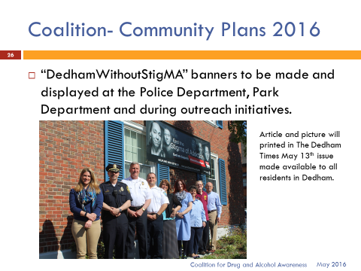

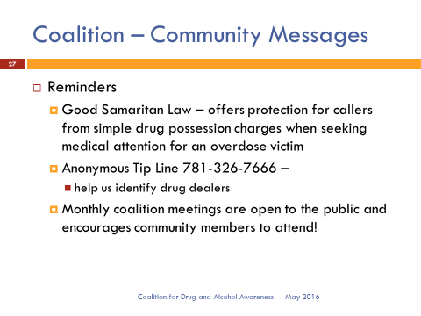 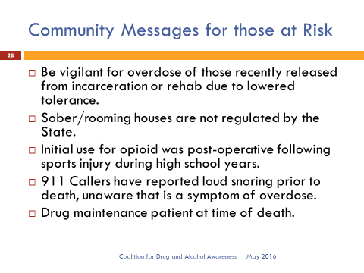



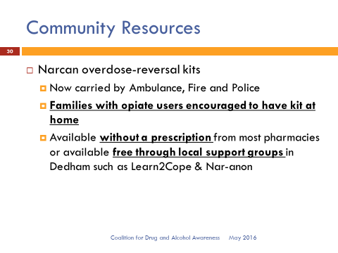

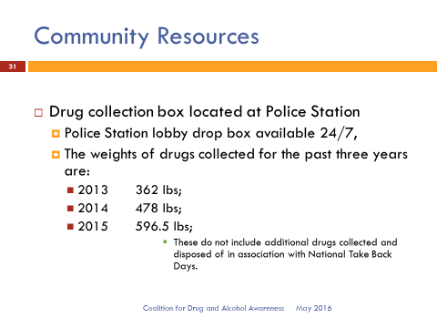

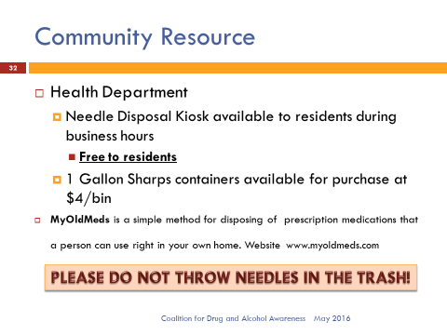



Mr. Butler asked Leanne Jasset, co-chair of the Dedham Coalition for Drug & Alcohol Awareness, if she had any comments. Ms. Jasset stated that she is grateful that the groups have started up in Dedham, such as Learn2Cope and Nar-anon. Ms. Jasset added that the participation is been great. It is been a very positive experience.

Mr. Keogh stated that he's glad that these programs are getting to the kids early. Mr. Keogh added, when you have a Middle Schooler you are nervous about breaking their innocence. Getting to kids early and educating them is the key. Mr. Keogh added that he is pleased to see the change in thinking regarding stigma, that is being spearheaded by the Govenor. Mr. Keogh continued, saying it is very impressed with the resources that Dedham has gathered to deal with this increasing problem.

Mr. MacDonald thanked Ms. Gardner for the presentation. Mr. MacDonald informed all that his wife works on a drug and alcohol rehab floor, so he has heard the stories about young and old people and their addictions. Mr. MacDonald added that this issue's not going away and is more in the forefront as leaders like the Governor are speaking about it. Mr. MacDonald stated that he is deathly afraid of the possibility of the legalization of marijuana at our next election. Mr. MacDonald believes that would be a huge mistake if it passes will have a negative impact on our children. Mr. MacDonald continued, saying that we think we have problems with drugs now, watch out if marijuana does get legalized here in Massachusetts. Mr. MacDonald stated that the Board usually does not take a position on the ballot questions but this one would be a game changer.

Mr. Butler asked Mr. Kern, if you'd say a few words regarding this issue.

Mr. Kern commended Mr. Butler, Ms. Gardner and everyone else that has been doing the work of raising the awareness in our community, while using limited resources in the most effective way. Mr. Kern added that he has attended some of the SAPC group meetings. Mr. Kern stated that he has some experience with this within his family and he suspects most families do. Mr. Kern added that that does not equip you for organizationally trying to figure out how to best, as a community, provide some help for people affected by this. Mr. Kern continued, saying that they have made good progress and are still striving to build better coordination to immediately help someone in need.

Mr. Butler thanked Ms. Gardner for her efforts and complimented her for turbocharging the coalition. Mr. Butler stated that Ms. Gardner has demonstrated the skills necessary to help drive this Coalition. Mr. Butler added that he would like to hear back from the Town Manager in about two months, regarding the progress he's made with Superintendent Welch, in synchronizing the various departments in Town to tackle the three or four major problems that they want to go after. For example, when the Schools and the Police encounter situations involving a mental health problem. Mr. Butler continued, saying what more can the Police do beyond calling Fallon Ambulance and letting the healthcare system take over. Mr. Butler stated that he’d like to hear Mr. Kern and Mr. Welch’s ideas in a few months.

Mr. Guilfoyle expressed his thanks to all the Coalition members involved and stated that he has attended a few of their meetings. Mr. Guilfoyle stated that this is a horrible disease that does not discriminate and touches many families in Dedham. Mr. Guilfoyle added that he appreciates the strides the Coalition has made regarding addiction and stigma stereotypes. Mr. Guilfoyle continued, saying that awareness is one of the most important things regarding this disease. Mr. Guilfoyle added that he looks forward to future updates.

**DISCUSSION & VOTE WITH TREASURER/COLLECTOR JANE LEPARDO RE: NEW BOND ISSUE, BANS & APPOINTMENT OF ASSISTANT COLLECTOR AND REAPPOINTMENT OF ASSISTANT TREASURER**

Jane Lepardo, Treasurer/Collector for the Town of Dedham, was present before the Board. Ms. Lepardo stated that it is a pleasure for her to be able to appoint Sandra Matar. She started as an intern about five years ago and then was stolen by the Treasurer/Collector's office. Ms. Lepardo added that in addition to her Bachelor's Degree, Sandra received her Master’s in Public Administration last year. Ms. Lepardo continued, saying that Sandra has done a remarkable job and she is relied upon heavily in that office. Ms. Lepardo stated that it is her pleasure to ask the Board to approve the appointment of Sandra Matar, Dedham resident and former Town meeting member, as the Assistant Town Collector.

Mr. Butler moved to approve the appointment of Sandra Matar as Assistant Town Collector, as recommended by Town Treasurer/Collector Jane Lepardo; seconded by Mr. Keogh. **On the Vote:** Mr. Keogh, yes; Mr. Butler, yes; Mr. Guilfoyle, yes; Mr. MacDonald, yes.

Ms. Lepardo stated that the next appointment is for Donna Bowse, who has been with the Town for 25 years. Ms. Lepardo added that Ms. Bowse is her resource for historical information going back many years. Ms. Lepardo continued, saying that this is actually a reappointment to Assistant Treasurer for Donna Bowse and asked the Board’s approval for this, under Ms. Lepardo’s leadership as Collector/Treasurer for the Town of Dedham.

Mr. Butler moved approval of the appointment of Donna Bowse as Assistant Town Treasurer as recommended by Town Treasurer/Collector, Jane Lepardo; seconded by Mr. MacDonald. Hey Kirsten **On the Vote:** Mr. Keogh, yes; Mr. Butler, yes; Mr. Guilfoyle, yes; Mr. MacDonald, yes.

Ms. Lepardo stated that she gave the Board a copy of the official vote on a Bond issue. Ms. Lepardo added that the Town had a sale yesterday morning on the bond issue of over $20 million as well as a BAN (Bond Anticipation Note). Ms. Lepardo continued, saying that the Town received very favorable responses on both of them and all that information is detailed in the vote needs to be read and accepted into the minutes officially. Ms. Lepardo asked the Board to sign a copy of the BAN so she could mail it to the DOR tomorrow. Mr. Lepardo stated that the paperwork is being prepared by our Bond Counsel attorney Brenda McDonough, which we will receive back hopefully by Friday or Monday at the latest. Ms. Lepardo asked the Board to sign the paperwork by next Wednesday so she can get the paperwork back to Lynn Foster. Ms. Lepardo informed all that the Town received a rate on the BAN of 8.5 and that is a rolling BAN that is related to the ECEC project. Ms. Lepardo continued, saying that the bond issue is a combination of different Capital items from the last Capital Budget - FY 15, road money, sidewalk design, police vehicles, DPW equipment and the $17.4 million for the work on the Ames property. Ms. Lepardo informed all that the bond was purchased by Robert Beard at a true interest cost of 2.59. The Town received a rate of .85 on the BAN from Eastern Bank.

Mr. Butler moved that the Board of Selectmen of the Town of Dedham, Massachusetts (the "Town"), certify that at a meeting of the Board held June 9, 2016, at which meeting all members of the Board were duly notified and at which a quorum was present, the following votes were unanimously passed, all of which appear upon the official record of the Board:

Voted: that the sale of the $20,568,692 General Obligation Municipal Purpose Loan of 2016 Bonds of the Town dated June 22, 2016 (the "Bonds"), to Robert W. Baird & Co., Inc. at the price of $21,301,111.12 and accrued interest, if any, is hereby approved and confirmed. The Bonds shall be payable on June 15 of the years and in the principal amounts and bear interest at the respective rates, as follows:

|  |  |  |  |  |  |
| --- | --- | --- | --- | --- | --- |
| Year | Amount | Interest  Rate | Year | Amount | Interest  Rate |
| 2017 | $948,692 | 2.00% | 2029 | $ 680,000 | 2.125% |
| 2018 | 945,000 | 2.00 | 2030 | 680,000 | 2.25 |
| 2019 | 945,000 | 2.00. | 2031 | 680,000 | 2.50 |
| 2020 | 940,000 | 2.00 | 2032 | 580,000 | 2.50 |
| 2021 | 940,000 | 2.00 | 2033 | 580,000 | 2.625 |
| 2022 | 750,000 | 5.00 | 2034 | 580,000 | 2.75 |
| 2023 | 750,000 | 5.00 | 2036 | 1,160,000 | 3.00 |
| 2024 | 750,000 | 5.00 | 2038. | 1,160,000 | 3.00 |
| 2025 | 750,000 | 3.00 | 2041 | 1,740,000 | 3.00 |
| 2026 | 750,000 | 3.00 | 2043 | 1,160,000 | 3.00 |
| 2027 | 680,000 | 3.00 | 2046 | 1,740,000 | 3.00 |
| 2028 | 680,000 | 2.00 |  |  |  |

Further Voted: that the Bonds maturing on June 15, 2036, June 15, 2038, June 15, 2041, June 15, 2043 and June 15, 2046 (each, a "Term Bond") shall be subject to mandatory redemption or mature as follows:

Term Bond due June 15, 2036

Year Amount

2035 $580,000

2036* 580,000

*Final Maturity

Term Bond due June 15, 2038

Year Amount

2037 $580,000

2038* 580,000

*Final Maturity

Term Bond due June 15, 2041

Year Amount

2039 $580,000

2040 580,000

2041* 580,000

*Final Maturity

Term Bond due June 15, 2043

Year Amount

2042 $580,000

2043* 580,000

*Final Maturity

Term Bond due June 15, 2046

Year Amount

2044 $580,000

2045 580,000

2046* 580,000

*Final Maturity

Further Voted: to approve the sale of a $600,000 0.85 percent General Obligation Bond Anticipation Note of the Town dated June 15, 2016, and payable June 15, 2017 (the "Note"), to Eastern Bank at par.

Further Voted: that in connection with the marketing and sale of the Bonds, the preparation and distribution of a Notice of Sale and Preliminary Official Statement dated June 1, 2016, and a final Official Statement dated June 8, 2016 (the "Official Statement"), each in such form as may be approved by the Town Treasurer, be and hereby are ratified, confirmed, approved and adopted.

Further Voted: that the Bonds shall be subject to redemption, at the option of the Town, upon such terms and conditions as are set forth in the Official Statement.

Further Voted: that the Town Treasurer and the Board of Selectmen be, and hereby are, authorized to execute and deliver a continuing disclosure undertaking in compliance with SEC Rule 15c2-12 in such form as may be approved by bond counsel to the Town, which undertaking shall be incorporated by reference in the Bonds for the benefit of the holders of the Bonds from time to time.

Further Voted: that we authorize and direct the Treasurer to establish post issuance federal tax compliance procedures in such form as the Treasurer and bond counsel deem sufficient, or if such procedures are currently in place, to review and update said procedures, in order to monitor and maintain the tax-exempt status of the Bonds.

Further Voted: that each member of the Board of Selectmen, the Town Clerk and the Town Treasurer be and hereby are, authorized to take any and all such actions, and execute and deliver such certificates, receipts or other documents as may be determined by them, or any of them, to be necessary or convenient to carry into effect the provisions of the foregoing votes.

The Board further certifies that the votes were taken at a meeting open to the public, that no vote was taken by secret ballot, that a notice stating the place, date, time and agenda for the meeting (which agenda included the adoption of the above votes) was filed with the Town Clerk and a copy thereof posted in a manner conspicuously visible to the public at all hours in or on the municipal [building that the office of the Town Clerk is located or, if applicable, in accordance with an alternative method of notice prescribed or approved by the Attorney General as set forth in 940 CMR 29.03(2)(b), at least 48 hours, not including Saturdays, Sundays and legal holidays, prior to the time of the meeting and remained so posted at the time of the meeting, that no deliberations or decision in connection with the sale of the Bonds were taken in executive session, all in accordance with G.L. c.30A, §§18-25, as amended; Seconded by Mr. Keogh. **On the Vote:** Mr. Keogh, yes; Mr. Butler, yes; Mr. Guilfoyle, yes; Mr. MacDonald, yes.

Mr. Butler asked Ms. Lepardo asked what happens when a Bond goes to market.

Ms. Lepardo informed all that they had the preliminary official statement which is a pretty sizable document which is put out to the market and to those interested in the Town of Dedham. Ms. Lepardo added that the Town had its AAA bond rating reaffirmed by Standard & Poors. Ms. Lepardo continued, saying that this is a 30 year bond and the Town of Dedham had seven bids. Ms. Lepardo stated that the Town of Dedham is a very attractive investment in the bond market.

Mr. Butler asked Ms. Lepardo to explain the true interest cost that the Town is paying.

Ms. Lepardo informed all that the true interest cost reflects the interest that the Town is paying, net of the premium that the Town is receiving. Ms. Lepardo stated that the true interest cost is 2.599%. Ms. Lepardo added that even though this was a 30 year bond. It was still very attractive investment for people.

Mr. MacDonald asked Ms. Lepardo if she ever considered handling this process via an electronic platform.

Ms. Lepardo stated that the paperwork came after the fact really was not an inconvenience, but she will talk to the Town’s Bond Counselor to see if that is an option.

Ms. Baker informed all that the Board is being asked to consider a 268A, Section 20(d) exemption on behalf of Ms. Jasset. Ms. Baker further explained that Ms. Jasset will be opening an independent pharmacy known as Dedham Pharmacy and Medical Supply. On occasion the Health Department will reach out to the Pharmacy during an urgent or emergency situation for supplies. Ms. Baker added that Town Council has advised and assisted in drafting the exemption that is before the Board and because it involves a financial interest it requires the Board to consider authorizing the exemption. As an elected member of the Board of Health, Ms. Jasset is a special Municipal employee and thus qualifies for this exemption.

Mr. MacDonald moved to accept the exemption; seconded by Mr. Keogh. **On the Vote:** Mr. Keogh, yes; Mr. Butler, yes; Mr. Guilfoyle, yes; Mr. MacDonald, yes.

Mr. MacDonald stated that this will be on file with the Town Clerk.

Ms. Baker stated that it will be filed in the morning.

**DISCUSSION & VOTE RE: 5TH ANNUAL DEDHAM TURKEY TROT (11/24/16)**

Dan Hart was present before the Board as the Executive Board and race directors for the Turkey Trot are either out of Town or have previous commitments. Mr. Hart informed all that there are no significant changes, from previous years, to the event. Mr. Hart added that the start time will remain at 8:30am, same course and same number of runners, approximately 2000. The last finisher will be in prior to 9:30am. Mr. Hart informed all that they raised $54,000 last year and all that stayed in the Town of Dedham ($25,000 went to the Food Pantry, $15,000 went to the Youth Commission, $10,000 went towards Veterans Road playground and $4000 to the Horizons at Dedham Country Day program scholarship as well as 1800 pounds of food was donated to the Food Pantry). Mr. Hart asked for the Board's approval to run the race again this year.

Mr. MacDonald moved approval of the fifth annual Dedham Turkey Trot – 11/24/16; seconded by Mr. Butler. **On the Vote:** Mr. Keogh, yes; Mr. Butler, yes; Mr. Guilfoyle, yes; Mr. MacDonald, yes.

**DISCUSSION & VOTE RE: WINE & MALT FOR WESTPORT RIVERS VINEYARD & WINERY FOR DEDHAM FARMER’S MARKET (6/15/16 – 10/26/16) & REQUEST FROM DSC FOR APPROVAL OF MARKET SIGNAGE AND PUBLIC PARKING SPACES**

The Board was informed that this would be the Ninth Annual Market and that it will start on Wednesday, June 15, 2016. Rep stated that they are changing the hours to 3 PM - 7 PM. Rep explained the reasoning was because of the parking situation and hope that the later hours will allow for easier parking and give commuters time to take advantage of the Market. Rep stated that they will change the location of the market towards the courthouse end which will provide more viewership for customers. This will also provide more shade for the vendors.

Mr. MacDonald moved approval of the request by Westport Rivers Vineyard and Winery to provide samples and sell wine at the Dedham Farmers Market; seconded by Mr. Butler. **On the Vote:** Mr. Keogh, yes; Mr. Butler, yes; Mr. Guilfoyle, yes; Mr. MacDonald, yes.

Ms. Baker informed the Board that there were motions in front of them regarding the Market itself. Ms. Baker continued, saying that the Board is required to designate the Farmers Market as a Public Market and there is also a request for signage that has been the same for the last several years. Ms. Baker added that the market is also seeking the use of five public parking spaces as they have in the past.

Rep informed all that they would like to change the parking spot locations, having 2 on High Street and 3 on Court Street.

Mr. MacDonald moved to designate the Dedham Farmers Market as a Public Market, approval of the signage throughout the Town on publicly owned land as outlined in the request and the use of five public parking spaces for vendors as outlined; seconded by Mr. Butler. **On the Vote:** Mr. Keogh, yes; Mr. Butler, yes; Mr. Guilfoyle, yes; Mr. MacDonald, yes.

Rep invited the Board to the Market opening for a photograph and the ringing of the cowbell.

**DISCUSSION & VOTE W/ VSO BILL AITKEN TO ACCEPT POW/MIA TABLE FOR TOWN HALL**

Bill Aitken, Dedham VSO, was present before the Board. Mr. Aitken stated that he would like to request permission to display the POW/MIA Missing Man Table here at Town Hall. Mr. Aitken added that he has the table in his office and would like to have it officially dedicated to the Town by Operation Rolling Thunder. Mr. Aitken continued, saying that he needs the Board’s permission before he can set up the dedication date.

Mr. MacDonald moved approval of the request to display the POW/MIA Missing Man Table at Town Hall; seconded by Mr. Butler.

Mr. MacDonald stated that this reminded him that the Board previously accepted the POW/MIA chair and some

people are probably wondering where that is. Mr. MacDonald added that we are waiting for the New Town Hall to be finished before they have the designation of that chair and find a place of honor for it.

Mr. Butler stated that he was visiting and Air and Space Museum on the West Coast a few weeks ago where he saw a Table and Chair on display.

Mr. Guilfoyle informed all that the American Legion will be doing a dedication at the general meeting on Monday and they have a designated area upstairs in the lounge.

**On the Vote:** Mr. Keogh, yes; Mr. Butler, yes; Mr. Guilfoyle, yes; Mr. MacDonald, yes.

**DISCUSSION & VOTE RE: REQUEST FOR A ONE DAY LICENSE BY SETTING THE SPACE (6-16-16)**

Christa Silvieus, VP of Sales and Marketing for Setting the Space, was present before the Board. Ms. Silvieus stated that they are an interior design and staging firm, which has six retail locations with one at Legacy Place. Ms. Silvieus informed the Board that they are requesting a one day liquor license for a private event at the store from 6 PM - 9 PM on June 16, 2016. Ms. Silvieus added that she has spoken with Beth Winbourne, General Manager at Legacy Place, and her management team. Ms. Silveus continued, saying that they have approved the closure of the store for a private event.

Mr. MacDonald moved approval of the request for a one day liquor license by Setting the Space on June 16, 2016; seconded by Mr. Butler. **On the Vote:** Mr. Keogh, yes; Mr. Butler, yes; Mr. Guilfoyle, yes; Mr. MacDonald, yes.

**DISCUSSION & VOTE RE: ALTERNATIVE YEAREND TRANSFERS**

Ms. Baker informed all that these yearend transfers are opportunities before the end of the fiscal year for departments to move monies within their budgets with a cap of $5000. These will also be presented to Fin Comm on Monday evening. Ms. Baker informed all of the following requests of transfers:

Parks and Recreation is asking for $5000 in additional funding for the upcoming Flag Day Parade. The transfer will come from Police Officers’ salaries and will go to the Parks and Recreation budget for the Parade.

The Veteran Services Department is looking to move approximately $1100, which will be funded through a surplus and the Police salaries to accommodate the spring travel and conference that is upcoming.

The Town Clerk's office is looking to move money from meetings and conferences and dues and membership to increase their supply budget to accommodate the purchase of specialized voter IDs and vital record paper prior to the end of the fiscal year.

The Human Resources Department has a surplus in the printing budget of $2500, so Ms. Johnson would like to move that money into her temporary wages budget as she has had an increase in hours by her temporary assistant to get through the close of the fiscal year.

The Facilities and Maintenance Department is looking to transfer a surplus of $5000 from the heat budget to the maintenance and overtime budget. This will help to deal with the issues throughout the Town and School Buildings until the new HVAC position is filled.

Parks and Recreation Department is looking to transfer $3500 from their supply budget into their seasonal help budget which will allow Mr. Stanley to bring on a few extra workers before the end of the fiscal year to get the parks and fields ready for the summer months.

Mr. Butler moved to approve the alternative year-end transfers; seconded by Mr. Keogh. **On the Vote:** Mr. Keogh, yes; Mr. Butler, yes; Mr. Guilfoyle, yes; Mr. MacDonald, yes.

**DISCUSSION WITH THE MOTHER BROOK ARTS & COMMUNITY CENTER BOARD RE: EXTENSION OF LEASE**

Mr. Butler informed all that he will be recusing himself from the following discussion. Mr. Butler stated that he spoke earlier with an attorney at the State Ethics Commission and explained the situation as follows. Mr. Butler has been a member of the Board of Directors of the Dedham School of Music since 2008 and in 2013 the Music school started renting space at The Mother Brook Arts and Community Center. Even though Mr. Butler personally does not have a personal financial interest, the organization that he is affiliated with may have a financial interest in the lease at some point down the road. The State Ethics attorney gave Mr. Butler a few options and he's decided that the most straightforward approach is simply to recuse himself. Mr. Butler stated that he will be leaving the room during the discussion. Mr. Butler continued, saying that later this evening the Board will go to into Executive Session, relative to the purchase, exchange, lease or value of real property and he will recuse himself from that discussion as well.

Jean Ford Webb, Executive Director at the Mother Brook Arts and Community Center, was present before the Board. Ms. Ford Webb thanked the Board for giving them the opportunity to speak this evening. Ms. Ford Webb stated that she is nervous as she feels the decision he is asking the Board to make is probably one of the most important things you can do to ensure the continued success of the Mother Brook Arts and Community Center. Ms. Ford Webb added that they believe and most folks in Town believe that we've been extremely successful to date of fulfilling their mission, the mission that was prescribed by the Avery Reuse Committee and the Board of Selectmen in 2013. Ms. Ford Webb continued, saying that they continue to be dedicated the economic revitalization in East Dedham and to provide a stimulating gathering place for residents and guests. Ms. Ford Webb informed the Board that as they continue to look for resources and court foundations, government funders, donations and engaged in negotiations with a prospective restauranteur, we find ourselves increasingly handicapped by the length of our lease. The MBACC’s long-term viability has been called into question without a longer lease, the restauranteur absolutely requires that we have a longer lease so he can have a longer lease. Ms. Ford Webb stated that they are also on the precipice of other significant investments in the property. Ms. Ford Webb informed the Board that they have received donations that will go towards a pottery studio, a full renovation to the old playground area, completion of the HVAC system with about $150,000 of air-conditioning equipment and new bathrooms. Ms. Ford Webb added that she believes Board's decision to bring this organization into existence in 2013 has been very well received in the community. Ms. Ford Webb continued, saying that this lease extension is an absolutely necessary next step in our ability to continue to do the work that they're doing. Ms. Ford Webb asked that the Board vote for a lease extension.

Ms. Ford Webb invited Jim Kaufman to say a few words. Mr. Kaufman read the following statement.

My name is Jim Kaufman of Highland Street in Precinct 4 and four years ago was a founding member of the Board of Directors of the Mother Brook Arts and Community Center. In response to a vision articulated by the Avery Re-Use Committee, Town Meeting, and The Board of Selectmen and with the support of the Mother Brook Community Group, we launched a small non-profit. We were motivated by the dream of serving the Town of Dedham by fulfilling our mission statement. That mission is "To build a vibrant and sustainable center that enriches the Dedham Community and stimulates the revitalization and growth of the Mother Brook neighborhoods through the arts." We are grateful to the Town of Dedham for its wisdom and support, and to the countless number of volunteers and donors who have striven to help us achieve what initially seemed to be only an inflated dream. As our report to your Board details, we have come an enormous distance toward fully achieving the Town's goals for our work. A quality and affordable restaurant as a key driver of economic health for East Dedham Square was a promise we made to Dedham in our agreement with the Town. Jean has detailed the critical obstacle we now face in securing a restaurant without a long term lease. I would like to reiterate the urgency of that matter. However, please permit me to spend a moment emphasizing other critical aspects of the challenge we will face without a lease that reassures our current and future stakeholders. First, as you might guess, current and prospective tenants will remain concerned about committing resources and investment in a location that may have a short life-span. Second, the motivation that inspires dozens of volunteers may wane if they cannot see their labors as part of an ongoing benefit to the Town. Most importantly, donors are reluctant to fund a non-profit which may have its mission curtailed by the expiration of a lease. This is no small issue. Our ability to fully realize the mission we assumed on behalf of the Town requires very large amounts of philanthropy. Those goals cannot be achieved from rents alone. Programming that would permit MBACC to serve as the catalyst for wider economic and cultural enrichment demands high levels of donations. Corporate, foundation, state, and individual philanthropy will be seriously handicapped if those supporters cannot see a path to the long term viability of the MBACC. A lease extension is critical for all of those reasons. Please know that all who have been involved with this project are grateful to the Selectmen for their wisdom creating and supporting the articulated mission. We now respectfully ask that you continue to serve as the critical partner for the success of our mission.

Thank you.

Mr. MacDonald stated that they would not be voting on this issue this evening because the item on the agenda says discussion, it does not say discussion and vote. The Board has an Executive Session after the open meeting and real estate is one of the items we will be discussing. Mr. MacDonald thanked Ms. Ford Webb and Mr. Kaufman for the great work they have done down there. Mr. MacDonald added that he sees this as a progression because no one knew what to expect when we did the lease, a number of years ago. Mr. MacDonald asked what happened to the Cultural Council $200,000 grant. Ms. Ford Webb informed the Board that they received a $210,000 grant from the Mass Cultural Council and that the Mets that dollar for dollar. Ms. Ford Webb explained that the grant went towards the heating portion of the HVAC system. Ms. Ford Webb continued, saying that there was a separate $200,000 grant.

Mr. MacDonald stated that he did not see that listed in the financials.

Ms. Ford Webb answered that she did not mean to leave that out and we definitely did get $200,000 from the State of Massachusetts with the help of Senator Rush and Representative McMurtry. Ms. Ford Webb informed the Board that they've used some of the money to pay off debt, fix the heating system and increase programming and property improvements.

Mr. MacDonald asked Ms. Ford Webb if the MBACC was a 501c3. Ms. Ford Webb answered yes. Mr. MacDonald asked through filing 990s for their tax returns. Ms. Ford Webb answered yes. Mr. MacDonald asked Ms. Ford Webb if they have their finances audited or at least reviewed. Ms. Ford Webb answered that they would have to have an audit this year because of the two large gifts they received. Ms. Ford Webb stated that their budget has gone from zero when they started to about $620,000.

Mr. Kaufman stated that was a one-year large bump because of the heating system.

Mr. MacDonald asked that the financials were shared with the Town Manager's office. Ms. Ford Webb answered that is public information. Ms. Baker informed all that the lease requires that the financials be shared with the Town Manager's office.

Mr. MacDonald stated that would be helpful because as we get into discussions would help to have the whole financial picture. Mr. MacDonald added that the idea when the Town entered into this lease was that it would take a while to build the Center and there were going to be startup costs and investments within the building. Mr. MacDonald continued, saying that when set the rent as we did. Mr. MacDonald informed all that we were criticized for the rent we were charging but he thinks it was the right thing to do. We realized it was a startup with a lot of learning and a lot of cost associated with the Center and your presentation this evening is the next step of what you found out over the last few years.

Ms. Ford Webb stated that they have a long way to go for it to be sustainable and went on to describe some costs they have incurred, such as fixing doors and security issues. Ms. Ford Webb added that they are not anywhere near fully programmed, explaining that they plan on having a children's after school program, summer program and a vacation week program. Ms. Ford Webb continued, saying that they have been incredibly fortunate regarding the help they have received from individuals and local businesses.

Mr. MacDonald stated that it is truly amazing the amount of work that is happened within that building and the results have exceeded what he thought the demand was going to be. Mr. MacDonald added that they should not take his questions as a criticism they just need some answers so when they go into deliberations they have all the information they need.

Ms. Ford Webb informed the Board that they are in the transition stage of hiring a bookkeeper getting ready for an audit.

Mr. Kaufman stated that he believes Mr. MacDonald raises a very important question regarding the perception of the rent by some in the community who may not have understood what the real vision and mission was, the mandate they received as a nonprofit organization, and that was the economic revitalization of the East Dedham square area. Mr. Kaufman added that the range of rents that were considered are so dwarfed by the vast amounts of money they put into infrastructure of the building and continue to put in.

Mr. Guilfoyle clarified that the current lease is through January 1, 2022.

Mr. Kern stated it was originally five years with a five-year option.

Ms. Ford Webb stated that the original lease began March 1, 2013 and they're looking for a 30 year lease from day one. Ms. Ford Webb added that the language in their request asks for 10 years with a 10 year option and a seven year option, so the total would be 30 years from day one.

Mr. Kaufman informed all that in their talks with prospective restauranteurs and consultants, they have learned that the infrastructure investment in the Town's building, to facilitate the restaurant, is going to be many, many hundreds of thousands of dollars. Mr. Kaufman continued, saying that it is impossible to attract somebody willing to make that type of investment if they do not feel comfortable they are going to be there for a long time.

Mr. Guilfoyle stated that we're looking to go out to 2042.

Ms. Ford Webb answered that is correct.

Mr. Guilfoyle added that these big decisions we are making for the Town and we will be speaking to counselor Eichman later on in Executive Session.

Mr. Butler rejoined the meeting.

Mary Gilbert, Town Meeting member from Precinct 7, was present before the Board. Ms. Gilbert thanked the Board for their attention this evening. Ms. Gilbert asked for clarification regarding the next step, saying that when it is ultimately voted the agenda will say discussion with vote?

Mr. MacDonald clarified that it will say discussion and vote.

Ms. Gilbert asked if the Board had an idea of when that might happen.

Mr. MacDonald stated that the next meeting is July 28.

Ms. Gilbert stated that she thought it would be a little bit earlier than that. Ms. Gilbert added that the hope was to get something done today so they could move forward.

**TOWN MANAGER’S REPORT**

The Government Finance Officers Association, GOFA) notified us that our CAFR, the Comprehensive Annual Financial Report, qualified for the Certificate of Achievement for Excellence in Financial Reporting, GOFA’s highest award.  I wanted to get Andrea in to recognize her, as well as the entire finance team, but she is extremely busy with the MUNIS implementation, so I’d like to suggest that we do it at the next meeting. That is a difficult award to get in a difficult standard to hold.

Mr. Kern has had conversations with. Mr. Keogh and Mr. Guilfoyle regarding specific properties and the Abandoned Housing Initiative. Mr. Kern has reached out to attorney Jeff Blake, with Kopelman and Paige, and he will be setting up a meeting with Cathy Cardinale, Health Director. This is a process that the Attorney General created so that if the property is truly abandoned, the AG's office does the research and brings a significant level of resource to bear on the problem. Sometimes it gets to the point where a receiver is appointed and goes into receivership, the property is sold and reconciled that way. Other times, with the threat of that happening, other arrangements can be made. It has been very successful in some communities and it really works if it's applied to a property that is truly been abandoned. Mr. Kern stated that they have 3 on the list for Dedham.

Mr. Kern stated that the turnout for the web site public input meeting was a little disappointing.  We will have a booth at the farmers market so people can give their input regarding the website. There has been a lot of work on the site by Doreen, John, and Lisa. Mr. Kern stated they will continue to work through the summer and should be ready to go before Thanksgiving.

Mr. Kern visited with the Dedham Retirement Board to go over the Town’s intentions regarding early contribution to the pension and it went well.

Mr. Keogh asked Mr. Kern, what he thought the biggest obstacle regarding abandoned properties was. Is it a long red tape process or something running into?

Mr. Kern stated that the difference with this program is that he does not think it is long. If you go through the typical tax title process, it takes forever. Mr. Kern added, to go through a foreclosure and get a decision in Land Court can be a long stretch. Mr. Kern continued, saying that once Attorney Blake gets here and we get set up with the Attorney General's office, it should move pretty quickly.

Mr. Keogh asked when the last time we did this was.

Mr. Kern answered he thinks one time in Dedham.

Mr. Guilfoyle stated the Town took their property over taxes.

Mr. Kern stated that the Town is not actually used this particular program before.

Mr. Butler stated that the property in question was on Grant Ave.

Mr. Kern stated that this is a receiver, which is different than what was available up until this program came into existence. Mr. Kern added that the old way was to grind it to Land Court. Mr. Kern continued, saying that through this program we would go through a district court

Mr. MacDonald asked if this was just for abandoned houses and not for blighted piece of property.

Mr. Kern stated if the owner of the house hasn't left, this program does not apply.

**REQUEST BY THREE SQUARES NEW ENGLAND FOR ONE DAY LIQUOR LICENSE AND APPROVAL OF THE 5TH ANNUAL RIDE FOR FOOD, 9-25-16, FROM 11AM-1PM, BEGINNING AND ENDING AT NOBEL & GREENOUGH**

Mr. MacDonald moved approval; seconded by Mr. Keogh. **On the Vote:** Mr. Keogh, yes; Mr. Butler, yes; Mr. Guilfoyle, yes; Mr. MacDonald, yes.

**DRAINLAYER LICENSE APPLICATION APPROVAL**

Celtic Landscaping, Inc.

121 Shawmut Road

Canton, MA 02021

Mr. MacDonald moved approval; seconded by Mr. Keogh. **On the Vote:** Mr. Keogh, yes; Mr. Butler, yes; Mr. Guilfoyle, yes; Mr. MacDonald, yes.

**REQUEST BY NEWBRIDGE ON THE CHARLES FOR A ONE DAY LIQUOR LICENSE – 6-23-16, 6:30-10:30PM**

Mr. MacDonald moved approval; seconded by Mr. Keogh. **On the Vote:** Mr. Keogh, yes; Mr. Butler, yes; Mr. Guilfoyle, yes; Mr. MacDonald, yes.

**REQUEST BY BREAKING FOR AIDS RIDE FOR PERMISSION TO TRAVEL THROUGH DEDHAM ON 9-23-16**

Mr. Keogh moved approval; seconded by Mr. Butler. **On the Vote:** Mr. Keogh, yes; Mr. Butler, yes; Mr. Guilfoyle, yes; Mr. MacDonald, yes.

**REQUEST FOR MARLBORO STREET BLOCK PARTY, 6-25-16 FROM 4PM – 12 AM**

Mr. Keogh moved approval; seconded by Mr. MacDonald. **On the Vote:** Mr. Keogh, yes; Mr. Butler, yes; Mr. Guilfoyle, yes; Mr. MacDonald, yes.

**REQUEST TO TAKE AN ITEM NOT ON AGENDA**

Mr. Butler moved to take an item not on the agenda; seconded by Mr. Keogh. **On the Vote:** Mr. Keogh, yes; Mr. Butler, yes; Mr. Guilfoyle, yes; Mr. MacDonald, yes.

**REQUEST FROM BETH EMERY TO PLACE A FRAME SIGNS AT EAST STREET, WHITING AVENUE AND THE ENDICOTT ROTARY TO ADVERTISE DEDHAM YOUTH SOCCER FALL REGISTRATION**

Mr. Butler moved approval; seconded by Mr. Keogh. **On the Vote:** Mr. Keogh, yes; Mr. Butler, yes; Mr. Guilfoyle, yes; Mr. MacDonald, yes.

**MEETING MINUTES APPROVAL, 3-28-16, 4-14-16, 5-16-16**

Mr. Butler moved approval; seconded by Mr. Keogh. **On the Vote:** Mr. Keogh, yes; Mr. Butler, yes; Mr. Guilfoyle, yes; Mr. MacDonald, yes.

Mr. Kaufman stated that the Mother Brook representatives were surprised that there was not going to be a vote this evening, so he wanted to give the BBoard some additional information. Mr. Kaufman added that they looked long and hard for a restaurant tour to make division of that part of the mission successful and they have somebody who is very close to signing an agreement with them. This person is extraordinary generous and is offering to make significant prevents to the building, other than the restaurant. Mr. Kaufman asked the Board if there is any possibility of a special session by the selectmen to consider this any sooner than July 28. Mr. Kaufman continued, saying that they are very fearful that they're going to lose the prospective restauranteur, and the repairs he is willing to make to the building. He apologized for the imposition but it is incredibly important for them.

**James O’Brien – 614 East Street**

Mr. O'Brien stated that the lease extension is new information brought forward, and is a linchpin in the negotiations. Mr. O'Brien asked for a possible special meeting before the next allocated meeting.

Mr. Kaufman stated anything you could do to help us out with this situation.

Mr. MacDonald stated that the Board is going into Executive Session and it is premature for them to talk about this until Executive Session is through. Mr. MacDonald continued, saying, depending upon the outcome, the Board will take the request under consideration. Mr. MacDonald added that it would be helpful to have copies of the documents you are referencing regarding the restauranteur being willing to go in there under specific terms. Mr. MacDonald stated that if you have a restaurant that is expressing interest to you and is making certain demands, it would be helpful to see that. Mr. MacDonald informed all that most restaurants the Board approves have 10 year leases, so if something different is being requested of you would be helpful to have that information.

Ms. Ford Webb stated that she can get something to the Board within 48 hours that will include that information. Ms. Ford Webb added that the prospective restauranteur's request is for a 10 year lease with options, which we cannot give them at this time.

Mr. Guilfoyle informed all that the Board would be entering into Executive Session with Kopelman & Paige, pursuant to G.L. c.30A Section21(a)(6), to consider the purchase, exchange, lease or value of real property and we will only be exiting Executive Session to adjourn.

Mr. MacDonald moved to enter Executive Session; seconded by Mr. Keogh. **On the Vote:** Mr. Keogh, yes; Mr. Butler, abstained; Mr. Guilfoyle, yes; Mr. MacDonald, yes.

Mr. Butler recused himself from the discussions during Executive Session.

Mr. MacDonald moved to adjourn the meeting; seconded by Mr. Keogh. **On the Vote:** Mr. Keogh, yes; Mr. Butler, abstained; Mr. Guilfoyle, yes; Mr. MacDonald, yes.

The next meeting is scheduled for Thursday, July 28, 2016 at 7p.m. This is to certify that the above is a true and accurate record of the Minutes of the Board of Selectmen’s Meeting held on June 9, 2016, which minutes were approved on July 28, 2016.

___________________________

Dennis Guilfoyle – Chairman