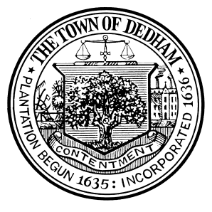 | TOWN OF DEDHAM  MEETING  NOTICE | POSTED:  TOWN CLERK

POSTED IN ACCORDANCE WITH THE PROVISIONS OF M.G.L. CHAPTER 30A SECTION 20 AS AMENDED.

Board or Committee: | Human Rights Commission
Location: | Dedham Town Hall
Day, Date, Time: | Wednesday, December 15th, 2021 6:30 PM
Submitted By: | Margaret Adams, Human Rights Commission Clerk
Date: | December 12, 2021

POSTED IN ACCORDANCE WITH THE PROVISIONS OF M.G.L. Ch. 30A, SECTION 20 AS AMENDED.

- Public Comment
- Approval of September and October Minutes
- Review Town Meeting Vote on HRC Article 15 Amendment
- Updating our HRC Resource Guide
- I Am Dedham for December 2021 January 2022
- Dedham No Hate Banner group photographs
- Ranking of Priorities from 4 Courageous Conversations Sessions in the
- Context of Designing Dedham Draft Proposals
- MLK Day Planning
- Old Business/New Business

