A regular Meeting of the Board of Selectmen was held on Thursday March 2, 2017, at 7pm in the Francis O’Brien Meeting Room, 26 Bryant Street, Dedham, Massachusetts. Present were:

Dennis J. Guilfoyle

Dennis J. Teehan

James A. MacDonald

Michael L. Butler

Brendan G. Keogh

Mr. Guilfoyle called the Meeting to order at 7:00 PM

**PLEDGE OF ALLEGIANCE**

Led by Mr. Guilfoyle.

Mr. Guilfoyle asked that everyone stand for a moment of silence in honor of Dedham Police Officer Robert Chermesino.

Mr. Guilfoyle stated that this is a terrible loss for the community.

Dr. Teehan introduced Steve Jordan, from the Mass Association for the Blind. Mr. Jordan reached out to Dr. Teehan and if Representative Paul McMurtry would be willing to host a movie for blind kids at his theatre. These children are visually impaired who require special equipment to be able to follow the movie. Dr. Teehan reached out to Rep. McMurtry on short notice during the busy Holiday season. Dr. Teehan informed all that when the community reaches out to the Rep., he always does his best. Rep. McMurtry jumped through hoops to get this set up. Dr. Teehan stated that he wanted to bring the Rep. in to acknowledge what he did for these kids and present him with a token of appreciation from the Mass Association for the Blind. Dr. Teehan asked Mr. Jordan to come forward to present Rep. McMurtry with a framed photo.

Mr. Jordan stated that they watched Santa Claus is coming to Town.

Dr. Teehan asked Mr. Jordan to explain how the equipment works.

Mr. Jordan informed all that this was for adults with visual impairment and developmental disabilities. Mr. Jordan explained that one of his goals was to get people out and get them involved in the community. Mr. Jordan added that some of the people he works with do not get the chance to get out and go to the movies. Mr. Jordan stated that he contacted Dr. Teehan and asked if he could reach out to Rep. McMurtry to see if something could get done and within a few days the event was set up.

Mr. Jordan proceeded to read a letter of appreciation to Re. McMurtry. Mr. Jordan presented Rep. McMurtry with a framed photo from the day of the event.

Rep. McMurtry stated that he has been given the privilege to own the Dedham Community Theatre and serve the community as State Representative. Rep. McMurtry added that anything they can do to help these deserving adults they are happy to do. Rep. McMurtry thanked Dr. Teehan for reaching out to him.

**DEDHAM CITIZENS - OPEN DISCUSSION**

None.

**ACTION BY THE BOARD**

**DRAINLAYER RENEWAL APPLICATIONS**

Ms. Baker informed the Board that the following applicants are being recommended for renewal by the Engineering Department:

Celtic Landscaping, Inc.

W.D. Cohen Contracting Corp

Dr. Teehan moved approval; seconded by Mr. Keogh. **On the Vote:** Mr. Keogh, yes; Dr. Teehan, yes; Mr. Butler, yes; Mr. Guilfoyle, yes; Mr. MacDonald, yes.

**Gift of $100 from the Friends of the Dedham Public Library to the Dedham Coalition for Drug & Alcohol Awareness**

Dr. Teehan moved approval; seconded by Mr. Keogh. **On the Vote:** Mr. Keogh, yes; Dr. Teehan, yes; Mr. Butler, yes; Mr. Guilfoyle, yes; Mr. MacDonald, yes.

**Gift of $100 from Dr. Steven Kassels to the Dedham Coalition for Drug & Alcohol Awareness**

Dr. Teehan moved approval; seconded by Mr. Keogh. **On the Vote:** Mr. Keogh, yes; Dr. Teehan, yes; Mr. Butler, yes; Mr. Guilfoyle, yes; Mr. MacDonald, yes.

**MINUTES APPROVAL - 2-16-17 & 2-21-17**

Mr. Keogh moved approval; seconded by Mr. Butler. **On the Vote:** Mr. Keogh, yes; Dr. Teehan, yes; Mr. Butler, yes; Mr. Guilfoyle, yes; Mr. MacDonald, yes.

**PUBLIC HEARING – VOTE ON NEW OFFICER/DIRECTOR FOR UNI RESTAURANTS, LLC D/B/A CHICAGO GRILL, 270 PROVIDENCE HIGHWAY, DEDHAM**

Mr. MacDonald recused himself from the next two agenda items as both matters will go before the ABCC.

Ms. Baker informed the Board that this change is happening across the state for all Uno Restaurant Licenses. Ms. Baker added that the ABCC does require the Local Licensing Authority to advertise and approve what is being proposed.

Mr. Butler moved approval of the New Officer/Director for Unos, Constantine Georgakopoulos; seconded by Mr. Keogh. **On the Vote:** Mr. Keogh, yes; Dr. Teehan, yes; Mr. Butler, yes; Mr. Guilfoyle, yes; Mr. MacDonald, abs.

**PUBLIC HEARING – VOTE ON REQUEST FOR ISSUANCE OF A (SPECIAL LEGISLATION) WINE & MALT RESTAURANT LICENSE TO SHAKE SHACK LEGACY PLACE DEDHAM LLC, D/B/A SHAKE SHACK, 26 LEGACY PLACE, DEDHAM; & APPROVSL OF KAITLIN DENUNZIO AS MANAGER**

Ms. Baker stated that Jim Devlin was present on behalf of Shake Shack but the proposed manager was unavailable. Ms. Baker asked the Board to continue the hearing until March 16, 2017, at which time the manager will be present.

Mr. Keogh moved to defer the agenda item until the next BOS Meeting, March 16, 2017; seconded by Dr. Teehan. **On the Vote:** Mr. Keogh, yes; Dr. Teehan, yes; Mr. Butler, yes; Mr. Guilfoyle, yes; Mr. MacDonald, abs.

**DISCUSSION & VOTE W/ TREASURER COLLECTOR RE: INTERFUND ADVANCE BORROWING**

Jane Lepardo, Town Treasurer/Collector, was present before the Board. Ms. Lepardo informed the Board that there was an article that was voted on and approved at the November, 2016 Town Meeting. Ms. Lepardo added that it was a change in purpose on the Municipal Campus borrowing authorization, so she had to go through Bond Counsel to get an additional green light approval letter. Ms. Lepardo informed The Board that the request was for $500,000 for the schematic design of the Public Safety Building and the borrowing authorization is $1,150,000.

Mr. MacDonald moved approval of the Inter Fund borrowing for $500,000; seconded by Mr. Keogh. **On the Vote:** Mr. Keogh, yes; Dr. Teehan, yes; Mr. Butler, yes; Mr. Guilfoyle, yes; Mr. MacDonald, yes.

**PRESENTATION OF TOWN MANAGER’S FISCAL YEAR 2018 BUDGET MESSAGE**

Mr. Kern stated that he would follow a similar process to the previous two years and go over the budget that has been put together over the past few months. Mr. Kern added that the all-day session with the Finance Committee will take place on Saturday March 4, 2017.

Mr. Kern then referred to the following presentation:

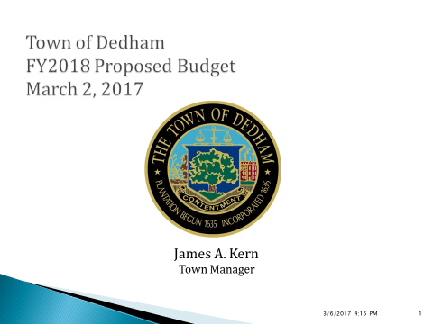

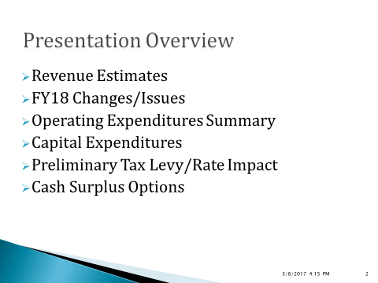

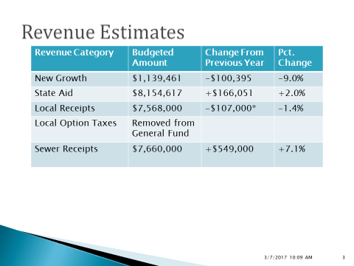

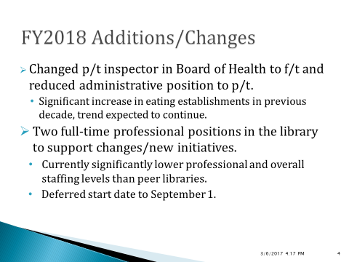

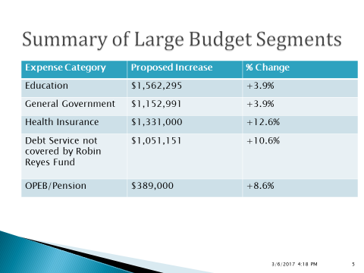

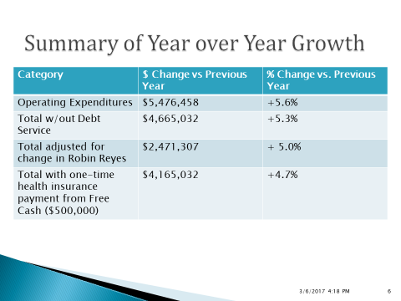

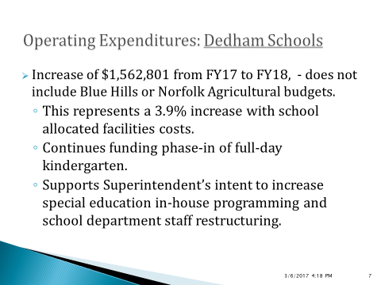

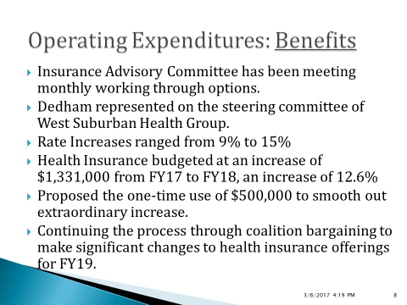

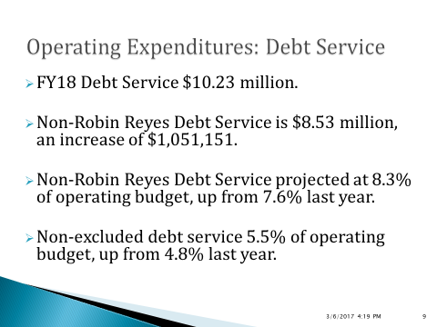

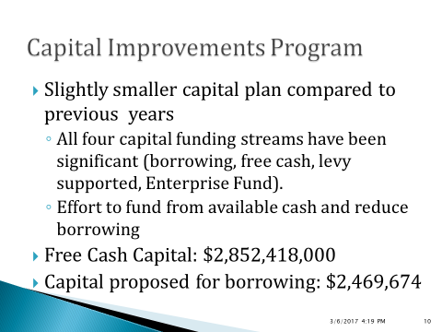

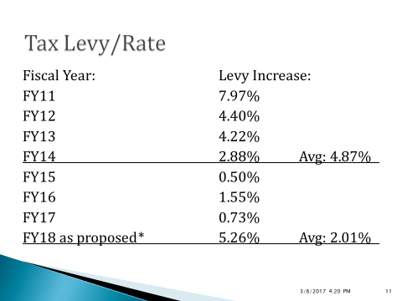

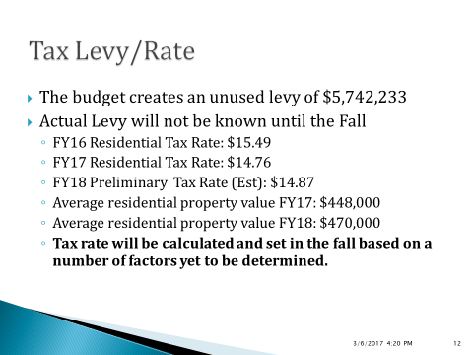

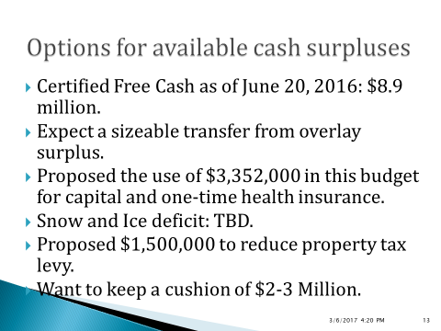

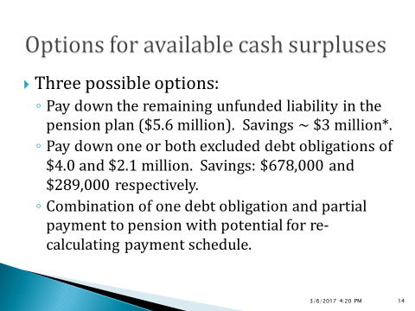

Dr. Teehan clarified that the pension plan option would manifest in FY19 and the excluded debt savings would manifest in FY18.

Mr. Kern stated potentially FY18, correct. Mr. Kern added that it is a complicated but we all went through this process last year, the Board commissioned a public Meeting and took questions via email from residents.

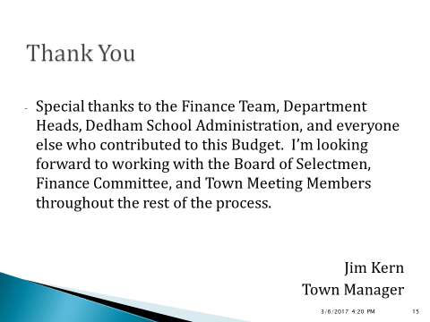

Mr. Kern stated that an awful lot of work has gone in to this process up until now and a lot of work will go into continuing it on the part of almost all volunteers. Mr. Kern added that he appreciates the effort that everyone puts into it, both those who do it as their work and also those who do it as volunteers. Mr. Kern continued, saying that this year was more challenging because of the conversion to a new Financial Management System.

Mr. MacDonald thanked Mr. Kern and the team that put the presentation together. Mr. MacDonald pointed out that this is a huge undertaking that calls for a lot of time, effort and collaboration between the Town, Schools and all the other departments within Town Hall. Mr. MacDonald stated that at the end of the day, when you look at all this information, the important thing to remember is that this Board will set the tax rate next December. The tax rate will be based on what happens at this Town Meeting. Mr. MacDonald informed all that there is a lot of discussion that has to happen with the options for the available surpluses. Mr. MacDonald stated that the Town is lucky to be in the situation to have these kind of conversations and have the Funds available to either pay down pensions or pay down debt. Mr. MacDonald added that the Board has to remember that whatever they do we have to keep in mind what is going to be the best impact for our taxpayers. Mr. MacDonald stated that this Board, working with others, make a good decision last year on the pension. Mr. MacDonald continued, saying that one thing he didn't see in the report was the state assessments, like the retired teacher’s assessment and the MBTA assessment. Mr. MacDonald thanked all that were involved in putting the report together and stated he looks forward to hearing the Finance Committee’s recommendations.

Dr. Teehan stated that one of the things he noticed was the cost of the debt and continued, saying that that is not obviously always a bad thing but it is something that costs the taxpayers. Dr. Teehan added that what the Board heard from last year’s Meeting, where they asked the residents what they should do with the surplus money, was to pay down debt. Dr. Teehan stated that they are faced with a similar decision this year, about how to approach a great problem to have, which is, how we maximize the most back to the taxpayers in the long haul. Dr. Teehan added that he sees the Board receiving a clear mandate, which is to pay down debt. Dr. Teehan stated that whatever the Board decides to do they will be acting in the best Interest of the residents of Dedham.

Mr. Butler clarified that Mr. Kern will present this to the Finance Committee and asked if the Meeting is open to the public.

Mr. Kern stated that it is.

Mr. Butler stated that people are welcome to attend and asked what time the Meeting started.

Mr. Kern responded 8:30 AM in the lower conference room of Town Hall.

Mr. Butler stated that people are encouraged to attend, especially Town Meeting Members.

Mr. Kern stated that he believes the practice of holding this Meeting on a Saturday morning is a good one. Mr. Kern added that Saturday is more convenient for people than trying to get out of the house at seven o'clock on Tuesday night.

Mr. Butler stated that after Mr. Kern's remarks various Department heads come before the Finance Committee throughout the day.

Mr. Kern informed the Board that all department heads will present their budget to the Finance Committee.

**TOWN MANAGER’S REPORT**

Mr. Kern informed all that the second round Interviews for the Council on Aging Director have begun and we have a start date target of April 1, 2017.

Mr. Kern stated that he participated in the Mass Fire Chiefs Association Conference yesterday and it is always good to get out and listen to other people. Mr. Kern added that he was part of a panel that focused on how to best advise Fire Chiefs and their efforts to gain political support and about the whole process of building buildings.

Mr. Kern informed the Board that he spoke with the Board of assessors, about the overlay surplus and will be reaching out to the Town's Retirement Board and the State retirement people to discuss options with the Pension Funding.

Mr. Kern stated that the first coalition collective bargaining session was held yesterday to work towards an agreement for this year and the next two years, regarding the Town's Health Insurance.

**OLD/NEW BUSINESS**

Mr. Butler stated that the Dedham Coalition for Drug and Alcohol Awareness will be producing television episodes to be shown on Dedham Cable-TV in the next year. Mr. Butler added that they're looking for volunteers that are interested in helping with this. Mr. Butler continued, saying that interested residents can contact him or the Public Health Nurse, Jessica Gardner.

Mr. Guilfoyle stated that he went to the Manor Neighborhood Committee Meeting the other night regarding MacDonald Square and there's been some good progress made. Mr. Guilfoyle added that looks like something might get done, finally.

Mr. MacDonald moved to adjourn the Meeting; seconded by Dr. Teehan. **On the Vote:** Mr. Keogh, yes; Dr. Teehan, yes; Mr. Butler, yes; Mr. Guilfoyle, yes; Mr. MacDonald, yes.

The Meeting was adjourned at 8:12 PM.

The next Meeting is scheduled for Thursday, March 16, 2017 at 7p.m. This is to certify that the above is a true and accurate record of the Minutes of the Board of Selectmen’s Meeting held on March 2, 2017, which minutes were approved on March 16, 2017.

________________________

Dennis Guilfoyle – Chairman