A Meeting of the Board of Selectmen was held on Thursday August 24, 2017, at 6:30PM at The Endicott Estate 656 East Street, Dedham, Massachusetts. Present were:

Dennis J. Teehan

James A. MacDonald

Michael L. Butler

Dennis J. Guilfoyle

Brendan G. Keogh

Dr. Teehan called the Meeting to order at 6:34 PM.

**PLEDGE OF ALLEGIANCE**

Led by Dr. Teehan.

**DEDHAM CITIZENS - OPEN DISCUSSION**

There was no open discussion.

**ACTION BY THE BOARD**

**REQUEST BY THE DEDHAM MOOSE LODGE FOR OUTDOOR SERVICE FOR THEIR ONGOING EVENTS: AUGUST 26 & 30, SEPTEMBER 6, 13, 16 & 30, 2017**

Mr. Guilfoyle moved approval; seconded by Mr. Keogh. **On the Vote:** Mr. Keogh, yes; Dr. Teehan, yes; Mr. Butler, yes; Mr. Guilfoyle, yes; Mr. MacDonald, yes.

**REQUEST FOR THE 5TH ANNUAL BLOCK PARTY ON BARROWS STREET – SEPTEMBER 9, 12PM – 6PM, RAIN DATE SEPTEMBER 10**

Mr. Guilfoyle moved approval; seconded by Mr. Keogh. **On the Vote:** Mr. Keogh, yes; Dr. Teehan, yes; Mr. Butler, yes; Mr. Guilfoyle, yes; Mr. MacDonald, yes.

**REQUEST BY SAINT SUSANNAS/SAINT VINCENT de PAUL TO HOLD THE “FRIENDS OF THE POOR WALK, 9/20/17 STARTING AT 9:30AM**

Mr. Guilfoyle moved approval; seconded by Mr. MacDonald. **On the Vote:** Mr. Keogh, yes; Dr. Teehan, yes; Mr. Butler, yes; Mr. Guilfoyle, yes; Mr. MacDonald, yes.

**DRAINLAYER APPLICATIONS**

**Renewal**

C.C. Construction

P.O. Box 1493

South Dennis, MA 02660

**Renewal**

Lawn Barber, Inc.

P.O. Box 2970

Acton, MA 01720

Mr. Keogh moved approval; seconded by Mr. Guilfoyle. **On the Vote:** Mr. Keogh, yes; Dr. Teehan, yes; Mr. Butler, yes; Mr. Guilfoyle, yes; Mr. MacDonald, yes.

**REQUEST FROM DEDHAM ROTARY CLUB TO HANG A BANNER IN DEDHAM SQUARE FROM OCTOBER 2 – 27, ADVERTISING THE 7TH TASTE OF DEDHAM, TAKING PLACE ON OCTOBER 26 FROM 6:30PM – 9PM**

Mr. Guilfoyle moved approval; seconded by Mr. Keogh. **On the Vote:** Mr. Keogh, yes; Dr. Teehan, yes; Mr. Butler, yes; Mr. Guilfoyle, yes; Mr. MacDonald, yes.

**REQUEST FORM THE DEDHAM FRIENDS OF RECREATION FOR A 1 DAY BEER AND WINE LICENSE FOR THE 27TH ANNUAL DEDHAM DAY AT MEMORIAL PARK, SEPTEMBER 24 FROM 12PM – 6PM**

Mr. Guilfoyle moved approval; seconded by Mr. MacDonald. **On the Vote:** Mr. Keogh, yes; Dr. Teehan, yes; Mr. Butler, yes; Mr. Guilfoyle, yes; Mr. MacDonald, yes.

Ms. Baker informed the Board that she received a notice from Mr. Elfar, who operated a Secondhand Dealer’s license at 920 Providence Hwy., Edward Elfar jewelry and art gallery. Mr. Elfar has notified the Town Manager’s office that the property is coming down as part of a redevelopment of the site and he has returned his license to the Town and is no longer operating.

Mr. MacDonald moved to rescind the license that was turned in by the Edward Elfar jewelry and art gallery; seconded by Mr. Guilfoyle. **On the Vote:** Mr. Keogh, yes; Dr. Teehan, yes; Mr. Butler, yes; Mr. Guilfoyle, yes; Mr. MacDonald, yes.

**MINUTES APPROVAL – 7/13/17 & 8/2/17**

Mr. Guilfoyle moved approval; seconded by Mr. MacDonald. **On the Vote:** Mr. Keogh, yes; Dr. Teehan, yes; Mr. Butler, yes; Mr. Guilfoyle, yes; Mr. MacDonald, yes.

**DISCUSSION AND VOTE RE; DEDHAM FINANCIAL NEWSLETTER**

Dr. Teehan informed all that the Board agrees that they had to do a better job of communicating and being transparent with their constituents regarding what is going on in Town Hall, how our taxes are working, etc. Dr. Teehan added that Mr. Butler worked diligently with several staff members at Town Hall and put together a Financial Newsletter. Dr. Teehan asked Mr. Butler to explain this Financial Newsletter a little bit more in detail.

Mr. Butler informed all that a working group was formed at Town Hall, which included Town Manager Jim Kern, Director of Finance Andrea Terkelsen and Economic Development Director, John Sisson. Mr. Butler added that to begin they took a look at what other communities were doing and how they get the message out to their residents regarding how their tax dollars were being spent. The working group looked at a few communities close to Dedham as well as a few communities in other parts of the country. Mr. Butler continued saying that once they compiled all the information they turned to John Sisson for some editing and then to Lisa Bazinet to format all this information.

Mr. Butler informed all that what they have tonight is pretty close to the final version that will go out to taxpayers. Mr. Butler added that the Newsletter will be on the website in the next few days. Mr. Butler continued, saying that this Newsletter will be inserted into the next tax bills that go to every resident Dedham. Mr. Butler proceeded to give a summary of what will be included in the Newsletter. Mr. Butler added that he hopes the residents find this informative and also encourage people to give the Board suggestions regarding how they may do things the next year.

Dr. Teehan asked Mr. Kern if he had anything to add. Mr. Kern repeated the appreciation to the people that contributed to this Newsletter and added that if people have questions after reading this Newsletter they can go on to the website or contact the Town Manager, Director of Finance and other people that were involved in this project directly.

Mr. Butler added layout was most important part of this Newsletter. Mr. Butler stated that this was the best first draft he seen in terms of graphic design and all credit goes to Lisa Bazinet. As Butler continued, saying that there are a few more tweaks to be made.

Dr. Teehan asked if this letter will go out in October.

Mr. Butler stated that tax bills usually go out in mid-September.

Dr. Teehan informed all that the vote they are taking tonight will authorize including Newsletter with the tax bill.

Mr. Guilfoyle moved approval to include the Financial Newsletter with the next tax bill; seconded by Mr. MacDonald. **On the Vote:** Mr. Keogh, yes; Dr. Teehan, yes; Mr. Butler, yes; Mr. Guilfoyle, yes; Mr. MacDonald, yes.

**DISCUSSION & VOTE RE: FUN RUN REQUEST WITH DAN O’NEILL**

Mr. O’Neill stated that the races will start and finish from Condon Park as opposed to Mother Brook. Mr. O’Neil added that the races will take place on October 7 and December 9, 2017.

Mr. MacDonald moved approval for the Fun Run Series as described by Mr. O’Neil again this year on October 7 and December 9; seconded by Mr. Guilfoyle. **On the Vote:** Mr. Keogh, yes; Dr. Teehan, yes; Mr. Butler, yes; Mr. Guilfoyle, yes; Mr. MacDonald, yes.

**DISCUSSION & VOTE RE: EDITS TO H3752 (DEDHAM PLAZA LIQUOR LICENSES**

Ms. Baker informed all that the Town received notice from Jody in Representative McMurtry’s office that there has been some changes to the language as presented to the legislature and as has been the case in the past, with the Board, it has been forwarded to Town Council, who has approved the changes. Ms. Baker added that they are non-substantive and do not require a second shot through Town Meeting.

Mr. Keogh moved that the Board accept the changes to H3752; seconded by Mr. Guilfoyle. **On the Vote:** Mr. Keogh, yes; Dr. Teehan, yes; Mr. Butler, yes; Mr. Guilfoyle, yes; Mr. MacDonald, yes.

Mr. McDonald stated that the Board receives quite a few requests through Town Meeting for special legislation for alcohol licenses and it seems like it has been 10+ years that the fee has been $5000 designated to go into the Economic Development Fund. Mr. McDonald added that the value of these licenses continue to increase and the needs for the Economic Development Fund for the Town to continue to grow. Mr. McDonald stated that he is looking for an increase in the fee for these legislated alcohol licenses.

**DISCUSSION & VOTE RE: CHANGE OF OFFICERS & DIRECTORS FOR UNO RESTAURANT LLC, D/B/A UNO CHICAGO GRILL, 270 PROVIDENCE HIGHWAY**

Mr. McDonnell recused himself for the next three agenda items as they may go before the ABCC.

Edwin Bradt, UNOs Manager, was present before the Board. Mr. Bradt read the following statement from UNO Restaurant LLC:

The changes being recorded via the change in beneficial interest’s application which represents an update in ownership of the licensed parent company known as UNOs Restaurants Holdings Corporation. The changes taking place are three levels above the licensed entity within the holding company structure, a current private equity company, a shareholder through its respective funds, which is what to be known as Newport Capital, now holds 16% ownership of UNOs Restaurant Holdings Corporation and will hold 55% ownership of such entity under the new company structure. Another publicly traded entity, Fidelity National Title Insurance Company will hold the remaining 15% ownership of UNOs Restaurant Holdings Corporation as part of the changes taking place. Note that there are no changes in officers, directors or premises Managers and there are no changes in the shareholders license entity being reported. Finally, there are no updates to the premises or its current method of operations.

Ms. Baker informed all that this is part of a statewide filing for all the holdings with Chicago Grill and requires a vote of the Board for the ABCC.

Mr. Guilfoyle moved approval; seconded by Mr. Butler. **On the Vote:** Mr. Keogh, yes; Dr. Teehan, yes; Mr. Butler, yes; Mr. Guilfoyle, yes; Mr. MacDonald, yes.

**DISCUSSION & VOTE RE: COMCAST STATEMENT OF DENIAL**

Ms. Baker informed all that the Cable Advisory Committee has been has met on at least two occasions with Comcast as their license to do business in the Town of Dedham is due to be renewed. Attorney Epstein is recommending that the Board issue a preliminary assessment of denial, it is not a firm OR are a final denial it is a notice to Comcast so that the Committee, Attorney Epstein and the representatives from Comcast can get back to the table and negotiate an appropriate renewal license before the current license expires. Ms. Baker added that this vote is to simply put Comcast back on notice that the Town would like to get back to the seriousness of the negotiations to get a new license negotiated before the current license expires. If the Committee has further recommendations, Comcast will then appear before the Board, with Attorney Epstein, to bring the Board up to date.

Mr. Keogh recused himself as he is employed by Communication Company which could put him into conflict.

Mr. Butler moved that the Board issue a preliminary assessment of denial to Comcast; seconded by Mr. MacDonald. **On the Vote:** Mr. Keogh, Abstained; Dr. Teehan, yes; Mr. Butler, yes; Mr. Guilfoyle, yes; Mr. MacDonald, yes.

**DISCUSSION & VOTE RE: APPOINTMENTS TO SUSTAINABILITY COMMITTEE**

Ms. Baker informed all that there were two postings to encourage applicants to apply to the Sustainability Committee and a total of six positions are available for consideration. Ms. Baker added that the Board received a total of 10 applications and of those 10 applications, three of them are incumbent members of the Committee:

Mr. Hafrey

Mr. Kabat

Ms. Harrison

Ms. Baker continued, saying that there are six positions total to be reappointed or appointed.

Mr. Keogh moved to put all the names into nomination; seconded by Mr. MacDonald. **On the Vote:** Mr. Keogh, yes; Dr. Teehan, yes; Mr. Butler, yes; Mr. Guilfoyle, yes; Mr. MacDonald, yes.

Mr. McDonald voted as follows:

Leigh Hafrey incumbent

Charles Kabat incumbent

Deb Harrison incumbent

Clarissa Robyn

Emily Walton

Scott Thompson

Mr. Keogh voted as follows:

Leigh Hafrey incumbent

Charles Kabat incumbent

Deb Harrison incumbent

Clarissa Robyn

Emily Walton

Diane Young

Mr. Butler voted as follows:

Leigh Hafrey incumbent

Charles Kabat incumbent

Deb Harrison incumbent

Matt Simonson

Emily Walton

Clarissa Robyn

Mr. Guilfoyle voted as follows:

Leigh Hafrey incumbent

Charles Kabat incumbent

Deb Harrison incumbent

Scott Thompson

Clarissa Robyn

Matt Simonson

Dr. Teehan voted as follows:

Leigh Hafrey incumbent

Charles Kabat incumbent

Deb Harrison incumbent

Larissa Robyn

Matt Simonson

Scott Thompson

Mr. McDonald stated that it is great to have 10 applications for the six positions on the Sustainability Committee. Mr. McDonald added that regardless of the final tally we should make sure as a Board that we express our thanks to all those that submitted a resume and came before the Board to give a statement.

Ms. Baker informed all that the following applicants have received five votes:

Leigh Hafrey incumbent

Charles Kabat incumbent

Deb Harrison incumbent

Larissa Robyn

Ms. Baker added that there is a three-way tie and asked the Board to consider the following applicants for the final two positions:

Matt Simonson

Scott Thompson

Emily Walton

Mr. McDonald voted for the following applicants:

Emily Walton

Matt Simonson

Mr. Keogh voted for the following applicants:

Emily Walton

Scott Thompson

Mr. Butler voted for the following applicants:

Emily Walton

Matt Simonson

Mr. Guilfoyle voted for the following applicants:

Matt Simonson

Scott Thompson

Dr. Teehan voted for the following applicants:

Matt Simonson

Scott Thompson

Ms. Baker informed all that there is another tie. Ms. Baker added that Matt Simonson is now the fifth appointee.

The last vacancy is between Emily Walton and Scott Thompson.

Mr. McDonald voted for the following applicant:

Emily Walton

Mr. Keogh voted for the following applicant:

Emily Walton

Mr. Butler voted for the following applicant:

Emily Walton

Mr. Guilfoyle voted for the following applicant:

Scott Thompson

Dr. Teehan voted for the following applicant:

Emily Walton

Ms. Baker stated that the following applicants have been recommended for appointment by the Board:

Leigh Hafrey incumbent

Charles Kabat incumbent

Deb Harrison incumbent

Clarissa Robyn

Matt Simonson

Emily Walton

Mr. Guilfoyle moved to accept all the nominees for the vacancies in the Sustainability Committee; seconded by Mr. MacDonald. **On the Vote:** Mr. Keogh, yes; Dr. Teehan, yes; Mr. Butler, yes; Mr. Guilfoyle, yes; Mr. MacDonald, yes.

**DISCUSSION & VOTE RE: 2017 FALL TOWN MEETING DATE & DATE TO CLOSE THE WARRANT**

Ms. Baker informed all that the Charter allows for a Town Meeting in the spring and the fall. Ms. Baker added that she is recommending that Town Meeting be held on Monday, November 13, 2017 and that the warrant, for said Town Meeting on Friday, September 8, 2017 at the close of business.

Mr. MacDonald moved to close the warrant on September 8, 2017 and to hold Town Meeting on November 13, 2017; seconded by Mr. Keogh. **On the Vote:** Mr. Keogh, yes; Dr. Teehan, yes; Mr. Butler, yes; Mr. Guilfoyle, yes; Mr. MacDonald, yes.

**TOWN MANAGER’S REPORT**

A lot of time being spent on both building projects.  I’m going to do the Ames last:

Mr. Kern informed all that Constellation New Energy, who acquired Con Edison, reported a billing error that affected most residents of Dedham.  Mr. Kern added that a letter went out yesterday to all accounts stating that a 10% refund will be included on top of next month’s billing statement error correction.

Mr. Kern stated that Mr. Polito, the representative to Blue Hills, let him know today that MSBA approved the sizable renovation of the school. Mr. Kern added that this will require all nine communities that contribute students to Blue Hills to approve it individually at the Fall Town Meeting.

Mr. Kern stated that he met briefly with General Counsel regarding the marijuana moratorium and possible approaches on the marijuana question.  Mr. Kern added that the chairman may want to cover it here or in New/Old Business.

Mr. Kern informed all that the oral arguments in regards to the pipeline – FERC - lawsuit will be heard on October 19, 2017 in Washington DC at the district court.

Mr. Kern mentioned that the Town has created a list of properties to pursue under the abandoned housing initiative. Mr. Kern added that he will be updating the Board as needed.

Mr. Kern stated that in light of the delayed expected completion of the new Senior Center/Town Hall, he has been attending, along with the owner of the company, the weekly construction Meetings. Mr. Kern added that he has also been attending Meetings regarding structural issues that were being identified as not being clarified sufficiently. Mr. Kern continued, saying that he has been spending some effort making sure that clarification is not an issue and will continue to monitor the situation closely. Mr. Kern informed all that he expects to have a better idea of when the project will be complete by next week.

Dr. Teehan stated that it sounds like there is little bit of uncertainty right now as to when the final chapter of this story will be completed. Dr. Teehan asked the other Board members if they want to have someone from the construction company come to a future Meeting or if it is sufficient to have Mr. Kern continue attending the weekly Meetings and report back.

Mr. Guilfoyle stated that he would definitely like to have somebody come in to give the Board a rundown on what is going on.

Mr. Keogh stated that he is in favor of having someone come in to give the Board and update.

Mr. McDonald stated that this should be an agenda item for every Meeting from now until the move in. Mr. MacDonald suggested that the Board have a specific list of what they want they want covered and send it to the Town Manager to be forwarded to the OPM.

Mr. Butler asked Mr. Kern Chief if he was meeting with the OPM next week.

Mr. Kern answered yes Wednesday morning.

Mr. Butler suggested that the Board submit their questions to Mr. Kern by Tuesday so he can be prepared for the Meeting on Wednesday. Mr. Butler agreed that this should be an agenda item for every Meeting going forward. Mr. Butler stated that the completion date had been mid-September and as of the last Selectmen’s Meeting and have been moved to mid-November. Mr. Butler continued, saying that one of the primary reasons for this was due to a labor shortage.

Dr. Teehan stated that the purpose of this is not to look back but look forward to get this done as appropriately and efficiently as possible. Dr. Teehan summarized by stating three take-home items:

1. This will be an agenda item for every Meeting until the building opens
2. The Board will have someone in from the construction company at the next Meeting to answer questions from the Board
3. The Board will prepare questions for Mr. Kern to ask the OPM next Wednesday

Mr. Kern suggested including the Chairman of the BPCC.

**DISCUSSION & VOTE RE: TRSANSFER OF ALL ALCOHOL RESTAURANT LICENSE FROM YARDHOUSE DEDHAM, LLC, D/B/A YARDHOUSE TO YARD HOUSE USA, INC. D/B/A YARDHOUSE, 200 LEGACY PLACE**

Mr. MacDonald recused himself for the next two agenda items as they will go before the ABCC.

Joe Devlin, Attorney for Yard House, and Megan Kirk, General Manager for Yard House, were present before the Board. Mr. Devlin summarized the request saying a Yard House was purchased by Darden Restaurants, the largest restaurant owner in the world. Mr. Devlin added that Darden owns the Olive Garden among other well-known restaurants. Mr. Devlin informed the Board that it is the same slate of officers that they have at all their other locations. Mr. Devlin stated there are 55 Yard House Restaurants nationally with three in Massachusetts. Mr. Devlin stated that nothing is changing at the Legacy Place location.

Mr. Butler moved approval of the transfer of the All Alcoholic Restaurant license from Yard House Dedham, LLC, d/b/a Yard House to Yard House USA, Inc., d/b/a Yard House, 200 Legacy Pl.; seconded by Mr. Guilfoyle. **On the Vote:** Mr. Keogh, yes; Dr. Teehan, yes; Mr. Butler, yes; Mr. Guilfoyle, yes; Mr. MacDonald, Abstained.

**DISCUSSION & VOTE RE: TRANSFER OF ALL ALCOHOLIC RESTAURANT LICENSE FROM SUPREME RESTAURANT GROUP, INC., TO RAAL CORPORATION D/B/A EL CENTRO, 338 WASHINGTON STREET (FKA) 350 WASHINGTON STREET) & APPROVAL OF SOPHIA ISLAM AS MANAGER**

Peter Zahka, was present on behalf of RAAL Corporation d/b/a El Centro. Mr. Zahka introduced Ravi Islam, the owner of the Corporation and El Centro as well as Sophia Islam, the proposed Manager of record.

Mr. Zahka informed all that the applicants are looking to open a New Mexican restaurant, known as El Centro with approximately 3300 ft.² on the first floor at 338 Washington, FKA 350 Washington Street. Mr. Zahka stated that his clients have owned and operated restaurants since 2005 with El Centro being the fourth. Mr. Zahka added that his clients are proud of their record as it pertains to alcohol service. In their three Restaurants since 2005 they’ve never had a violation. Mr. Zahka continued, saying that as you can see by the floorplan my clients are proposing 100 seats which includes 18 seasonal outdoor seats, which will be gated. Mr. Zahka informed all that there is a bar but it is typically used by patrons dining alone or waiting. The anticipated foods to alcohol ratio is 80% to 20%. Mr. Zahka added that the hours of operation will be 11 AM to 3 PM for lunch and 5 PM to 10 PM for dinner and they will stay open until 11 PM Friday and Saturday. Mr. Zahka continued, saying that approvals by the planning Board and the Zoning Board of appeals have been attained. Mr. Zahka handed out pictures of the Belmont restaurant location.

Mr. Zahka stated that Sophia Islam is the proposed Manager of record and she has been in the restaurant business, with her husband, since 2005. Ms. Islam has filled every role imaginable in a restaurant. Mr. Zahka added that Ms. Islam reviewed and understands Dedham’s alcohol rules and regulations and she is TIPS certified. Mr. Zahka continued, saying that Ms. Islam plans on being at the Dedham restaurant a minimum of 50 hours per week. Mr. Zahka informed the Board that his clients have a policy that goes in their employee handbooks which outlines their alcohol service policies at their other restaurant locations, which will be modified for the Dedham location. Mr. Zahka stated that his clients will be incorporating ID scanners everyone who comes in will be ID and anyone appearing under 25 will have to produce a second means of identification. Mr. Zahka stated that they will answer any questions the Board may have.

Mr. Butler asked Ms. Islam if she had experience as a Manager of record.

Ms. Islam answered no, this is the first time as Manager of record.

Mr. Butler asked Ms. Islam how she handles intoxicated customer.

Ms. Islam answered that she would make sure that the customer is comfortable and isn’t causing a scene and makes sure that they get home safely and responsibly. Ms. Islam added that Chief takes this issue very seriously.

Mr. Guilfoyle stated that he is glad to hear that they are getting a scanner, a costly but effective tool. Mr. Guilfoyle suggested that Ms. Islam make an appointment to meet with alcohol Police Ofc. Michael Buckley.

Ms. Islam stated that she already has his card.

Mr. Keogh stated that he thinks there responsible service alcohol policy is tremendous and suggested monthly meetings to go along with their weekly Meetings.

Mr. Keogh asked when they plan to open a restaurant.

Mr. Islam stated probably three months.

Mr. Butler moved approval of the transfer of the all Alcoholic Restaurant License from Supreme Restaurant Group Inc., to RAAL Corporation D/B/A El Centro, 338 Washington St. (FKA 350 Washington St.); seconded by Mr. Guilfoyle. **On the Vote:** Mr. Keogh, yes; Dr. Teehan, yes; Mr. Butler, yes; Mr. Guilfoyle, yes; Mr. MacDonald, abstained.

Mr. Butler moved approval of Sophia P. Islam as Manager of El Centro restaurant, 338 Washington St.; seconded by Mr. Guilfoyle. **On the Vote:** Mr. Keogh, yes; Dr. Teehan, yes; Mr. Butler, yes; Mr. Guilfoyle, yes; Mr. MacDonald, abstained.

**RECOGNITION OF DEDHAM SUMMER 8’S BASEBALL TEAM**

Dr. Teehan stated the Board wanted to have in Dedham Summer 8’s baseball team in because it was such an amazing run this year for them. Dr. Teehan proceeded to read a letter from Kevin Doyle regarding the Dedham Summer 8’s baseball team.

Dan Maher, Manager of the Dedham Summer 8’s Baseball Team, introduced his coaches:

Kevin Doyle

Ben White

Bob Bogie

Jamie Gallagher

Mr. Maher stated that they had the summer of their lives and it started out by hosting a tournament here in Dedham and then they just started winning games and kept on winning. Mr. Maher added that every game had a new hero. Mr. Maher continued, saying that they kept telling the boys to play Dedham baseball. Dedham baseball means:

1. Give 100% all the time
2. Be respectful of the umpires
3. Be respectful of your opponents
4. Bring a high level of sportsmanship to the field
5. Be a good teammate and make sure you are always having fun

Mr. Maher and the coaches told the boys when they go to these different locations that they are not only representing themselves, they are representing Dedham Youth Baseball and more importantly the Town of Dedham.

Mr. Maher informed all that Instead of putting an emphasis on winning or losing, they emphasized these five things. Mr. Maher stated that he is extremely proud of the boys.

The Board then gave the coaches and players certificates of recognition.

**OFFICIAL SWEARING-IN OF POLICE OFFICERS JOHN TWOMEY & MEGHAN JENKINS**

Police Chief Michael D’Entremont introduced John Twomey, who is closing in on the end of his field training. Chief D’Entremont informed all that he graduated from the Boston Police Academy back at the end of June. Chief D’Entremont informed all that Mr. Twomey is a 2008 graduate of Dedham High School and received a community service award at graduation. Mr. Twomey also played soccer and ran track. In 2011, Mr. Twomey earned a bachelor’s degree from Westfield State majoring in Criminal Justice. Chief D’Entremont informed all that Mr. Twomey’s work experience included time with the Oak Bluffs Police Department working as a Traffic Officer and later as a Special Police officer. Chief D’Entremont added that Mr. Twomey completed an internship with the Montgomery County Public Defender’s Office in Washington DC. Chief D’Entremont stated that Mr. Twomey is doing a fine job at this point in time and he will very shortly he will be patrolling the Town.

Chief D’Entremont introduced Meghan Jenkins who just graduated from the Reading Police Academy on August 15. Chief D’Entremont added that at graduation Ms. Jenkins was presented with the defensive tactics award for her work at the Academy. Chief D’Entremont continued, saying that Ms. Jenkins is currently assigned to field training, writing that officer Ken Ellis. Ms. Jenkins is a 2007 graduate of Dedham High School, where she played softball and soccer and ran track. In 2011 Ms. Jenkins earned a Bachelor’s Degree in Criminal Justice with a minor in psychological service from Fitchburg State. Chief D’Entremont informed all that Ms. Jenkins’ work experience includes a few years with Suffolk County Sherrif’s office as a Corrections Officer, Security Officer with Longwood Security and an internship with the Ayer Police Department.

Paul Munchbach, Dedham’s Town Clerk, proceeded to swear in officers Twomey and Jenkins.

Mr. Guilfoyle stated that the new officers should listen to the supervisors as the Department has a great group of people out there. Mr. Guilfoyle emphasized that the new officers should use their common sense. Mr. Guilfoyle added that it’s all about coming to work and doing a great job for the Town of Dedham and going home to your family at night.

Mr. Butler congratulated officers Twomey and Jenkins and stated that it is always a highlight during the year to welcome new Public Safety Officers. Mr. Butler added that the added scrutiny on Police Officers makes the job harder than it has ever been. Mr. Butler stated that he expects that Officers Twomey and Jenkins will follow the great example of the Lieutenants and the Chief.

Mr. Keogh congratulated the two new officers and thanked their families for all the support.

Mr. MacDonald congratulated the two new officers and welcomed them into the best Police force in the Commonwealth. Mr. McDonald added that the job is a lot different today than in the past which can add additional stress. Mr. McDonald continued, saying that the Town is lucky to have the Police Chief who is a great mentor as well as are the Sergeants and Lieutenants. Mr. McDonald told officers Twomey and Jenkins that his goal is that they each have a long healthy career with the Town of Dedham and are able to retire at some point.

Dr. Teehan stated that to be a Police Officer in 2017 you have to wear many hats and that speaks to the challenges of the career ahead of you. Dr. Teehan added that this Board is committed to providing you and other new officers the best support possible so you can go out and do your job.

Dr. Teehan asked the officers to point out any family they had in the audience.

Officer Twomey recognized his father Kevin and his mother Susan and went on to thank his family for putting up with him while he was at the Academy for seven months. Officer Twomey went on to thank the Police Department for giving him this opportunity and is looking forward to the next 32 years. Officer Twomey added that he has lived in Dedham his whole life and is looking forward to making it a better place.

Officer Jenkins recognized her parents, Paul and Mary Jenkins as well as her Grandfather Tim Sullivan. Ms. Jenkins added that she has also lived in Dedham her whole life and is very excited for this opportunity. Ms. Jenkins thanked the Board and for all the support from her family and added that she is proud to wear this uniform and to begin her career.

**OFFICIAL SWEARING-IN OF DEPUTY FIRE CHIEF FRED LOEWEN, LIEUTENANT MICHAEL GREALY & FIREFIGHTERS KEN REESE, SEAN RIVERS & RICHARD ARCHIBALD**

Dedham Fire Chief William Spillane, stated that this is another exciting night for the Dedham Fire Department as he will introduce Dedham’s three newest Firefighters: Firefighter Ken Reese, Firefighter Sean Rivera and Firefighter Richard Archibald. Chief Spillane informed all that the new Firefighters are all veterans of the US military and recently completed the 10 week program over at the Brookline Fire Academy. Chief Spillane added that during the program they went through some stressful times learning the fundamentals of what it means to be a Firefighter. Chief Spillane stressed that their training continues every single day that they should listen to their superiors who have much more experience than they do. Chief Spillane informed all that they been on the trucks for about a month and have been outstanding.

Paul Munchbach, Dedham’s Town clerk, swore in Ken Reese. Firefighter Reese’s wife proceeded to pin him.

Paul Munchbach, Dedham’s Town clerk, swore in Sean Rivera. Firefighter Rivera’s training officer proceeded to pin him.

Paul Munchbach, Dedham’s Town clerk, swore in Richard Archibald. Firefighter Archibald’s father proceeded to pin him.

Chief Spillane informed all that Fire Department has two candidates that are being promoted. First is Lieut. Michael Grealy who is a 26 year veteran of the Dedham Fire Department and since being promoted he has been assigned to the Fire Prevention Office to handle inspections throughout the Town. Chief Spillane added that Lieut. Grealy has had the good fortune over the last 12 years to work with one of the best in the business, John Fontaine.

Paul Munchbach, Dedham’s Town Clerk, swore in Lieut. Grealy. Lieut. Grealy was pinned by his daughter.

Chief Spillane introduced Deputy Chief Fred Loewen. Chief Spillane stated that he has made 13 promotions over the five years he’s been Chief and this is probably his favorite. Chief Spillane added that he has worked with Fred a long time and it’s been great to see Fred’s determination coming up through the ranks. Deputy Chief Loewen has spent hours and hours and months and months of studying and dedication to get to this point of his career.

Paul Munchbach, Dedham’s Town Clerk, swore in Deputy Chief Loewen. Deputy Chief Loewen was pinned by his father, Retired Firefighter Frederick Loewen.

Dr. Teehan opened the floor to the new Firefighters, Lieut. Greely and Deputy Chief Loewen.

Firefighter Ken Reese stated that his wife Emily was with them this evening. Firefighter Reese added that he himself is not a Dedham native but his wife’s family has a long history in Dedham. Firefighter Reese continued, saying that they are so glad to have the opportunity to live and work in this Town. Firefighter Reese informed all that without his wife this would not been possible.

Firefighter Sean Rivera stated that his family could not attend this evening due to a prior commitment. Firefighter Rivera added that it is a blessing to be here tonight and feels fortunate to be able to work in the Town that he grew up in. Firefighter Rivera continued, saying that this is a humbling experience and intends to give the Town his best.

Firefighter Richard Archibald stated that his parents, Richard and Susan, were with them this evening and thanked them for their continued support. Firefighter Archibald informed all that he is a lifelong Dedham native and is very happy to be part of the fire Department and he appreciates the opportunity.

Lieut. Michael Grealy stated that his three daughters, his wife, his sister, his niece, his uncle John (a detective with the Boston Police Department), and his brother-in-law Dennis Kane (a member of engine 33 - Boston fire Department). Lieut. Greely thanked his entire family and his brother Firefighters for their help and pushing them through the years of studying in the daily grind.

Deputy Chief Fred Loewen stated that he has too any family members present to name. Deputy Chief Loewen congratulated the newest Firefighters stating he’s worked with them and they are fine men. Deputy Chief Loewen also congratulated Lieut. Grealy. Deputy Chief Loewen thanked his family, his parents and most importantly his wife Marie who has been beside him for 40 years.

Dr. Teehan opened the floor for comments from the Board.

Mr. Keogh thanked the firefighters for their service and also thanked the families for their support. Mr. Keogh added that his brother is a Boston Firefighter so he understands the work you’ve put in to get to this point.

Mr. McDonald told the new firefighters that this is the best job in the world and you have the best Department to work with. Mr. McDonald informed all that his brother is a Boston Firefighter. Mr. McDonald added that this Department has terrific officers and a dedicated Chief and they will help and guide you through tough situations. Mr. McDonald continued, saying that the new Firefighters should fall back on their training and they should also listen to their superiors. Mr. McDonald stated that the job is a dangerous one and told him to be safe. Mr. McDonald added that he hopes you all have a long career and enjoy retirement.

Mr. Guilfoyle thanked the new Firefighters for choosing to serve the Town of Dedham. Mr. Guilfoyle advised the new firefighters to pay attention to their superiors and follow their lead. Mr. Guilfoyle urged them to use common sense and to be safe. Mr. Guilfoyle congratulated Lieut. Greely and Chief Deputy Loewen on their hard work and dedication to get to this point.

Mr. Butler congratulated the three new firefighters and added that he has seen time and time again how the more experience firefighters lead the way for the new firefighters. Mr. Butler continued, saying that it is a demanding job day in and day out and urged them to never give up.

Dr. Teehan stated his thanks to the new Firefighters, the Lieut. and the Deputy Chief. Dr. Teehan added that it is a great job but a tough one. Dr. Teehan continued, saying that he didn’t realize how tough it was until he started working as a doctor with the Boston Fire Department. Dr. Teehan wished the new firefighters all the best in their careers and the new Lieut. and Deputy Chief the best in the new positions.

**DISCUSSION WITH DORE & WHITTER, ARCHITECS RE: PROPOSED PUBLIC SAFETY BUILDING**

Dr. Teehan stated that this is a critical project for the future of Dedham and he supports it emphatically. Dr. Teehan added that he thinks it is important for this presentation to be made to the Board in open session to give some background as to how we got to this point. Dr. Teehan continued, saying that Brad Doer will be giving the presentation and then there will be a discussion period.

Mr. Dore stated that he wants to give everyone a chance to understand the process and also as a note of the process is not finished. Mr. Dore added that they are at a relatively early stage in the overall design. Mr. Dore continued, saying that they have an opportunity to spend an awful lot of time with the Chiefs and their men to start to understand what the function of the building is, how the building will be used and to start to understand the site. Mr. Dore informed all that this is a very important building/project for Dedham as the current facilities are challenged.

Mr. Dore gave the following PowerPoint presentation:



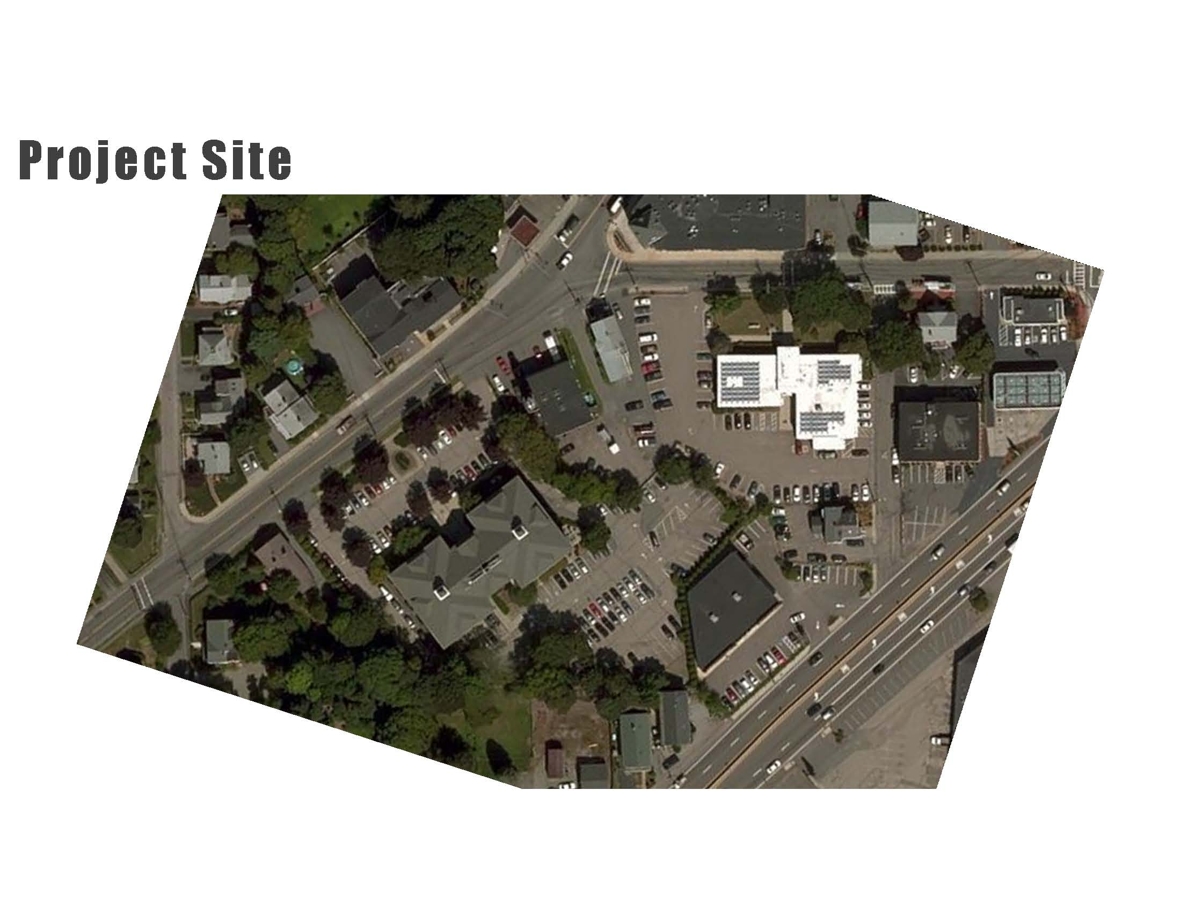

Town Hall – Replaced By Public Safety Building

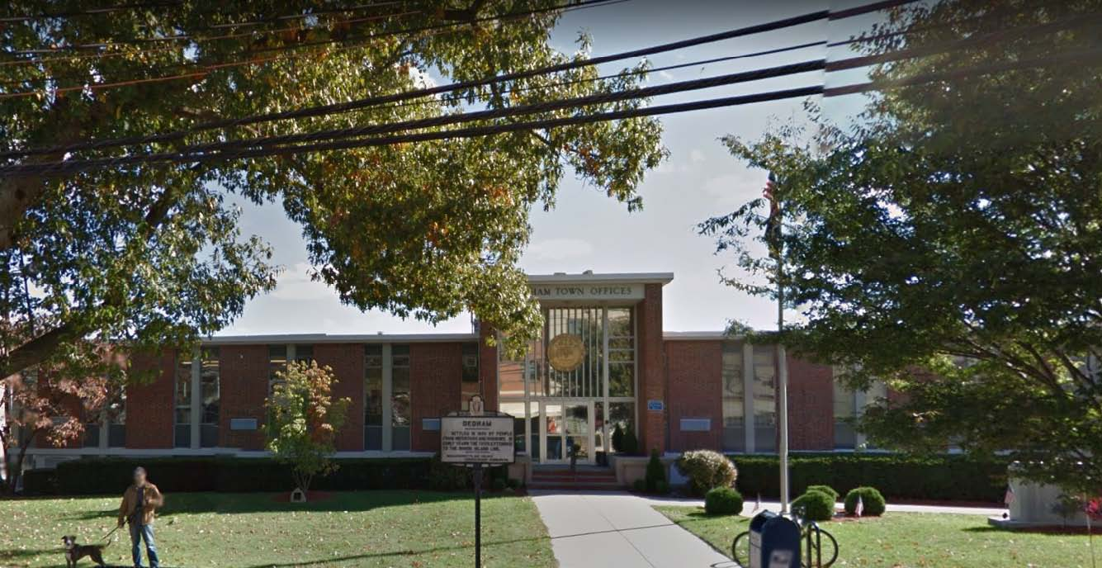

.

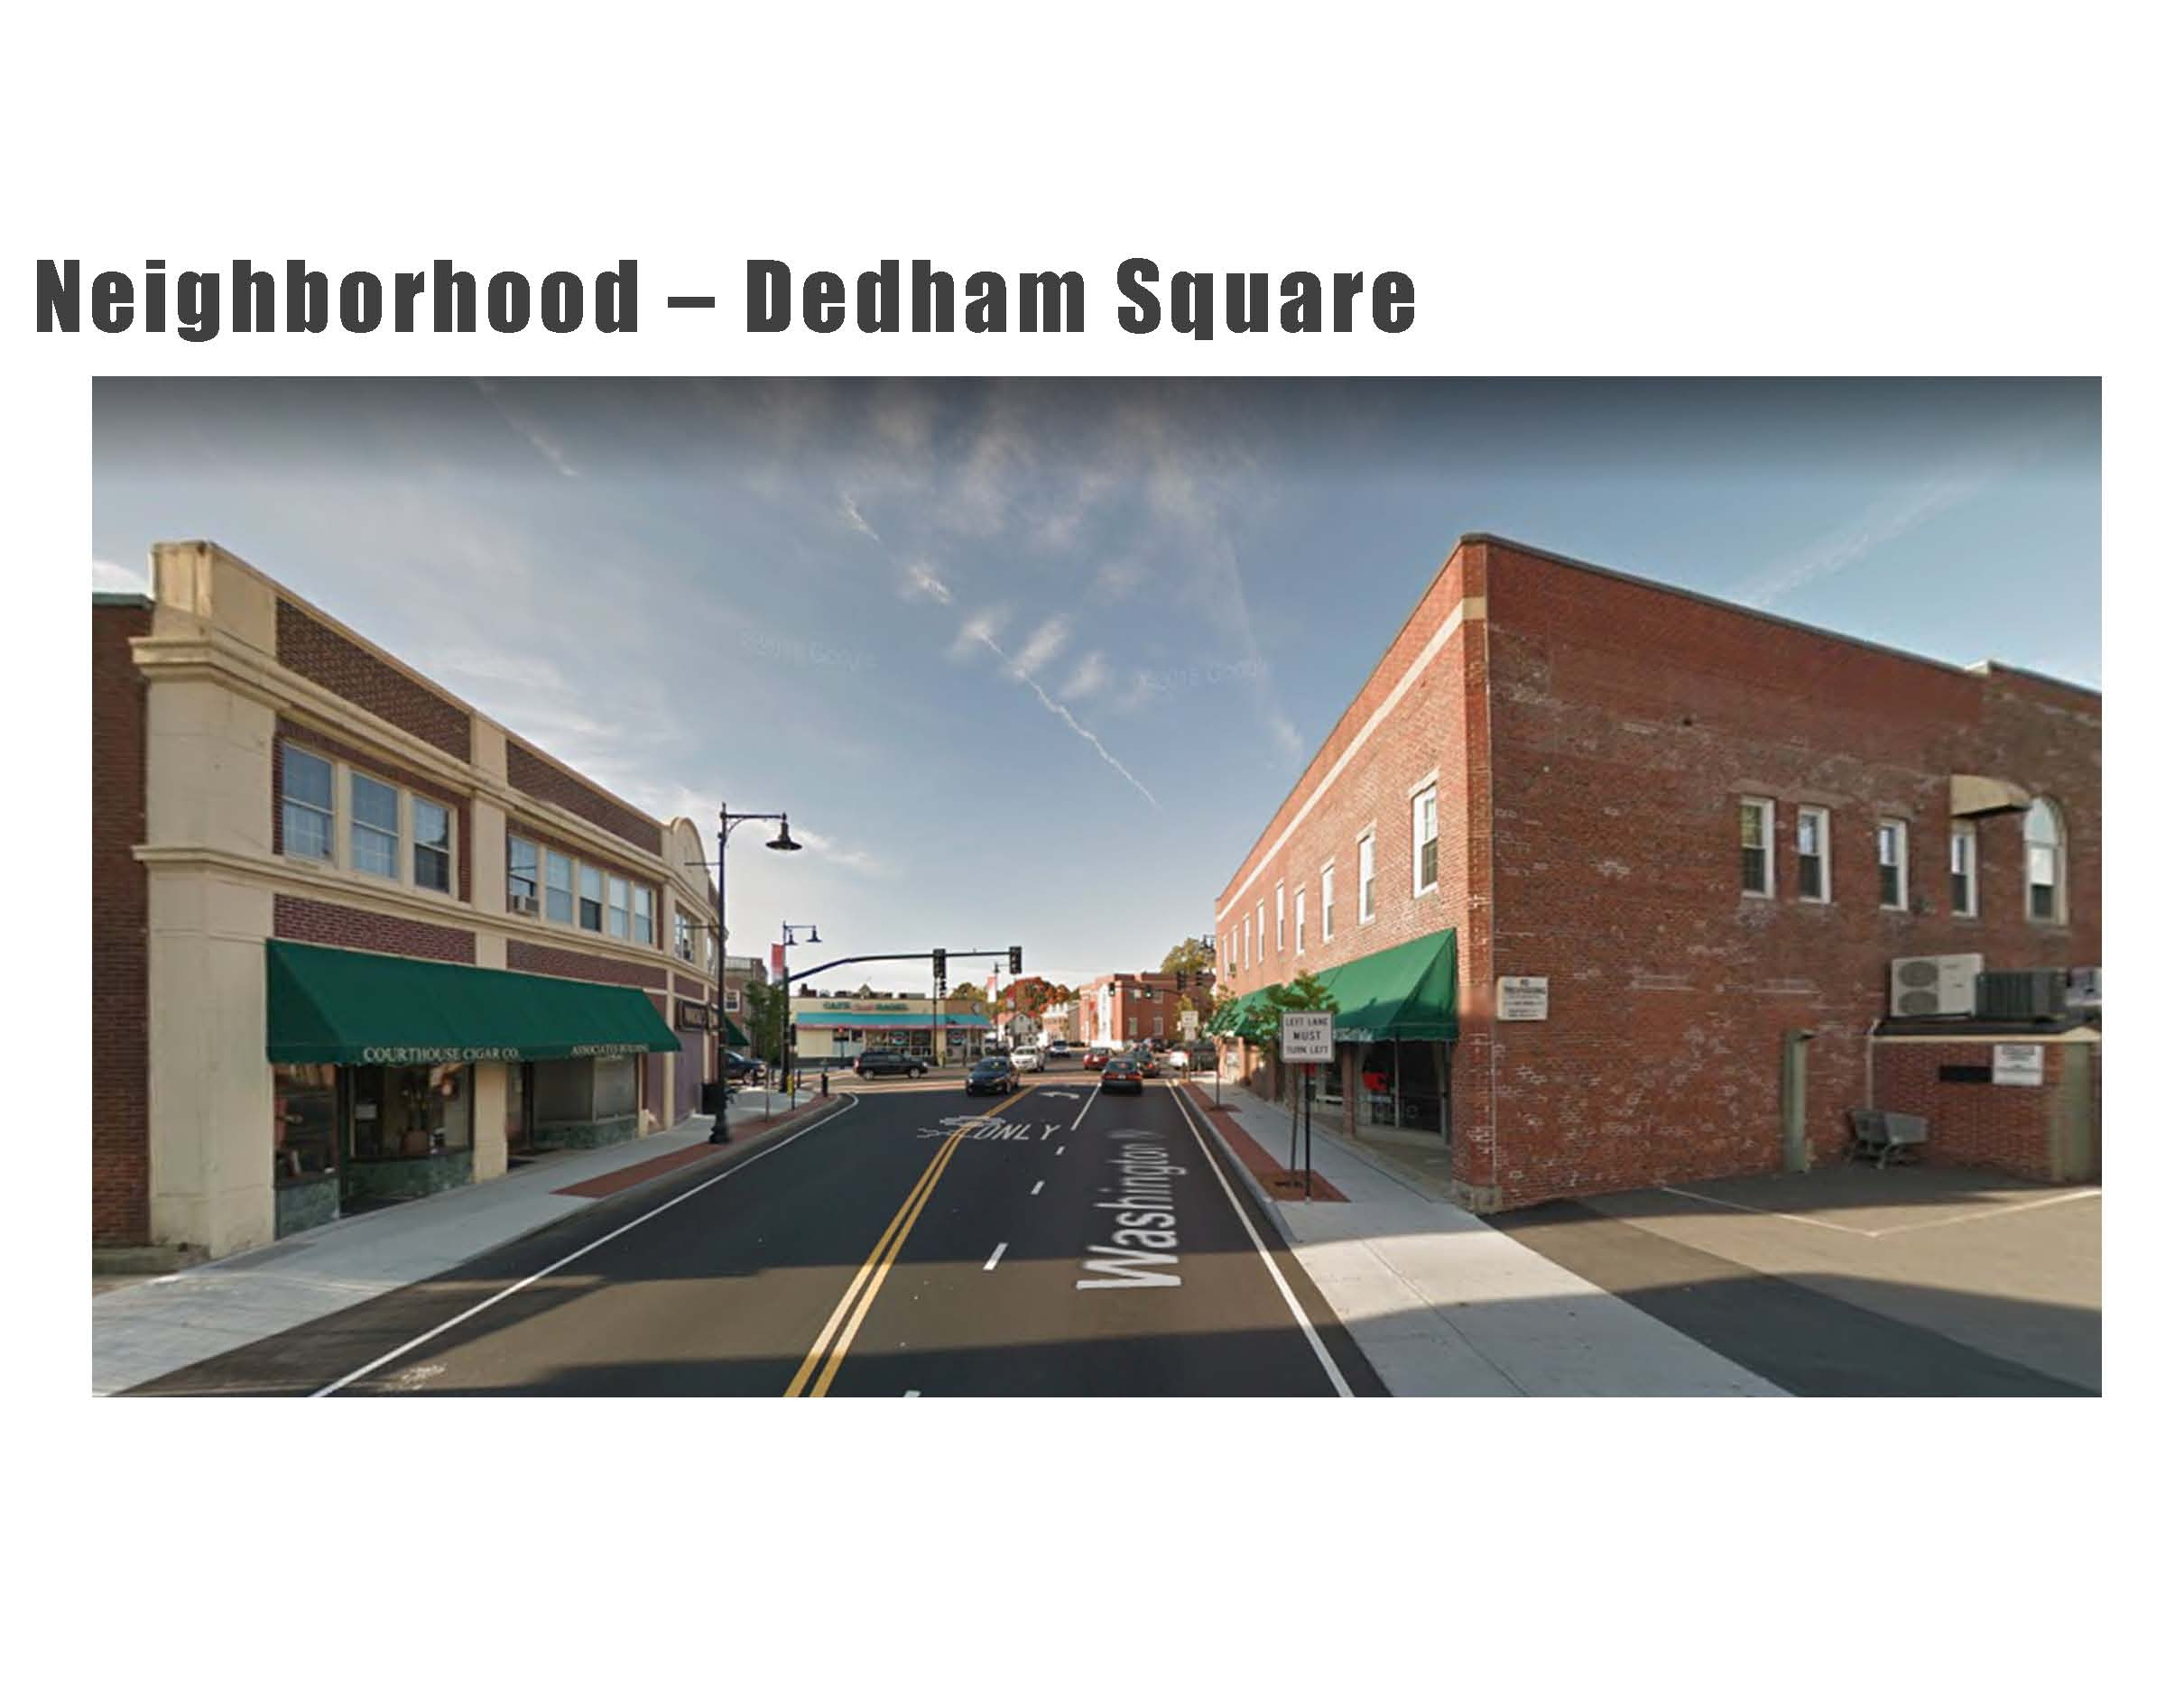

Mr. Dore stated that it is very important to understand the neighborhood that we’re going to be part of.

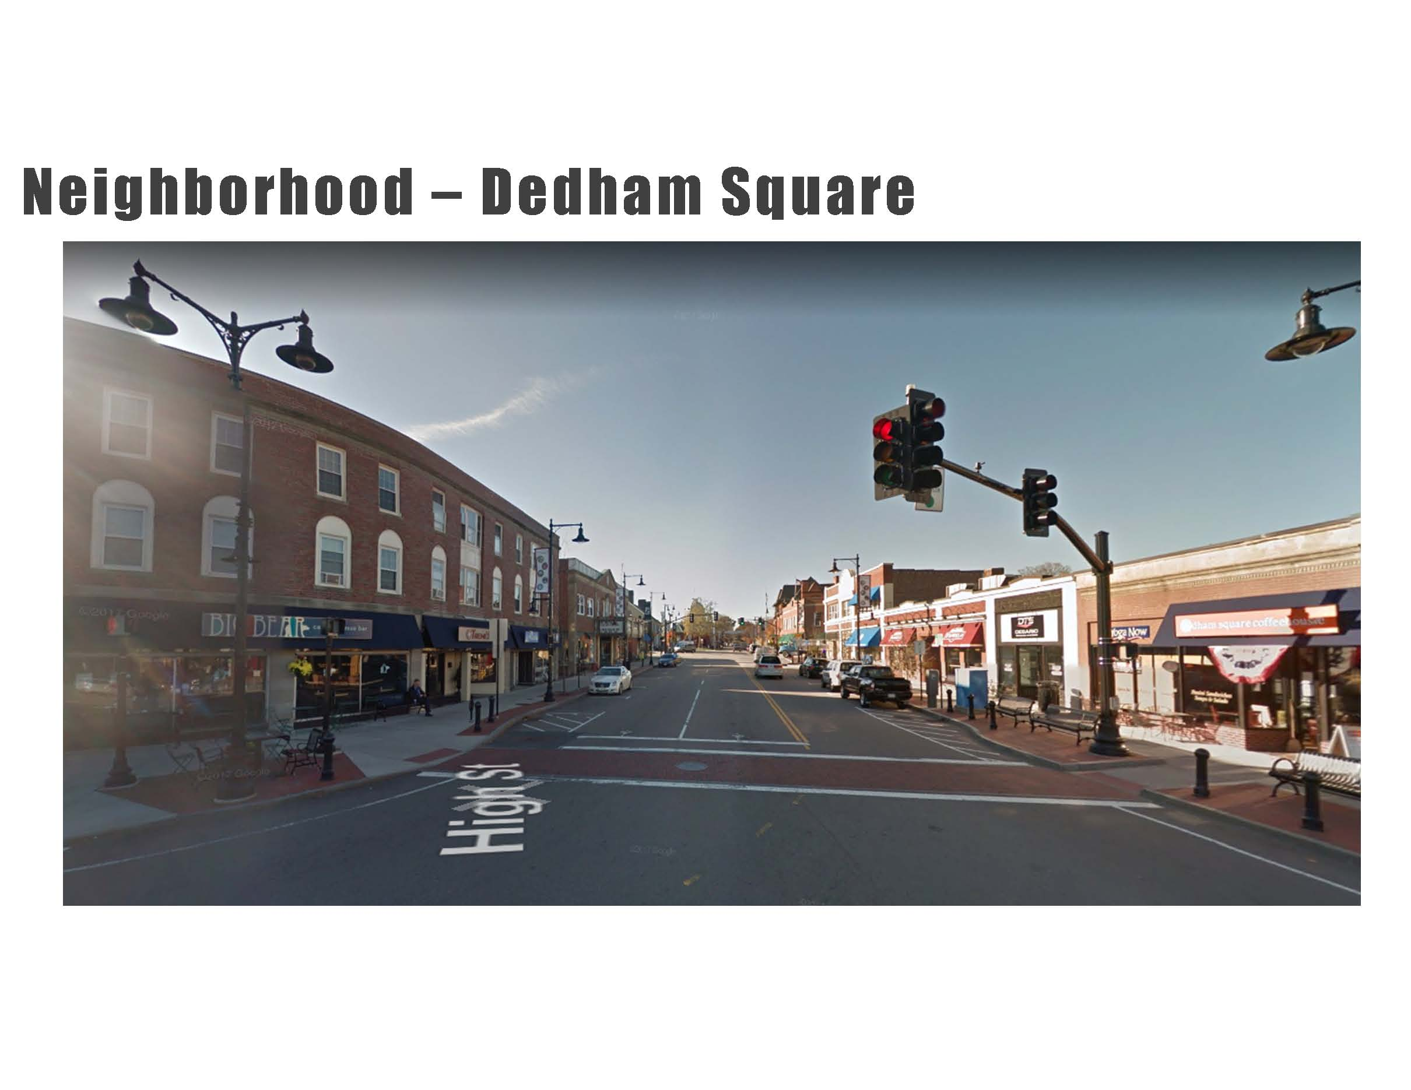

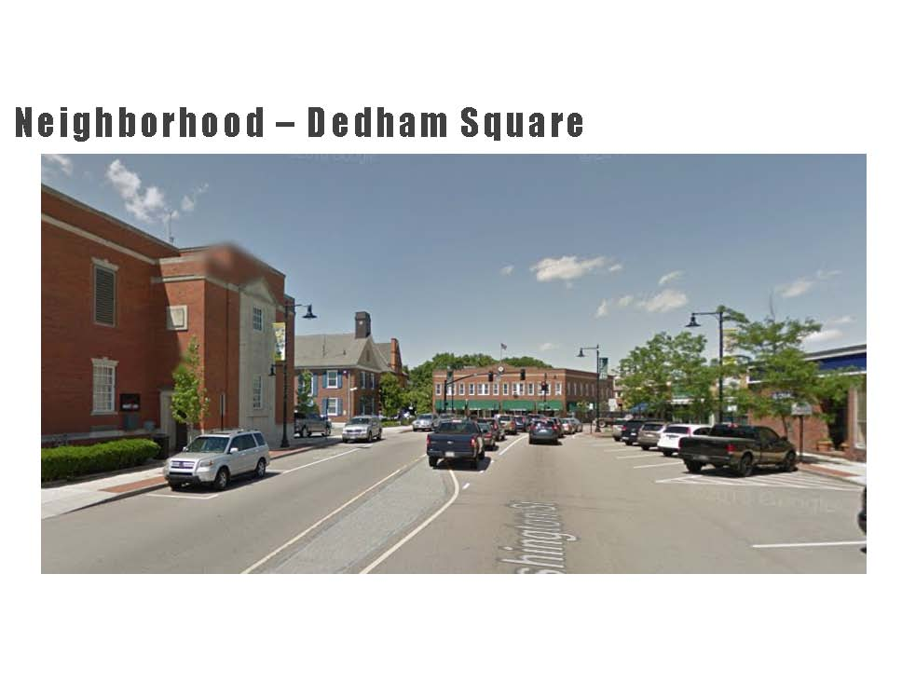

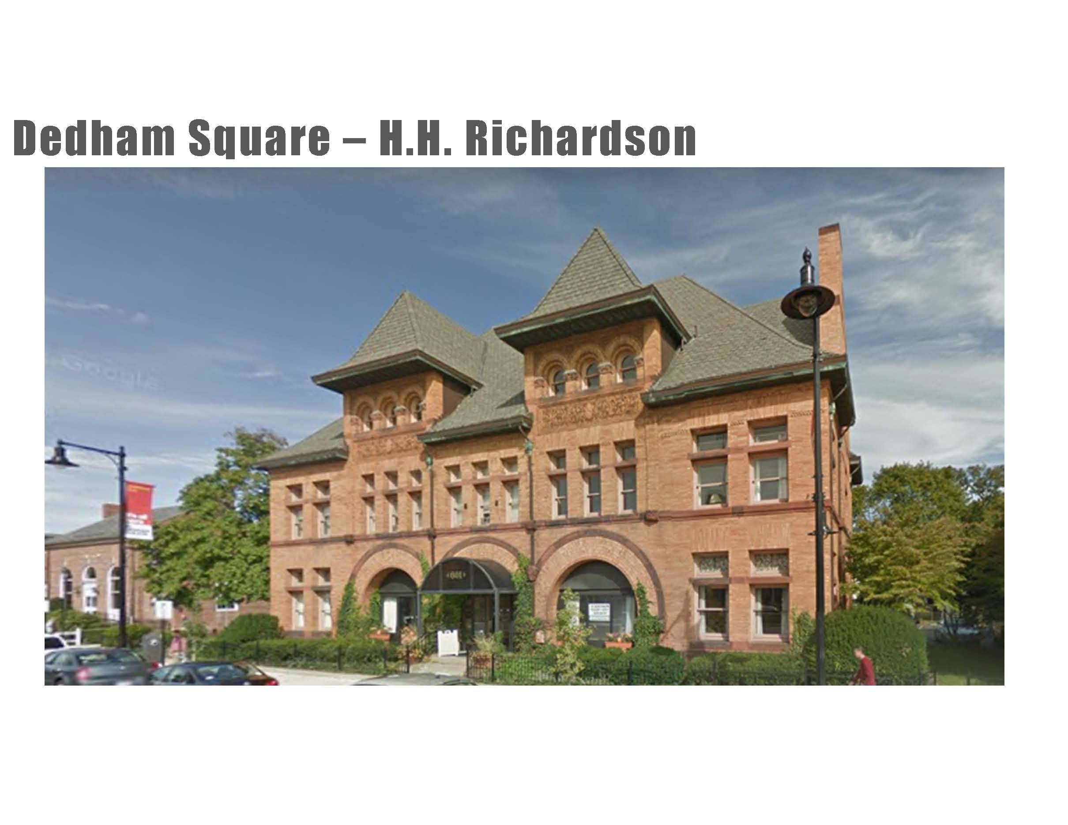

Mr. Dore stated that this is a very iconic building in Dedham. It was built by H. H. Richardson, a very famous architect from the early 19th century. Mr. Dore added that if you were to try to re-create the building like this today, it would not only be hard to find the craftsman to do it but it would be very expensive.

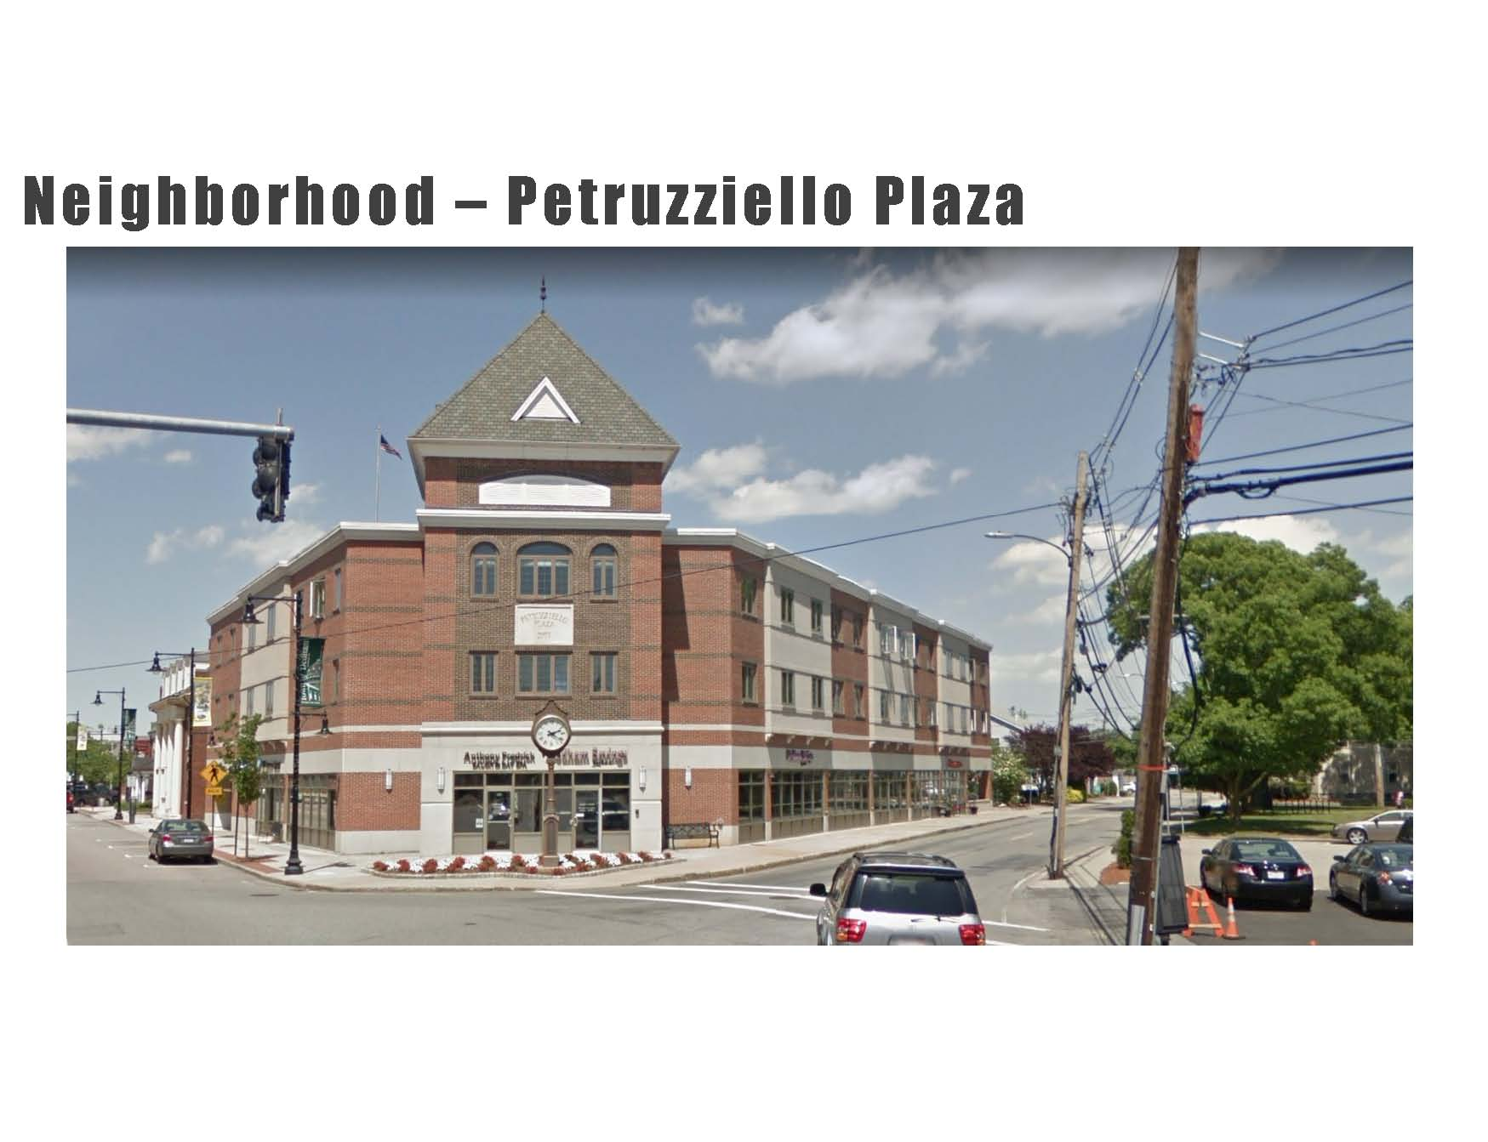

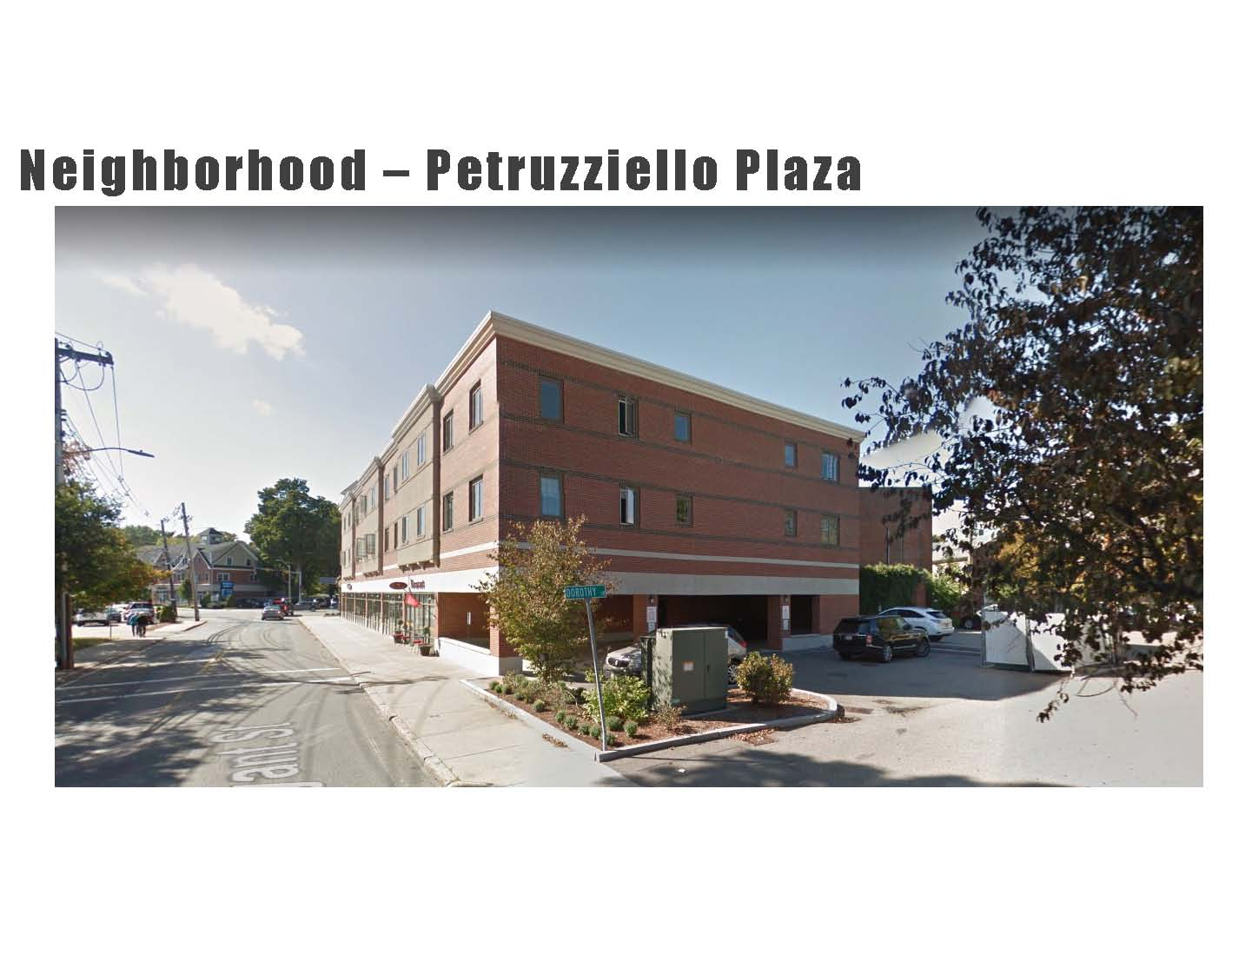

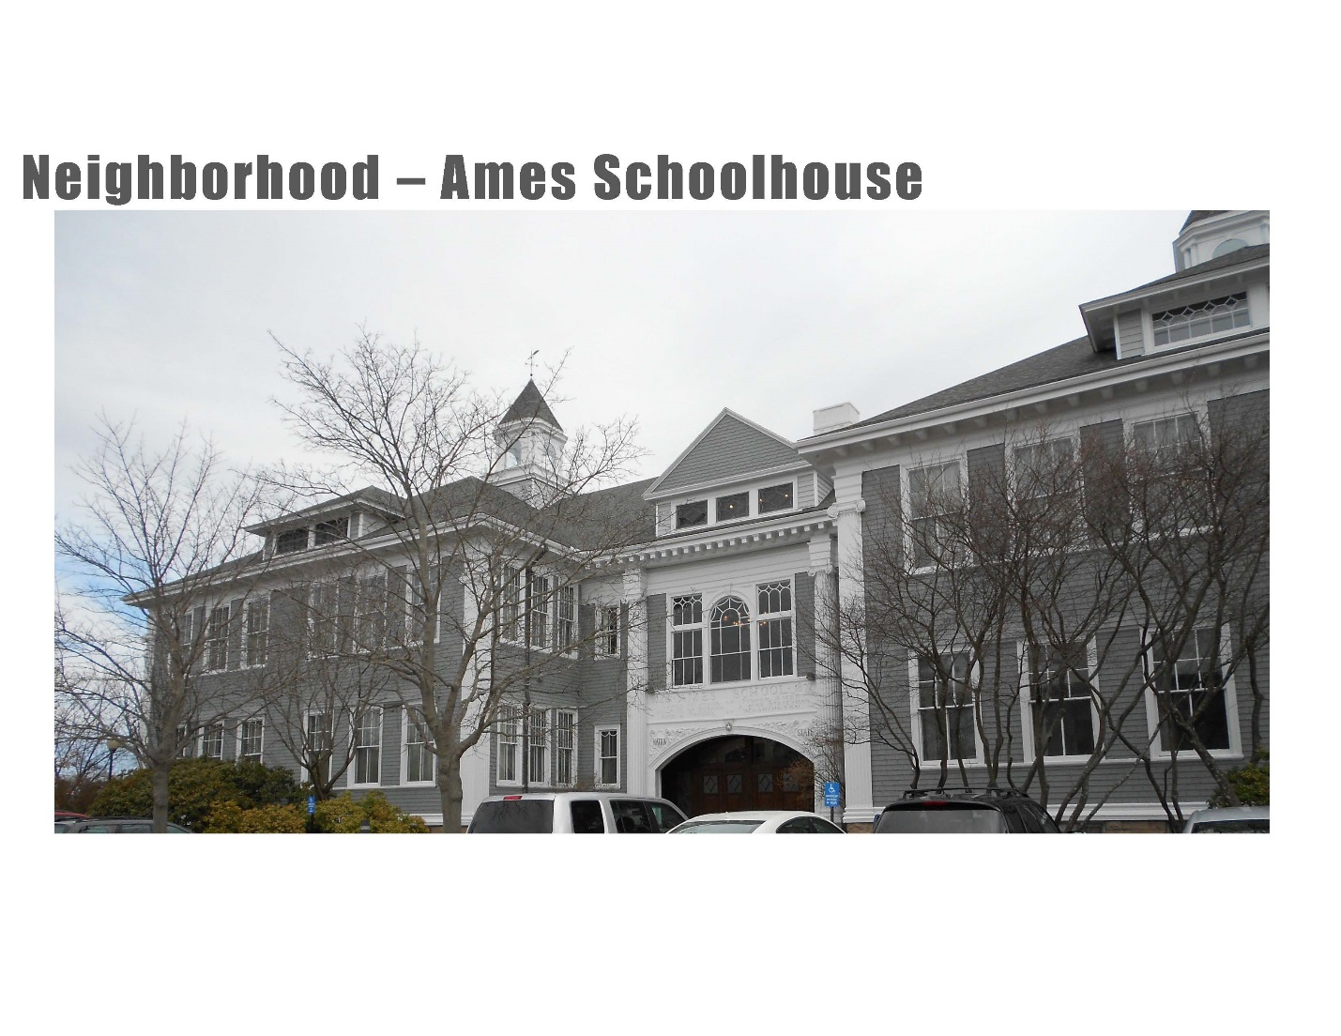

Mr. Dore stated that from a design perspective they don’t want to be in competition with the Ames schoolhouse

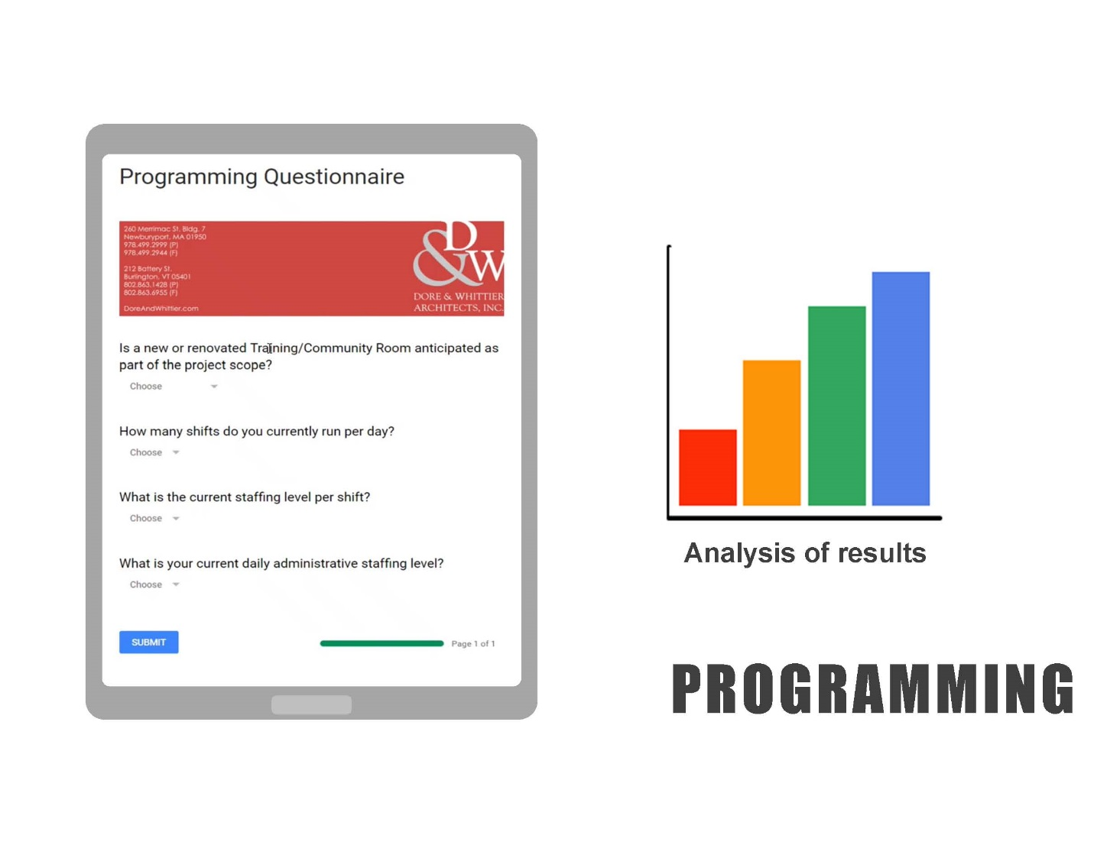

Mr. Dore informed all that the first thing they linked to the program was the building from the inside out. Mr. Dore added that they spent a lot of time trying to understand the function of the building is. Mr. Dore asked the fire and Police chief if they would like to add anything.

Chief Spillane talked about the collaboration with Dore and Whittier and Chief D’Entremont. Chief Spillane spoke about the design needs are keeping within the space allotted. He added that a lot of time and effort went into this and he is pleased with what they’ve come up with. The new space will provide all the needs of the Fire and Police Departments.

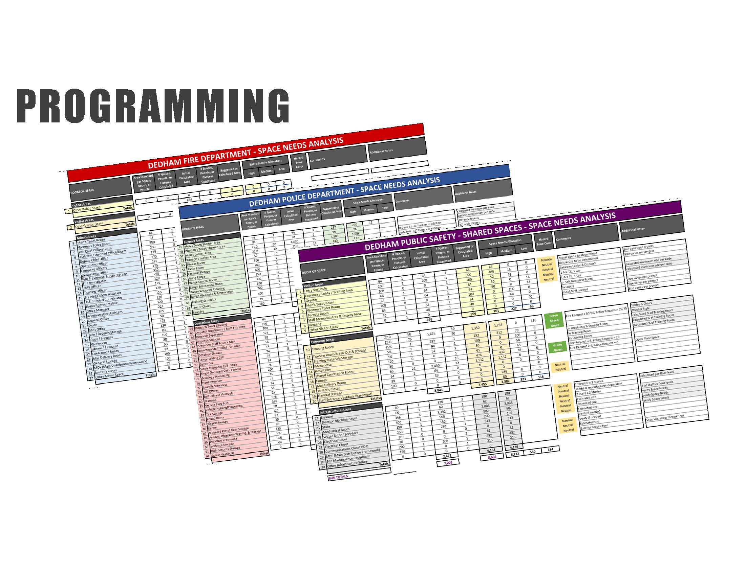

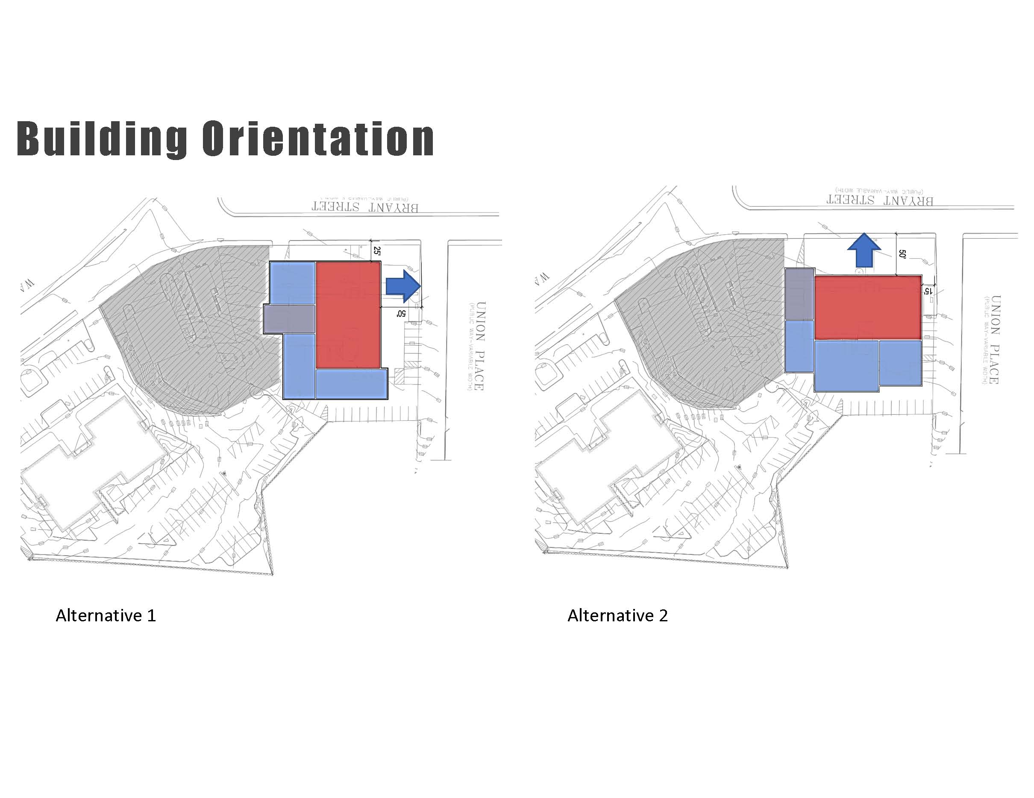

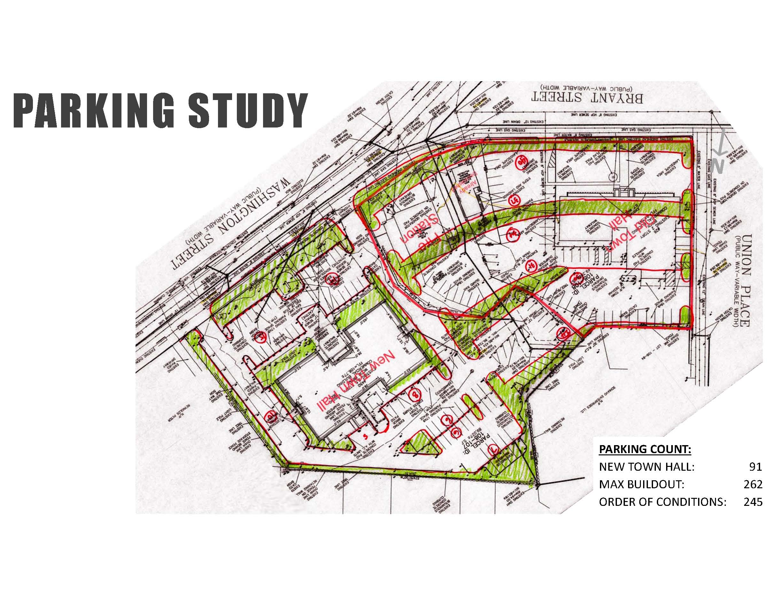

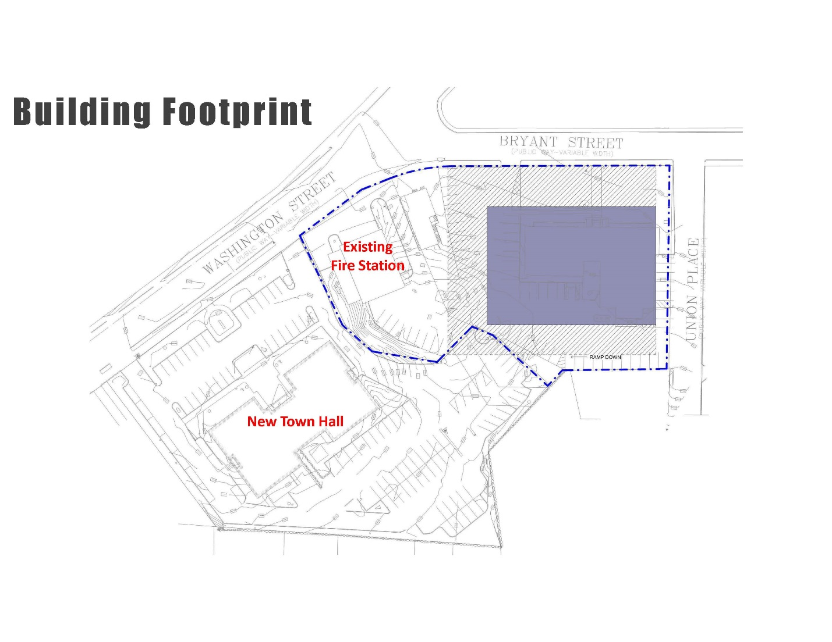

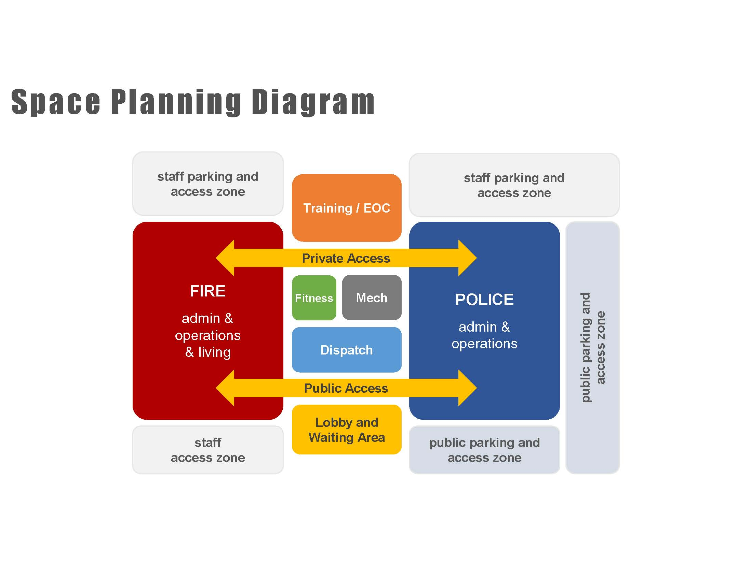

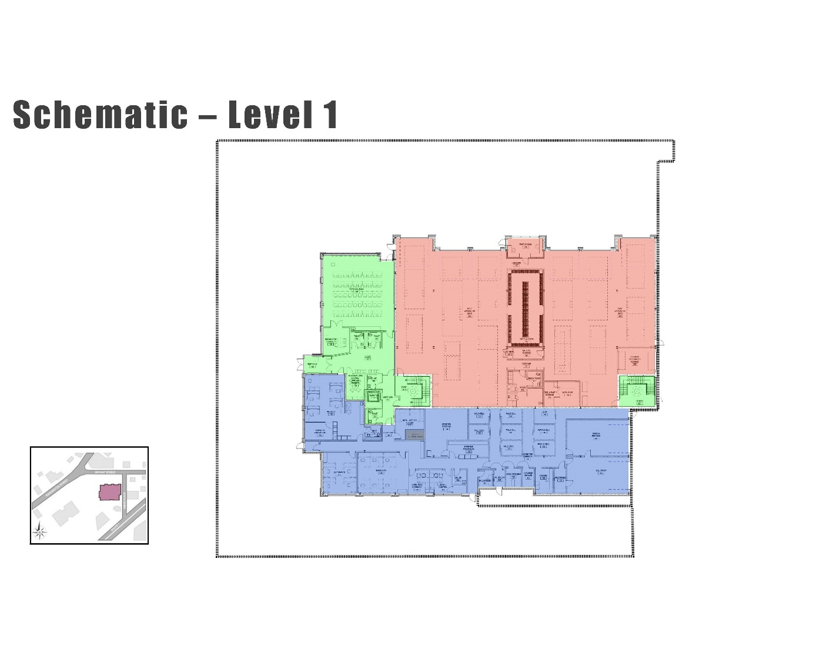

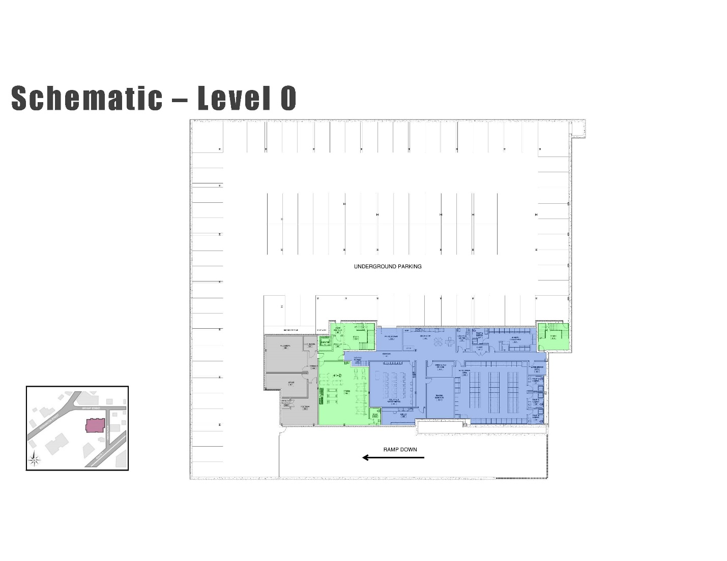

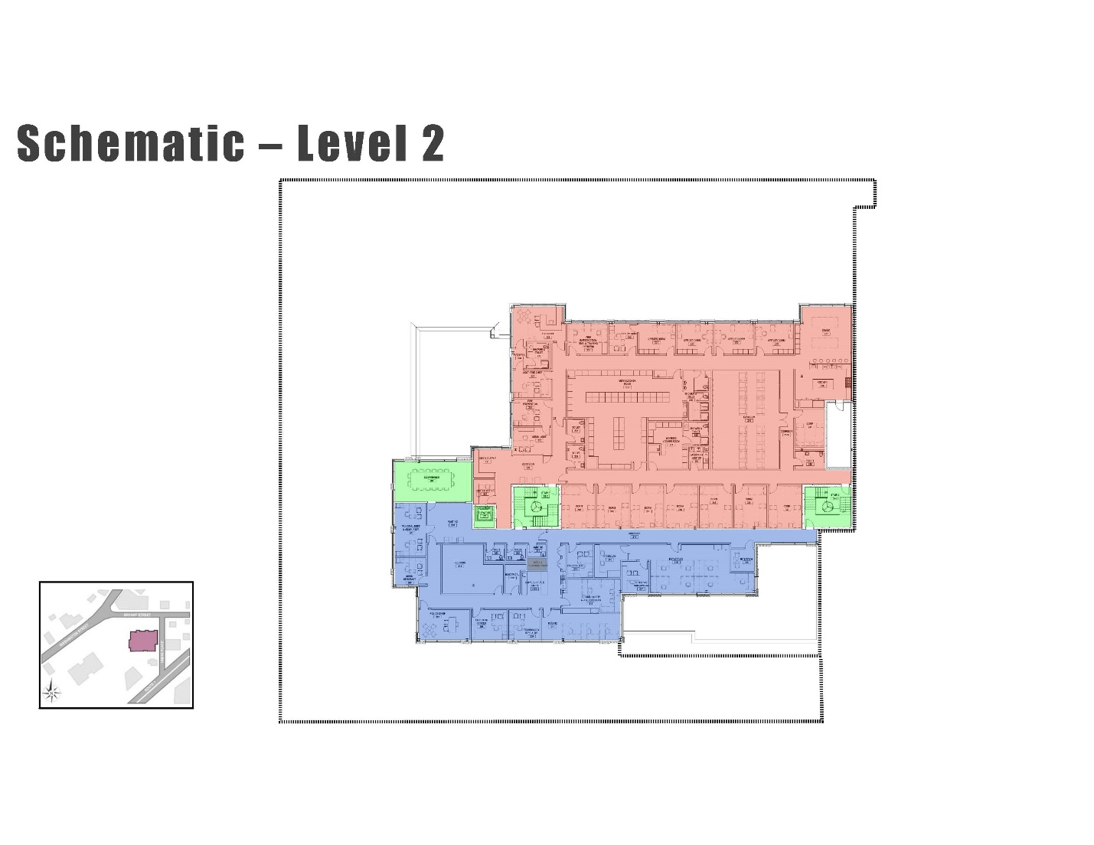

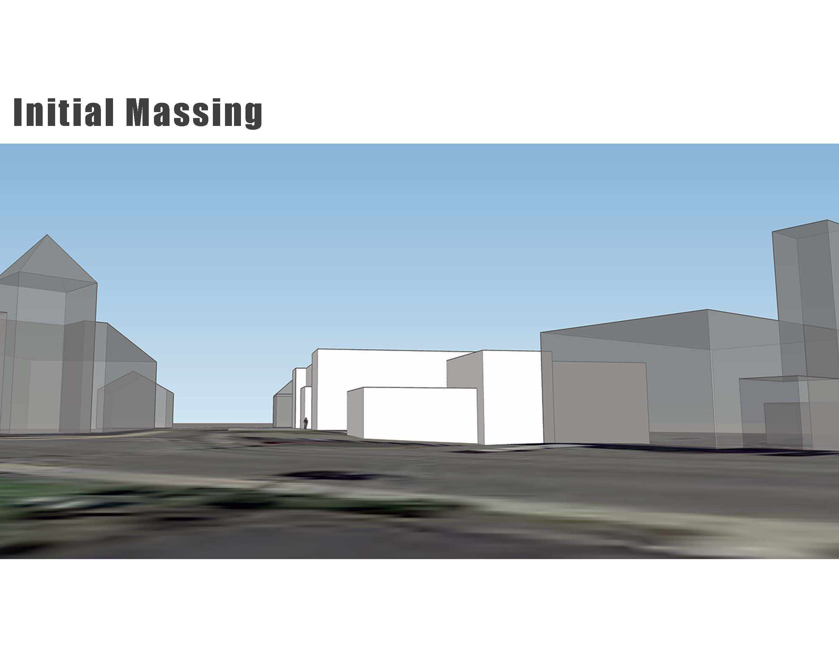

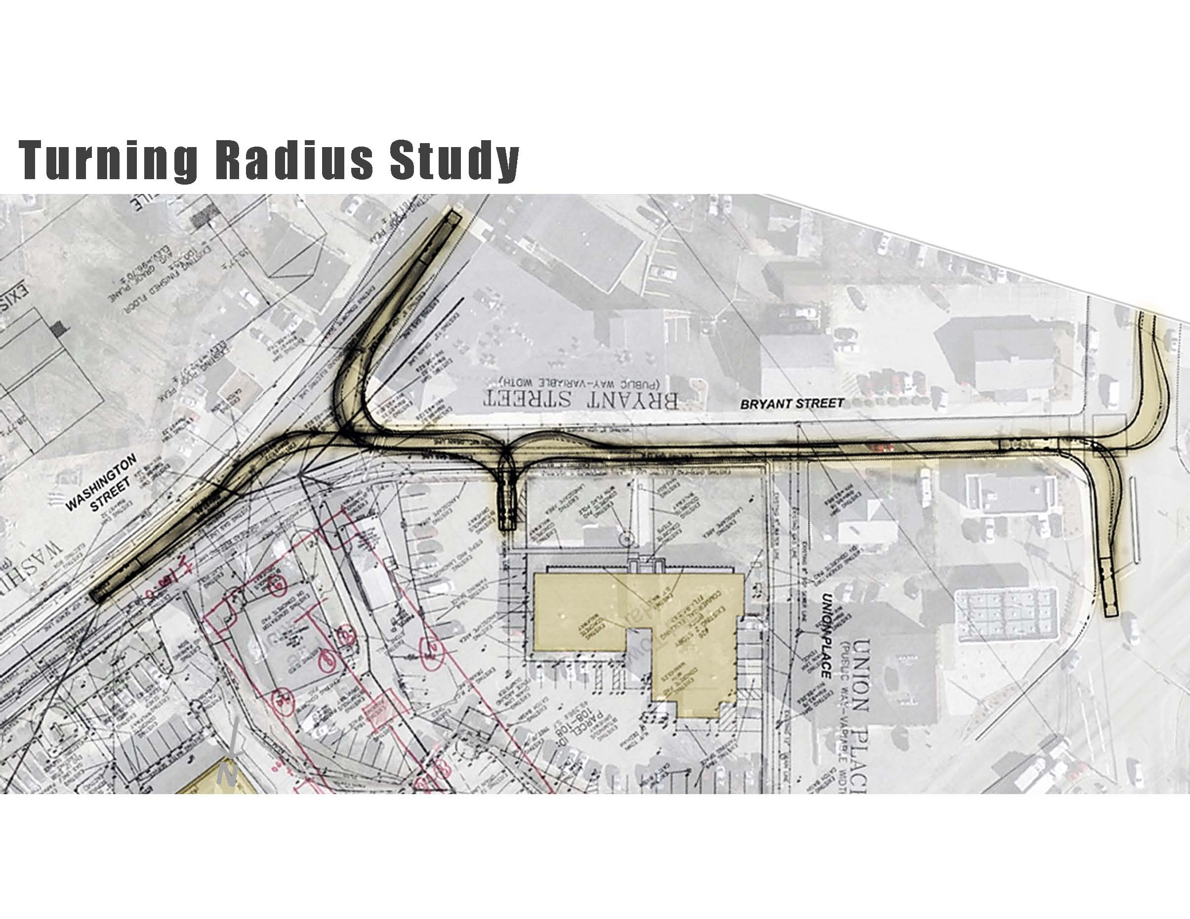

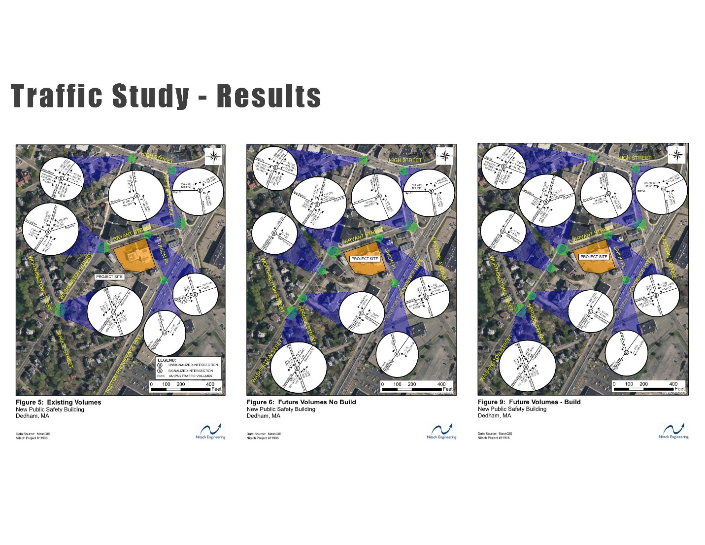

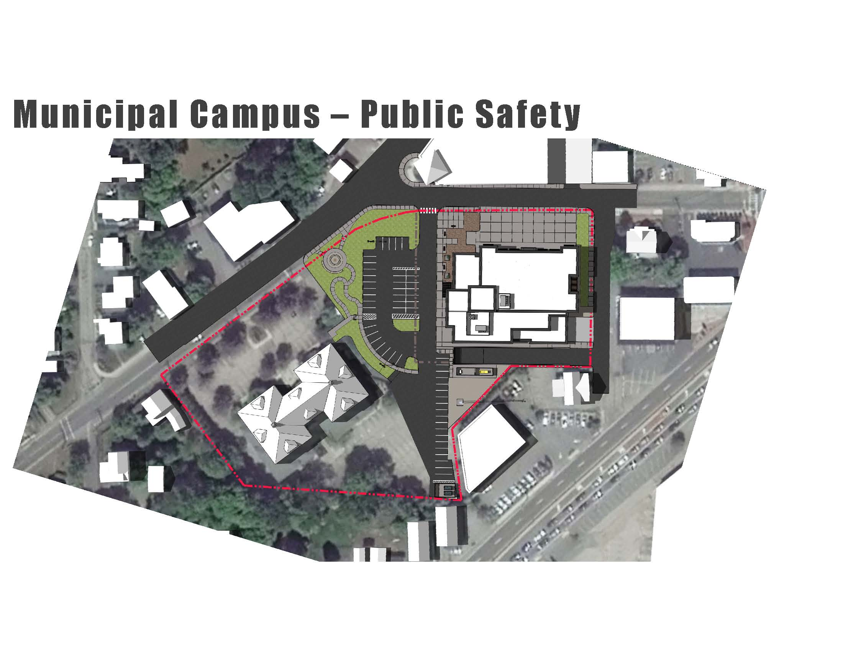

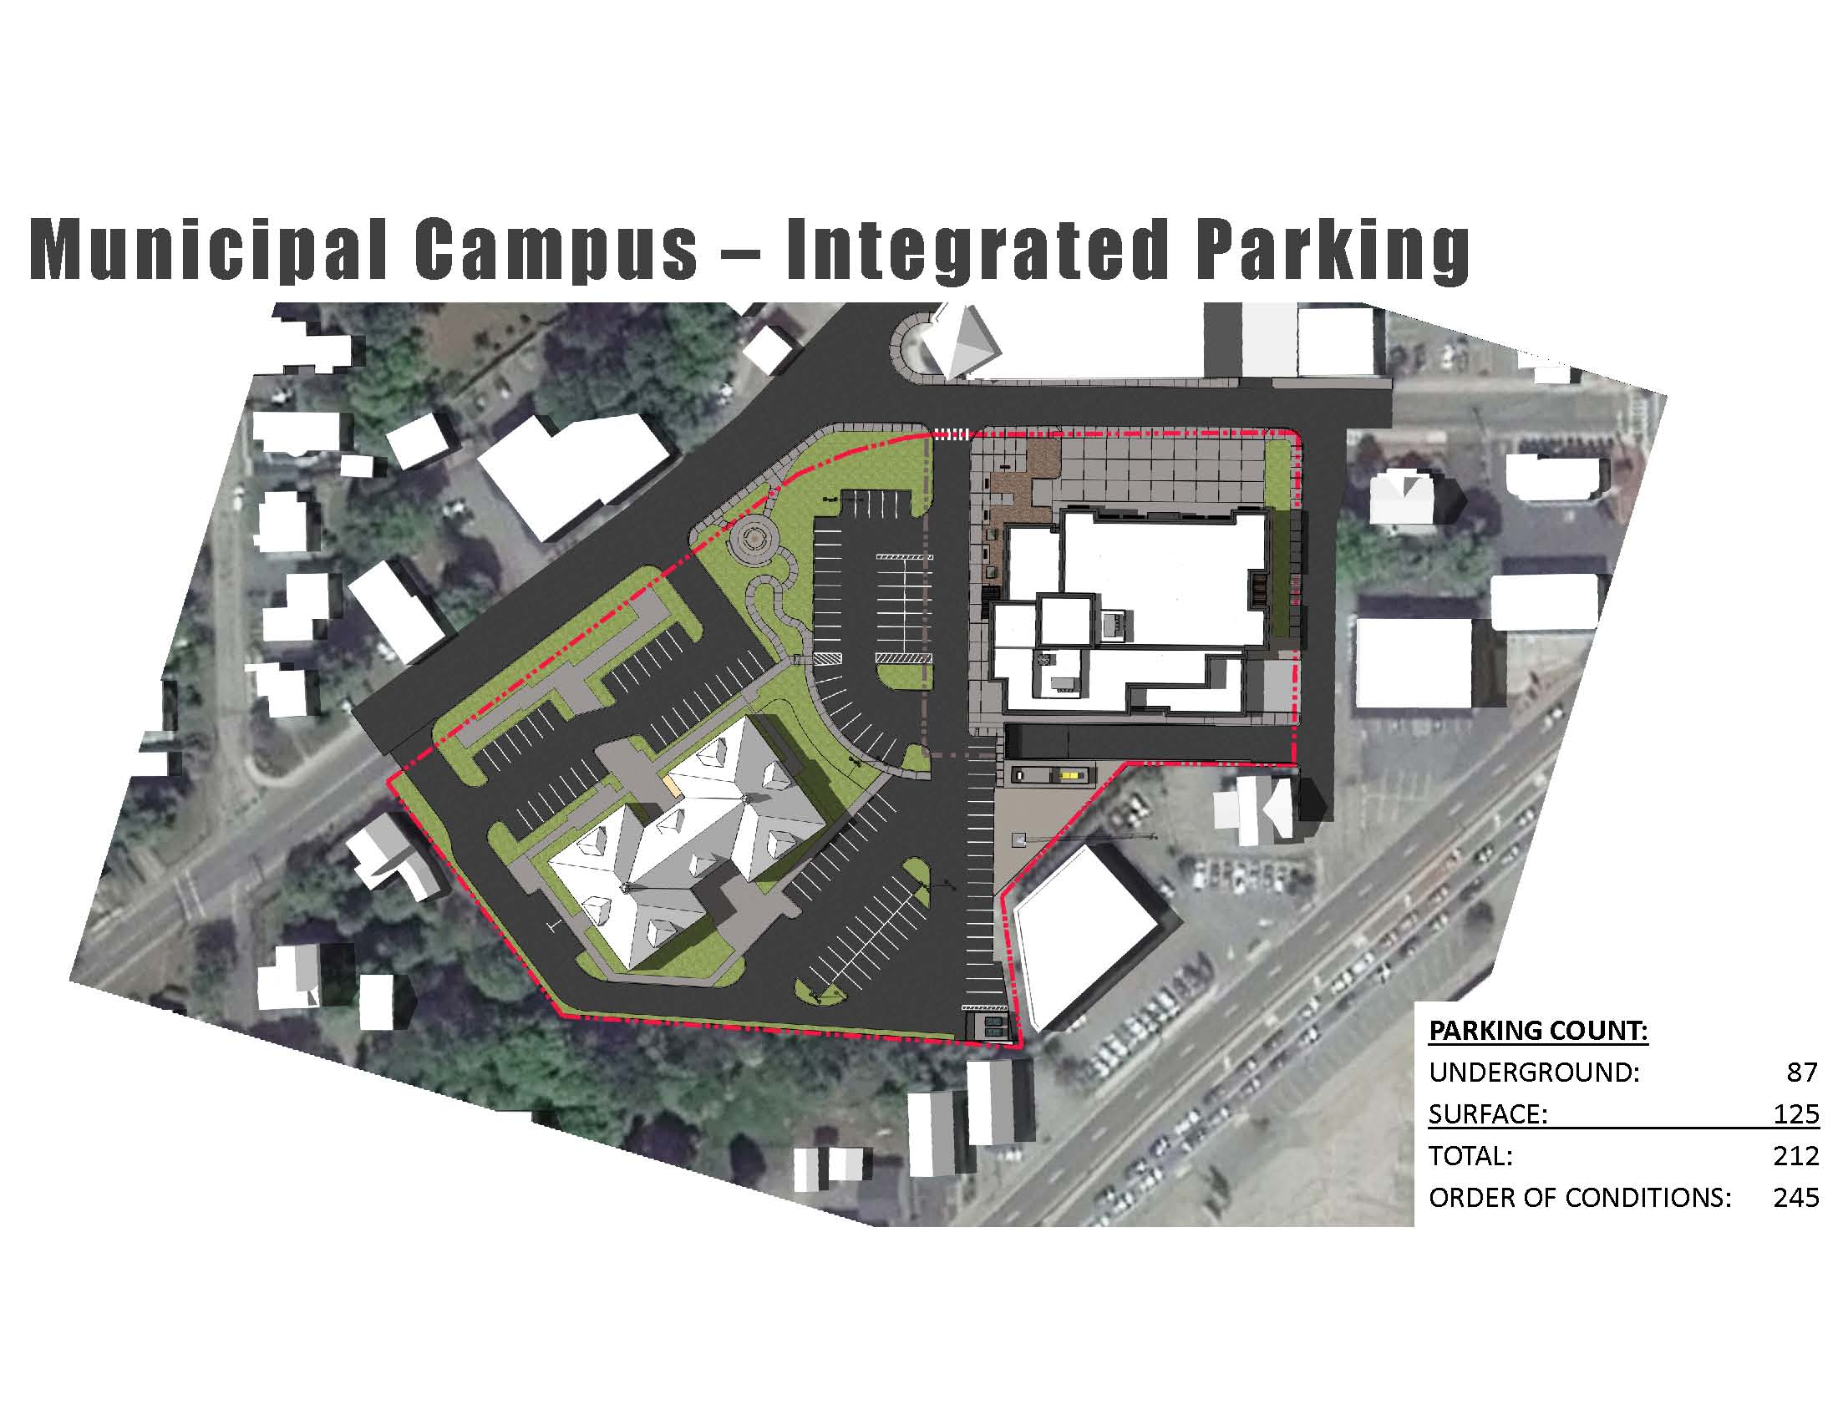



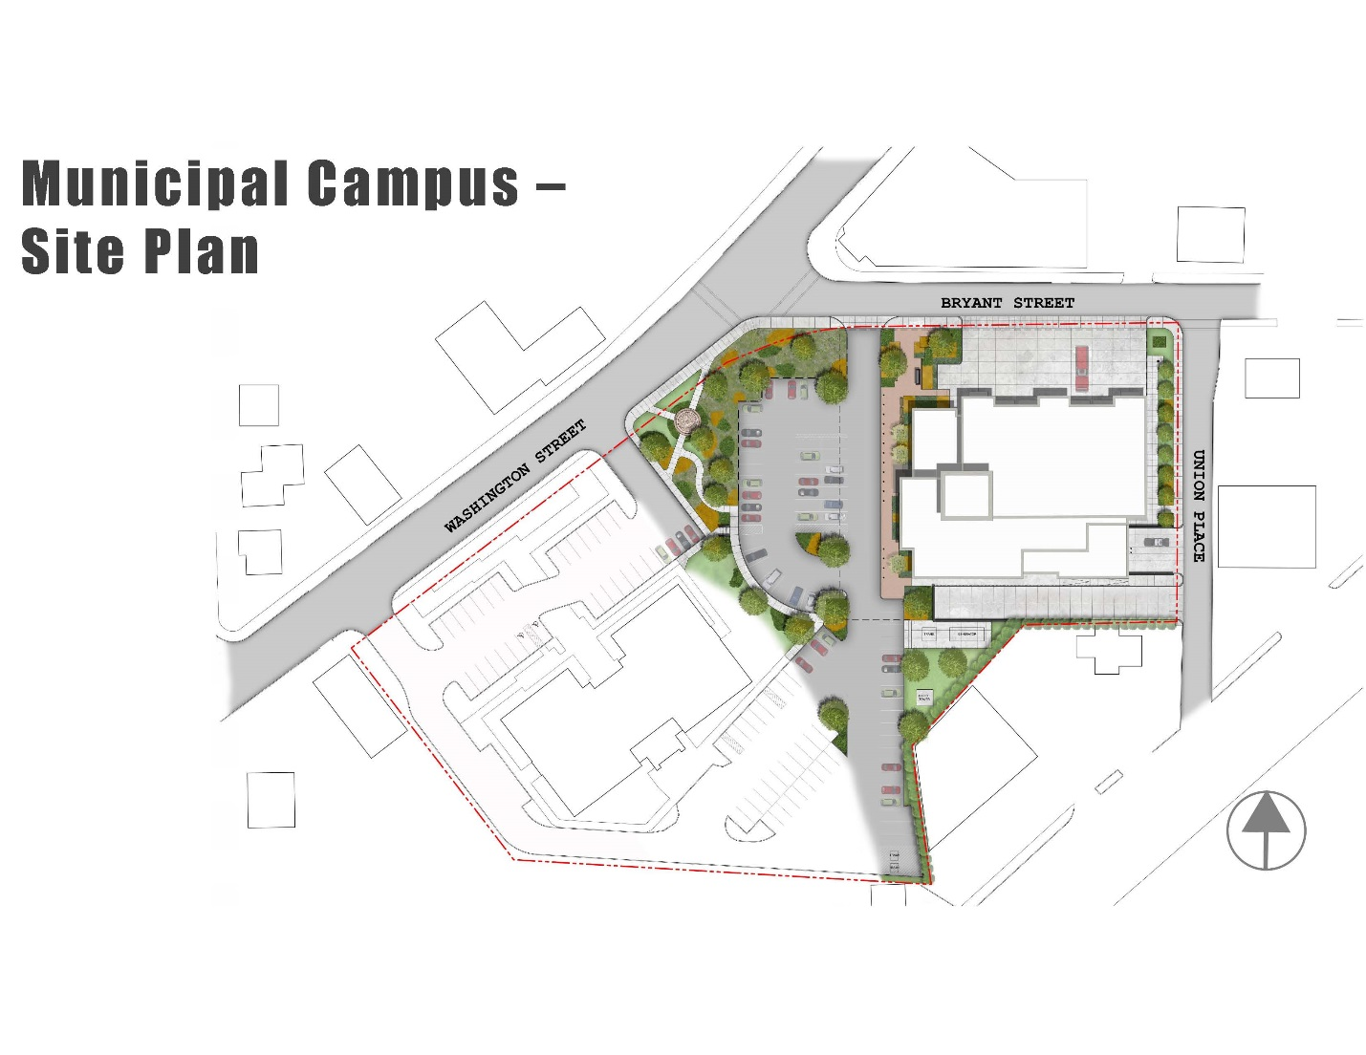

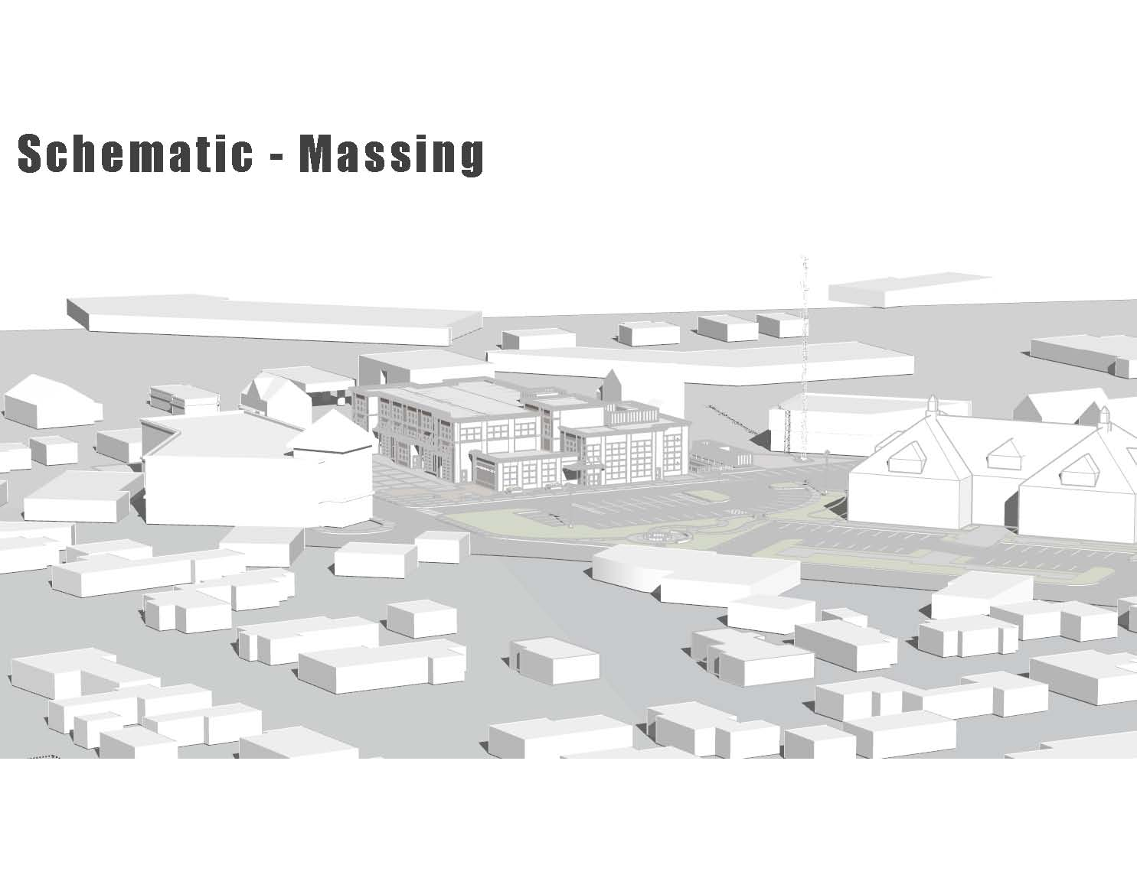

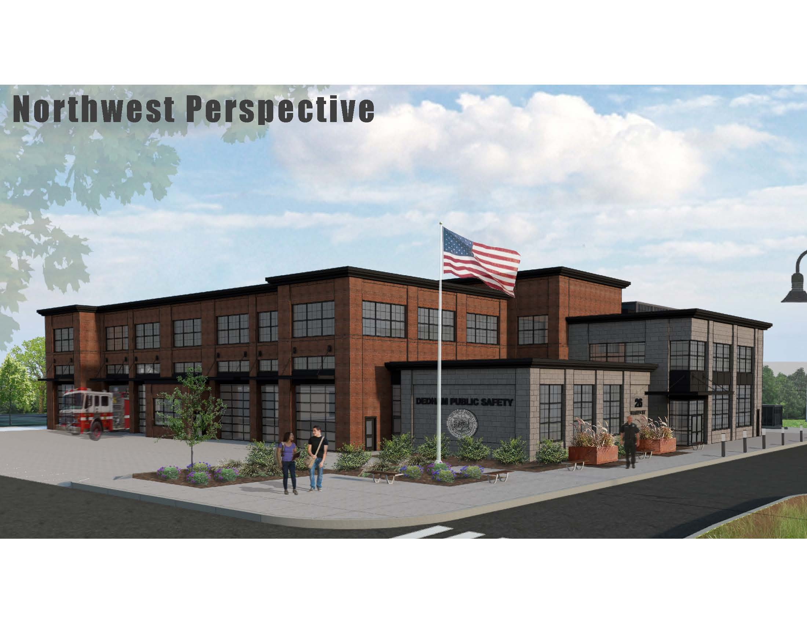

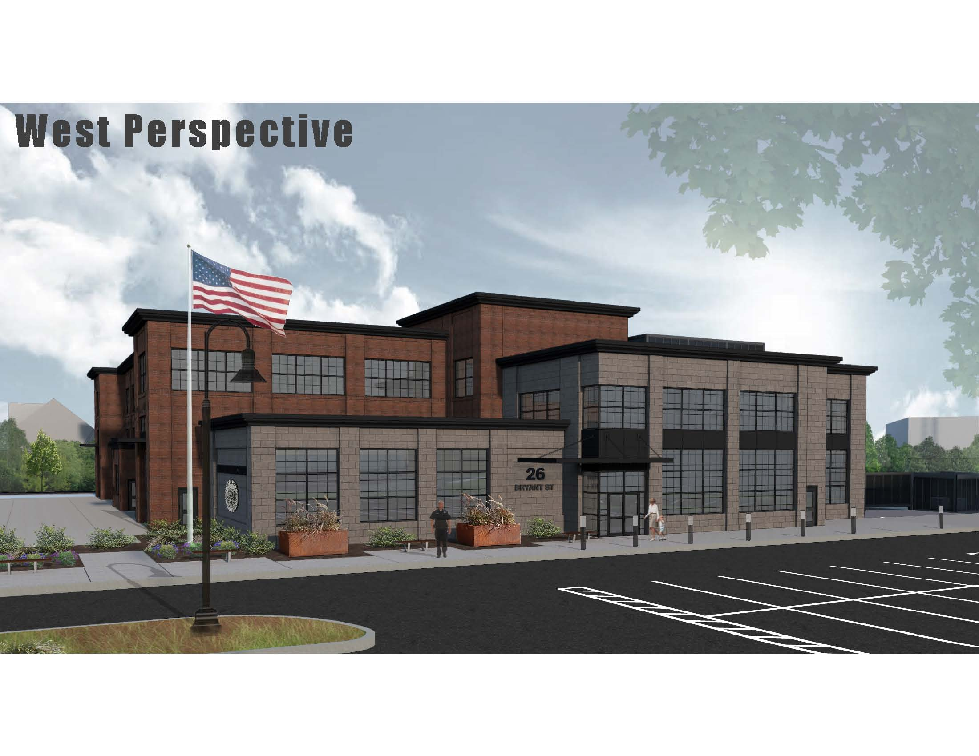

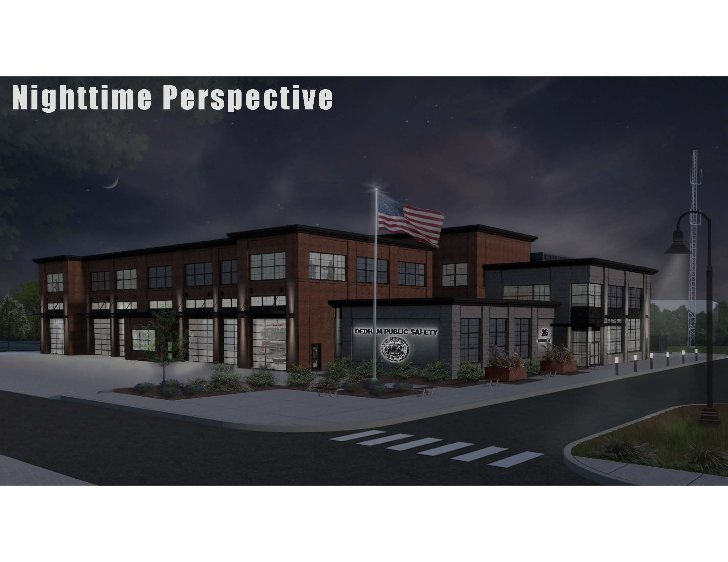

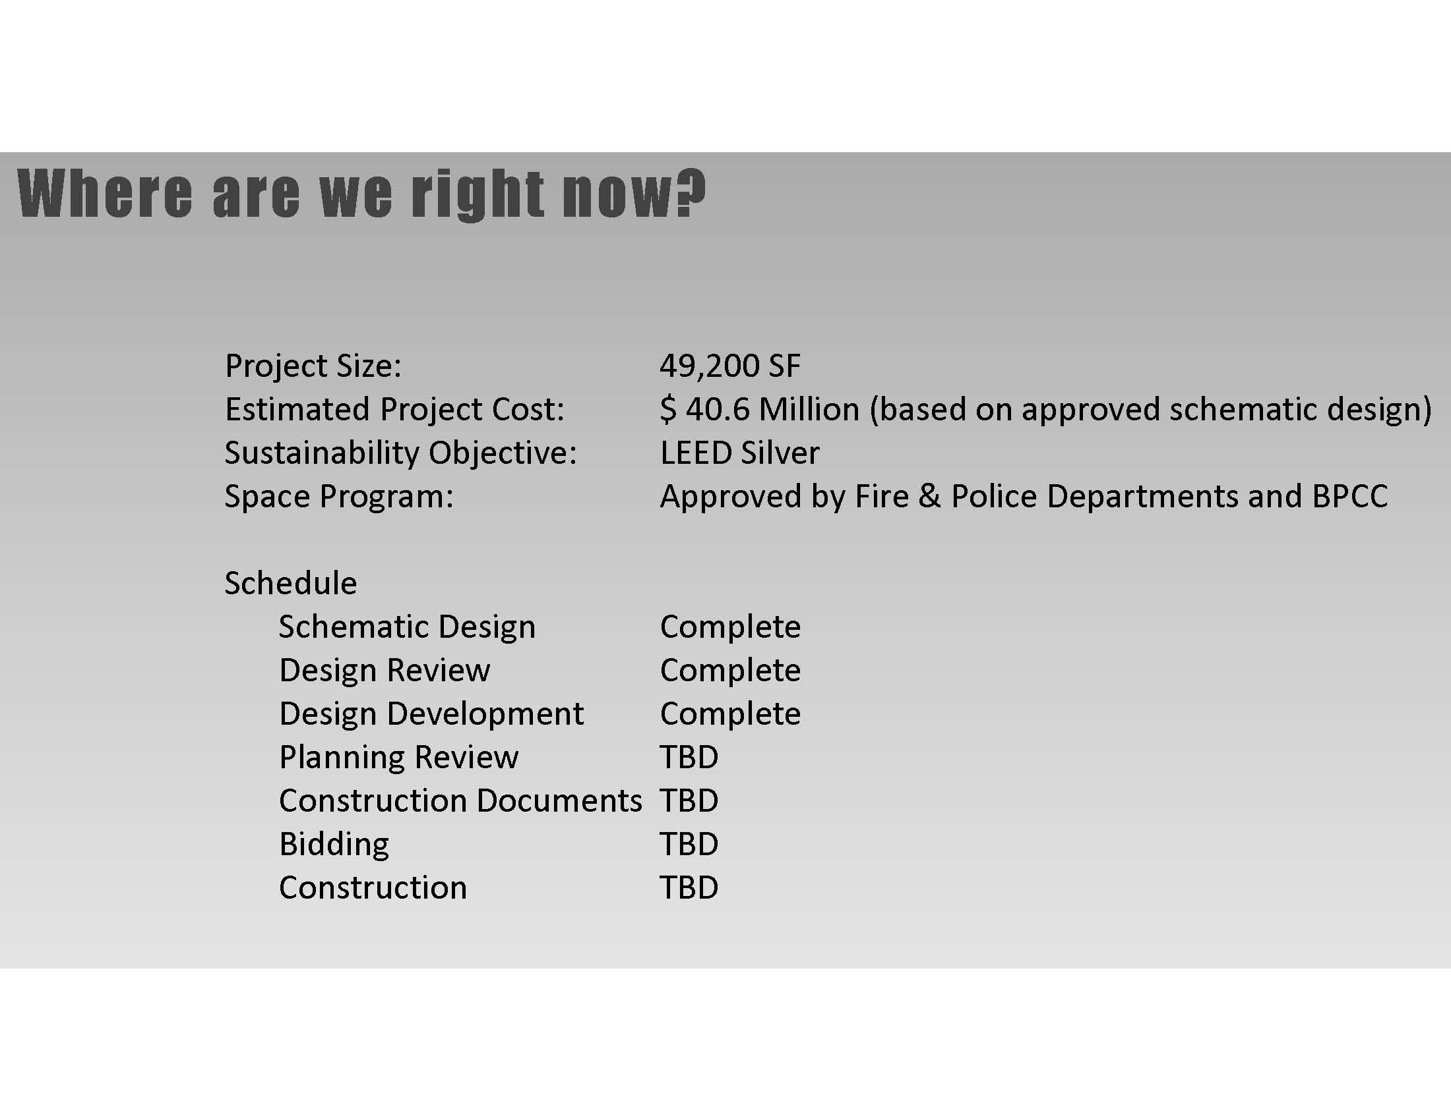

Mr. Butler suggested that they include the landscaping slide be included with detail off to the side of the slide. Mr. Butler added that this will be helpful for the proposed building design as well.

Mr. Butler asked Mr. Dore what the setback is from the street to the bays.

Mr. Dore answered about 60 feet. This will allow the apparatus to be completely off the street so it can maneuver to park back in the building. Mr. Dore asked Chief Spillane to speak to this issue.

Chief Spillane stated that as everyone knows when leaving or returning to the firehouse we have to stop traffic on Washington Street so that truck can maneuver safely back into the building. Chief Spillane added that with this new design there will be enough room for the vehicles to pull into the apron in front of the station and be totally off the street.

Mr. McDonald stated that for the 24 years he’s been on this Board they been talking about a public safety facility and we have never gotten it together. Mr. McDonald added that they are finally at a concept that would work and will be ready to go to Town Meeting in the fall with a few modifications. Mr. McDonald continued, saying that the work Mr. Dore has done with the Chiefs on the program aspect is excellent and satisfies the needs of the Police and Fire Departments on the inside. Mr. McDonald stated that he understands why the building looks the way it does but asked if it is possible to soften the appearance and have it blend in more with the neighborhood with more of a New England look.

Mr. Dore stated that that was one of the things discussed with the Design Review Advisory Board. Mr. Dore added that maybe it is something where the building can be softened with some arches on some of the windows. Mr. Dore continued, saying that he believes these things are achievable but at the same time they want to maintain the functionality of the building understanding that the area we had to work with is somewhat limited.

Mr. Guilfoyle stated that he would like to see it softened as well, to fit in better with the neighborhood. Mr. Guilfoyle added that he would like to have the building not have such an industrial look.

Dr. Teehan stated that he philosophically does not agree with the idea that this building should not compete with the Ames building. Dr. Teehan added that he believes that aesthetics do count and this new design clashes with the neighborhood. Dr. Teehan continued, saying that we waited for 40 or 50 years for this building and he thinks it is incumbent upon this Board that it is done right.

Mr. Keogh asked Mr. Dore how long it would take to get another option on the table.

Mr. Dore stated that it depends on what we’re talking about as aesthetics has a broad range. Mr. Dore added that he is trying to accommodate a number of different things regarding the functionality of the building, which he believes this rendering does. Mr. Dore continued, saying that as well as taking into effect the aesthetics there is also the cost factor. Mr. Dore informed all that small aesthetic changes wouldn’t take too long but a wholesale change would take a lot of time.

Jim Sullivan, Chair of the Building Planning Construction Committee, informed all that this is a very small piece of property. Mr. Sullivan added that if you take a look at the Natick Public Safety Building, which is an entire city block long. If you shrunk that building it would look exactly like the proposed building for Dedham. Mr. Sullivan continued, saying that the Islington building is a quaint 9000 ft.² and you can’t get quaint at 42,000 ft.² on a small compact area. Mr. Sullivan stated that the picture that appeared on Facebook had to be shrunk and lost all detail. Mr. Sullivan added that this presentation has about five times as much detail as the first presentation Mr. Dore made.

Amy Haelsen, Executive Director Dedham Sq., Circle and a member of the Dedham Square master plan Committee. Ms. Haelsen stated that we’re going to be living with this building for a very long time and while the main objective is to make it functional for the Police and fire Departments, it also needs to work within the character of Dedham Square. Ms. Haelsen added that there are some concerns that this building looks a little too industrial and she would concur with any effort to soften and make it a little bit more New England like.

Jessica Porter, member of the Dedham Square Steering Committee, stated that she would like the new public safety building to feel more welcoming.

Shaw McDermott, 580 Bridge St., stated that he hopes this building will be looked at in 75 years will say this is something Dedham did well. Mr. McDermott added that there was some talk about the possibility of having a pocket park on the campus.

Mr. Dore stated that there was some discussion about whether or not there could be a water feature of front or some type of gazebo. Mr. Dore pointed out that there really is not a lot of area to work with regarding this.

Mr. McDermott stated that electrical wires need to be removed from the front of the building.

Mr. Dore stated that they have a plan to take all the wires outside the facility on Bryant Street underground and actually need to do this so the apparatus can maneuver with plenty of space.

Mr. Kern informed all that the estimated cost for power lines underground was $500,000. Mr. Kern added that he feels compelled to bring up the financial element of this. Mr. Kern added that we all agree that we want to do this without having to go to the debt exclusion, we want to do it under the levee limit. Mr. Kern continued, saying that we can do that but there is a line and we are at that line.

Fred Civian, chair Precinct 1, stated that one of the things he was looking for in this new campus was more open space for people to be able to relax. Mr. Civian added that the second thing he was looking for is that the pedestrian access is optimized as much as possible. Mr. Civian continued, saying that he does not understand why there is not and 8000 ft.² to 10,000 ft.² top lot of some sort here.

Dr. Teehan thanked Mr. Dore for taking the time to give the presentation and answer all the questions.

Dr. Teehan informed all that he hopes that the public Meeting on the 19th will hold more answers and details.

Ms. Baker informed all that the public Meeting will take place on Tuesday September 19, 2007 at 7 PM at the Middle School.

**OLD/NEW BUSINESS**

Mr. Guilfoyle informed all that the Fallen Heroes Road race will take place on September 16, 2017.

Dr. Teehan stated that they would now adjourn to executive session to discuss collective bargaining as discussing this in open session would be detrimental to the best interest of the Town. Dr. Teehan added that they would adjourn to room 204 and only exit executive session to adjourn the Meeting.

Mr. Butler moved that the Board enter into executive session for the purpose of discussing collective bargaining; seconded by Mr. Guilfoyle. **On the Vote:**

**ROLL-CALL**

Mr. Keogh, yes

Dr. Teehan, yes

Mr. Butler, yes

Mr. Guilfoyle, yes

Mr. MacDonald, yes.

Mr. McDonald moved to adjourn the public Meeting; seconded by Mr. Keogh. **On the Vote:** Mr. Keogh, yes; Dr. Teehan, yes; Mr. Butler, yes; Mr. Guilfoyle, absent; Mr. MacDonald, yes.

The Meeting was adjourned at PM.

The next Meeting is scheduled for Thursday September 14, 2017 at 7p.m. This is to certify that the above is a true and accurate Record of the Minutes of the Selectmen’s Meeting held on August 24, 2017, which minutes were approved on September 14, 2017.

________________________

Dennis Teehan, Jr. - Chairman