A Meeting of the Board of Selectmen was held on Thursday September 14, 2017, at 6:30PM in the Francis O’Brien Meeting Room, 26 Bryant Street, Dedham, Massachusetts. Present were:

Dennis J. Teehan

James A. MacDonald

Michael L. Butler

Dennis J. Guilfoyle

Brendan G. Keogh

Dr. Teehan called the Meeting to order at 6:33 PM.

**PLEDGE OF ALLEGIANCE**

Led by Dr. Teehan.

**DEDHAM CITIZENS - OPEN DISCUSSION**

Micah Flynn – 33 Eleanor Street

Mr. Flynn stated that he would like to give a brief statement of support for the proposed Rail Trail project. Mr. Flynn informed all that he and his wife moved from Somerville to Dedham a few years ago and added that Somerville has a Community path which is an excellent amenity for the Community. Mr. Flynn continued, saying that he thinks it would be an excellent addition to the Town.

**RECOGINITION – ST. MARY’S LIFETEEN**

Mr. MacDonald stated that a fantastic program, called St. Mary’s LIFETEEN, started 20 years ago. Mr. MacDonald informed all that his son was involved with LIFETEEN for about 15 years. Mr. MacDonald asked the representatives from LIFETEEN to say a few words.

Kevin Rosa, the current Youth Minister at ST. Mary’s, stated that he went through the program and it became a second family to him. Kevin added that the program did service trips to the Boston Common and around Dedham.

Fr. Wayne Belschner stated that LIFETEEN is celebrating its 20 Anniversary with a kind of reunion of all the old alumni. Fr. Wayne informed all that the weekend will culminate with a 20th anniversary mass. Fr. Wayne added that to see the impact the program has had on its members and the Community is truly amazing.

Sean Flynn stated that this program has increased the involvement in the Community. Mr. Flynn stated that after 9/11, the LIFEHOUSE was open for any and all teens and about 150 showed up to have a place to go before their parents came home. Mr. Flynn added that the program has been there for the kids and their high moments and low moments.

Mr. Guilfoyle stated his congratulations to the program and looks forward to his freshman getting involved.

Mr. Butler stated that LIFETEEN has had quite a track record over the last 20 years and a lot of hard work and perspiration has gone into building this program.

Dr. Teehan stated that he went to LIFETEEN when he was in Middle School and the impact on the Community cannot be understated.

Mr. McDonald read the Certificate of Recognition given to LIFETEEN from the Board of Selectmen.

**PROCLAMATION – KNIGHTS OF COLUBES – TOOTSIE ROLL DRIVE**

John Deschenes, Deputy Grand Knight of Council 234, Knights of Columbus in Dedham was present before the Board. Mr. Deschenes stated that every year, on Columbus Day weekend, since back in the 1970s, Council 234 has been collecting money in Dedham at various stores and at times a few intersections. Mr. Deschenes informed all that the money is used to help children with physical and intellectual disabilities. Mr. Deschenes continued, saying that last year we were able to get a piece of equipment for a young lady that needed it badly. Mr. Deschenes introduced Grand Knight, Frank Jurczak and Charlie Black. Mr. Deschenes stated that the Knights were hoping to be granted permission to be out and about that Columbus Day weekend and hope that the drive will be successful again.

Mr. Guilfoyle informed all that he has been a member of Council 234 for many, many years. Mr. Guilfoyle thanked the current Knights for their hard work and dedication raising money for such wonderful children.

Mr. Black informed all that last year they came in the top 10, as they always have, in Massachusetts by raising over $7000 it all goes to help people in difficult situations with physical and mental disabilities. Mr. Black added that all the money goes into the State Council and the State Council fills needs made known by the local Councils.

Dr. Teehan read the proclamation for the Knights of Columbus Council 234 in Dedham.

**DISCUSSION RE: AMES BUILDING PROJECT**

Dr. Teehan stated that the Board has asked that there be a presentation updating them on where the project is for a reasonable timeline, at this point, for completion.

Suresh Bhatia, the owner’s Project Manager for Atlantic Construction and the owner and president of Atlantic Construction and Management, Inc. was present before the Board. Mr. Bhatia introduced the following people:

Ron Votta, the on-site owner’s Project Manager

Peter and Libby Turowski, the Architects

John Votta, Atlantic’s on-site representative,

Pat Thompkins, Owner CTA

Steven Taylor, an Executive with CTA





Mr. Bhatia informed all that the early demolition project was divided into two portions; early demolition was completed and all the abatement was done so there was no asbestos left, which allowed us to bid the project on the basis that it was a complete gut renovation.

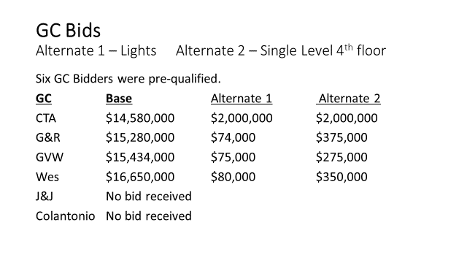

Mr. Bhatia stated that all bidders had to be certified in the historic renovations.

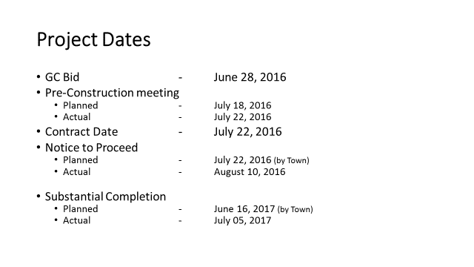

Mr. Bhatia stated that as with any other renovation project, there were challenges and with historical renovations there are usually more challenges.

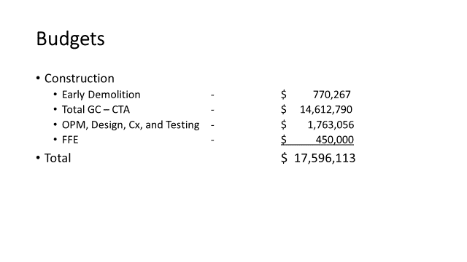

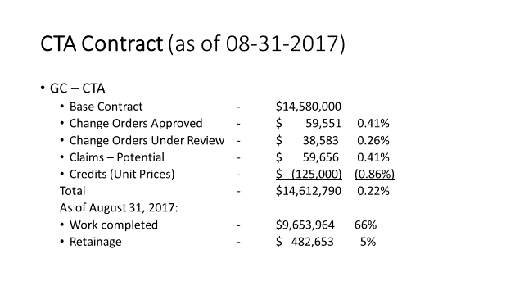

Mr. Bhatia informed all that the project is approximately .22% in change order conditions which includes claims potential. Mr. Bhatia stated he believes the project has been very successful in holding the budgets to date.

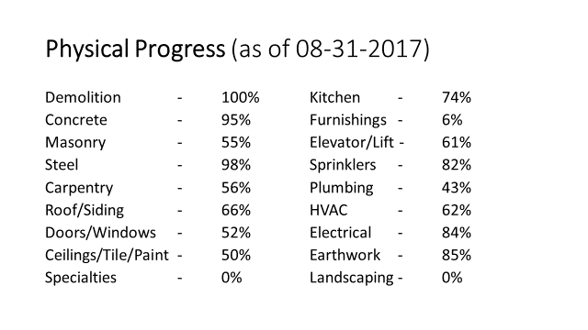

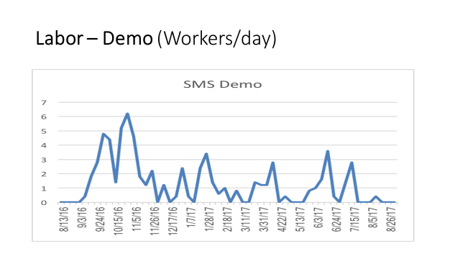

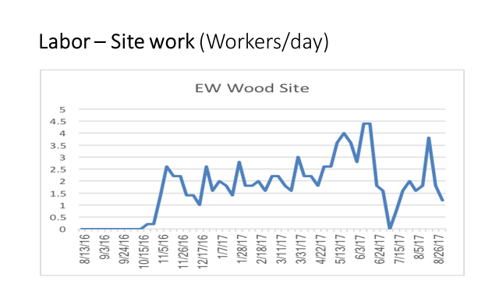

Mr. Bhatia stated as you can see from the last two charts, the project got off to a rather slow start which has impacted the project up to this day.

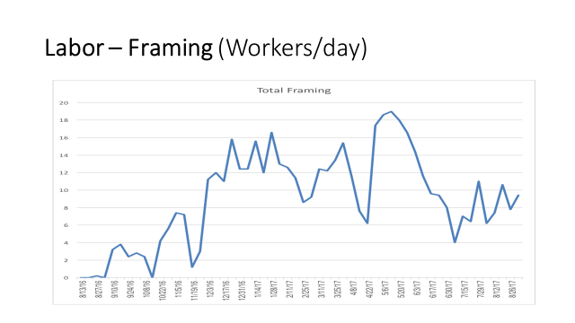

Mr. Bhatia stated that as the last two charts show this is a labor-intensive project and the labor issues that we have experienced have caused some of the delays.

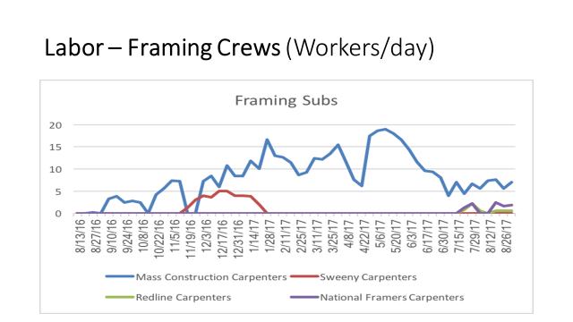

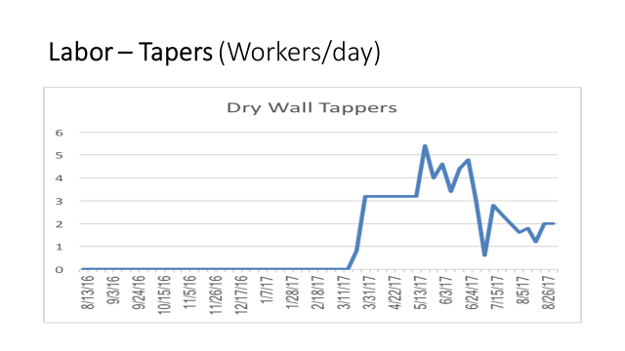

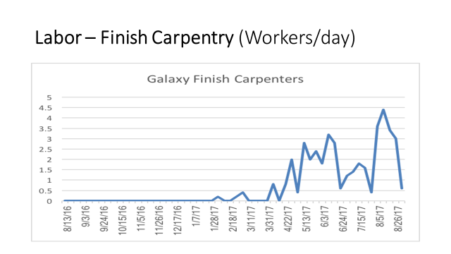

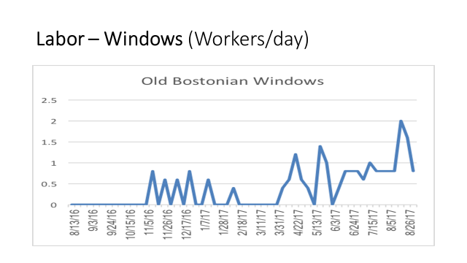

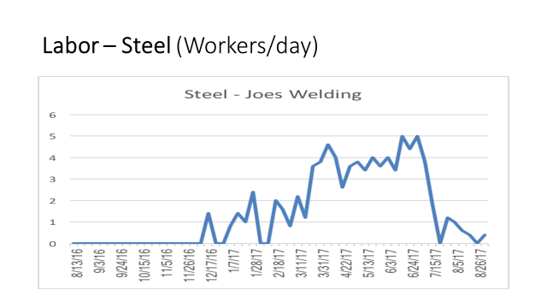

Mr. Bhatia stated that the last few charts show the issues with consistent labor as it is spiking and then decreasing.

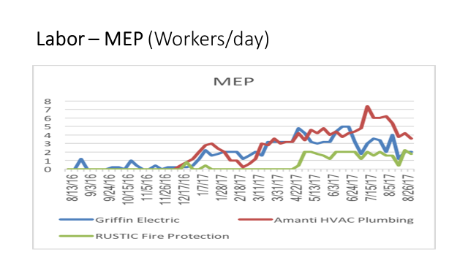

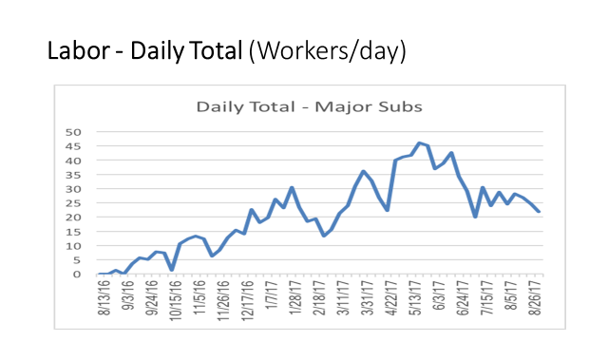

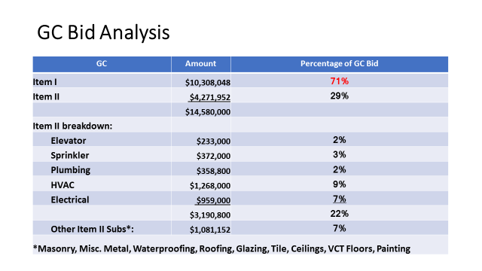

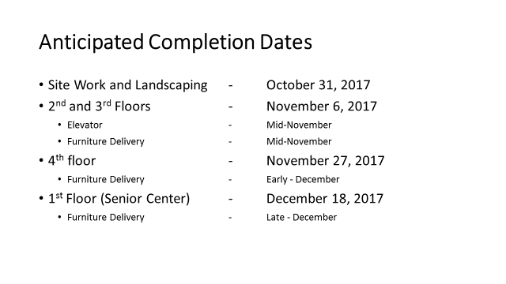

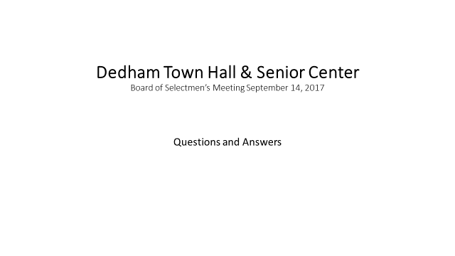

Mr. Bhatia asked the Board if they had any questions.

Mr. MacDonald asked Mr. Bhatia why the Board should believe any of the completion dates in that presentation when any other dates that have been presented have not been met.

Mr. Bhatia stated that he was going let the General Contractor answer that question as he is the one driving the bus.

Mr. McDonald asked Mr. Bhatia to explain the role of the General Contractor.

Mr. Bhatia informed all that Atlantic Construction is the owner’s Project Manager and they manage the designer and the Contractor and when there are issues we try to resolve them and move forward. Mr. Bhatia added that he does not want to sugarcoat anything but there were challenges.

Mr. Kern stated that the following was a list of bullets that CTA provided for the Board:

1. Received critical inspection of wiring above ceilings this week, which allows for completion and progression of many finish trades including flooring and ceilings.
2. Manpower is increasing managing 38 workers prior months to 52 yesterday and 49 today.
3. Roof and windows have been installed at the addition and it is watertight.
4. HVAC equipment is going to be set on 9/21.
5. Work is started on the finishes in the basement.
6. Many structural issues have been resolved.
7. Vault Construction has been completed.
8. Main electrical distribution equipment is set.

Pat Tompkins, CTA Director, stated that he understands that everyone in the Town, especially everyone in this room is anxious to get in the building. He also recognized their logistical challenges to the completion of this project. Mr. Tompkins added that it is a very complicated, intricate historic renovation project and there have been challenges to this point, such as the manpower. Mr. Tompkins stated that there is a lot of momentum on the project right now as the manpower on the project has gone up from somewhere in the high 30s to about 50 as of right now. Mr. Tompkins addressed the question from Mr. MacDonald regarding why the Board should believe any set dates by saying that they feel confident in the current dates of completion for all phases of the project. Mr. Tompkins added that there are challenges known and unknown. Mr. Tompkins Informed the Board that they opened up one of the stairwells last week and I found a big sinkhole underneath the foundation. Mr. Tompkins stated that with the proper teamwork from everyone on project, they will get the job done.

Mr. Keogh stated that he was under the impression that this was a project that would be completed in July and then he was told September and now it’s even longer than that. Mr. Keogh asked Mr. Tompkins what date he is comfortable with.

Mr. Tompkins answered the dates that were in Mr. Bhatia’s presentation.

Mr. Keogh asked Mr. Tompkins why the manpower spiked down in July.

Mr. Tompkins added that there been some projects that have been delayed due to unforeseen circumstances and workers have to pack up and go home while we fix the issue.

Mr. Keogh wondered why there were so many stoppages regarding the manpower and why they were so extended.

Mr. Tompkins answered that on this job the stops and starts, from his perspective, have been a little excessive and in the past the team could have done a better job of solving them. Mr. Tompkins added that his company is one third of the team he puts one third of the blame squarely on his company.

Mr. Keogh stated that this Board has a responsibility to the people in this Community. Mr. Keogh added that this project is over budget and off the timeline. Mr. Keogh continued, saying that is not very happy with the progress.

Mr. Tompkins stated that he completely understands the frustration with the schedule. Mr. Tompkins reiterated that it’s a high priority for himself and his company and wants to get this project done as much as the Board does. Mr. Tompkins continued, saying that in regards to the budget, they had a less than 1% difference and on a project like this, it would be best in class.

Mr. Kern clarified that the cost of the project is over budget as it relates to the original estimate.

Dr. Teehan stated that a lot of the expense added on to the project was due to conscious choice by the people in this room to make the building more equipped to be a 100 year old building.

Mr. Guilfoyle stated that they are anxious to get into the building because the constituents are wondering what’s going on with their tax money. Mr. Guilfoyle added that he would like to have an update, from CTA, at every Selectmen’s meeting from this point forward to December on how the project is progressing.

Dr. Teehan stated that he thinks it is important for everyone to remember that in the grand scheme of things this project is going to be a success no matter when it opens. Dr. Teehan added that he is obviously disturbed by the lack of communication to this Board regarding progress on this project. Dr. Teehan continued, saying that at the June 15 Selectmen’s meeting he asked for an update and was told that the building would open on September 15, 2007. Dr. Teehan stated that at the end of July he was called and told that the building would open in November or December. Dr. Teehan added that he wonders what happened between June 15 and the end of July to cause a two or 3+ months delay. Dr. Teehan stated that he finds it hard to believe that there wasn’t any indication that the September 15 date was inaccurate. Dr. Teehan asked Mr. Tompkins when they realized that this project was going to be behind schedule and why it was not communicated to this Board.

Mr. Thompson stated that one thing that did happen along the timeframe that was pretty significant was serious restructuring, reframing of the roof which was completely unforeseen. Mr. Thompson added that the Selectmen should have been kept in the know.

Dr. Teehan stated that it makes sense just move forward now. Dr. Teehan added that he would like an update on this project at every Selectmen’s meeting until the project is done. Dr. Teehan continued, saying that all developments with this project have to come through this Board.

Mr. Guilfoyle and Mr. Thompson had a conversation about the average number of workers per each month.

Mr. McDonald stated that this is what the Community wants and what they are paying for. Mr. McDonald asked Mr. Tompkins what happened behind the scenes that caused this delay. Mr. McDonald continued, saying that once this project is done there should be an independent report to find out what happened and learn from past mistakes to move on with future projects.

Mr. Bhatia suggested that the Board members do a walk-through of the Ames building before the next meeting.

The Board agreed.

**PUBLIC HEARING RE: REQUEST FOR ALTERATION OF PREMISES FROM MIDLAND HOTEL CORP. /BAMBOO FINE ASIAN CUISINE, 55 ARIDNE ROAD**

Mr. MacDonald recused himself for the next five agenda items as they could potentially go before the ABCC.

Peter Darlow, Architect for Bamboo Restaurant, Sam Sidhom, General Manager for the Holiday Inn and Lily Chen, one of the owners of Bamboo, were present before the Board.

Mr. Darlow stated that they are in front of the Board to discuss the proposed alterations to Bamboo Restaurant. Mr. Darlow informed all that they seek to adjust the seating arrangement by shifting the seating to enlarge the bar and lounge area. Mr. Darlow added that the total number of seats is not changing.

Mr. Butler asked Mr. Darlow what the current seating capacity was.

Mr. Darlow answered the liquor license states 180.

Mr. Butler asked if the seating capacity will remain 180.

Mr. Darlow stated yes it would.

Mr. Keogh moved approval of the request for the alteration of premises from Midland Hotel Corp/Bamboo Fine Asian cuisine, 55 Ariadne Road; Seconded by Mr. Guilfoyle. **On the Vote:** Mr. Keogh, yes; Dr. Teehan, yes; Mr. Butler, yes; Mr. Guilfoyle, yes; Mr. MacDonald, abstained.

**VIOLATION HEARING – SMJ AQUITAINE DEDHAM, INC., D/B/A AQUITAINE, 500 LEGACY PLACE**

Dr. Teehan declared the hearing open.

Ms. Baker swore in Sgt. Buckley and the defendants.

Sgt. Buckley informed all that the defendants waived the reading of the Police report.

Jeffrey Gates, owner and Manager of Aquitaine in Dedham and Abra Kleinberg, bartender at Aquitaine, were present before the Board.

Mr. Butler asked Mr. Gates what the company policy was for checking identification.

Mr. Gates answered that they check anyone who appears under the age of 30. Mr. Gates added that is part of the company’s handbook.

Mr. Butler stated that Abra Kleinberg is the bartender who is reported to have served the minor.

Mr. Butler asked Ms. Kleinberg if she was TIPS certified.

Ms. Kleinberg stated that she is.

Mr. Butler asked Mr. Gates if the company required any periodic training for their staff.

Mr. Guilfoyle asked Mr. Gates what he has done to change since this compliance check.

Mr. Gates informed all that this is the first time this has happened to him in his 30 years in the business. Mr. Gates apologized putting his company in this position and for taking up everyone’s time at this hearing. Mr. Gates added that they talk about the policy at every shift change, lunch and dinner. Mr. Gates continued, saying that Abra, who is a great employee and was very upset about this incident. Mr. Gates informed all that they did give Abra a warning that goes into her folder.

Mr. Keogh suggested that Mr. Gates have a monthly sit-down meeting as well as the daily shift meetings to further drive home Aquitaine’s policy.

Mr. Guilfoyle asked Ms. Baker if Aquitaine had any other compliance issues in the past.

Ms. Baker answered no.

Mr. Guilfoyle asked Sgt. Buckley if Aquitaine has been involved with any of his training programs.

Sgt. Buckley answered that they did not attend his last training but that he hopes to attend the training that Legacy Place will be hosting. Mr. Buckley added that the substance abuse collaboration is going to sponsor another TIPS class which is free, at the beginning of November.

Mr. Guilfoyle moved to close the violation hearing; seconded by Mr. Keogh. **On the Vote:** Mr. Keogh, yes; Dr. Teehan, yes; Mr. Butler, yes; Mr. Guilfoyle, yes; Mr. MacDonald, abstained.

Dr. Teehan informed all that they will make a decision at their next meeting.

**VIOLATION HEARING – LEGAL SEA FOODS, LLC, D/B/A LEGAL C BAR, 736 LEGACY PLACE**

Attorney Peter Zahka was present on behalf of Legal Sea Foods. Also present were Tom Clancy, Director of Operations, Meredith Lobsitz, General Manager and Manager of record and Robert Neilson, Assistant GM and Bar Manager.

Mr. Zahka stated that they waive the reading of the Police report and accept everything that is contained therein. Mr. Zahka added that with the Board’s permission Mr. Clancy would like to make a brief statement. Mr. Zahka continued, saying that his client does take serving a minor or any violation seriously and believe that the policies and practices that were in place before this evening or actually set up to avoid such a situation.

Ms. Baker swore in Sgt. Buckley and the representatives from Legal C bar.

Mr. Clancy started off by apologizing to the Board and stating that they preferred that this did not happened. Mr. Clancy added that they do not want this violation to happen again and have taken steps to ensure that it won’t. Mr. Clancy informed all that the server in question is no longer with Legal C Bar Dedham. Mr. Clancy added that legal C bar’s policy is to card everyone that looks under 40 years old. Mr. Clancy continued, saying they spent a good amount of time with their entire staff making sure the policy is understood. Mr. Clancy informed all that Legal C Bar had an alcohol awareness meeting that was attended by Sgt. Buckley to reaffirm the policies and procedures. Mr. Clancy stated that the Town of Dedham policy is that any employee dealing with alcohol must be TIPS or Serve Safe certified within 90 days of hire. Mr. Clancy informed the Board that legal C bar’s policy is all new employees must be certified within 30 days. Mr. Clancy stated that he along with Sgt. Buckley Beth Winbourne, General Manager of Legacy Place, will be organizing an awareness training class at Legacy Place sometime in the future. Mr. Clancy added that legal C bar has been in Dedham for around eight years and this is our first violation and he’d like it to be their last violation.

Mr. Guilfoyle asked Ms. Baker if Legal C Bar had any prior violations.

Ms. Baker answered this is the first violation.

Mr. Guilfoyle asked Sgt. Buckley if Legal C Bar has been involved with his awareness programs before.

Sgt. Buckley answered, they have.

Mr. Butler asked Mr. Clancy if any of his staff, at the time of the violation, had expired certifications.

Mr. Clancy answered that they had six people that needed to be certified.

Mr. Guilfoyle moved to close the violation hearing; seconded by Mr. Keogh. **On the Vote:** Mr. Keogh, yes; Dr. Teehan, yes; Mr. Butler, yes; Mr. Guilfoyle, yes; Mr. MacDonald, abstained.

**VIOLATION HEARING – NATIONAL AMUSEMENTS, INC., D/B/A SHOWCASE CINEMA DE LUX AND STUDIO 3 RESTAURANT & BAR, 670 LEGACY PLACE**

Attorney Edward J. Richardson, representing Showcase Cinema, was present before the Board. Mr. Richardson stated that his clients accept the statements of fact contained in the Police report and therefore waive the reading of the report by Sgt. Buckley.

Ms. Baker swore in the representatives from Showcase Cinema.

Mr. Richardson stated there is no dispute regarding the violation. Mr. Richardson added that the server had some personal problems at the time which may have contributed to her being distracted. Mr. Richardson continued, saying the server was in fact TIPS certified. Mr. Richardson informed all that regardless, server was terminated as National Amusements has a zero-tolerance policy towards any liquor violation, in particular underage service. Mr. Richardson stated that all servers are TIPS certified annually and they take all possible measures to avoid service to underage persons. Mr. Richardson added that less than a month after the incident, National Amusements held a General alcohol awareness training, which was performed by Mike Marcantonio. Mr. Richardson introduced Sean Judge, the area Manager with 20 years of consecutive service and Mike Flynn, the managing director. Mr. Richardson informed all that National Amusements conducts its own internal compliance audits.

Mr. Guilfoyle asked Mr. Judge if he is had any compliance failures at the Dedham location where he had to terminate an employee.

Mr. Judge answered yes.

Mr. Guilfoyle asked Mr. Judge what changes have been made since this violation.

Mr. Judge stated that they made sure that everyone was TIPS certified. Mr. Judge added that they will do their certification training include cashiers, Managers and anyone else working with IDs. Mr. Judge continued, saying that made sure that the Managers are addressing and reinforcing National Amusements’ identification procedures and policies during a pre-shift huddle basis.

Mr. Guilfoyle asked Ms. Baker if National Amusements had prior violations.

Ms. Baker answered no.

Mr. Guilfoyle asked Sgt. Buckley if National Amusements has been involved with any of his training.

Sgt. Buckley informed all that the Showcase Cinema hosts all of his trainings. Sgt. Buckley and stated that he uses Mike Marcantonio who is a master TIPS trainer for all of his seminars.

Mr. Guilfoyle asked who the Manager of record at Showcase Cinemas is.

Mr. Judge informed all that there is an application in for a change of Manager to Paul LeClair.

Mr. Guilfoyle asked who the Manager of record was at the time of the violation.

Ms. Baker informed all that the Town’s records indicate that Shannon Hammond was the last Manager of record.

Mr. Guilfoyle asked if she was still employed by National Amusements.

Mr. Judge answered that she is not.

Mr. Butler asked what the company policy is for checking IDs.

Mr. Judge answered that they check IDs for anyone looking under the age of 40.

Mr. Butler asked how long the server in question was with the company.

Mr. Flynn answered that she was a college student and worked during summers and holidays

Mr. Guilfoyle moved to close the violation hearing; seconded by Mr. Keogh. **On the Vote:** Mr. Keogh, yes; Dr. Teehan, yes; Mr. Butler, yes; Mr. Guilfoyle, yes; Mr. MacDonald, abstained.

**VIOLATION HEARING – DEDHAM LQ HOLDINGS, D/B/A VICTORY GRILLE, LLC, 253 ELM STREET**

Atty. Kevin Hampe, representing Victory Grille, stated that they waived the reading of the report and admit to the violations as stated.

Ms. Baker swore in Sgt. Buckley and the representatives from Victory Grille.

Mr. Hampe introduced Jennifer Marshall, the Manager of record a Victory Grille, and George and Spiro Deamantopoulos, owners of Victory Grille

Mr. Hampe informed all that this is the first violation in the two years since Victory Grille opened and has been involved with the Town of Dedham for a long period of time and are very embarrassed that this happened. Mr. Hampe added that within two weeks of the violation they held a meeting with all their employees to discuss the situation and impress upon them the seriousness of these type of violations and the possible consequences. Mr. Hampe continued, saying that Victory Grille cards anyone that looked under the age of 30 and have since raised that age to 35. Mr. Hampe informed all that the employee involved in the incident is no longer with the business. Mr. Hampe added that the number of employees recently took a class with Sgt. Buckley. Mr. Hampe continued, saying that they were actually glad it was a compliance check where no one got seriously hurt. Mr. Hampe stated that the owners are here in the Manager of record is here as well to answer any questions you may have.

Mr. Guilfoyle asked Ms. Baker if the victory girl had any prior violations.

Ms. Baker answered no.

Mr. Butler asked Mr. Deamantopoulos if they checked employee’s current certification since the compliance check.

Mr. Deamantopoulos stated that they did check and all were certified at the time of the violation.

Mr. Keogh spoke of his Restaurant experience and suggested regular meetings to update employees regarding the policies of the Restaurant and to be thorough with their checking of IDs.

Mr. Guilfoyle moved to close the violation hearing; seconded by Mr. Keogh. **On the Vote:** Mr. Keogh, yes; Dr. Teehan, yes; Mr. Butler, yes; Mr. Guilfoyle, yes; Mr. MacDonald, abstained.

**DISCUSSION & VOTE RE: LAYOUT OF QUARRY ROAD**

Ms. Baker informed all that the Town Engineer, Jason Mammone, is not available this evening. Ms. Baker added that this item is something that the Board has done in the past and this is the next step in the process for quarry Road as you have done in the past for Birch Street. Ms. Baker continued, saying that the Board is required to take a vote after the Planning Board has received the layout.

Mr. Guilfoyle moved to accept the Planning Board’s report for the layout of Quarry Road and to direct the Engineering Department to move forward with collecting executed waivers of appraisal and damages from all owners of record; seconded by Mr. Keogh. **On the Vote:** Mr. Keogh, yes; Dr. Teehan, yes; Mr. Butler, yes; Mr. Guilfoyle, yes; Mr. MacDonald, yes.

**ACTION BY THE BOARD**

**REQUEST FROM THE RESIDENTS OF LINCOLN STREET FOR A BLACK PARTY ON FRIDAY SEPTEMBER 22, 2017 FROM 4:30PM – 11PM**

Mr. McDonald moved approval; seconded by Mr. Butler. **On the Vote:** Mr. Keogh, yes; Dr. Teehan, yes; Mr. Butler, yes; Mr. Guilfoyle, yes; Mr. MacDonald, yes.

**REQUEST FOR A BLOCK PARTY ON ALPINE, WINTHROP AND QUINCY ON SATURDAY SEPTEMBER 30, 2017 FROM 2PM – 11PM**

Mr. McDonald moved approval; seconded by Mr. Butler. **On the Vote:** Mr. Keogh, yes; Dr. Teehan, yes; Mr. Butler, yes; Mr. Guilfoyle, yes; Mr. MacDonald, yes.

**REQUEST FROM THE SPRILLOW NEIGHBORHOOD (SPRUCE, WHITE AND WILLOW) ON SATURDAY OCTOBER 14, 2017 FROM 2PM-6PM**

Mr. McDonald moved approval; seconded by Mr. Butler. **On the Vote:** Mr. Keogh, yes; Dr. Teehan, yes; Mr. Butler, yes; Mr. Guilfoyle, yes; Mr. MacDonald, yes.

**DRAINLAYER APPLICATION**

**Peter DeGirolamo & Sons, Inc.**

**77 East Belcher Road**

**Foxboro, MA 02035**

Mr. McDonald moved approval; seconded by Mr. Butler. **On the Vote:** Mr. Keogh, yes; Dr. Teehan, yes; Mr. Butler, yes; Mr. Guilfoyle, yes; Mr. MacDonald, yes.

**REQUEST FOR A 1 DAY LIQUOR LICENSE FROM THE CHURCH OF ST. JOHN OF DAMASCUS FOR THEIR ANNUAL BAZAAR ON FRIDAY NOVEMBER 3, 12PM – 9PM, SATURDAY NOVEMBER 4, 10AM – 5PM AND SUNDAY NOVEMBER 5, 2017 FROM 12PM – 3PM**

Mr. McDonald moved approval; seconded by Mr. Butler. **On the Vote:** Mr. Keogh, yes; Dr. Teehan, yes; Mr. Butler, yes; Mr. Guilfoyle, yes; Mr. MacDonald, yes.

**REQUEST FOR A 1 DAY LIQUOR LICENSE FRON FRIENDS OF DEDHAM CIVIC PRIDE FOR THEIR ANNUAL BEER AND WINE TASTING AT THE ENDICOTT ESTATE, NOVEMBER 3, 2017, FROM 6:30PM – 9:30PM**

Mr. Keogh moved approval; seconded by Mr. Butler. **On the Vote:** Mr. Keogh, yes; Dr. Teehan, yes; Mr. Butler, yes; Mr. Guilfoyle, yes; Mr. MacDonald, yes.

Mr. Guilfoyle moved to take an item not on the agenda; seconded by Mr. MacDonald. Mr. McDonald moved approval; seconded by Mr. Butler. **On the Vote:** Mr. Keogh, yes; Dr. Teehan, yes; Mr. Butler, yes; Mr. Guilfoyle, yes; Mr. MacDonald, yes.

**REQUEST FORM SAINT VINCENT DE PAUL SOCIETY TO HANG SIGNS, STARTING SEPTEMBER 19, ADVERTISING THEIR WALK FOR THE POOR ON SATURDAY SEPTEMBER 30**

Mr. Keogh moved approval; seconded by Mr. Butler. **On the Vote:** Mr. Keogh, yes; Dr. Teehan, yes; Mr. Butler, yes; Mr. Guilfoyle, yes; Mr. MacDonald, yes.

Mr. Butler moved to take an item not on the agenda; seconded by Mr. Keogh. Mr. McDonald moved approval; seconded by Mr. Butler. **On the Vote:** Mr. Keogh, yes; Dr. Teehan, yes; Mr. Butler, yes; Mr. Guilfoyle, yes; Mr. MacDonald, yes.

**REQUEST FROM THE AMERICAN LEGION FOR OUTSIDE SERVICE OF ALCOHOL ON THE FOLOWING DATES AND TIMES:**

**Sunday September 17, 2017 Horseshoe Tournament 3PM-8 PM**

**Saturday September 30, 2017 Dedham field hockey fundraiser 1 PM-5 PM**

**Saturday October 14, 2017 Norfolk County Sheriff’s Dept. Fundraiser 3 PM-8 PM**

Mr. Guilfoyle moved approval; seconded by Mr. MacDonald. **On the Vote:** Mr. Keogh, yes; Dr. Teehan, yes; Mr. Butler, yes; Mr. Guilfoyle, yes; Mr. MacDonald, yes.

**MINUTES APPROVAL – 8/24/17**

Mr. Guilfoyle moved approval; seconded by Mr. Butler. **On the Vote:** Mr. Keogh, yes; Dr. Teehan, yes; Mr. Butler, yes; Mr. Guilfoyle, yes; Mr. MacDonald, yes.

**DISCUSSION RE: PUBLIC SAFETY BUILDING UPDDATE**

Brad Dore, a principal with Dore and Whittier architects, was present before the Board. Mr. Dore informed all that his firm is working for the Town as the designer for the proposed Public Safety project. Mr. Dore added that at the previous Board meeting he was asked to go back and take a look at the building and see if they could make it a little warmer, a little more inviting and perhaps a little more New England to look at. Mr. Dore continued, saying that in the last week and a half they have attempted to do that. Mr. Dore stated that they have created a short flyby video to help people visualize the building from a whole bunch of different angles. Mr. Dore presented the video to help people visualize what the building will look like from a whole bunch of different angles and to see the scaling in relationship to other buildings and the relationship of the proposed building as part of a municipal campus.

Mr. Dore then played the video again and paused to point out the changes and modifications that have been made. Mr. Dore described the nuances of the building, such as the arches, gazebo, landscaping, etc.

Mr. Dore stated that we may not have resolved all of the issues but from working within the framework of trying to make sure we address the program requirements of both the Police and Fire and keeping the building the same but trying to deal with some of the exterior aesthetics to make it a little bit more warm or inviting. Mr. Dore continued, saying that hopefully they’ve had some success there.

The Board asked Chief D’Entremont to speak about the benefits of Planning and building this new combined public safety building.

Chief D’Entremont stated that as far as a joint facility it offers shared space such as an HVAC system and a much larger public lobby with restrooms off the lobby. This new combined public safety building offers an emergency operations center/training room/Community room. Chief D’Entremont added that the new space offers secure parking for the Officers and a fitness area to be shared as well. Chief D’Entremont pointed out that the new building will have significantly better booking area with a sally port. Chief D’Entremont also pointed out that there would be locker facilities for the female Officers which do not exist in the current building. Chief D’Entremont continued, saying that the detectives would have an area to do their work with fingerprints that have fuming hood, so any chemicals that they are working with would be properly ventilated out of the building. Chief D’Entremont informed all that the new building will offer space for record storage and property and evidence storage. Chief D’Entremont stated that this new facility will be a tremendous benefit to the Officers and the Community.

Mr. Guilfoyle reiterated that this building will be a huge improvement for our Police Department, Fire Department and the entire Town of Dedham.

Mr. Kern stated that he would be working off a spreadsheet which is a format he has used previously. Mr. Kern emphasized that this is not a spreadsheet about the new Public Safety building, it is a spreadsheet about an approach to building buildings in Dedham that is sustainable and going forward this should be a template for whatever public buildings Dedham is endeavoring to build. Mr. Kern presented the following spreadsheet.



Mr. Kern pointed out that the that the first two columns represent the meals tax and the hotel tax, which goes into a special use stabilization fund called the Robin Reyes fund. Mr. Kern stated that if you had them together, you get the total contribution of those two tax revenues, $2.6 million, for 2020. Mr. Kern informed all that the next column represents an amount of money that he would propose that the Town reallocatet. Mr. Kern continued, saying that after that there is room in our other capital program to augment the amount of money being provided by the Robin Reyes fund, such that we can fund this series of buildings for the foreseeable future, out 30 years. Mr. Kern added that the columns on the left reflect revenue, the four buildings represented by the middle four columns.

The Kern made reference to a larger spreadsheet that shows the estimated cost and our estimated term. For example, the combined public safety building is programmed at $37 million that uses the three new million dollars each puts us at 40 ½ million dollars (30 years at 2.9%). Mr. Kern mentioned that the modifications that the design team has made since we last met, would change that total by about $2 million.

Dr. Teehan thanked Mr. Kern for his presentation. Dr. Teehan stated that there’s been a lot of talk about the design of this building and I don’t think anyone disputes that the building is essential. Dr. Teehan added that there have been concerns of whether the building integrates well into the neighborhood and into the Ames building next door. Dr. Teehan continued, saying that one of the things that consistently comes up when we talk about the design of the building, is that the design relates very much to the cost. Dr. Teehan informed all that he spoke with Mr. Dore the other day and one of things that he thought about the building is that he would like to see it look more like a historic New England building, more like the Ames schoolhouse. Dr. Teehan stated since any changes made to the building will directly affect the cost, we have to take a look at whether we can afford it in the end.

Mr. Guilfoyle stated that the safety that the new combined safety building will bring is something that he is excited about.

Mr. McDonald commented that what Mr. Dore showed them this evening, while it’s not everything he wanted, satisfies the need financially and aesthetically. Mr. McDonald added that while it should be a pleasing building outside we had to remember what the purpose of the building is. Mr. McDonald read a passage from the 1997 Town report by Chief Teehan, where he stated that the Police station at that time had many deficiencies which the Town needs to address. Mr. McDonald read on, stating that Chief Teehan wrote that the Police station was built over 35 years ago and housed about half of the number of employees at that time as compared to today. Mr. McDonald read that there has not been any significant repair to this facility since it opened and it will be important for the Town to address the serious needs of the Police station in the very near future. Mr. McDonald pointed out that every Police Chief has made this a priority issue and it is time for the Town to put up. Mr. McDonald stated that after 20 years, it’s time and there are so many reasons that have been pointed out this evening. Mr. McDonald reminded all that there will be an open session where they will be a presentation on Thursday, September 21 at 7 PM at the Dedham Middle School and he hopes that Town meeting members and others will show up to give their input.

Dr. Teehan stated that it is his expectation that this stay on the agenda for every meeting going forward.

**VOTE TO RATIFY MEMORANDUM OF UNDERSTANDING WITH DEDHAM POLICE ASSOCIATION (LTS. & SGTS.)**

Mr. McDonald moved to ratify the vote taken in executive session on August 24, 2017 to accept the memorandum of understanding with the Dedham Police Association, Lieut.s and Sgts.; seconded by Mr. Butler. **On the Vote:** Mr. Keogh, yes; Dr. Teehan, yes; Mr. Butler, yes; Mr. Guilfoyle, yes; Mr. MacDonald, yes.

**DISCUSSION & VOTE TO AUTHORIZE NEGOTIATIONS RE: CHAPTER 32b SECTIONS 21 - 23**

Mr. Kern informed all that sections 21 - 23 of chapter 32B, has already been accepted by the Board of Selectmen and it addresses the desire on the part of the Town to address health insurance expenses especially for those who fall under collective bargaining agreements. Mr. Kern added that this section came out about eight or 10 years ago to allow communities to move their unionized employees to a GIC equivalent or into the DIC. Mr. Kern explained that the GIC is the state-run insurance program that is available to virtually every state employee as a result of the passage of the statute it is available to municipalities. Mr. Kern continued, saying that by executing this, allows the Town to make adjustments to the programs offered to our unionized employees and also allows those unionized employees to negotiate other arrangements if they so desire. Mr. Kern informed all that the request he made of the Board is that they vote it such that we begin the process January 1 so that the change would occur at the beginning of the next fiscal year, which is July 1. Mr. Kern stated that this motion would allow for the movement into the GIC or a GIC benchmark and our intention would be to go with the GIC benchmark under the West suburban health.

Mr. Butler moved that the Board authorize the Town Manager to initiate, on or after January 1, 2018, the process authorized in G. L. c. 32B, sections 21 - 23 for affecting health plan design changes to either move to aso-called benchmark plans or enter the GIC, with a target implementation date for such changes on July 1, 2018 (and to utilize email for required notices as permitted by law); seconded by Mr. MacDonald.

Mr. McDonald stated that this is a process the Town has used before, which came to a successful agreement between the Town and those that have the right to collectively bargain. McDonald added that this is part of a process in order to achieve consensus between the Town and the men and women work so hard to deliver the services for the Town.

Mr. Guilfoyle asked if the Town was still working with the collective bargaining units on some sort of healthcare.

Mr. Kern answered that we are and added that he should have mentioned that he notified the cochairman of the employee commission that represents all of them, of his intention to continue negotiations.

**On the Vote:** Mr. Keogh, yes; Dr. Teehan, yes; Mr. Butler, yes; Mr. Guilfoyle, yes; Mr. MacDonald, yes.

Mr. Guilfoyle stated that he needed to excuse himself to attend the Planning Board meeting on behalf of the East Dedham revitalization committee. He asked Dr. Teehan to remind all of the Goldstar run for the fallen event happening this coming Saturday.

**TOWN MANAGER’S REPORT**

Mr. Kern informed all that the SBRC “opened” the bids for the General Contractor on the ECEC.  Mr. Kern added that there were five bidders total in the low bid was $18.5 million by H V Collins out of Providence.

Mr. Kern stated that he spoke with Rebecca Zachas from BCK Law regarding the oral arguments in the pipeline lawsuit.  The arguments are scheduled for Oct. 19th in the D.C. Circuit.  Each “side” gets about 15 minutes.  That means our side, which includes the City of Boston and River Keeper Alliance and us gets 15 minutes total.  It may turn out that only 2 of the three attorneys actually makes the oral argument and the attorney for River Keeper has argued 25 cases of this type in this court.  Regardless of who argues, our attorney will be there to answer any questions specific to the issues we raised.  According to the attorneys, the 15 minutes is usually used answering specific questions since the 3 judges would have already read the brief.  This court is one where a lot of very serious Federal issues are heard, the Chief Justice is Merrick Garland and the judges are among the best in the country.   The average time it takes to render a decision is about 4 months.  The only appeal would be to the U.S. Supreme Court.

Mr. Kern informed the Board that he toured Gonzalez Field to see the small modification to the lower parking lot and added that the expected completion date is end of September.

Mr. Kern stated that he and Joe Flanagan are speaking tomorrow afternoon with John Giorgio and Jon Eichmann on the Transfer Station and he expects to move forward in May.

**OLD/NEW BUSINESS**

Mr. McDonald wanted to remember Jack Kearney passed away recently. Mr. McDonald added that Jack was a member of the zoning Board of Appeals for a long time. Mr. McDonald offered condolences to his family.

Dr. Teehan reminded all that the Run for the Fallen will take place this Saturday, September 16, at 9 AM.

Dr. Teehan stated that they would now adjourn to executive session to discuss collective bargaining, as discussing this in open session would be detrimental to the best interest of the Town. Dr. Teehan added that the Board will only exit executive session to adjourn the open session Meeting.

Mr. McDonald moved that the Board enter into executive session; seconded by Mr. Keogh. **On the Vote:**

**ROLL-CALL**

Mr. Keogh, yes

Dr. Teehan, yes

Mr. Butler, yes

Mr. MacDonald, yes.

The Meeting was adjourned at 9:13PM.

The next Meeting is scheduled for Wednesday October 4, 2017 at 7p.m. This is to certify that the above is a true and accurate Record of the Minutes of the Selectmen’s Meeting held on September 14, 2017, which minutes were approved on October 4, 2017.

________________________

Dennis Teehan, Jr. – Chairman