A meeting of the Board of Selectmen was held on Thursday September 21, 2017, at 7PM in the Dedham MiddleSchool Auditorium, 70 Whiting Avenue, Dedham, MA. Present were:

Dennis J. Teehan

James A. MacDonald

Michael L. Butler

Dennis J. Guilfoyle

Brendan G. Keogh

The meeting opened with a presentation/discussion regarding the proposed Public Safety Building.

Mr. MacDonald welcomed all those in attendance and referred to the following slides from the evening’s power point presentation:

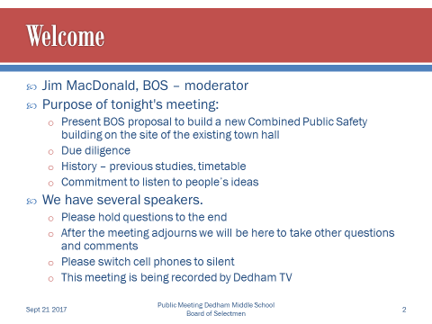

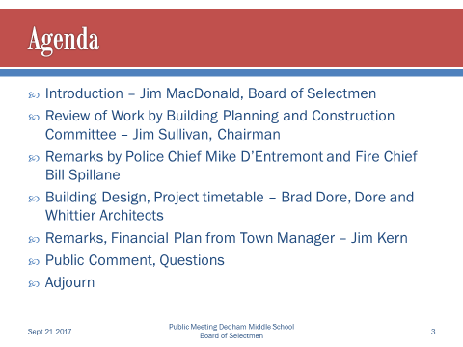

Mr. Sullivan informed all of the work done by the Building Planning & Construction Committee and referred to the following slide:

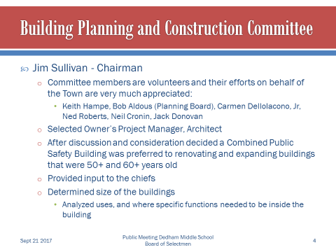

Police Chief Michael D’Entremont spoke about visits to other Public Safety Buildings and the positives of having a combined facility:

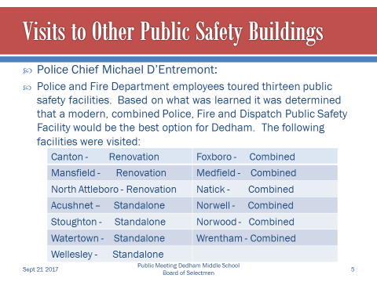

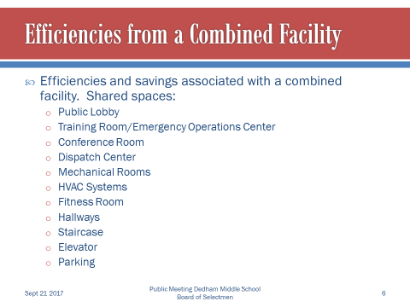

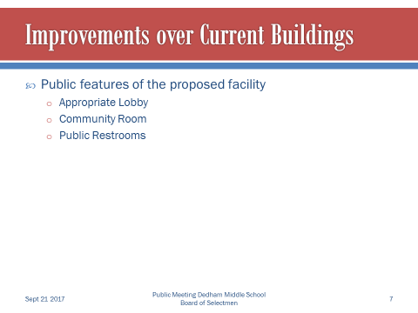

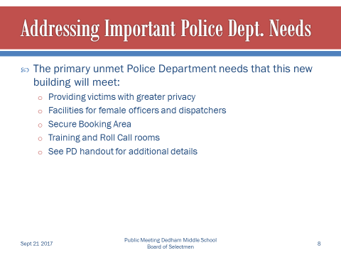

Fire Chief, William Spillane, referred to the following slides to inform all about important Fire Dept. needs and the deficiencies of the current Building:

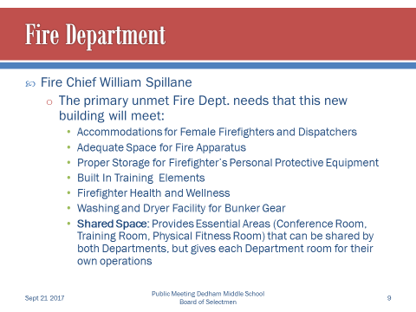

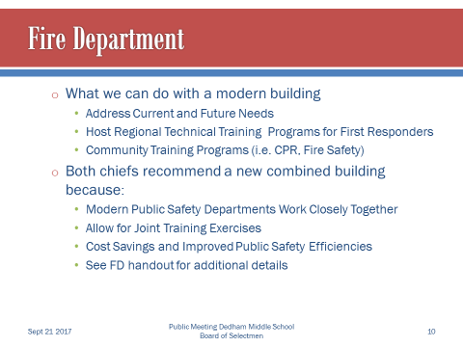

Brad Dore, Dore and Whittier Architects, informed all about the process of the design aspect of this combined public safety Building. Mr. Dore referred to the following slides:

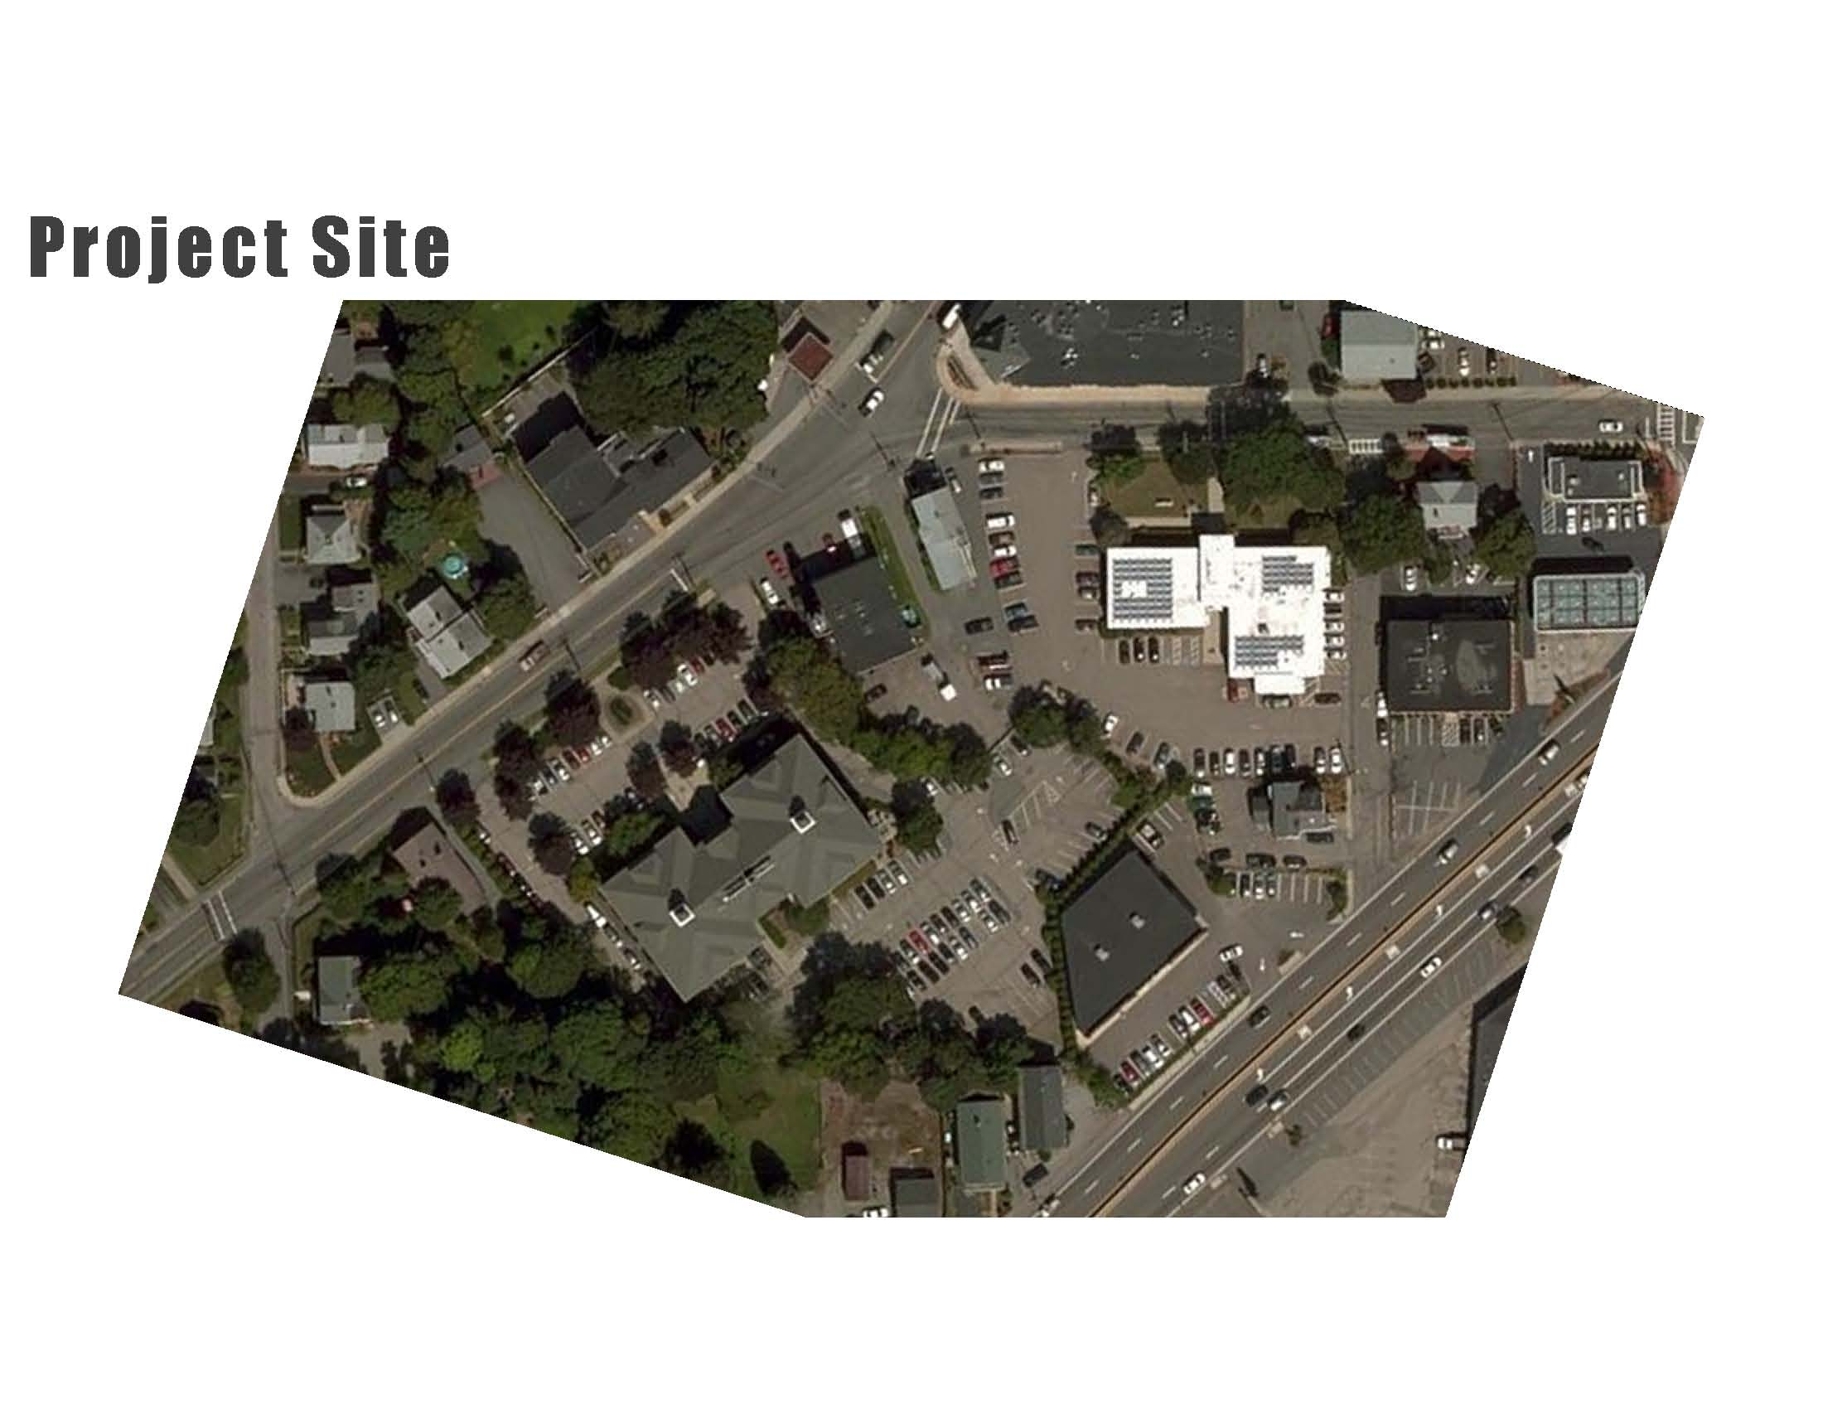

Town Hall – Replaced By Public Safety Building

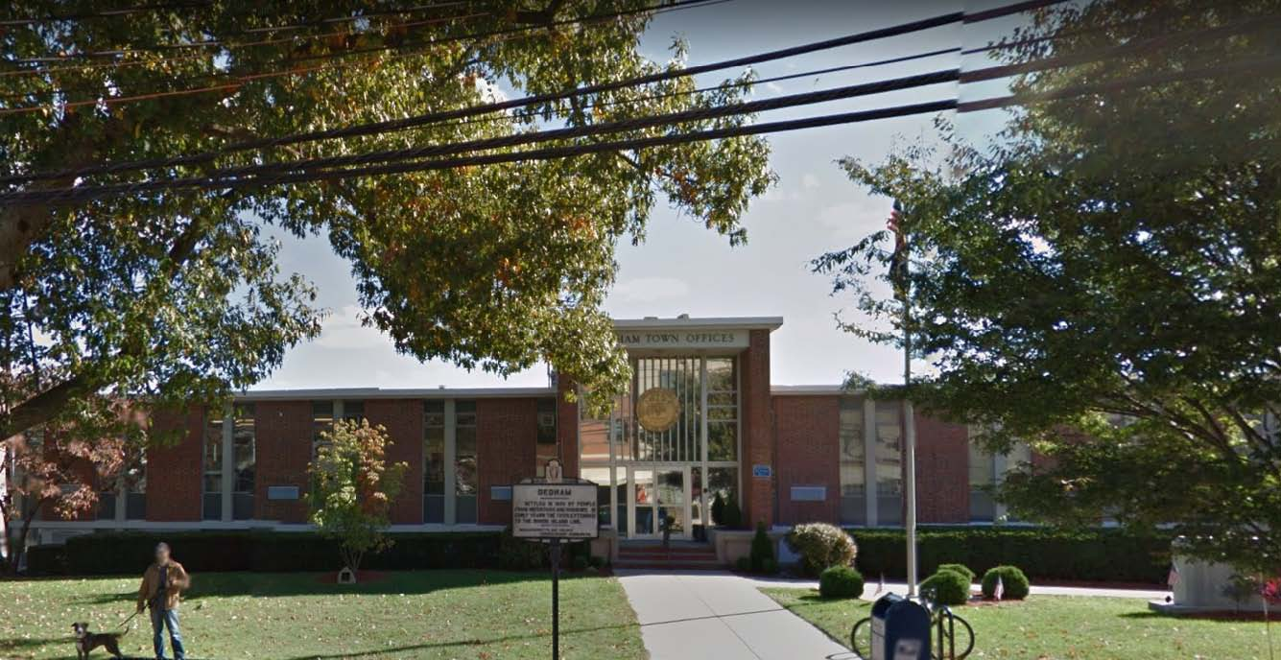

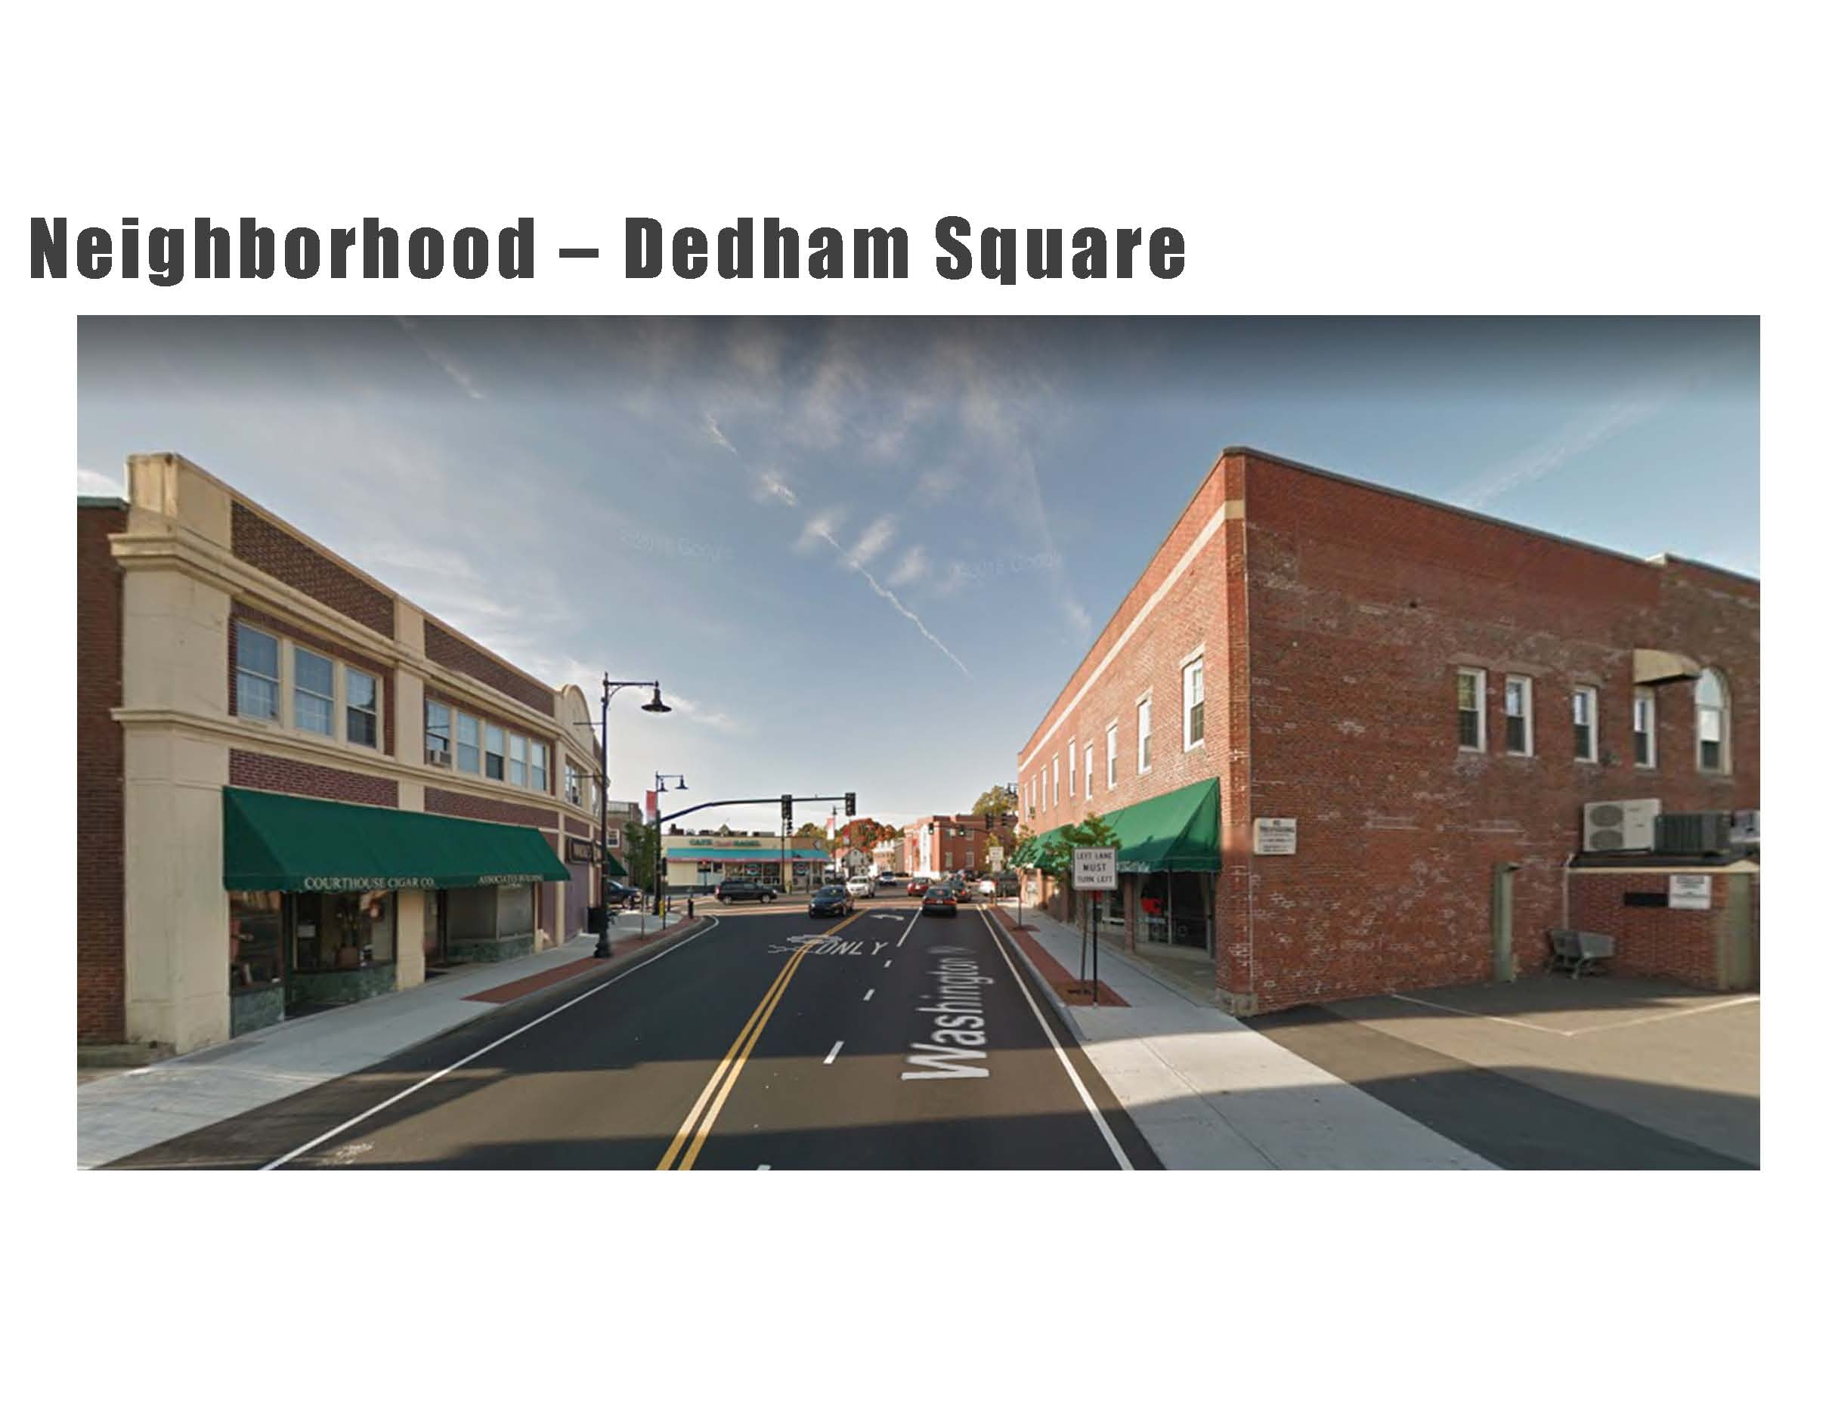

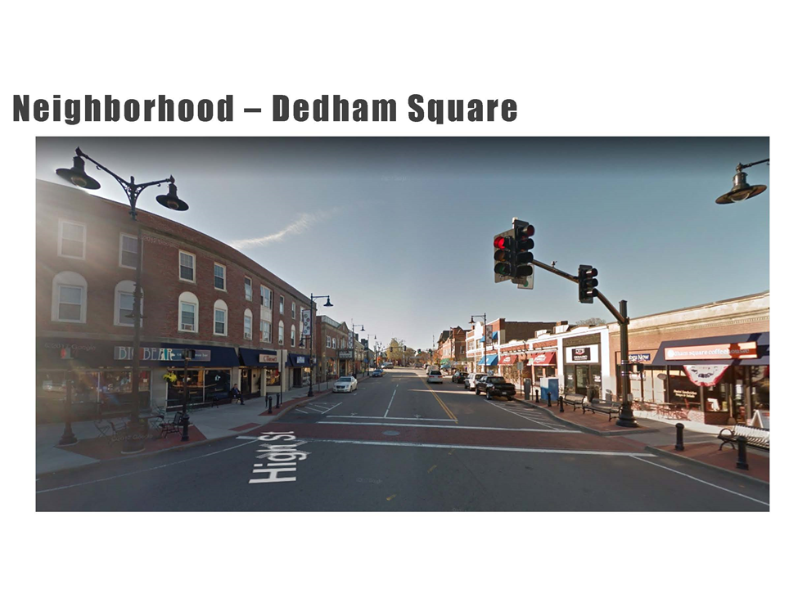

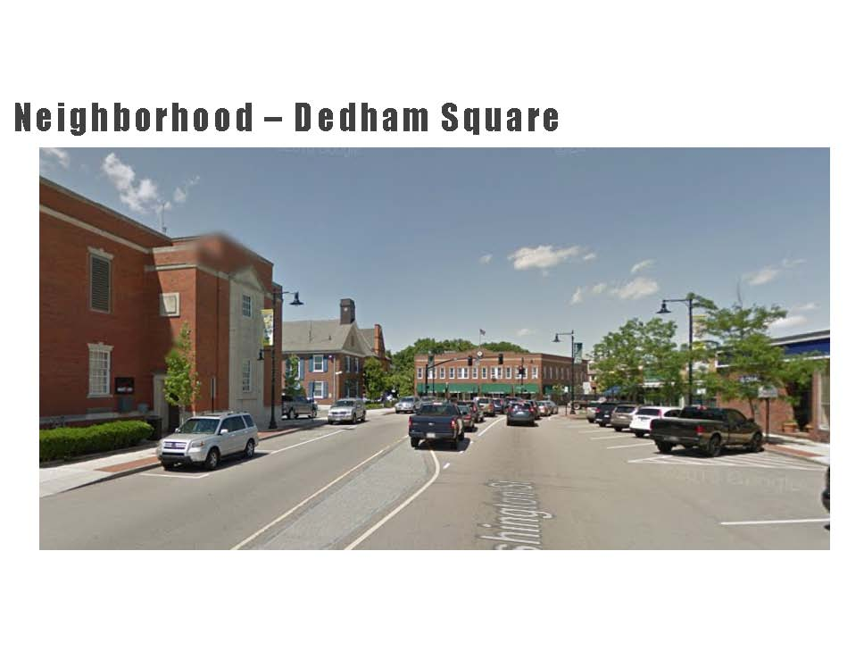

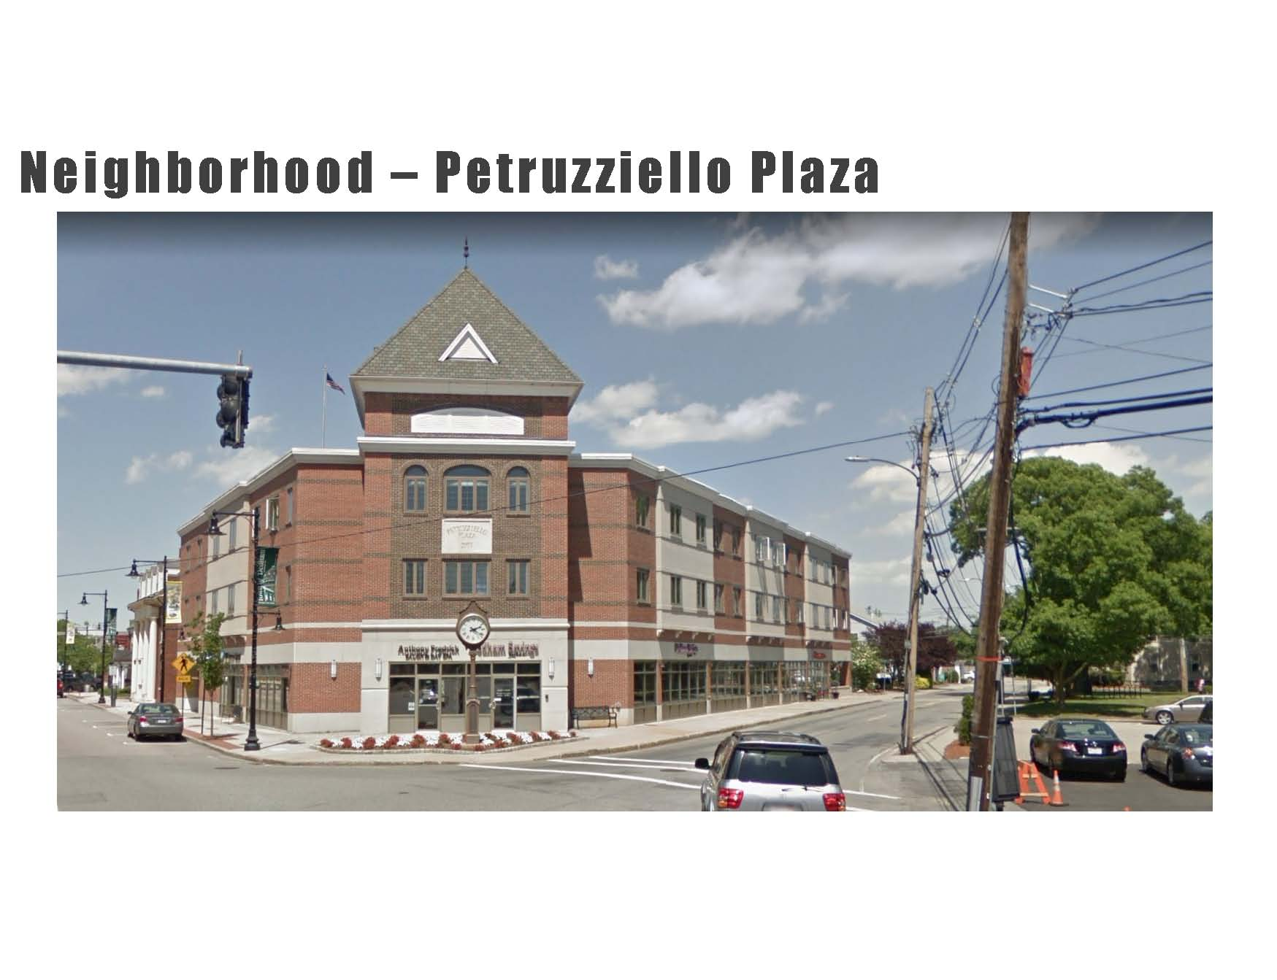

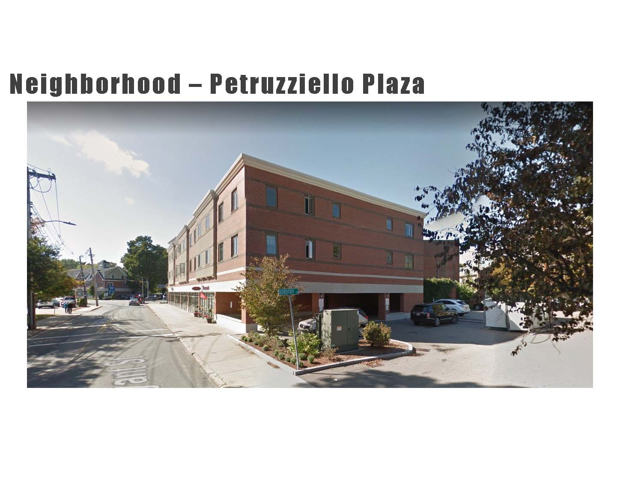

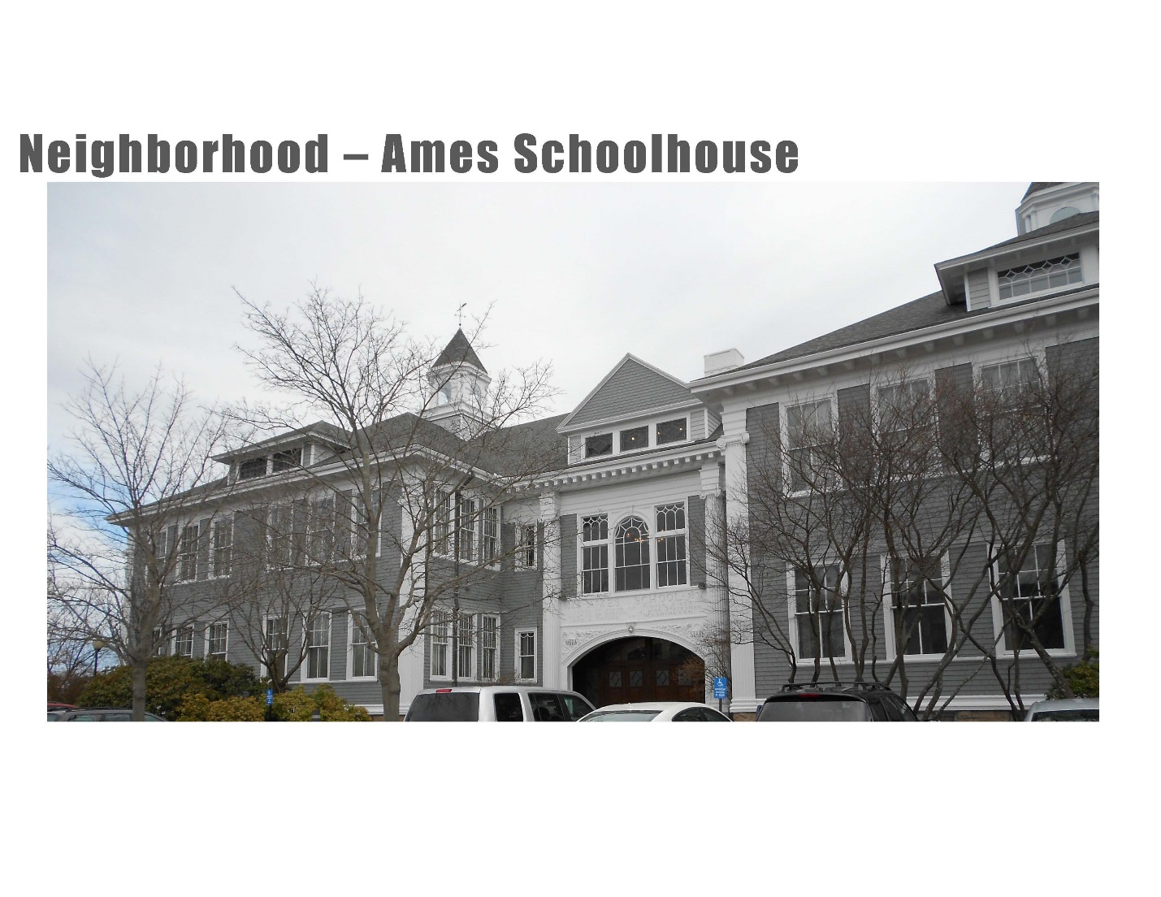

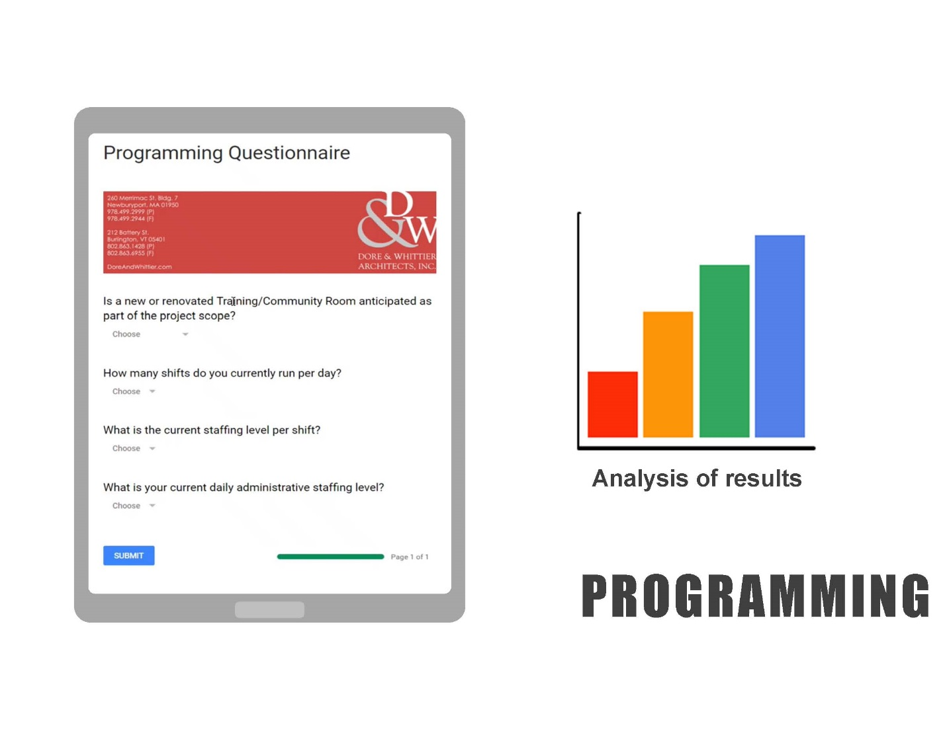

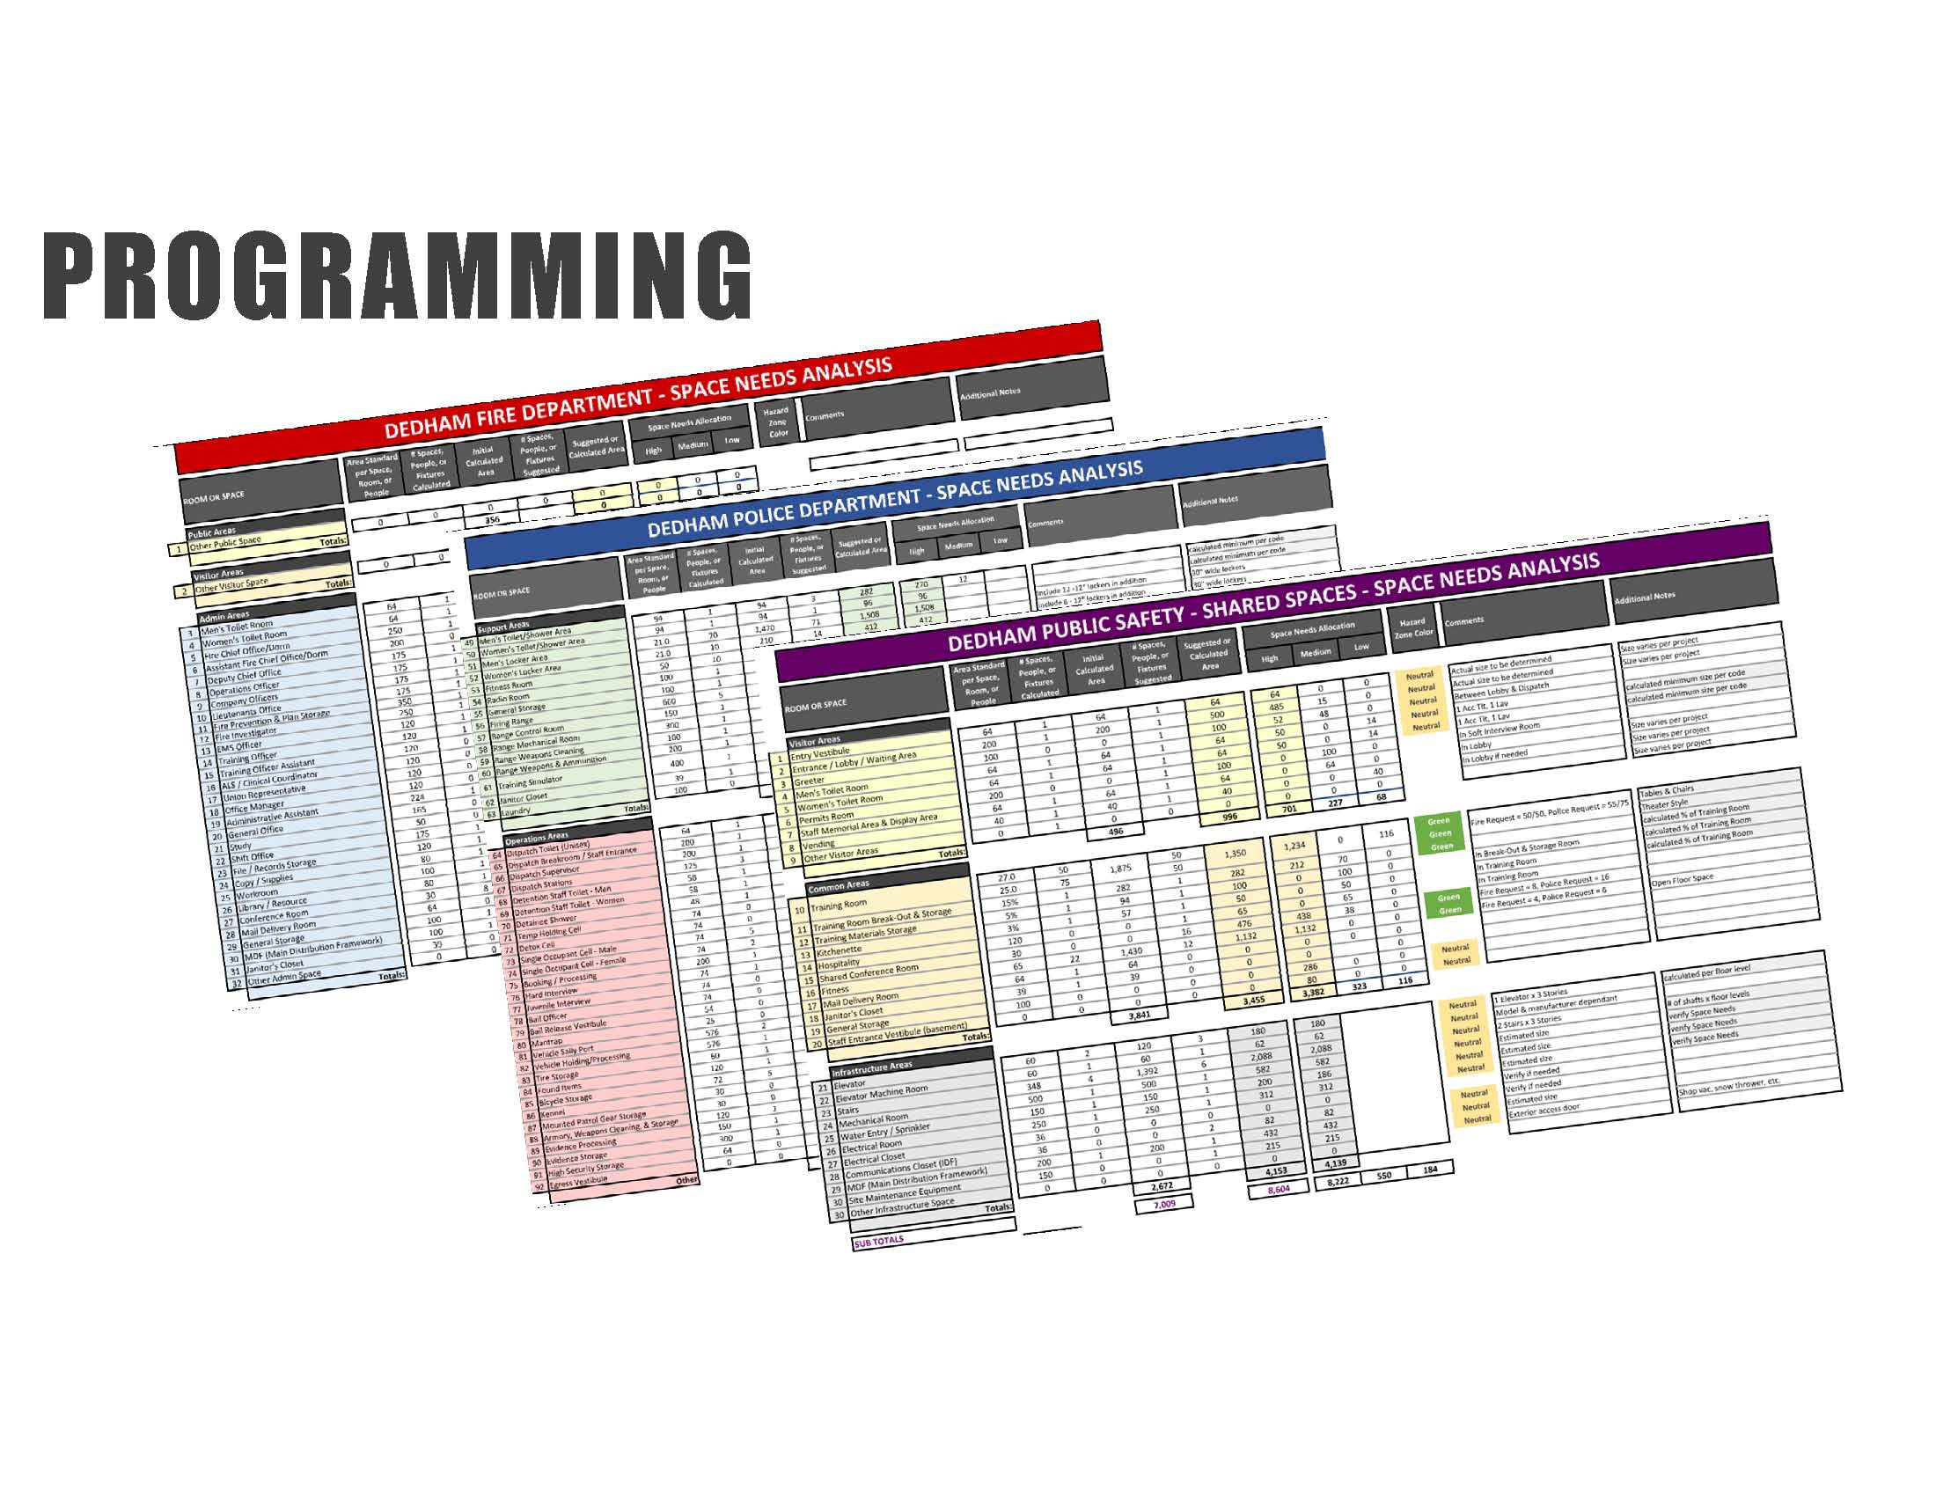

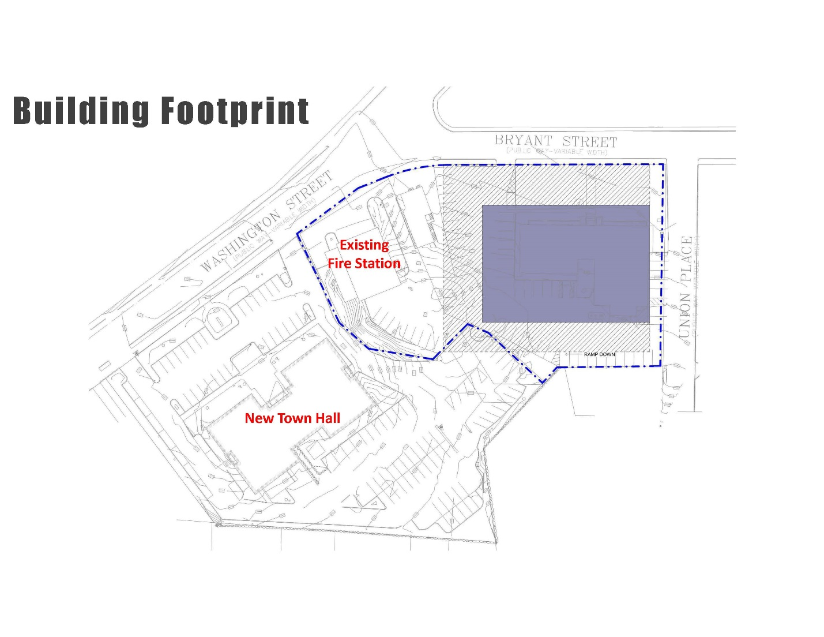

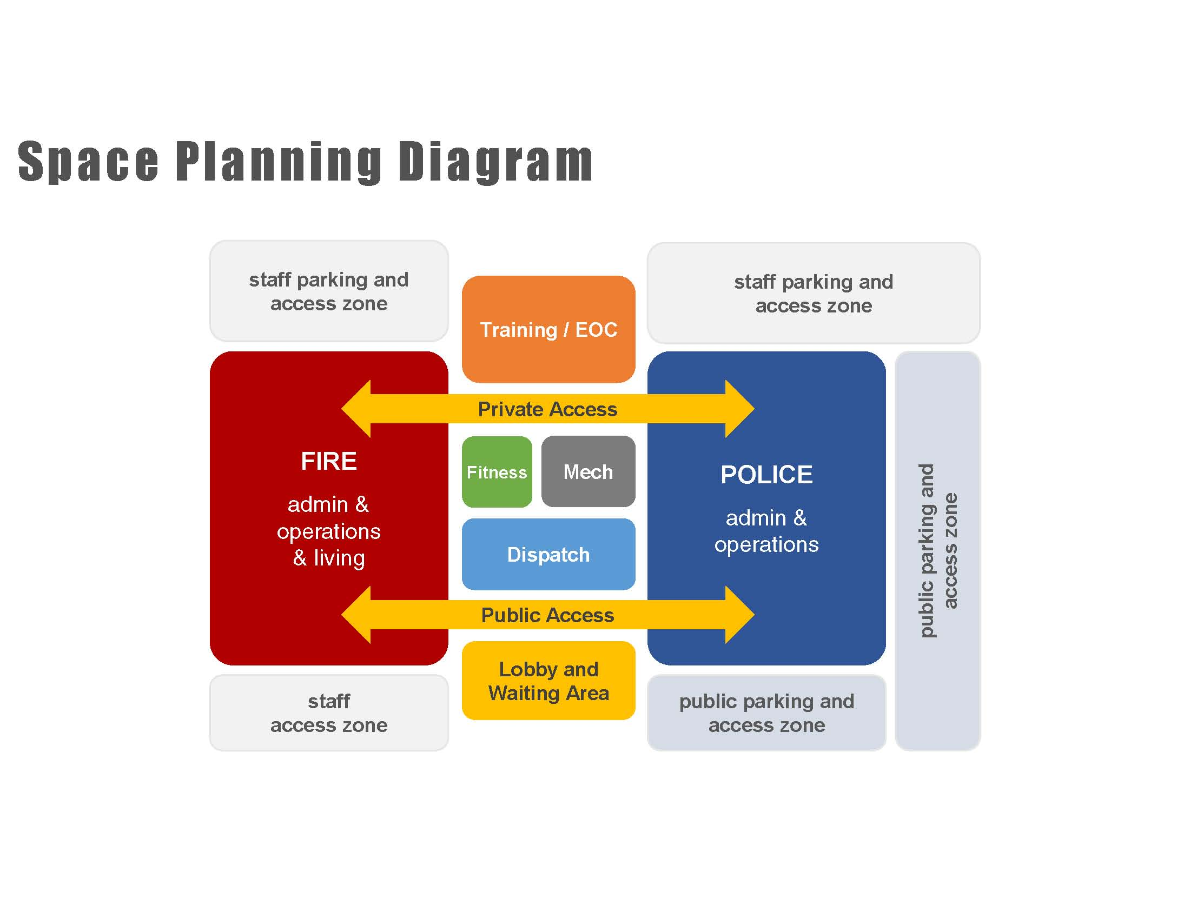

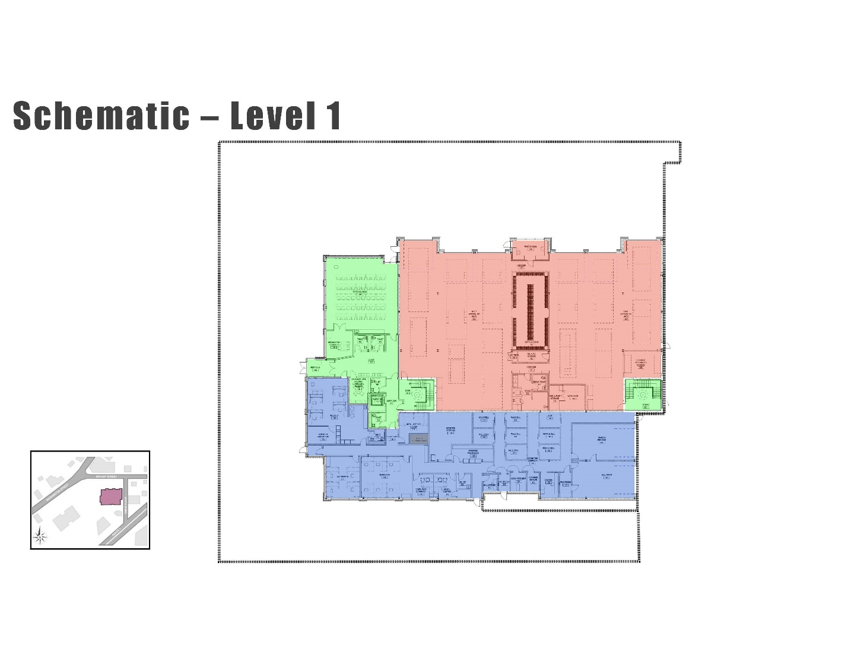

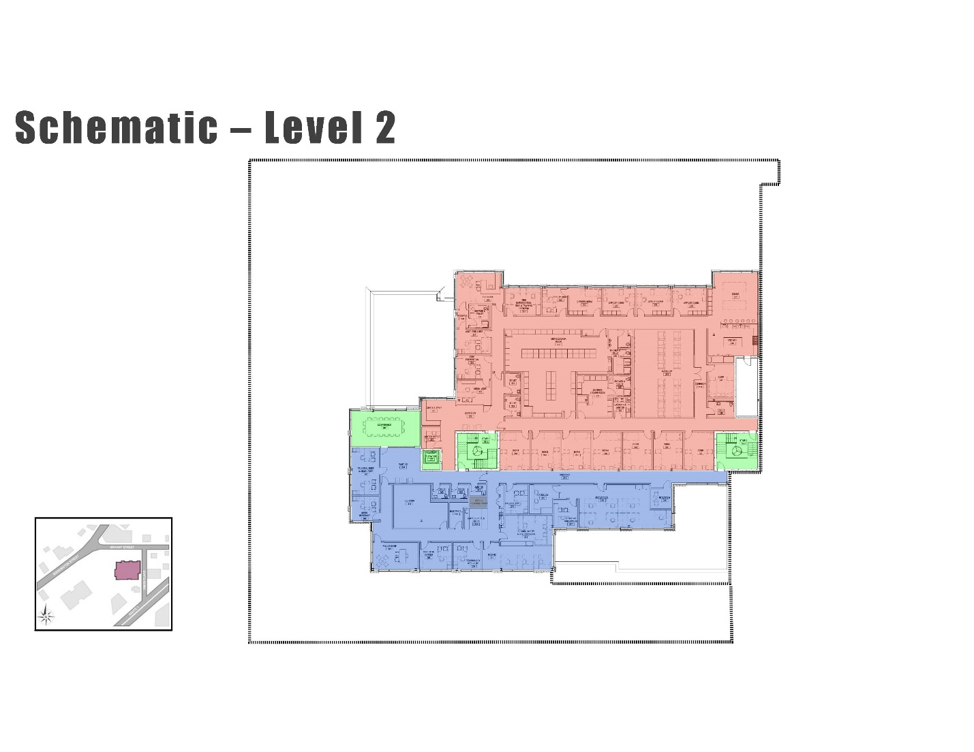

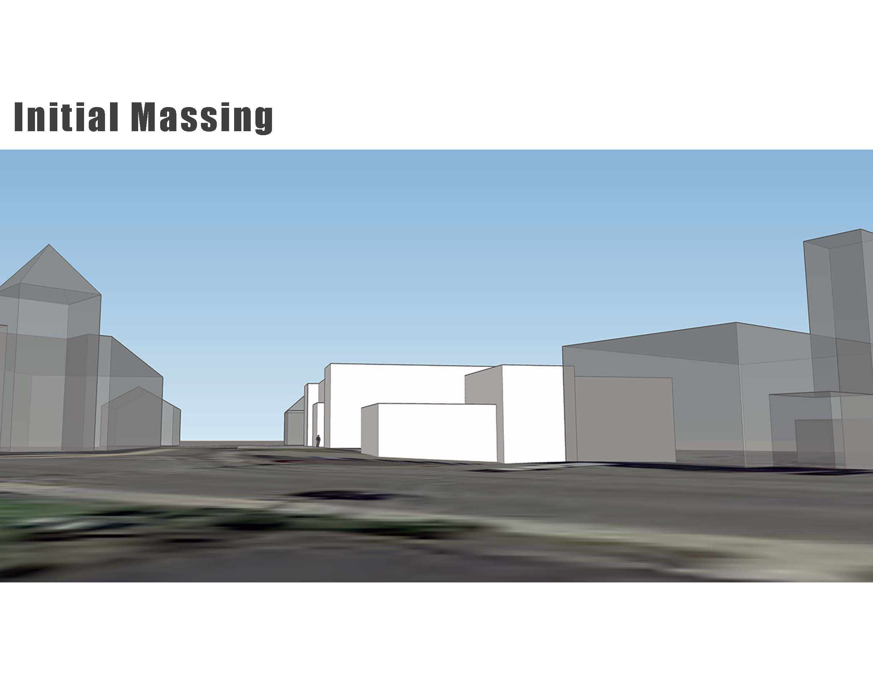

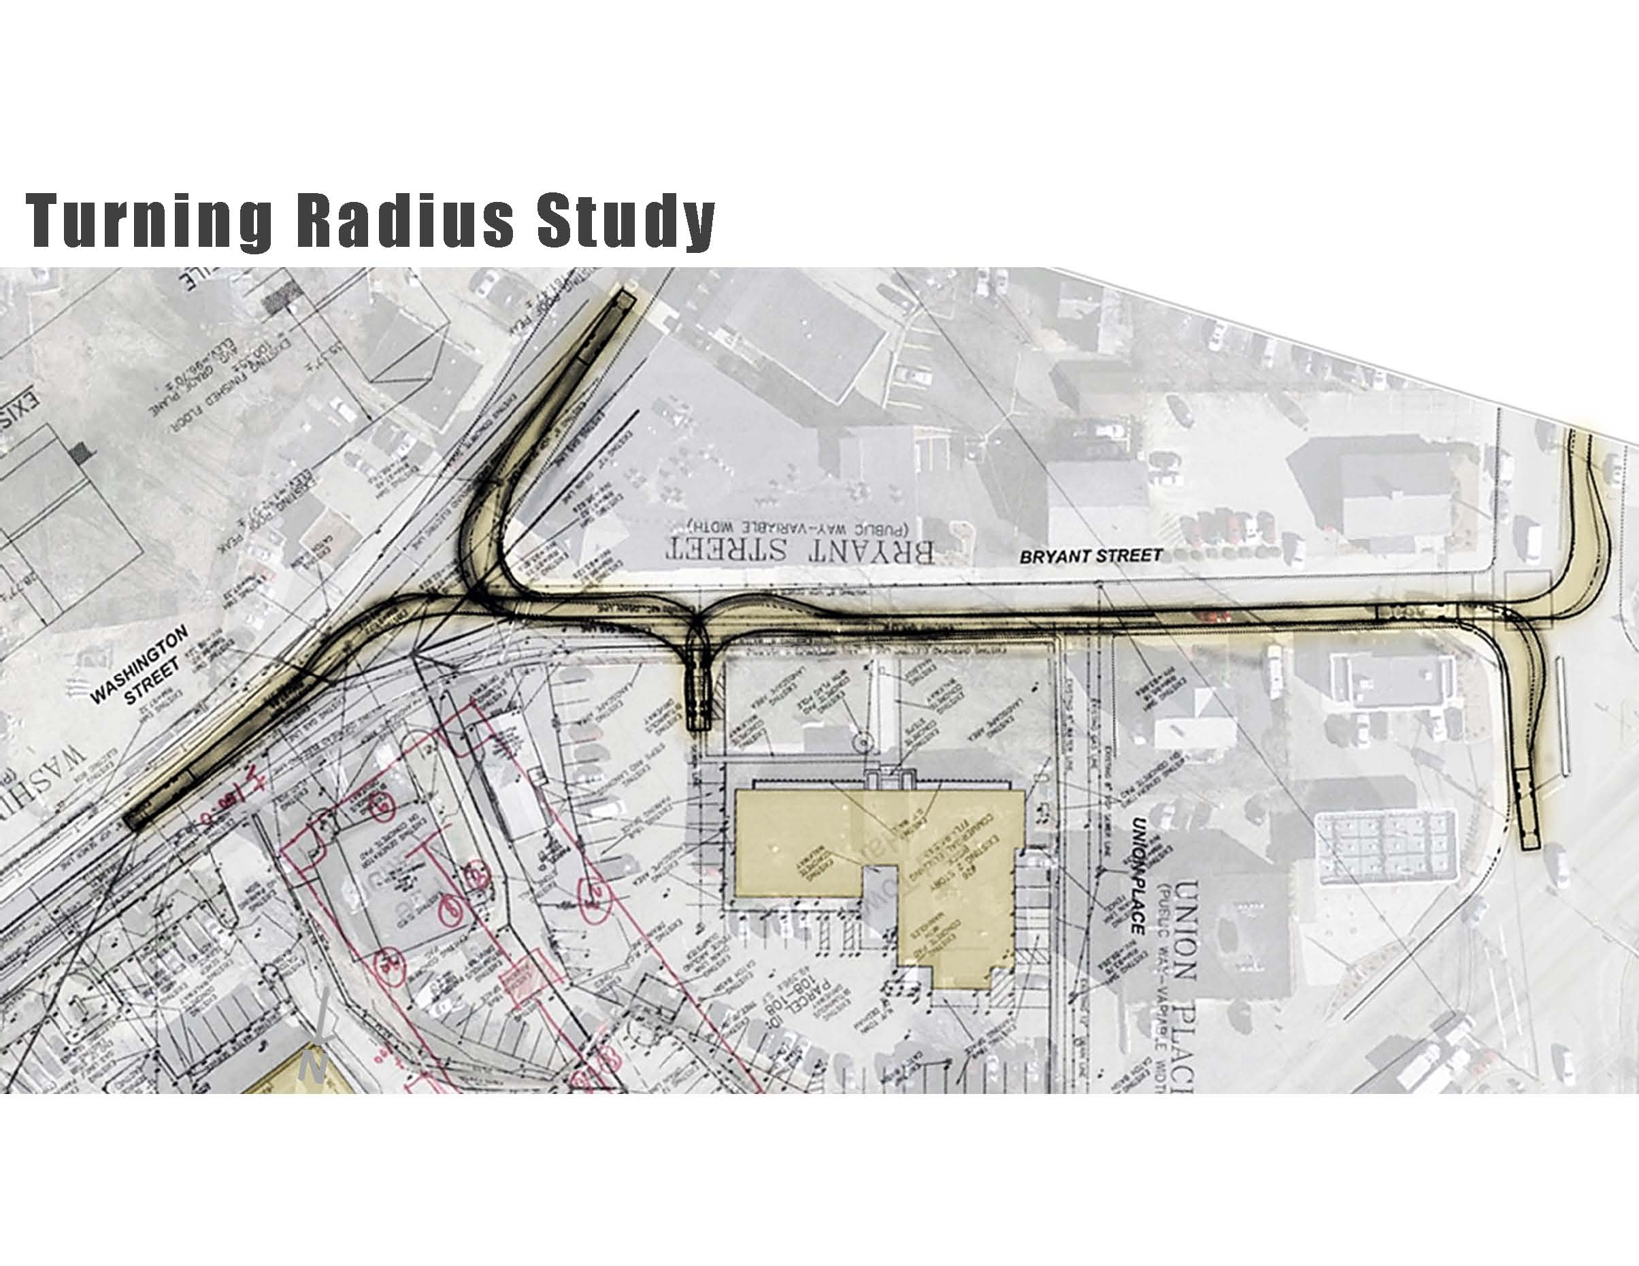

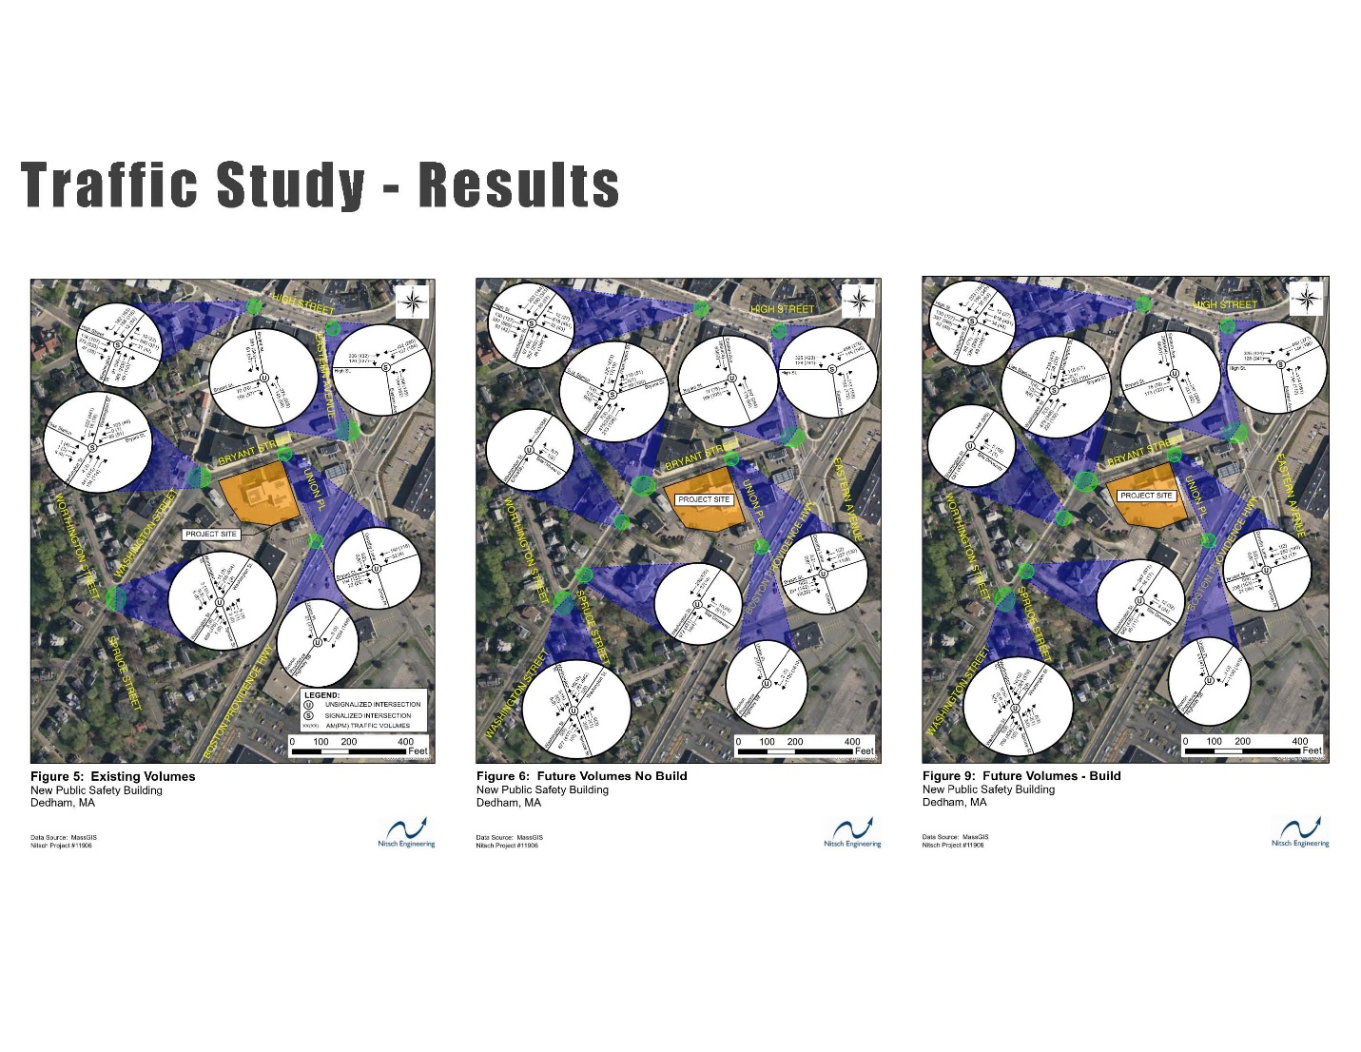

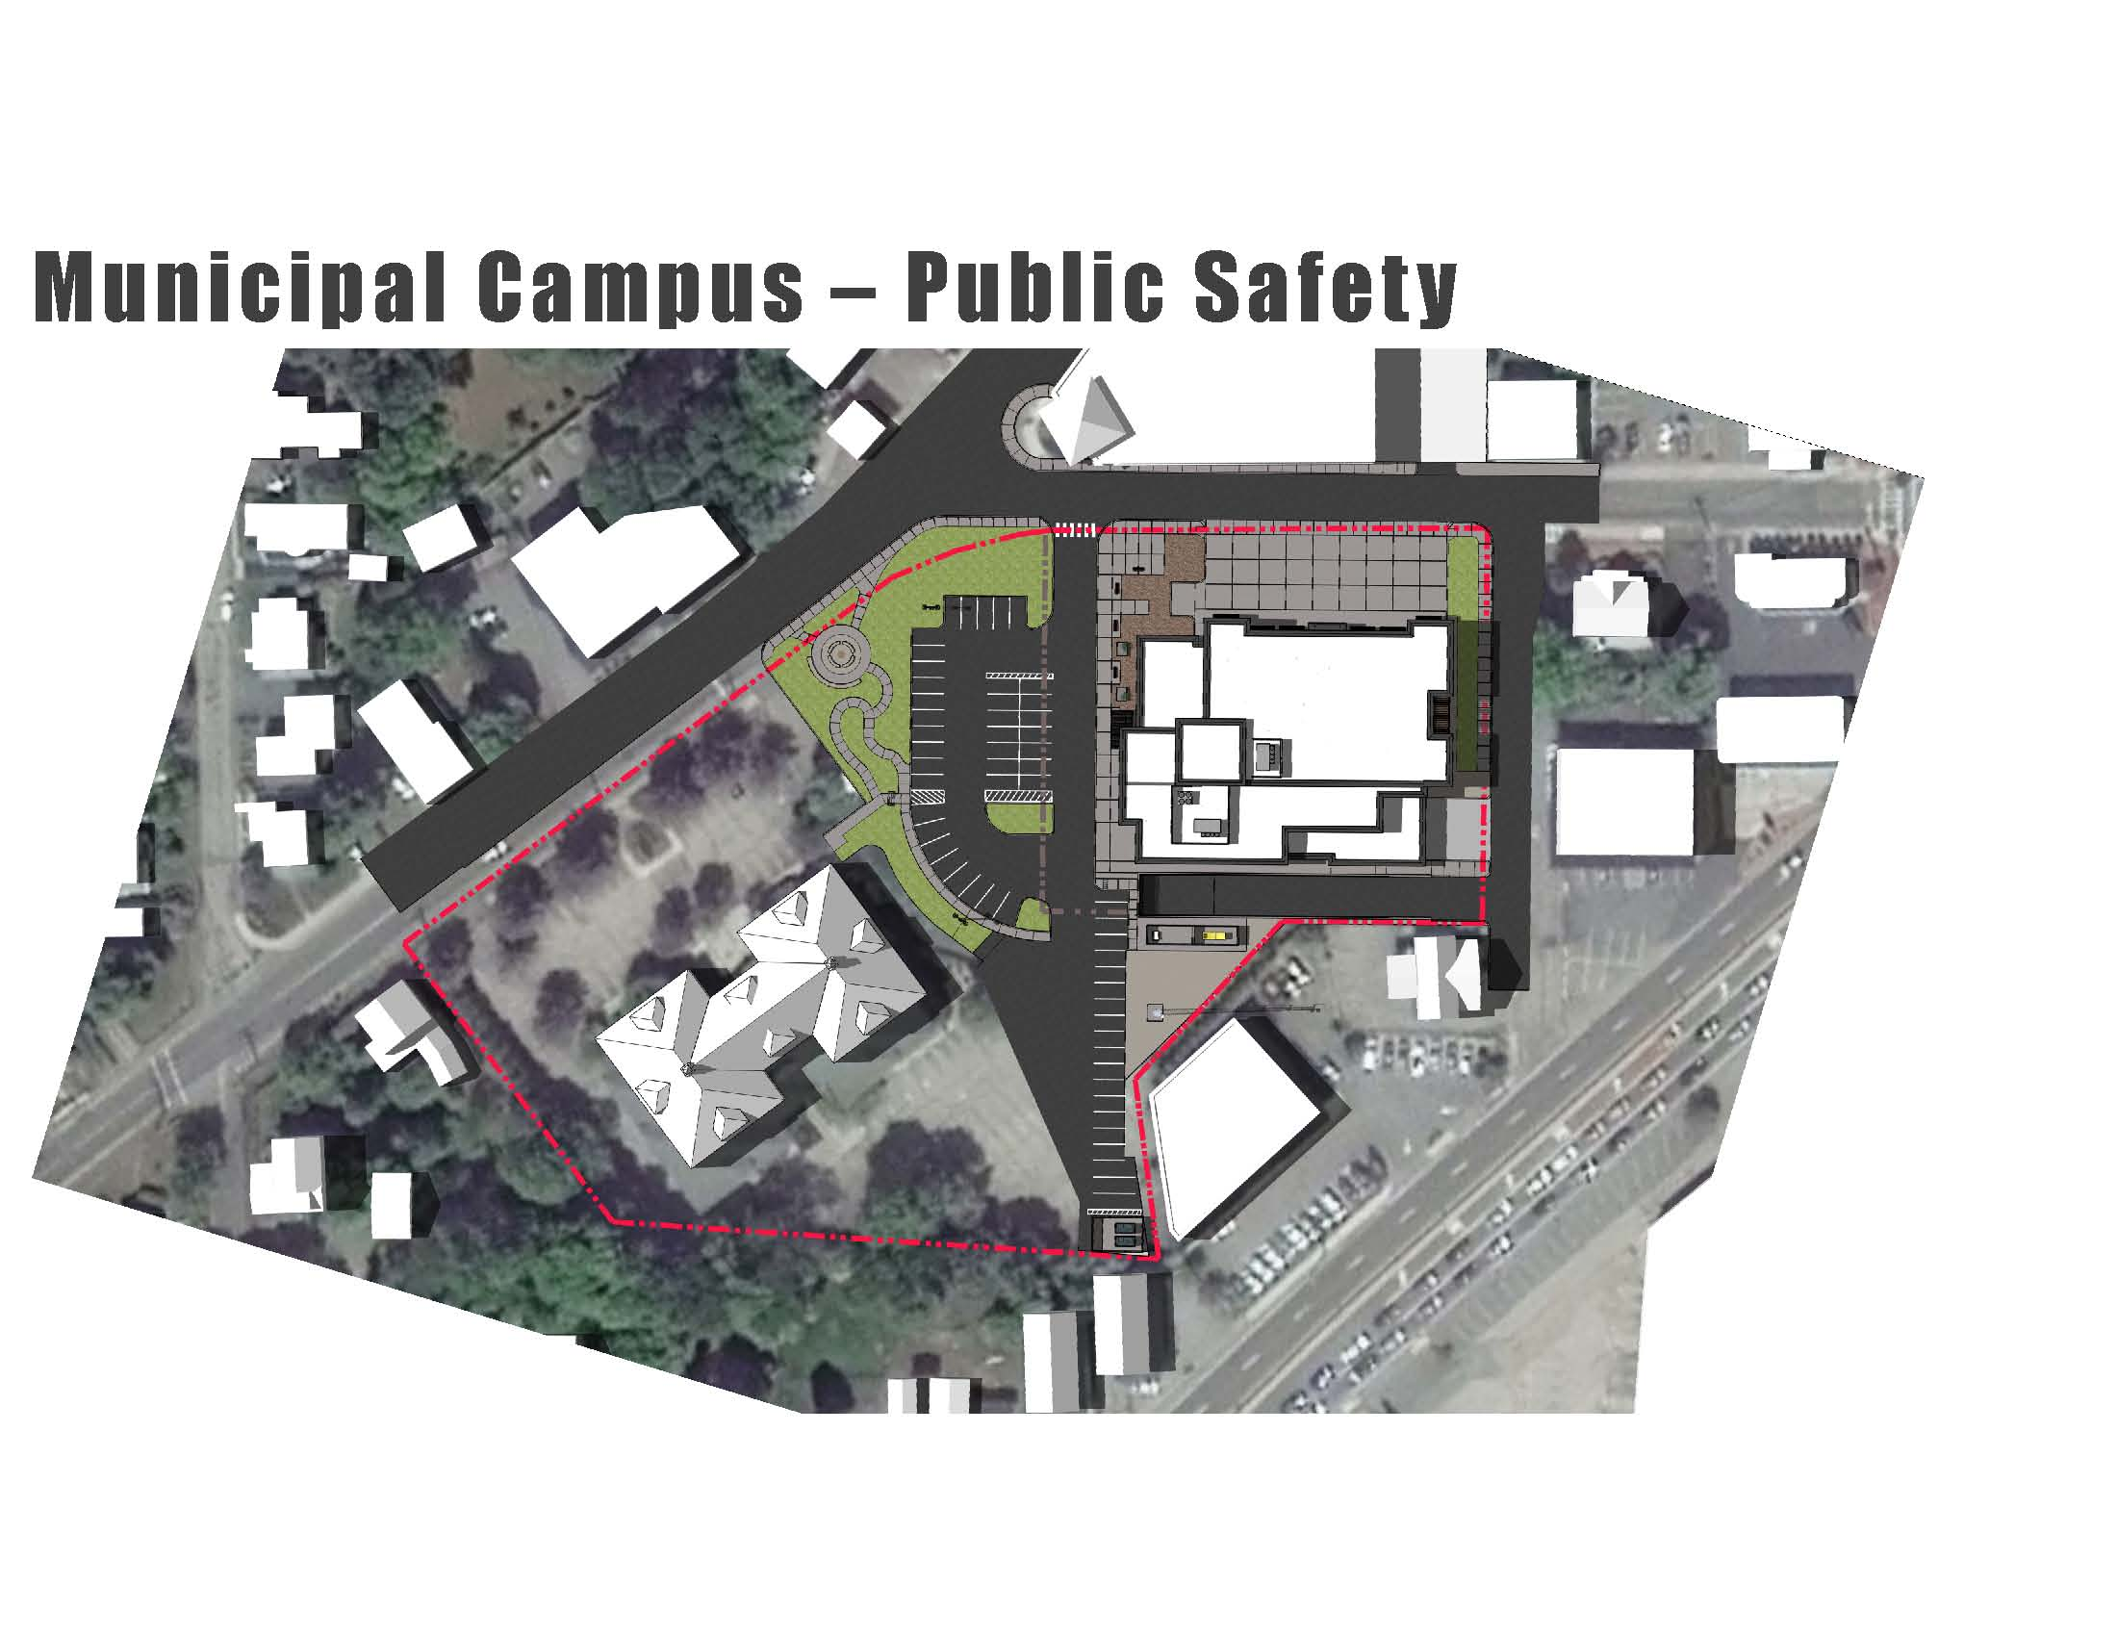

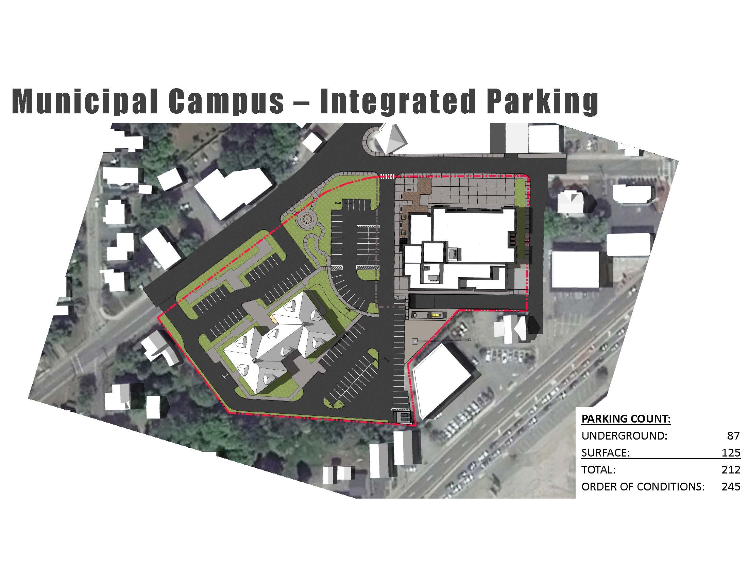

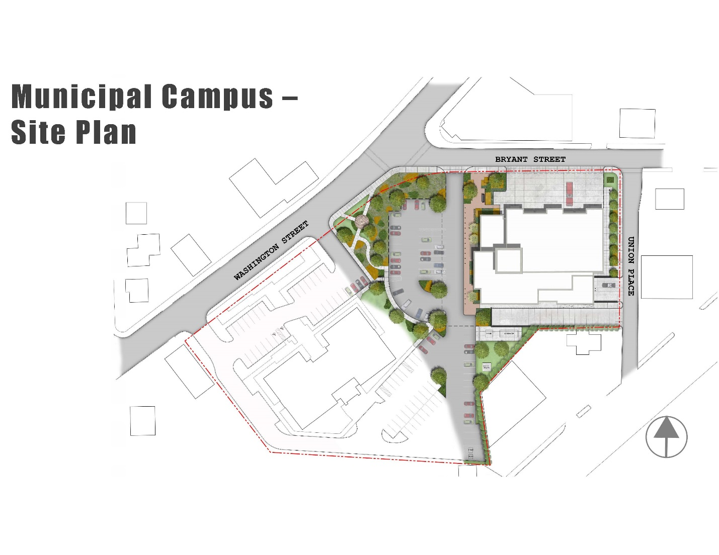

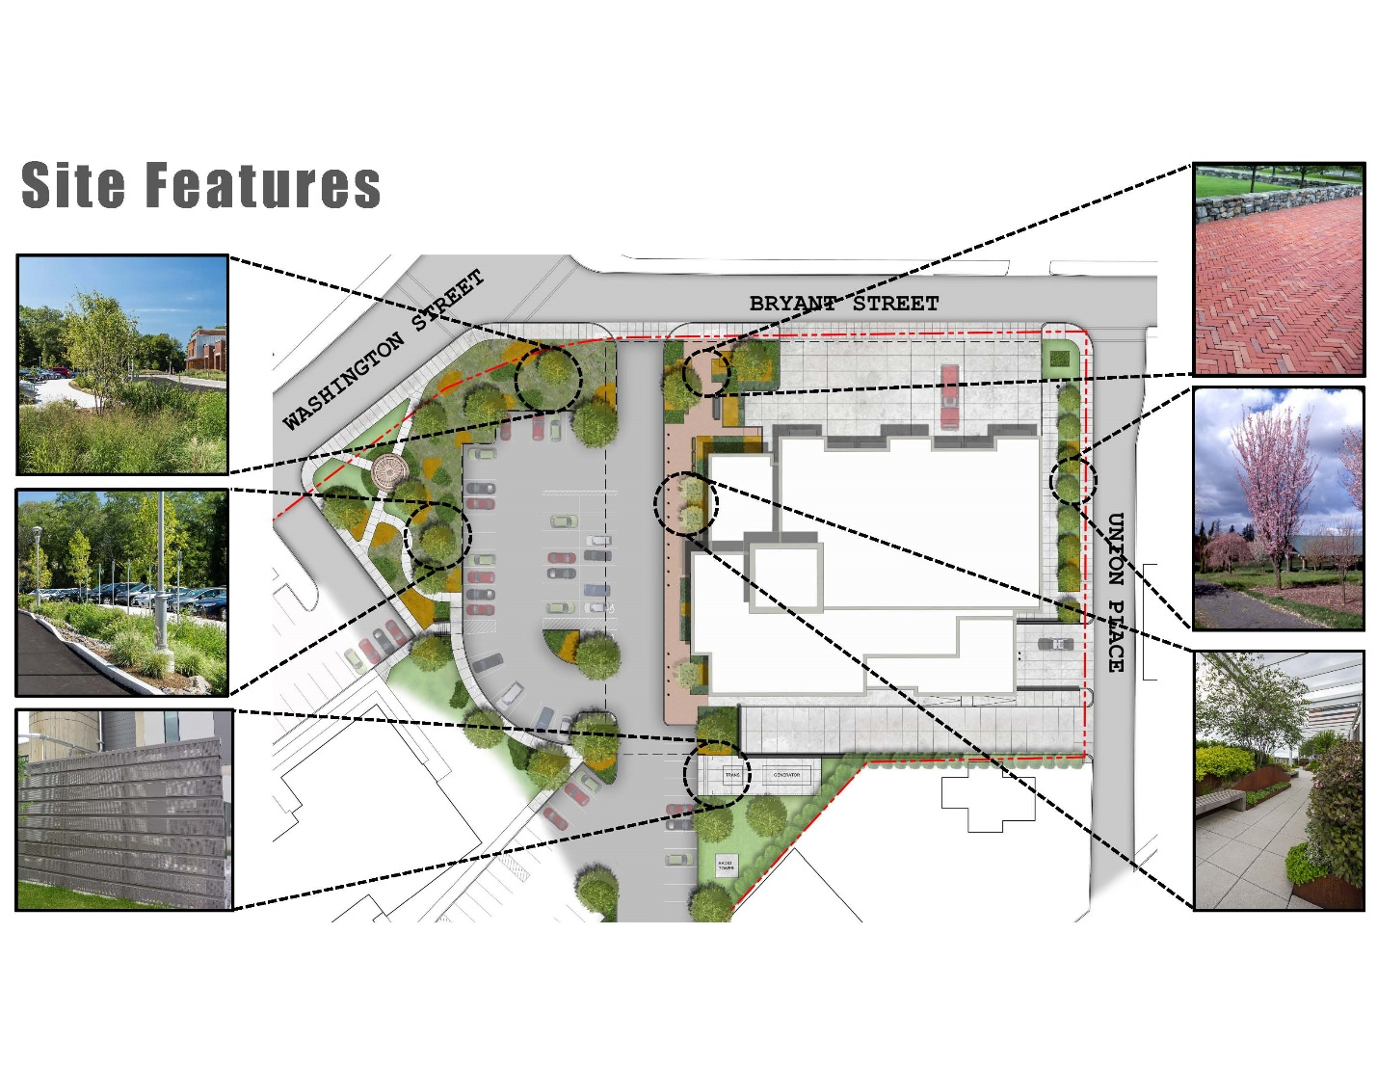

Mr. Dore then showed all a short animation fly by to help people envision what the Building will actually look like. After the presentation, Mr. Dore stated that he would take questions.

Mr. Kern spoke about how the Town would pay for this project, the Robin Reyes fund and the number of Building projects have been undertaken in the last 15 years.. Mr. Kern referred to the following slides:

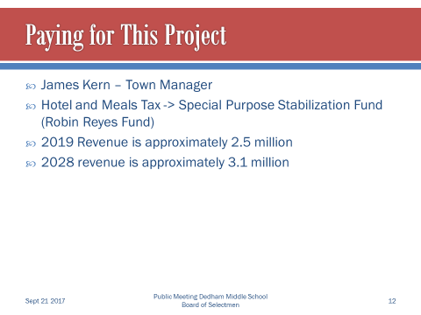

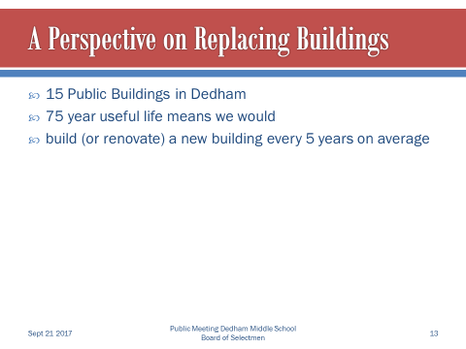

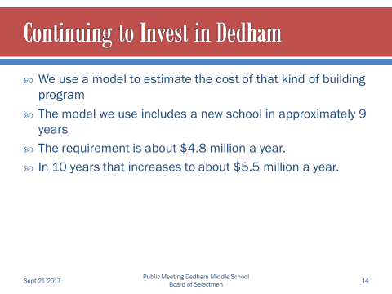

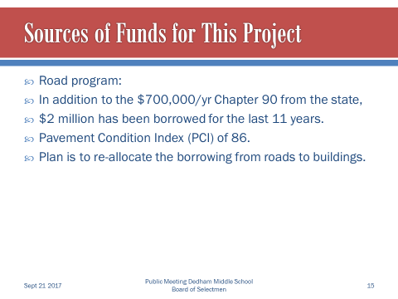

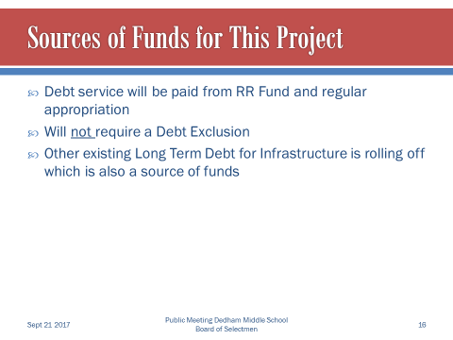

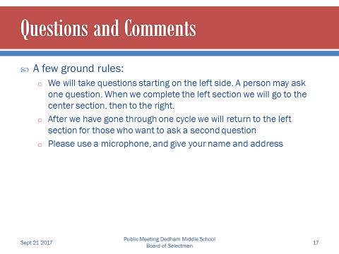

**Question & Answer**

**Judy Neiswander - 21 Church Street**

Ms. Neiswander stated that this is phenomenally important for the identity of Dedham and the most important Building in our lifetime. Ms. Neiswander added that it is large and is clearly the same size or even bigger than the Ames schoolhouse. She continued, saying that the design you showed is very attractive and can see this Building fitting in the South End in Boston. Ms. Neiswander stated that her question is if this Building is really appropriate to this location, considering that the most important context is the Ames Schoolhouse itself.

Mr. Dore stated that one of the first things he thought about when we were retained for this job is what we do with the Ames Building. Mr. Dore added that very early on he had a discussion with both Chiefs and the BPCC as to if they wanted to be sympathetic to the Ames Building where do we want to respect that Building and have it speak to the community as part of its history. Mr. Dore continued, saying that their primary objective was what we are trying to accomplish. Mr. Dore informed all that their initial discussion and the tact that we took his designers was to try and not replicate something that’s a hundred years old but rather realized that this is an important Civic Building. Mr. Dore stated that they also need to be somewhat cost-conscious in terms of what this Building represents the terms of the financial peace Mr. Kern spoke about. Mr. Dore added that they were trying to do their best, while listening to the groups they were working with, to accommodate the site and the functionality.

**Paul Reynolds – 134 Mount Vernon Street**

Mr. Reynolds stated that he has been attached to his project for a long time and knows that a modern Police and Fire Building needs to have much better facilities than we currently have. Mr. Reynolds added that when he saw the first plans he felt somewhere between horrified and deeply disappointed. Mr. Reynolds continued, saying that after people voiced their disappointment, Mr. Dore came back with a design that more closely reflects the grand vision of what a Municipal Building should look like. Mr. Reynolds stated that the design shown this evening, with proper material choices, he thinks is something you can live with it would be absolutely worth the investment.

**Jim Maher – 22 Sherman Road**

Mr. Maher asked both Chiefs if the design of the Building works for your staff and does it protect your equipment. Mr. Maher continued by asking if the outside design of the Building impact the performance of your staff at all

Chief D’Entremont informed all that the flow of the Building is very important to a Police Department. Chief D’Entremont added that they’re very happy with the interior design regarding the flow and security that it offers. Chief D’Entremont continued, saying that the exterior materials don’t really impact what we do. Chief D’Entremont stated that the interior function of the Building is what is most important to his staff.

Chief Spillane informed all that the Fire Department is little bit different regarding its needs, adding that this Building will be the Firefighters second home. Chief Spillane stated that the Building needs to be livable with enough space to accomplish tasks inside.

Mr. Maher asked Chief Spillane if his Firefighters were happy with this design and do they think this will be a better Station for them.

Chief Spillane answered, absolutely.

**Steve Cecil – 121 Haven Street**

Mr. Cecil stated that he is an architect and a landscape architect. Mr. Cecil added that he’s received a few phone calls regarding a discomfort with the design. Mr. Cecil continued, saying that the exterior design of the Building is providing a character that does not resonate in the context of Dedham as a Civic Building. Mr. Cecil stated that he believes this Building has the opportunity, with some modest changes, to reconsider the message that it’s giving to the community and what it contributes to this campus setting. Mr. Cecil added that he applauds the progress that has been made to date and as a resident this is a fantastically important investment for our community.

**Amy Clark – 474 Washington Street**

Ms. Clark stated that this Building will be basically in her backyard. She added that she is really excited about it and the functionality seems good and she likes the design. Ms. Clark asked Mr. Dore if there is any way to get a little more green space.

Mr. McDonald stated that the fly over showed some green space but it is just a conceptual view which is not defined. Mr. McDonald added that as the project moves forward, conversations need to continue taking place regarding what that green space will look like.

**Beppy Martin – 50 Village Avenue**

Ms. Martin stated that the changes that have been made are in the right direction. Ms. Martin added that the things she finds jarring Institute of materials on the exterior. Ms. Martin continued, saying that brick is the predominant image in Dedham Square and she believes it would make the new Building much more pleasant if there were brick throughout.

Mr. Dore stated that there are a few reasons for the two materials on the exterior. One being that we wanted to keep separate identities for the Police and Fire Departments. Mr. Dore added that they did look into and all brick exterior but adding a different material seemed to bring it down a little bit so it didn’t look so large and massive.

**Scott Thomson – 474 Washington Street**

Mr. Thompson stated that he appreciates the Bryant Street changes, especially with the utility poles.

Mr. Dore explained that those utility lines will be taken off the poles, the poles will be removed and the lines will be run underground.

**Melanie King – Church Street**

Ms. King stated that she really appreciates the design work that has been done. Ms. King added that her concern is with how the Building projects to Dedham residents and visitors alike. Ms. King wondered if the design to be treated a little more to better fit in with Dedham Square and the history of the Town of Dedham.

**Dean Kupstas – 55 Sherwood Street**

Mr. Kupstas stated that he supports this project one hundred percent and thinks that it is ridiculous the Police and Firefighters should be an outdated Buildings. Mr. Kupstas added that he doesn’t see the relevancy between the Dedham Square space and the design of this Building. Mr. Kupstas continued, saying that is on the question is if the architect can add a pedestrian view in the fly by presentation.

**Louisa Miller – 74 Court Street**

Ms. Miller stated that she came to this talk anticipating a great argument about the design but she really appreciates the changes that have been made. Ms. Miller added that she is opposed to the two different materials on the exterior. Ms. Miller asked for an estimate of the cost of this new Building and also asked if when the current Police Station is torn down if it can be turned into green space.

Mr. Kern informed all that the original estimated cost of the new combined Public Safety Building is between $40 million and $41 million. Mr. Kern added that they are going to be very careful with estimating and communicating differences between what was originally presented the changes that you have seen tonight. Mr. Kern continued, saying that he will work with the design team and the committee to put together an estimate. Where we have to be careful not to take an estimate that somebody presents and saying number was this now it’s more than that so we are over budget. Mr. Kern informed all that the estimate was at a little over $40 million and with the changes now, we’re using between $42 million and $43 million.

Ms. Miller stated that she was looking at the website and what the costs were. Ms. Miller added that she saw that this project was coming in at over $800 a square foot.

Mr. Dore informed all that when looking at the website, it is representative of construction costs only. The number that Mr. Kern spoke to is projects cost, which includes all the soft costs, furnishing, design, etc. Mr. Dore stated that when comparing other Buildings to this Building, it slightly different because those other projects do not include underground parking, which is not taken into consideration for square footage of the project.

**Meg Duncan – 51 Martin Bates Street**

Ms. Duncan stated that she feels this is a great project and she’s happy to see move forward. Ms. Duncan added that she really likes the design. Ms. Duncan continued, saying that when the existing Fire Department Building is torn down will be a great opportunity for more green/open space. Ms. Duncan asked if the East Dedham Fire Station will be brought over to this new location.

Mr. McDonald stated the East Dedham Fire Station will still be in existence.

**Susie McIntosh – 14 Allendale Way**

Ms. McIntosh informed all that she is the Vice President of Dedham Sq., Circle. Ms. McIntosh thanked Mr. Dore for the changes he made. Ms. McIntosh feels that the Town residents will be very proud of this strong Building and she believes that the Building materials, brick, limestone and granite, the materials are used a lot of Buildings around Dedham. Ms. McIntosh asked if all the parking spaces were actually needed and if it would be possible to put a parking deck off the back of Town Hall.

Mr. Dore spoke to the question regarding the number parking spaces, saying, yes they do need that many parking spaces. With shift changes in the number of personnel will be working in the Building. Mr. Dore stated that there is limited space to do any landscaping in terms of putting full-scale trees. Mr. Dore informed all that parking deck of the Ames Building is not really under his scope and suggested that if the Town wished to address that they could.

**Amy Black – 165 Adams Street**

Ms. Black stated that she is very happy to see tonight’s design as compared to what was presented in the paper.

Ms. Black added that the softness of the two materials works well. Ms. Black asked if some of the Town Hall employees could share in the 90 spaces of underground parking.

Mr. Dore stated that their vision is to keep the parking for just Fire and Police Department employees to avoid any congestion for their vehicles entering and leaving the underground parking.

**Jake Upton – 191 Lowder Street**

Mr. Upton thanked everyone involved in the planning of this new Building. Mr. Upton added that he really likes the design and thinks that the Building fits nicely with the Buildings in Town.

**Susie McIntosh**

Ms. McIntosh asked if there was an Owner’s Project Manager for this project.

Mr. McDonald answered yes, they are sitting right in front of you.

Mr. McDonald made some closing remarks and closed the Question and answer portion of the meeting. Boy

**Discussion & Vote Re: One Day Liquor License – 2nd Annual Fairbanks Fall Festival**

Mr. Guilfoyle moved to take action on an item not on the agenda; seconded by Mr. Keogh. **On the Vote:** Mr. Keogh, yes; Dr. Teehan, yes; Mr. Butler, yes; Mr. Guilfoyle, yes; Mr. MacDonald, yes.

Mr. Keogh moved approval of the request for a one-day liquor license for the second annual Fairbanks Fall Festival on Sunday, September 24, 2017 from 12 PM to 5 PM; seconded by Mr. Guilfoyle. **On the Vote:** Mr. Keogh, yes; Dr. Teehan, yes; Mr. Butler, yes; Mr. Guilfoyle, yes; Mr. MacDonald, yes.

The Meeting was adjourned at 9:13PM.

The next Meeting is scheduled for Wednesday October 4, 2017 at 7p.m. This is to certify that the above is a true and accurate Record of the Minutes of the Selectmen’s Meeting held on September 21, 2017, which minutes were approved on October 19, 2017.

________________________

Dennis Teehan, Jr. – Chairman