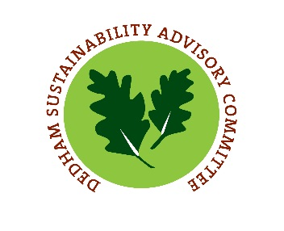

**Sustainability Advisory Committee Meeting**

**January 10, 2018**

**Present:** Chuck Kabat, John Gorham, Emily Walton, Clarissa Robyn and Virginia LeClair, Environmental Coordinator

**Guests:** Alison Staton, Transparency Committee Rep

John Gorham asked for a motion to open the meeting of January 10, 2018. C. Kabat motioned to open the meeting, E. Walton second. All in favor.

**Approval of Minutes**

E. Walton made a motion to accept the minutes of 12.13.17. E. Robyn second. All in favor.

**Compact of Mayors and Olin Student Project Discussion**

V. LeClair updated the Committee on a meeting that D. Harrison and L. Hafrey had with Alison Wood, Assistant Professor of Environmental Engineering at Olin College of Engineering. She reviewed the Capstone course and the dates that the program will start and the focus of the project on traffic as it relates to social, environmental and economic impacts in Dedham. Students will be imputing traffic data into ICLEI’s ClearPath software to help the town meet requirements laid out by the Compact of Mayors and to lay the foundation for a Climate Action Plan. The Committee was in support of this project and partnership.

**Plastic Bag Ban**

The Committee discussed the Plastic Bag ban that they are proposing to bring forward to Town Meeting in in the fall of 2018. C. Kabat was interested that Framingham chose not to implement the bag ban for restaurants and wondered if this may be an incentive to businesses when we go to implement the proposed Styrofoam ban in the future. He discussed the previous barriers that were of concern to V. LeClair, such as enforcement of the ban and commented that he thought the public would act as enforcers of this ban. To help bolster that support he mentioned offering public recognition for those businesses that are succeeding in their efforts.

Given the information that is available from 60 other communities we will not need to re-create the wheel and C. Kabat suggested that we ask other communities how the big grocery stores and box stores responded to the bans and how to go about reaching out to them.

E. Walton suggested reaching out to Dedham Square Circle for ways that we may ease the impact on small businesses. Ideas such as bulk purchasing of bags or other incentives so as not to alienate local small businesses.

C. Kabat wondered if Framingham’s reasoning for not implementing the ban for restaurants was to alleviate stress on those smaller businesses. V. LeClair said she would ask. As far as timing, Framingham enacted the ban at Town Meeting in 2016, but did not implement till 2018. The Committee thought this was to allow for supply previously purchased to be used up.

V. LeClair suggested creating a survey of questions to send to the most relevant communities to Dedham out of the 60 that have so far enacted the ban.

E. Walton suggested an education and outreach campaign in the papers weekly that would plug “did you know” facts regarding plastic bags.

V. LeClair said she reached out to Framingham, Newton, Brookline and Natick for best practices and is waiting for responses.

**Goals Review**

The Committee thought it best to wait until all the members were at the table prior to discussing goals. V. LeClair will send the 2016/17 goals to the members for review and comments in advance of the February 7th meeting.

**Old/New Business**

V. LeClair updated the committee on the benchmarking initiative that the Town is undertaking. The Committee reviewed future meeting dates, as well as set the date for the spring recycling event as 4/21/18, a day before Earth Day.

C. Kabat made a motion to adjourn. C. Robyn second. All in favor.