Contents

**BACKGROUND** 2

**RESPONSES & FINDINGS** 2

**General Findings** 2

**Question 1: Why would you visit the Town of Dedham website?** 3

**Question 2: What’s the best way for us to connect you with Town information?** 4

**Question 3: How do you currently obtain information about Town services, programs, events, and governance?** 5

**Question 4: What aspects of the current website are unsatisfactory?** 6

**Question 6: Overall, are you satisfied with the Town website?** 7

**Question 7: What is the most important type of content on the website?** 7

**Question 8: On the Town website, you can subscribe to receive emails for Calendar events (meetings at Town Hall), News, Job Posts, and Requests for Proposals. Which would you use?** 8

**RECOMMENDATIONS** 8

**Utilize Data and Responses** 8

**Improve Site Content and Navigation** 9

**Expand and Update Web Presence** 10

# **BACKGROUND**

This report was created in an effort to analyze the results of a Town communications survey. The survey was created to determine the successfulness of the Town’s communications strategy over the past year, particularly with respect to the website that was created over a year ago that replaced the former Town website. It was decided that it was best to compare the answers of the survey with data taken from Google Analytics (data from March 1st, 2017 to February 28th, 2018) to obtain a well-rounded understanding of the results. According to Google Analytics, the Town of Dedham website received 145,993 visitors during that one-year time period.

This survey was created by the Town staff who have led the administration of the Town website: John Sisson (Director of Economic Development), Lisa Bazinet (Social Media Coordinator), and Matthew Cubetus (Intern for website operations and community outreach). The survey was released to the public on February 22nd, 2018 and responses were accepted through March 31st, 2018. The survey was advertised in the Dedham Times, on the Town website, and included in the Town email subscriptions. The survey used a mix of check boxes (1, 2, 4), a multiple-choice grid (3), an open-ended response (5), multiple-choice (6, 7), and a check box grid (8). Given question five (5) was completely open-ended, those responses are being analyzed and acted on separately from this report, along with other open-ended responses under the “Other” option of several questions.

The survey was created using Google Forms. The original survey on the Town website from 2017 that was created by Mrs. Bazinet and Mr. Sisson was created using SurveyMonkey. It was determined that SurveyMonkey was prohibitively expensive to use again. Rather than use the Vision CMS built-in survey module, Google Forms was chosen as it was found to be more user and visitor-friendly.

# **RESPONSES & FINDINGS**

## **General Findings**

In total, the survey received seventy-one (71) responses from townspeople. Emails were collected and participants were prevented from submitting more than one response. The seventy-one responses represents 21.4% of total email subscribers, 24.7% of active email subscribers, 0.3% of the total population of Dedham, and 0.4% of the adult population of Dedham. The respondents are not necessarily subscribers, but it is reasonable to expect that most are given that most responses were received within a week of emailing subscribers about the survey.

Given both the number of responses and the proportion of them to the overall town and website visitor populations, it is reasonable to understand that statistically this survey lacks a strong response rate. Thusly, the findings of this report may be statistically skewed and not entirely accurate compared to the overall public opinion in Dedham. That being the case, the Department of Economic Development did its utmost to advertise this survey and the responses that were given are what have to be used to extrapolate what needs to be improved on in the Town’s communication strategy.

## **Question 1: Why would you visit the Town of Dedham website?**

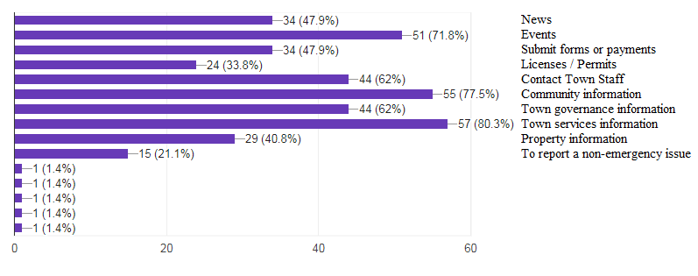

“Town services information” came in as the most selected response, with 80.3% of respondents choosing it as one of their answers. Compare this to the 16% of website visitors who visited the “Services” section of the website, according to Google Analytics. This disparity could be the case for a number of reasons: (1) The respondents mistook the “Town services information” option for something else, (2) The population of respondents is too small or simply not representative of the overall website visitor population, (3) because “Services” tends to be a gateway to pages not held in “Services”, Google Analytics could be counting those clicks towards other content areas, or (4) the question or answers are not worded appropriately in regards to the information sought.

The next popular responses for this question were “Community information” at 77.5%, “Events” at 71.8%, “Town governance information” and “Contact Town staff” both at 62%, “Submit forms or payments” and “News” at 47.9%, and “Property information” at 40.8% of respondents. The remaining options have responses below 40% and are most likely not statistically significant.

The most comparable section for “Community information” on the website is “Discover Dedham”, which receives a mere 1.76% of visitor clicks. This disparity may be accounted for due to the lack of content in that section. “Discover Dedham” has persisted as one of the sections that has been severely lacking in content since the new website’s inception.

The remaining significant options have clear paths from the website homepage which are used frequently. “Property information” refers to content within the Assessing Department, which is one of the most visited pages of the website. The Assessing Department landing page came in at 18,996 page visits (2.92%), second only to the homepage of the website. It is not presented with special navigation on the homepage, but is clearly being accessed easily.

## **Question 2: What’s the best way for us to connect you with Town information?**

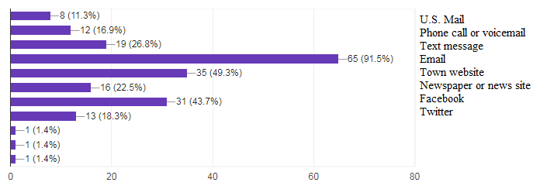

The overwhelming choice by respondents for this question was “Email”, coming in at 91.5% of responses. The closest options after “Email” were “Town website” at 49.3% and “Facebook” at 43.7%, with all other options below 40%.

It has been assumed that most respondents thus far are subscribers, therefore it is reasonable that the overwhelming majority of them selected “Email” as one of the options. Electronic media is the clear favorite, with the more traditional means of communication (“Phone call or voicemail”, “U.S. Mail”, “Newspaper or news site”, etc.) registering low, which is in-line with the changing dynamics of greater interpersonal communication.

A typed response was an option for respondents as well, with most who used it stating that all emergency or weather-related news from the Town should be phoned. All other, non-emergency news should be relegated to other means, according to those respondents.

## **Question 3: How do you currently obtain information about Town services, programs, events, and governance?**

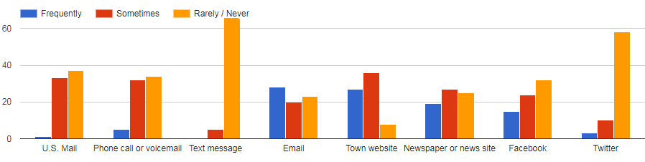

The responses to this question are particularly intriguing because the format (a vertical column chart) is measured in empirical numbers (not percentages) and only one option has “Frequently” as the highest-ranking response – “Email”.

Practically every respondent responded “Rarely / Never” to “Text message” and “Twitter”. The Town most likely does not send out texts (at least frequently) and has a limited presence on Twitter (or, respondents do not tend to use it). Most respondents answered “Sometimes” or “Rarely / Never” for “U.S. Mail”, “Phone call or voicemail”, and “Facebook”. The only response to have the options “Frequently” and “Sometimes” significantly exceed “Rarely / Never” is “Town website.”

“Email” and “Newspaper or news site” each have a relatively similar amount of responses for each option. This result is of particular note because it has been assumed that most respondents are subscribers. Twenty-three (23) respondents answered “Rarely / Never” to this option, suggesting that perhaps those individuals either are not subscribers or have elected to subscribe to few subscription emails.

## **Question 4: What aspects of the current website are unsatisfactory?**

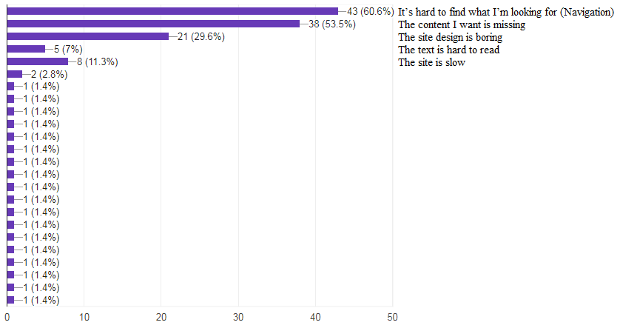

“It’s hard to find what I’m looking for” and “The content I want is missing” were by far the most common options chosen for this question, with 60.6% and 53.5% respectively. These two options are similar, making navigation the biggest issue for the site. This is most likely due to unclear or awkward wording used to describe pages of the site, and more popular pages may not be easily accessible from the website homepage. This connects with the issue regarding the Services section of the website first mentioned in Question 1, which may mean that users are attempting to find content in that section and are not able to for some reason.

“The site design is boring” was a distant third at 29.6%, with all other options registering below 15% of respondents—many of those being responses filed under the “Other” option. The Town is limited by the design templates that Vision presents, however improvements to make the site more dynamic are not impossible. Possible improvements will be laid out in recommendations.

## **Question 6: Overall, are you satisfied with the Town website?**

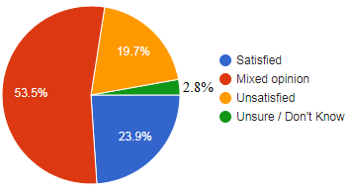

23.9% of respondents were satisfied, 19.7% were unsatisfied, and 2.8% weren’t sure how they felt about the website. Over half of respondents (53.5%) stated they had a mixed opinion of the website. As those working on the website have anticipated, the best days of the website are ahead, and will be met with more improvements. Nevertheless, it is encouraging to see that the site has a generally positive reception at the moment.

## **Question 7: What is the most important type of content on the website?**

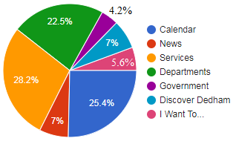

“Services” came in as the most important type of content for visitors to the website, with 28.2% responding so. This speaks to the issue in Question 1, which may lead to the conclusion that its findings are true in sentiment but the numbers are disproportionate. The results of this question are based on a different metric (single response pie chart) than Question 1, so that may contribute the disparity as well.

“Calendar” and “Departments” came in second and third with 25.4% and 22.5% respectively. “Discover Dedham”, “Government”, “News”, and “I Want To…” registered in the single digits. This is again consistent with the degree of interest of answers in Question 1.

## **Question 8: On the Town website, you can subscribe to receive emails for Calendar events (meetings at Town Hall), News, Job Posts, and Requests for Proposals. Which would you use?**

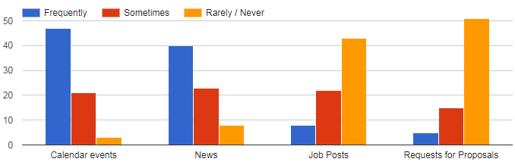

“Calendar events” and “News” were the most popular responses to this question, with most respondents responding with “Frequently” and “Sometimes”. “Job Posts” and “Requests for Proposals” are significantly neglected by visitors. This suggests that the subscription service for “Calendar events” and “News” items are extremely useful and popular, perhaps raising their importance. Then again, the respondents are theorized to mainly be subscribers who tend to be residents, therefore they are most likely not interested in Town jobs or RFPs inherently.

# **RECOMMENDATIONS**

After considering the findings of the communications survey and Google Analytics, the Department of Economic Development is recommending a plan for the future of the Town’s communication strategy. Many of these recommendations will be included in the “Editorial Plan” being developed.

## **Utilize Data and Responses**

The data collected by this survey was helpful in exploring visitor’s issues with the website. However, as mentioned before, this data may only take the Town so far in assessing the Town’s communications strategy given the small pool of responses. Google Analytics has all-encompassing information collected from every visitor of the website. Literacy in this service and continued use of it will present a much more accurate idea of how to improve the website in the future. There are some bugs within the Vision CMS system that have been shown in Google Analytics, but those may be addressed with the firm.

Nevertheless, human responses are helpful in hearing precise concerns. For instance, in Question 4 the responses “It’s hard to find what I’m looking for” and “The content I want is missing” were selected the most. It is necessary to know what exactly is missing or hard to find for visitors, so there lies a need for a direct interaction between Town officials and visitors. The Department of Economic Development has proposed adding a “Suggestion Box” to the website. This feature would allow visitors to detail precise issues with the website that may be systematically addressed by Town staff. In the current state of the “Suggestion Box”, visitors are asked to provide an email in which staff may contact them, what section of the website their suggestion is relevant, the nature of the suggestion (e.g. navigation, missing content), and an open-ended option to expand on their suggestion.

## **Improve Site Content and Navigation**

Site navigation and missing content are the two biggest issues respondents brought up in the survey. The policy that the Department of Economic Development recommends in regards to most issues about site navigation and missing content is being as mutually exclusive and collectively exhaustive (“MECE”) as possible. Some engineered redundancy is helpful for site visitors, but future work on the town website should be focused with MECE approach to avoid confusion and unnecessary redundancy.

In regards to site navigation, visitors are most likely confused because the average person is generally not familiar with the sometimes opaque terminology of municipal government. This may be addressed by organizing the pages within the main sections of the website (“Services”, “Departments”, “Government”, “Discover Dedham”, and “I Want To…” as they appear currently) more topically. An example of this would be grouping the various boards and committees under “Government” under generalized terms. A section labelled “Finance” could hold the following board and committee pages: Board of Assessors, Capital Expenditures Committee, Commissioners of Trust Funds, and Finance & Warrant Committee. This may allow visitors to better understand where what they are looking for is located.

Site content is a far larger issue to address. The site would generally do better by being more dynamic with timely sliders and images on most pages. The homepage slider improvements are already underway, with a schedule for seasonal sliders being developed and continued encouragement of department heads to submit content that may be used for the slider. The inclusion of more images generally is one that will require more individual input from department heads and how staff may balance their interests with improved site visuals.

The apparent most popular section of the website, “Services”, is lacking in a clear direction and sparse of original content—this much is evident to view on one’s own. A clearer, more dynamic approach to this content section should be taken to direct visitors to the appropriate resources. Given that “Services” is a broad topic, the improvements to this section may be broad and up to the discretion of the Town staff. A similar assessment has been made of “Discover Dedham”, which is an area of opportunity. Perhaps a greater community-based focus for that section may serve it well.

“Calendar” is next on the priority list along with “News”. The issue with those sections is a lack of clear guidelines governing the content posted there. Those issues will be addressed by the “User Guide” being developed by the Department of Economic Development for Town staff to rely on when creating content on the website.

The “Government” and “Department” sections require a greater uniformity of presentation and full inclusion of necessary information. In exploring the pages of both sections, it is clear that pages may be condensed by making contact information available on the landing page (rather than its own page).

In “Government”, upcoming meetings should be featured on the board / committee landing page, with a “Minutes Archive” providing minutes from previous meetings on a separate page. Boards and committees should also reference and link back to departments that staff or are relevant to them. A “Get Involved” page for persons looking to volunteer on a board or committee should be created, separate from job applications. Finally, it should be clear for boards and committees who is on them, when their term expires, their contact information, and what title (chair, vice chair, secretary, member, etc.) they hold on the board or committee. Typical meeting time and place should also be included.

“Departments” landing pages ought to universally have the following information on them: a bullet-point explanation of what the department does (rather than a separate “About Us” page), a list of boards and committees related to the department, when one should contact the department, and a directory of department personnel. In side columns on the same landing pages, the following should be available: the department’s address (with a hyperlink for directions), phone, fax, hours (differentiated if appropriate), an email subscription hyperlink, and social media widgets (if appropriate). For department subpages, the last pages should be Applications & Forms, FAQs, and Resources & Links when appropriate.

“I Want To…” is cited as one of the more helpful and widely used sections of the website. This area is in generally decent shape, however it may be helpful to expand upon it and include site wide FAQs in this section.

## **Expand and Update Web Presence**

The goal of the Town’s communication strategy generally is to reach townspeople and those interested in Dedham with important information. The results of Questions 2 and 3 show that, while the town appears to making good progress on current means of disseminating information (email, the website), there is room for expansion. Several town departments are active already on social media, however it has been noted and discussed that the Town does not have any social media accounts for the Town government in general.

The emergence of social media sites like Facebook, Twitter, and Instagram has presented tremendous opportunities for entities of all shapes, sizes, and orientations to have direct interactions with online users. Having a Town account on all three major social media platforms (and maybe more) could present a valuable new way to present information to the public, especially younger people who may not be aware of or very active in local government.

Having these accounts does present challenges, not unlike one of the significant challenges of the Town website: updating regularly. The current social media accounts of Town departments tend to not post very often, with the exception of some more active accounts like that of the Public Library and the Police Department. The presence of the accounts will not be meaningful unless a post is published at least once a day, and generally (especially on slow days) light-hearted posts will gain popularity.

As mentioned earlier, the Town website faces a similar issue of periodic updating. The sliders on the homepage, news items, board / committee information, and calendar items have often been allowed to remain well past their real-world expiration. Sliders should be monitored weekly and updated, news items must be set to expire, meetings need to be posted when they are scheduled, and changes in board / committee composition should be monitored and updated appropriately. Once other, larger issues with the website are addressed, these issues should not be too challenging to address and will be most of the work needed on the website.

In conclusion, the Town website and overall communication strategy has been improving and needs to continue to head in that direction. Much of the areas of opportunity have been presented due to restraints of time and resources. Those who have worked on the website understand that most of the findings of this report are in-line with the feelings they have had regarding website improvements. Improvements will require time and patience, but once it is done it will prove to be effective at having more meaningful interactions with the people of Dedham. The employees of the Town of Dedham do a lot of good work, and improving the way the Town communicates that work to the public will improve the relationship between the Town and the people.