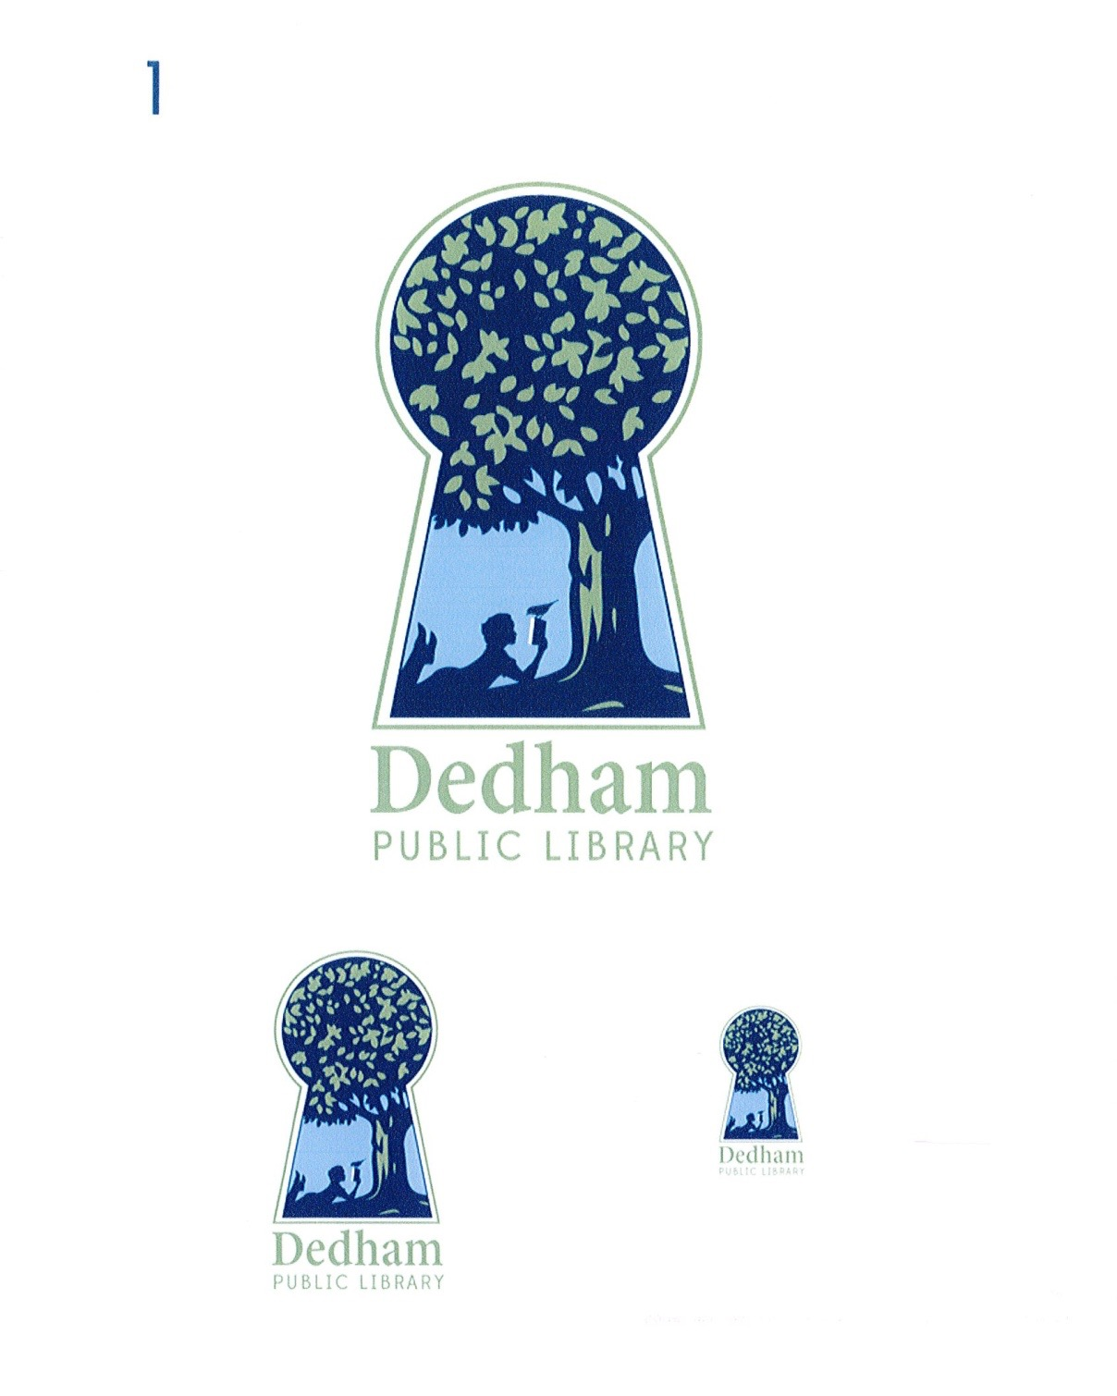
Bonnie Roalsen, Director Margaret Connolly, Chair
Dedham Public Library Sarah Santos, Vice Chair
43 Church Street Tracy Driscoll
Dedham, MA 02026 Mary Ann Sliwa
781.751.9281 Monika Wilkinson

DPL Trustees Meeting Minutes
January 11, 2018, Endicott library, 6:00 pm
Meeting Called By | Board of Library Trustees, Dedham
Type of Meeting | Monthly Meeting
Chairman | Margaret Connolly
Secretary | Monika Wilkinson
Attendees | Margaret Connolly, Tracy Driscoll, Sarah Santos, Mary Ann Sliwa, Monika Wilkinson, and Bonnie Roalsen
PUBLIC ATTENDEES | Richard Pierce

The January 11, 2018 meeting of the Dedham Library Board of Trustees was called to order at 6:02 pm by Chair, Ms. Connolly.

Public Input:

Mr. Pierce stated that the Friends of the Dedham Public Library new space is ready for the book sale. Walls have been painted, shelves have been emptied and labeled, and there is signage. An upcoming book sale is planned for January 19 and 20, 10:00-3:00. He thanked the Library. He also complimented Trustees on the content of the Letter to the Editor in the Dedham Times, which shared information about changes. He asked if there is a partnership with the Senior Center, since there was programming today led by Lisa Ingemi and John Walsh. Bonnie Roalsen confirmed that there was an effort to collaborate.

Action Items:

Discussion and Vote: Minutes of December 7, 2017

Regarding the minutes of December 7, 2017, there was no discussion. Ms. Sliwa made a motion to accept; Ms. Driscoll seconded; all voted in favor of accepting the December 7, 2017 minutes. Ms. Wilkinson abstained from the vote, as she missed a portion of the meeting.

Discussion and Vote: Financial Report December, 2017

Ms. Sliwa made a motion to accept the December Financial Report. Ms. Santos seconded the motion. All voted in favor.

Art Policy

Trustees decided to discuss general reactions to an Art Policy distributed by the Policy Working Group. Individual comments should be sent to Ms. Connolly and Ms. Wilkinson with discussion at a future meeting. Ms. Sliwa suggested a different tone of the language to make the policies less legal sounding. Some discussion ensued around communication to exhibitors. Ms. Roalsen suggested writing a version that is inviting for outreach but maintaining more formal language for the policy.

Discussion and vote: Closing of Library for flooring installation. Carpet will be installed at Endicott Monday (Library will be closed), Tuesday, and Wednesday, January 15-17, 2018 . Electrical work, data lines, and carpet will be worked on. The Library will be open for registration for ESOL 6:30pm-8:15, Wednesday, January 17, 2018. Ms. Wilkinson made a motion to close Endicott January 16 and 17 during the day, with the exception of opening on the 17th for registration only for ESOL for carpet installation and renovation. Ms. Santos seconded. All voted in favor.

Ms. Roalsen explained renovations planned at the Main Library and presented the expected amount of time needed for work. With the extent of work and coordination of work flow, several days will be needed to complete the project. Discussion of the impact on the community for closure while completing work, with special attention to school vacation week. Ms. Sliwa made a motion to authorize Director to close the Main Library as needed in February for renovations, electrical work, and carpet/flooring installation with dates to be determined under the Director’s oversight working with Facilities and contractors. Ms. Wilkinson seconded. All voted in favor.

Update on ESOL programming. Ms. Sliwa shared details of the model for the pilot program. Advertising has been shared in papers, schools, local organizations, social media, and newspapers. Transportation and space options have been explored. Parallel programming for children is being planned by the Library. Ms. Connolly commended Ms. Sliwa for all of her work in establishing this program and was joined by other board members. Registration is January 17, 6:30 - 8:15 pm, and January 19, 10 am - noon.

Director’s Report

Ms. Roalsen shared that there has been some positive recent press coverage with Globe South and Dedham Times. Many patrons have noted this coverage.

Three new digital services have been acquired which include unlimited access to 62 magazines; streaming service for music, art, voice; and streaming audiobooks.

Ms. Roalsen presented some data that she has looked at in preparing for budge: data traffic (up 400%), computer usage (92%), programming (up 2608%).

Some furniture has been delivered to the Main this week through gifts from the Friends of Library. Ms. Roalsen and Trustees expressed much gratitude for the generosity of the Friends.

Ms. Roalsen gave an update on Dedham.life. The Town will give an automatic feed from schools and Town to establish town calendar.

Old/New Business:

Preliminary discussion about of revised process for posting minutes. Director and Chair will be working on this.

Library Foundation update—currently paperwork is being filed. We need to establish Trustees agreement. We are currently considering board members.

Ms. Santos asked about announcements to schools for programming. Ms. Roalsen explained a variety of formats to reach the community and ways the Library can partner and support work of schools. Ms. Santos also asked about Super Awesome Fun Time at Endicott and Ms. Roalsen discussed delay until after renovation and coordination with other programs in the community.

Ms. Sliwa shared that Livable Dedham has a strategic plan and has listed the Library as a partner.

Ms. Roalsen shared that a tour of Dedham Community House was very productive, as were discussions of future partnerships.

Some discussion of possible Budget Hearing dates.

Discussion of timing for completion of Director’s Goals for March meeting.

Trustees budget meeting is still to be determined. Next monthly meetings will be February 7 and March 15 at 6 pm.

A motion to adjourn the meeting was made at 7:57 pm by Ms. Sliwa; Ms. Driscoll seconded; all voted in favor.

Action Item Table:

Action Item | Person | Date Due
Director's Goals Working Group | Ms. Wilkinson, Ms. Santos, Ms. Roalsen | March 2018
Donors Working Group | Ms. Wilkinson, Ms. Driscoll, Ms. Roalsen and staff | In progress
Policy Working Group: room reservations, art policy | Ms. Wilkinson, Ms. Connolly, Ms. Roalsen | On-going
Budget Subcommittee | Ms. Connolly, Ms. Driscoll, Ms. Roalsen | March 2018

Respectfully submitted,

Monika Wilkinson

