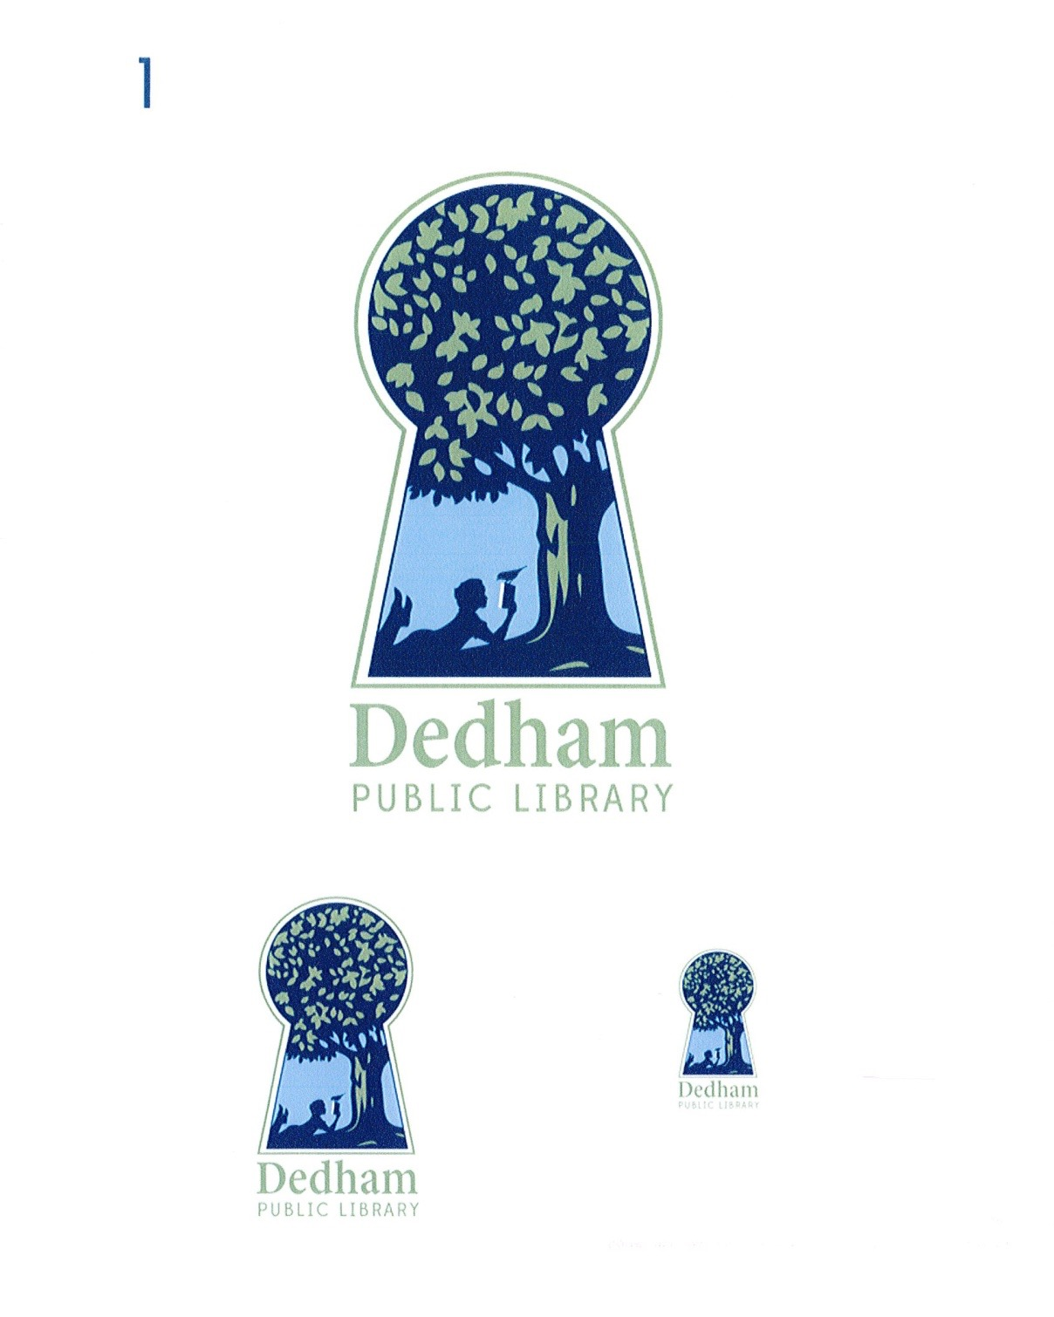
Bonnie Roalsen, Director Margaret Connolly, Chair
Dedham Public Library Sarah Santos, Vice Chair
43 Church Street Tracy Driscoll
Dedham, MA 02026 Mary Ann Sliwa
781.751.9281 Monika Wilkinson

DPL Trustees Meeting Minutes
March 20, 2018, Main Library, 6:00 pm
Meeting Called By | Board of Library Trustees, Dedham
Type of Meeting | Monthly Meeting
Chairman | Margaret Connolly
Secretary | Monika Wilkinson
Attendees | Margaret Connolly, Tracy Driscoll, Sarah Santos, Mary Ann Sliwa, Monika Wilkinson, and Bonnie Roalsen
PUBLIC ATTENDEES

The March 20, 2018 meeting of the Dedham Library Board of Trustees was called to order at 6:02 pm by Chair, Ms. Connolly.

Public Input:

There was no public input.

Action Items:
Discussion and Vote: Minutes of March 15, 2018 There was no discussion. Ms. Wilkinson made a motion to accept the minutes. Ms. Driscoll seconded the motion. All voted in favor.

Discussion and Vote: Early Closing of Endicott Branch, April 13, 2018 Ms. Driscoll shared the request from the Dedham Library Innovation Team (DLIT) to close the Endicott at 2 pm in preparation of the Havana Night event. She said that organizers were hoping to come in to begin set up at 1:00, and she would check to make sure that the early set up wouldn’t impact patrons. Signage and website notices would make the early closing clear. Ms. Driscoll made a motion to close the Endicott at 2 pm on April 13. Ms. Santos seconded the motion. All voted in favor.

A motion to adjourn the meeting was made at 6:05 pm by Ms. Santos; Ms. Sliwa seconded; all voted in favor.

Action Item Table:

Action Item | Person | Date Due
Director's Goals Working Group | Ms. Willkinson, Ms. Santos, Ms. Roalsen | Spring 2018
Donors Working Group | Ms. Wilkinson, Ms. Driscoll, Ms. Roalsen and staff | Spring 2018
Policy Working Group: meeting policy, art policy | Ms. Wilkinson, Ms. Connolly, Ms. Roalsen | Spring 2018

Respectfully submitted,

Monika Wilkinson

