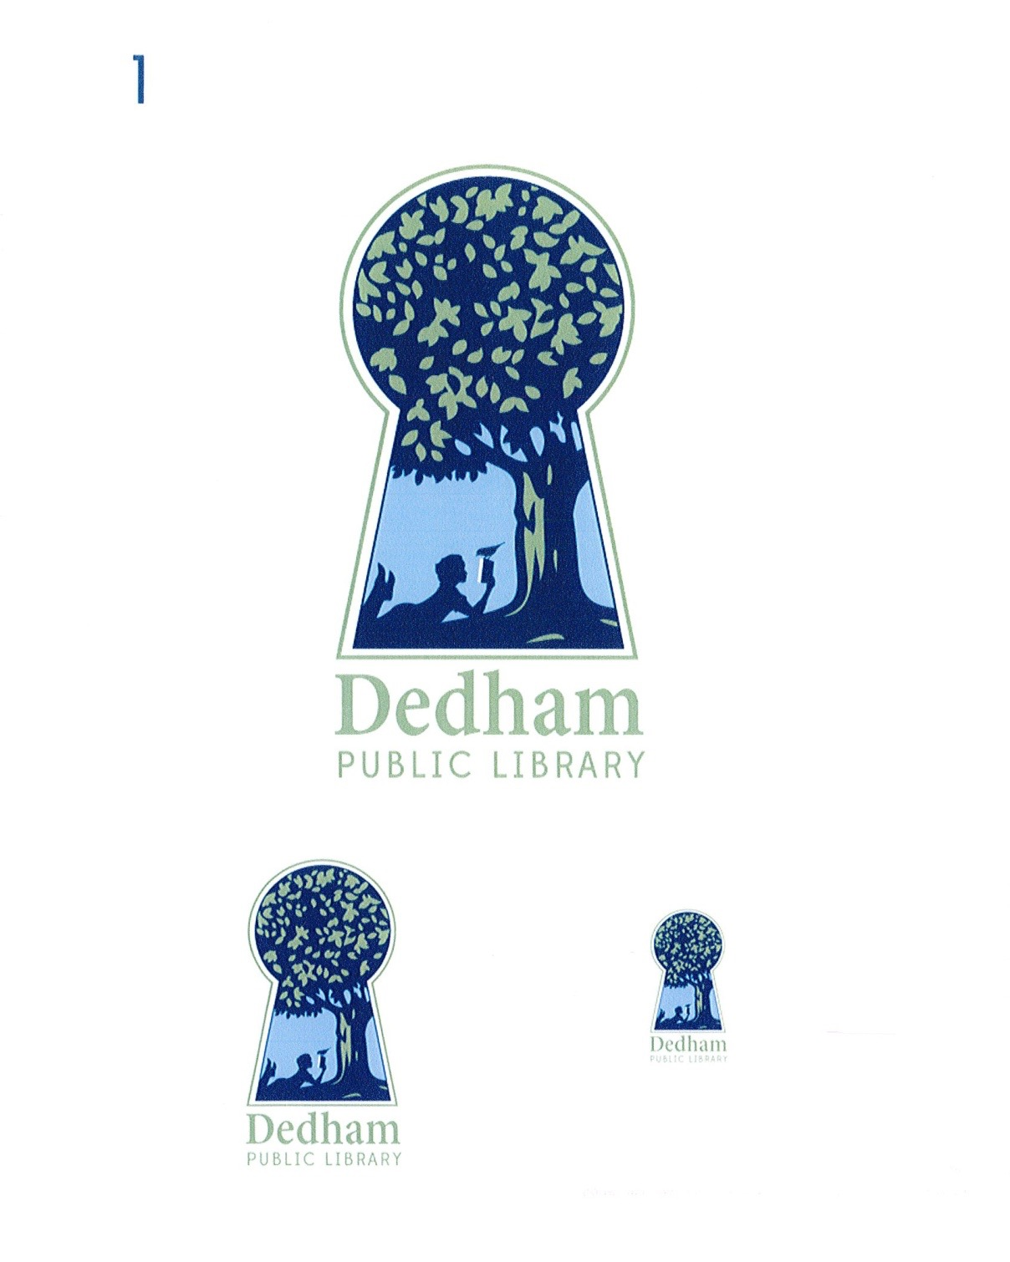
Bonnie Roalsen, Director Margaret Connolly, Chair
Dedham Public Library Sarah Santos, Vice Chair
43 Church Street Tracy Driscoll
Dedham, MA 02026 Mary Ann Sliwa
781.751.9281 Monika Wilkinson

DPL Trustees Meeting Minutes
April 12, 2018, Endicott Branch, 5:30 pm
Meeting Called By | Board of Library Trustees, Dedham
Type of Meeting | Monthly Meeting
Chairman | Margaret Connolly
Secretary | Monika Wilkinson
Attendees | Margaret Connolly, Tracy Driscoll, Sarah Santos, Mary Ann Sliwa, Monika Wilkinson, and Bonnie Roalsen
PUBLIC ATTENDEES | Richard Pierce

The April 12, 2018 meeting of the Dedham Library Board of Trustees was called to order at 5:34 pm by Chair, Ms. Connolly.

Public Input:

Mr. Pierce stated that the Friends of the Dedham Public Library recently passed motions to align Friends’ structure and processes outlined in bylaws. Their mailer trifold brochure will be ready for mailing in June and the Friends will be getting a PO Box. They are currently considering a museum pass passport program. Next book sale will be May 5 from 9:00 am -3:00 pm, and the last book sale earned over $700. The Friends are looking forward to organizing an event in memory of Mimi Harrington.

Tracy Driscoll complimented the Friends on the Art in Bloom exhibit.

Action Items:
Open Meeting Law Complaint: Christian Anthony. Acknowledge receipt of complaint received March 22. 2018. Ms. Sliwa made a motion to acknowledge the OML complaint and resolution thereof. Ms. Connolly seconded. All voted in favor.
Discussion and Vote: Minutes of March 20, 2018 This was postponed until the next meeting.

Discussion and Vote: Financial Report March 2018 Ms. Sliwa made a motion to accept the Financial Report. Ms. Wilkinson seconded. All voted in favor.

Director’s Report

Attendance jumped to 10,000 people for the month of March. The program “Smack Dab in Middle” was a great success. Other examples of popular events were the Indian comfort food cooking, Mr. G., and Irish step dancing. 3D printers are now circulating. We are one of the first libraries in the country to do this. First violins have been printed.

Summer reading planning is underway. The Main Library is hoping to be an open site for food vulnerable children. This effort would be part of the Summer Food Service Program, administered by the Massachusetts Department of Elementary and Secondary Education with support from the Child Nutrition Outreach Program at Project Bread. The program works to ensure children 18 years and younger have continued access to nutritious meals and provides free meals at approved Summer Food Service Program sites in areas with significant concentrations of low-income children. The Dedham Public Schools (DPS) can be a vendor, make food, and distribute it. There was some discussion about a recent connection made between Project Bread and DPS. Initially Ms. Roalsen had contacted DPS to inquire about the effort. Shortly after Ms. Wilkinson had made a similar inquiry when talking together with Project Bread representatives and Jeanne Johnson from DPS, and it was discovered that the Main Library is in a small designated area called an “open site”, which means it could be a distribution location in Dedham. Ms. Roalsen said that the Library would create “camp experience” programming that would support children who are at the library for breakfast and lunch. Outside funding would be explored.

Additionally, a music series is being planned with Thursday night performances.

The new website will be launched in early May.

The Dedham Library Innovation Team event will be held on Friday, April 13, at the Endicott Branch. Signage for early closing has been displayed to inform patrons of the change.

Old/New Business:

Ms. Wilkinson suggested the idea of bringing meetings out to the public on occasion (such as visiting NewBridge on the Charles – Hebrew Senior Life residents). She said this might be a way to involve the public and build interest in offerings of the library (ex. new website, ways to order things). Ms. Driscoll suggested inviting Dedham TV to film a meeting. Ms. Roalsen mentioned live streaming.

There was some discussion of agenda posting. Ms. Santos suggested earlier agenda posting to give public greater time to plan. Ms. Sliwa pointed to the great growth in public involvement and commended Ms. Roalsen for not closing the library for an extended time during renovations.

Ms. Sliwa asked about the timing of the director’s goals. Evaluations will be shared at next month’s meeting. Ms. Santos and Ms. Wilkinson will be meeting with Ms. Roalsen to identify goals for the next year, but it was agreed that goals should not be finalized until the previous year’s evaluation is shared.

Ms. Santos asked about the status of the handicapped access ramp. Ms. Roalsen said that weather has delayed the work.

A motion to adjourn the meeting was made at 6:47 pm by Ms. Sliwa; Ms. Wilkinson seconded; all voted in favor.

Action Item Table:

Action Item | Person | Date Due
Director's Goals Working Group | Ms. Willkinson, Ms. Santos, Ms. Roalsen | Spring 2018
Donors Working Group | Ms. Wilkinson, Ms. Driscoll, Ms. Roalsen and staff | Spring 2018
Policy Working Group: meeting policy, art policy | Ms. Wilkinson, Ms. Connolly, Ms. Roalsen | Spring 2018

Respectfully submitted,

Monika Wilkinson

