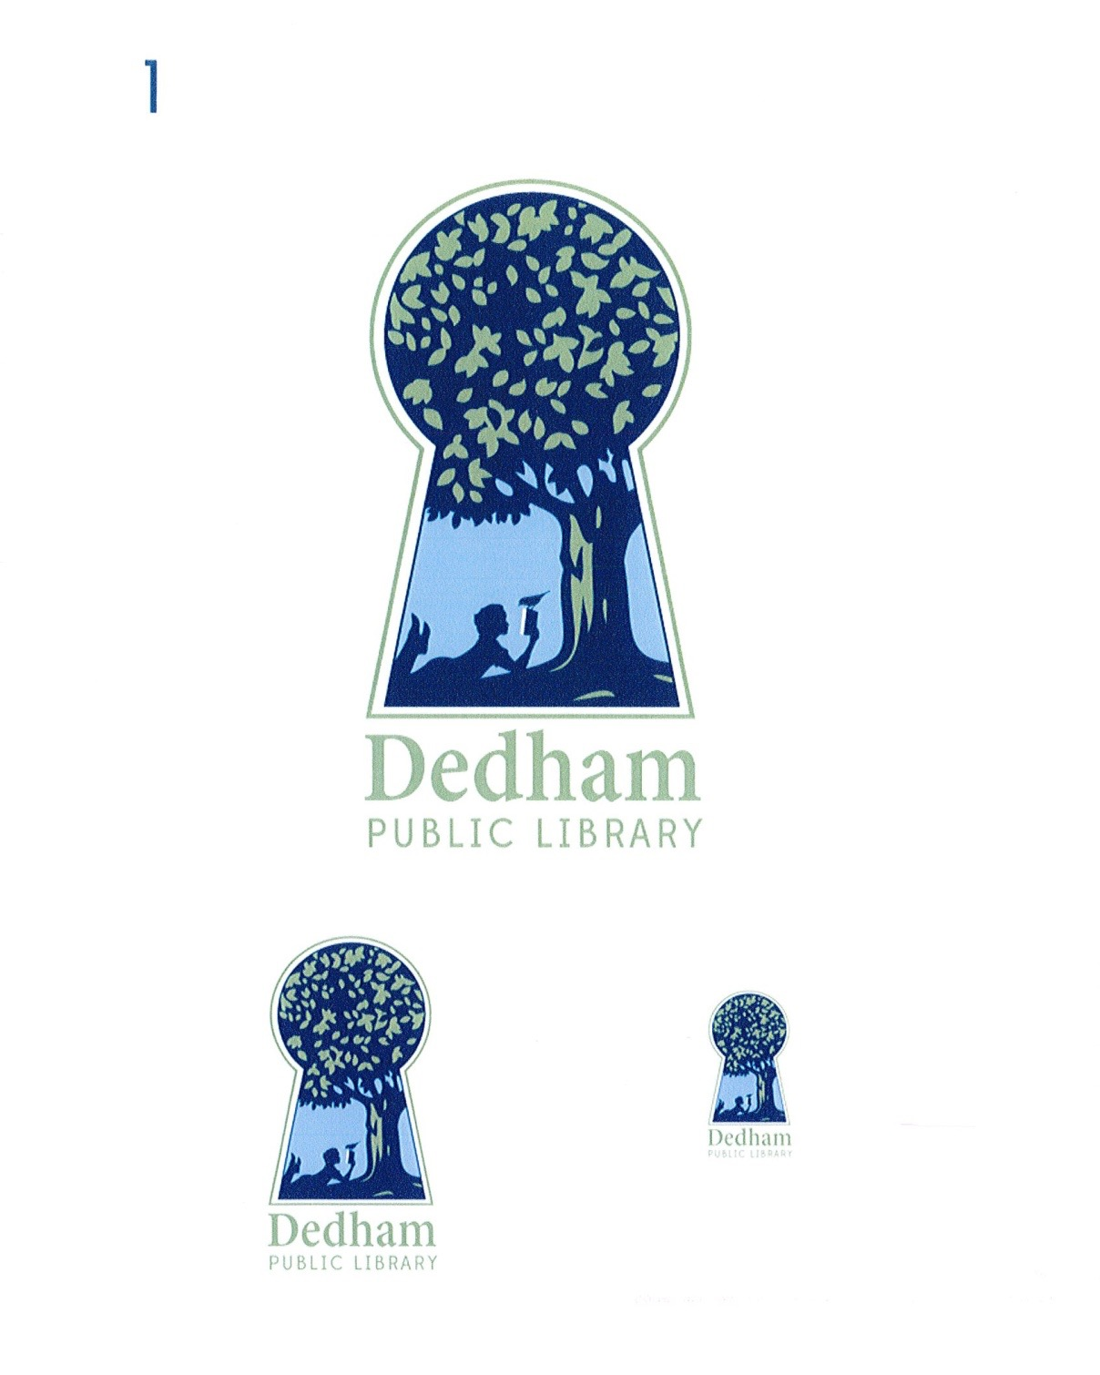
Bonnie Roalsen, Director Margaret Connolly, Chair
Dedham Public Library Sarah Santos, Vice Chair
43 Church Street Tracy Driscoll
Dedham, MA 02026 Mary Ann Sliwa
781.751.9281 Monika Wilkinson

DPL Trustees Meeting Minutes
November 16, 2017, main library, 6:00 pm
Meeting Called By | Board of Library Trustees, Dedham
Type of Meeting | Monthly Meeting
Chairman | Margaret Connolly
Secretary | Monika Wilkinson
Attendees | Margaret Connolly, Tracy Driscoll, Sarah Santos, Mary Ann Sliwa, Monika Wilkinson, and Bonnie Roalsen
PUBLIC ATTENDEES | Richard Pierce

The November 16, 2017 meeting of the Dedham Library Board of Trustees was called to order at 6:02 pm by Chair, Ms. Connolly.

Public Input:

Mr. Pierce stated that the Friends of the Dedham Public Library will soon be opening the new space in upcoming weeks. There will be a December book sale

Action Items:
Discussion and Vote: Minutes of September 14, 2017

Regarding the minutes of September 12, 2017, there was no discussion. Ms. Sliwa made a motion to accept; Ms. Driscoll seconded; all voted in favor of accepting the October, 2017 minutes.

Discussion and Vote: Financial Report September, 2017

Tabled

Director’s Report

5200 program attendance for October. New staff that started in September allowed for greater programming. New programming for all ages. The library has partnered with Youth Commission to expand programming. Olin College will be collaborating with robotics and coding-focused programs.

Three screens will be installed at Endicott to be used for programming, information, and gaming. A 3-D printer will be installed as well. There is now a total of 4 3-D printers currently and one that circulates.

Michael Welch Superintendent set up a meeting with organizations servicing youth for networking. Partnerships coming out of that and connecting staff to allow them to share resources.

The library is creating a fully integrated site called Dedham.life to share information across social media with a calendar and civic group section. The Youth Commission will be providing feedback.

Report: Strategic Plan Working Group

The Strategic Planning Working Group completed the Strategic Plan, which was submitted to the State on October 1, 2017. Ms. Sliwa thanked all that participated and stated she would be sending a copy of the completed document to everyone in the working group. Ms. Sliwa further thanked Ms. Roalsen for her leadership and insight. The Trustees will review and vote to formally accept the Strategic Plan at their next meeting.

Report: Policy Working Group

The Policy Working Group was in the process of readjusting their proposals to reflect the effect increased hours at both libraries would have on rental of room space. In addition, polices regarding use of the 3D printer and its materials and public art displays should be ready for review by January, 2018.

Report: Director’s Report

Programming: Drone flying programs began and the first session had over 35 people in attendance. This was a great intergenerational activity with all age-groups represented. A drone obstacle course is being planned for the Main and a micro drone will be used to maneuver the course. 23 people created/printed 3D pumpkins, which was another intergenerational activity.

Renovations: Ms. Roalsen updated the Board regarding renovations taking place. The Endicott was closed for a week as trim work and painting took place. The space will be redesigned for more effective utilization. The blinds will be pulled back for natural light. A gaming center will be set-up, as well as, 3D printers, makerspace and two 65” screens. Another bench has been donated by Dedham Civic Pride.

Old/New Business:

Ms. Santos asked if book marks could be created which displayed the new hours. She also suggested that we promote the new hours and programs in more ways.

A motion to adjourn the meeting was made at 6:55 pm by Ms. Wilkinson; Ms. Sliwa seconded; all voted in favor.

Action Item Table:

Action Item | Person | Date Due
Director's Goals Working Group | Ms. Willkinson, Ms. Santos, Ms. Roalsen | September 2017
Donors Working Group | Ms. Wilkinson, Ms. Driscoll, Ms. Roalsen and staff | Fall 2017; in progress
Policy Subcommittee: room reservations, art policy | Ms. Wilkinson, Ms. Connolly, Ms. Roalsen | On-going
Negotiation with Union | Ms. Roalsen | 2017

Respectfully submitted,

Tracy Driscoll

